 

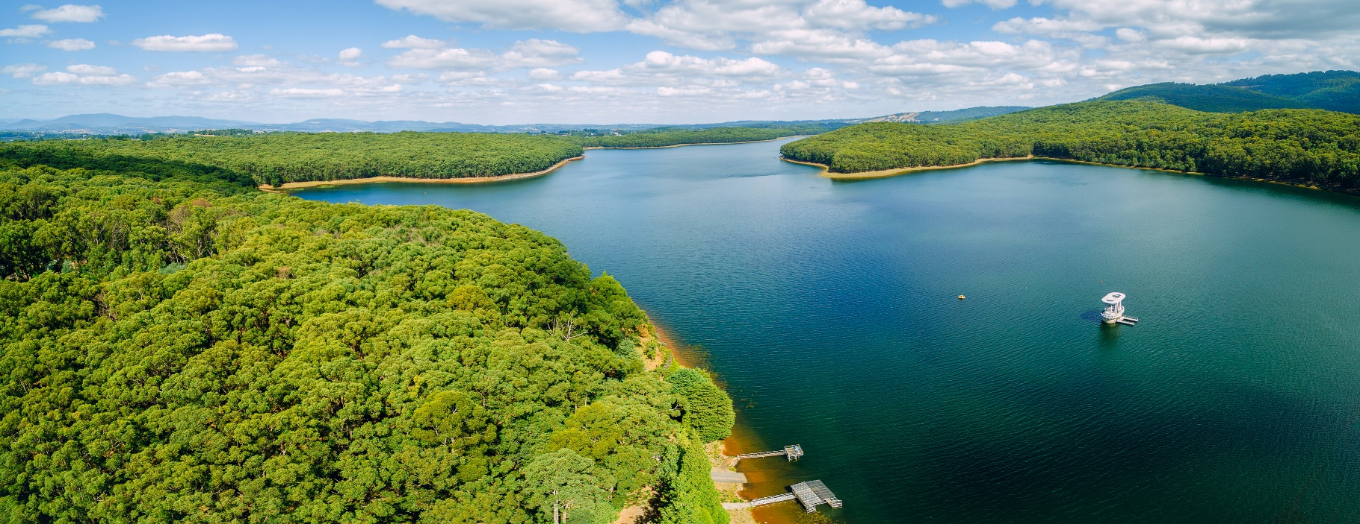

ERP25 – Review of 2008 Wood and Water Study

Phillip Jordan, Rory Nathan, Richard Benyon, Benjamin Henley, Trent Penman and Peter Hill

Report

Version 1

25 March 2020

Document status

|  |  |
| --- | --- |
| Client | Bushfire and Natural Hazards Cooperative Research Centre |
| Project | ERP25 – Review of 2008 Wood and Water Study |
| Document | VIC00055_RP_WoodAndWaterReview_v2.docx |
| This version | Version 1 |
| Authors | Phillip Jordan, Rory Nathan, Richard Benyon, Benjamin Henley, Trent Penman and Peter Hill |
| Project manager | Phillip Jordan |
| File name | S:\3_Projects\VIC00055\6_Deliverables\FinalReport\VIC00055_RP_WoodAndWaterReview_v1.docx |
| Project number | VIC00055 |

Acknowledgements

Copyediting and proofreading of this report were undertaken by Ann Milligan.

Rocianne Bortolazzo Pinto and Katherine Szabo provided assistance with preparation of maps, figures and data tables included in this report.

Project management support was provided by Loriana Bethune and Kelsey Tarabinin from the Bushfire and Natural Hazards Cooperative Research Centre.

Melbourne Water provided monthly streamflow data on inflows to Thomson, Upper Yarra, O’Shannassy and Maroondah reservoirs.

Document history

|  |  |  |  |  |  |
| --- | --- | --- | --- | --- | --- |
| Version | Date issued | Reviewed by | Approved by | Sent to | Comment |
| Draft A | 19/11/2019 | R.J. Nathan | P.I. Hill | CRC & DELWP | Draft |
| Draft B | 21/11/2019 | CRC & DELWP | P.I. Hill | Executive summary sent to stakeholders | Draft prior to presentations |
| Draft C | 27/11/2019 | P.I. Hill | P.I. Hill | CRC & DELWP | Response to initial comments by DELWP and Melbourne Water |
| Draft D | 9/12/2019 | R.J. Nathan | P.I. Hill | CRC & DELWP | Response to comments from Melbourne Water |
| Draft E | 16/12/2019 | R.J. Nathan | P.I. Hill | NGO and Industry stakeholders |  |
| Draft F | 13/02/2020 |  |  | Ann Milligan | Reference check and copyediting |
| Version 1 | 25/03/2020 | R.J. Nathan  A. Milligan | P.I. Hill | CRC | Final review and copyediting |

Copyright and Limitation

This report has been produced by Hydrology and Risk Consulting Pty Ltd ACN 603 391 993 (“HARC”) for the Bushfire and Natural Hazards Cooperative Research Centre. Unless otherwise indicated, the concepts, techniques, methods and information contained within the report are the intellectual property of the State of Victoria and may not be reproduced nor used in any form by third parties without the express written consent of the State Government of Victoria, Department of Environment, Land, Water and Planning.

The report has been prepared based on the information and specifications provided to HARC and the University of Melbourne by the Bushfire and Natural Hazards Cooperative Research Centre. HARC does not warrant this document as being complete, current or free from error, and disclaims all liability for any loss, damage, costs or expenses (including consequential losses) resulting from use of this report.

Copyright © State of Victoria 2020. All rights reserved.

Executive summary

**Introduction and context**

The *Wood and Water Study* (2008), hereafter referred to as WWS2008, comprised a group of studies that were undertaken by a team of researchers between 2006 and 2008. The purpose of WWS2008 was to estimate the impacts of different timber management regimes, as well as bushfire and climate change, on catchment water yield (i.e. streamflows) in Melbourne’s water supply catchments and to demonstrate how the different timber management regimes would impact on timber yield from the associated Forest Management Areas. The study was documented in six reports (Mein, 2008; Feikema *et al.*, 2006, 2008; Walker, 2008; Battad *et al.*, 2007; Salkin, 2008), and recommendations for future work were made in two of these (Mein, 2008; Feikema *et al.*, 2008).

Hydrology and Risk Consulting (HARC) and the University of Melbourne (UoM) were engaged by the Bushfire and Natural Hazards Cooperative Research Centre on 1 October 2019 to review WWS2008 and its supporting reports, and the relevant documents or data that have been published since the study was completed in 2008. This review focusses only on aspects relevant to catchment water yields, and not on timber production. The review has drawn upon existing published research on bushfires and catchment water yield in forested catchments of Victoria and other parts of Australia, as well as other analyses and modelling available up to September 2019. No new modelling was undertaken as part of this review.

This review has considered whether previous modelling of the catchment water yield impacts in Melbourne’s catchments remains current in light of:

* fire, logging and other disturbance events since 2008
* rainfall conditions, including potential climate change impacts on future rainfall
* expected changes to fire behaviour under climate change, taking into consideration the likelihood of more frequent and severe days of extreme fire weather
* any other factors considered likely to have a material impact on catchment water yield.

Mein (2008) focussed exclusively on the impact of these factors on catchment water yield, and excluded any discussion of impacts on water quality. This review has therefore focussed on catchment water yield from Melbourne’s catchments, without specific commentary on water quality.

**Factors emerging since 2008**

The Regional Forest Agreements (RFAs) for Victoria are due to expire on 31 March 2020. A Memorandum of Understanding (MoU) was signed on 27 March 2018 committing Victoria and the Commonwealth of Australia to work towards 20-year extensions to the RFAs, which come into effect from March 2020. On 7 November 2019, the Victorian Government announced a plan to immediately cease all logging in old growth forests, with all logging in native forests across the state to stop by 2030.

Significant changes to government policy, governance of the Yarra River catchment and the Melbourne water supply system since the completion of WWS2008, may have changed the economic, social, environmental and cultural benefits and costs of the options that were considered in WWS2008.

Demands for water will be influenced by climate variability and change, and by population growth. Per-capita, and hence total, demand for water will be moderated by integrated water management options. And, as has been demonstrated in recent years (including in early 2019), bushfires can have appreciable impacts on water quality in the reservoirs, which will affect Melbourne Water’s options for satisfying Melbourne’s water demand.

All these factors combine to influence the current and future water supply and demand for Melbourne, and hence the water resources system strategy and management.

**Assessment of the conclusions of WWS2008**

This report presents a detailed review of WWS2008, in light of developments over the last 11 years and the current state of knowledge about Melbourne’s forested catchments. Section 6 of this report presents our assessment of the four broad conclusions of the WWS2008 Summary Report (Mein, 2008) resulting from this review, together with our recommendations. Our assessment and recommendations are restated here.

1. *The expected yield of the water supply catchments is increasing, due to the continued aging of the forest after the 1939 bushfires.*

Inflows to Melbourne’s reservoirs over the 1997–2018 period were 31% below the long-term mean due to mean annual rainfall being about 11% below average. Some of Melbourne’s forested catchments were affected by high severity fires in 2009. Had rainfall been at the long-term mean and had there been no bushfires, conclusion (i) would have remained valid. However, future catchment water yields will depend upon future climatic conditions and bushfires. Feikema *et al.* (2013) provides reasonable projections of catchment water yield from those catchments that were severely affected by the 2009 bushfires, estimating that the total reduction in catchment water yield for all of Melbourne’s catchments, over coming decades, is projected to be between 12 and 24 GL/year.

1. *The impacts of changing timber management regimes on cumulative water yield are relatively small, modelled here as being all within –1.5% of the cease-logging regime.*

WWS2008 considered climate change, timber harvesting and bushfires in isolation. The WWS2008 Summary Report (Mein, 2008) recommended that a Monte Carlo approach should be undertaken to assess the combined effects of bushfires and climate change on catchment water yield to Melbourne’s reservoirs. Until such modelling is undertaken, WWS2008 still represents the most reliable projections of changes in catchment water yield from Melbourne’s forested catchments between the current timber harvesting regime and scenarios for cessation of logging across the catchments. Mein (2008) calculated that by 40 years after the cessation of logging, there would be an increase of 16 GL/year in water yield and a cumulative increase of 190 GL in catchment water yield over a 40 year period. It is recommended that the values of these increases in catchment water yield be incorporated into an analysis of cultural, economic, social and environmental costs and benefits under a range of future plausible scenarios. Annual average rates of timber harvesting, in terms of area logged, for the last decade have been similar to the rates of harvesting (in terms of area) that were set out in *Management Standards and Procedures* (Department of Environment and Primary Industries, 2014a) and projected in WWS2008 for the continuation of the status quo timber harvesting scenario. Taylor *et al.* (2018, 2019) produced higher projected increases in catchment water yield due to cessation of logging for the Thomson catchment than those that were predicted by WWS2008 for the closest comparable scenario. It is difficult to be certain without access to their model, but from the material presented in Taylor *et al.* (2018, 2019), it appears that several simplifying assumptions were made, which were all likely to have over-estimated the impact of timber harvesting on catchment water yield in the Thomson catchment.

1. *The impact of climate change on water yield can be large. For every 1% decrease in long-term average rainfall, water yield is reduced by 2–3% in all catchments. [For the last 10 years the reduction in flows has been of the order of 30%.]*

The observation that proportional reductions in mean annual catchment water yield are between two and three times the proportional reductions in mean annual precipitation remains reasonably consistent with observed streamflow and rainfall data in Melbourne’s catchments, and results from several modelling studies (Zhou *et al.*, 2015; Taylor *et al.*, 2019). Uncertainties in projected changes in precipitation, temperature and potential evapotranspiration are considerable, particularly for projections that are several decades into the future. In addition, previous modelling has not explicitly considered changes in forest types, which may be induced by climate change or more frequent high severity bushfires, and so may not adequately represent changes in rainfall-runoff generation response that have been observed across many Victorian catchments. Further modelling would be required to provide updated projections of catchment water yield under climate change for Melbourne’s forested catchments; such modelling should consider the overlapping effects of climate change, timber harvesting and bushfires.

1. *The potential impact of bushfires is also major. A repeat of the 1939 bushfires would see a decrease of 15% of the inflow to the Thomson Dam over the following 50 years.*

The conclusion remains valid that a future high severity bushfire, affecting a significant area of one or more catchments, would have a significant future impact on catchment water yield. Further modelling would be required to provide updated projections of the impacts of future bushfires. Such modelling should consider the overlapping effects of bushfires, climate change, climate variability and timber harvesting.

**Our recommendations**

1. Any future studies should quantify how climate variability and climate change, timber harvesting and bushfires combine to influence the runoff from catchments and hence the volumes of water that need to be supplied from other sources.
2. It is therefore recommended that an analysis be conducted of the cultural, economic, social and environmental costs and benefits under the range of future plausible scenarios, including revised modelling of expected change in catchment water yield.

Whilst investigations since 2008 about the feedbacks between bushfires, climate change and timber harvesting have produced variable results, these variations could be accommodated in an appropriately designed Monte Carlo simulation framework, as originally recommended by Mein (2008). The effects of potential changes in species distribution under climate change have not been tested in previous modelling of catchment water yield under climate change in Melbourne’s catchments. More frequent high severity fires due to changes in both climate and functional landscape structure (Lindenmayer *et al.*, 2011) may ultimately result in loss of ash eucalypt forest to acacia or other species, which may reduce actual evapotranspiration and increase catchment water yields in future.

1. Further modelling would be required, to provide more reliable projections of changes in catchment water yield under climate change to address these uncertainties. The Monte Carlo framework should therefore be designed to allow for the probability that climate change and/or recurrent high severity fires may result in transition between forest types. Combinations of these factors should be explicitly considered, to provide quantitative estimates of uncertainty in future catchment water yields.

Two recommendations from Feikema *et al.* (2008), a component of WWS2008, identified that further ground-truthing of spatial and temporal variations in leaf area index would help to reduce uncertainties in modelling. Research completed since WWS2008 indicates that future modelling of catchment water yield should transition to use sapwood area index instead of leaf area index. Further analysis of water yield at catchment scale, supported by plot-scale measurements of actual evapotranspiration, suggest catchment-level evapotranspiration for ash forests peaks 6 to 11 years earlier than indicated previously (by the eponymously termed “Kuczera curve”), with a more rapid decline following the peak. Models that include the initial increase in runoff in the first few years after timber harvesting would be consistent with the experimental data, in contrast to models (such as the Kuczera curve) that do not include this initial increase in runoff. Whilst experimental data have identified streamflow reductions as forests age in mixed-species eucalypt forest, changes in actual evapotranspiration have been found to have considerable spatial variation, driven by forest structure. Impacts on water yield in drier mixed-species eucalypt forest catchments have been found to be considerably more muted and shorter-lived than those in wetter catchments that are dominated by ash-type forests, and catchment models should take these differences into account.

1. Future modelling should rely upon the latest relevant research on spatial and temporal variations in actual evapotranspiration with forest age and forest type. Attention should be paid to recent analyses demonstrating a potential change in the shape of the Kuczera curve for different combinations of forest age, mean annual rainfall, and forest type. It is recommended that future modelling includes re-calibration to the longer streamflow data sets that are now likely to be available, particularly to confirm that the models can adequately capture changes in the rainfall-runoff generation response under long-term climatic variations and projected climate change.

Melbourne’s catchments experience a high degree of year to year variability and are influenced by numerous ocean–atmosphere mechanisms. In a multidecadal context, there is a high degree of uncertainty about global temperature mitigation and therefore future climate change. There also remains much uncertainty about how vegetation and catchments respond to higher concentrations of atmospheric CO2, changing rainfall, increasing temperatures, changing potential evapotranspiration, and changes to the spatio-temporal patterns of meteorological variables. Given these large knowledge-based uncertainties, it is not possible on the basis of existing research to tightly constrain future yield projections. Although there remains a large degree of future uncertainty, it is generally accepted that further declines in water yield to Melbourne’s catchments due to climate change are likely.

The recommendations are focussed purely on the terms of reference for this review and therefore do not consider any other further work that may be needed. Such consideration could include the cost of undertaking any further analysis relative to the added value that may be provided.

Contents

1. Introduction 1

1.1 Wood and Water Study and purpose of this review 1

1.2 Policy context 2

1.3 Structure of this report 3

2. Drivers of water yield in Melbourne’s forested catchments 4

3. Overview of Wood and Water Study 2008 methods and findings 8

3.1 Macaque model calibration 9

3.2 Future scenario modelling 9

3.3 Catchment water yield results 11

4. Assessment of recommendations from WWS2008 13

4.1 Analysis of recommendations from the WWS2008   
Summary Report 13

4.1.1 Assessment of combined effects of bushfire, climate change and   
timber harvesting on water supply from the forested catchments 13

4.1.2 Assessment of economic, social and environmental benefits and costs   
of options considered in WWS2008 18

4.1.3 Sustainability of increased yield from thinning treatments 20

4.2 Analysis of recommendations from the WWS Macaque   
modelling report 21

4.2.1 Improved methods for understanding and modelling spatial variations   
in AET and improved methods for understanding and modelling response of   
vegetation to bushfire 21

4.2.2 Improved methods for understanding and modelling response of   
forest growth and water use to changes in atmospheric CO2 concentrations 25

5. Analysis of relevant issues that have emerged since WWS2008 27

5.1 Areas of timber harvesting since WWS2008 27

5.2 Effects of bushfires in Melbourne’s catchments since 2008 28

5.3 Modelled impact on catchment water yield of cessation of logging   
since WWS2008 30

5.4 Response of Victorian catchments to climate variability   
and climate change 37

5.5 Reassessment of model calibration with additional data 45

5.6 Development of improved modelling approaches 47

6. Conclusions and recommended future investigations 50

7. References 53

Appendix A Glossary 62

Appendix B Brief for this Review 66

# Introduction

## Wood and Water Study and purpose of this review

The *Wood and Water Study* (2008), hereafter referred to as WWS2008, comprised a group of studies by a team of researchers over 2006, 2007 and 2008. Dr Russell Mein produced a *Summary Report* (Mein, 2008) which analyses the hydrological modelling of catchment water yield and water quality impacts which had been undertaken.

Hydrology and Risk Consulting (HARC) and the University of Melbourne were engaged by the Bushfire and Natural Hazards Cooperative Research Centre on 1 October 2019 to review WWS2008 and its supporting reports, and relevant reports or data that have been published since the summary report (Mein, 2008). Our review has considered whether previous modelling of the catchment water yield impacts in Melbourne’s catchments remains current in light of:

* fire, logging and other disturbance events since 2008
* rainfall conditions, including potential climate change impacts on future rainfall
* expected changes to fire behaviour under climate change, taking into consideration the likelihood of more frequent and severe days of extreme fire weather
* any other factors considered likely to have a material impact on catchment water yield.

Mein (2008) focussed exclusively on the impact of these factors on catchment water yield and excluded any discussion of impacts on water quality. In the context of water supply from Melbourne’s reservoirs, the impacts of timber harvesting on water quality in the major harvesting reservoirs are likely to be negligible if undertaken according to best practice procedures (Department of Environment and Primary Industries, 2014a). However, as has been demonstrated in recent years (including in early 2019), bushfires can have appreciable impacts on water quality in the reservoirs, which will influence water supply management for Melbourne. This review has therefore focussed on water yield from Melbourne’s catchments, without specific commentary on water quality.

A copy of the call for Expressions of Interest for this review, which formed the project brief, is provided in Appendix B. The review has drawn upon existing published research on bushfires, water yield and water quality in forested catchments of Victoria and other parts of Australia. The review was undertaken over a two-month period and the timeframe did not allow new modelling to be undertaken. Instead, the project team has relied upon research, analyses and modelling that have been completed and are available to the project team, up to September 2019. The scope of this review of WWS2008 is confined to specific technical aspects of the catchment water yield from Melbourne’s water catchments, in the trade-off between wood and water. Review of the timber yield component of WWS2008 was outside the scope of this review report (see Appendix B).

## Policy context

Regional Forest Agreements (RFAs) are 20-year plans, each agreed between the Australian Government and a state government, for the productive use and conservation of Australia’s native forests. They are a key outcome of the National Forest Policy Statement (Commonwealth of Australia, 1992, 1995) through which the Australian, state and territory governments committed to the sustainable management of all Australian forests, whether the forest is on public or private land, or reserved or available for timber production (Australian Government Department of Agriculture, 2015).

The main objectives of the Victorian RFAs are to provide for:

* a comprehensive, adequate and representative (CAR) reserve system,
* the ecologically sustainable management and use of forested areas in each RFA region, and
* the long-term stability of forests and forest industries.

The agreements are entered into after making a region-specific assessment of forest values, which includes:

* environmental values (including old growth, wilderness, endangered species, national estate values and world heritage values),
* aboriginal cultural values,
* economic values of forested areas and forest industries,
* social values (including community needs), and
* principles of ecologically sustainable development.

Between 1997 and 2001, Victoria and the Commonwealth of Australia entered into five RFAs: East Gippsland, Central Highlands, North East, Gippsland and West Victoria. All five RFAs are due to expire on 31 March 2020. On 27 March 2018, Victoria and the Commonwealth signed a Memorandum of Understanding (MoU) that,

*set out actions to be undertaken by the Australian and Victorian governments to ensure that long term extensions and updates to the Victorian RFA framework can be undertaken by 31 March 2020*.

The MoU committed Victoria and the Commonwealth to work toward 20-year extensions to the RFAs, which come into effect from March 2020. The extensions should have regard to the outcomes of further assessments, consistent with the *Regional Forest Agreements Act 2002*, and the engagement process that was set out in the MoU. In the MoU, the Victorian and Commonwealth governments,

*acknowledge the impact of climate change, extreme weather events (including drought and bushfires), scientific and technological progress, advances in our understanding of forests and ecosystems, the changing forest-based industries and opportunities, and the recognition of the rights of Victoria’s traditional owners to partner in land management and seek economic and cultural opportunities*.

The Department of Environment, Land, Water & Planning (DELWP) has appointed a Scientific Advisory Panel to provide independent science-based advice and recommendations on improvements to Victoria’s RFAs and the forest management system.

On 7 November 2019, the Victorian Government announced a plan to immediately cease all logging in old growth forests, with all logging in native forests across the state to stop by 2030 (Andrews, 2019; D’Ambrosio, 2019).

## Structure of this report

The structure of this report is as follows. Chapter 2 is a brief summary of Melbourne’s water supply system and the contributions of the forested catchments to Melbourne’s water supply. Chapter 3 provides an overview of the methods and findings of WWS2008. Chapter 4 considers relevant new information that has arisen since WWS2008 and whether each of the recommendations in the WWS2008 reports remains relevant, has been resolved, or should be addressed in future. Chapter 5 discusses other relevant issues that have emerged since WWS2008. Chapter 6 summarises conclusions and provides recommendations.

# Drivers of water yield in Melbourne’s forested catchments

Melbourne’s water supply system consists of 1,567 km² of catchments and eleven storage reservoirs, as shown in Figure 1. Most of the inflows are collected from catchment runoff into four of the reservoirs: Thomson, Upper Yarra, Maroondah and O’Shannassy.

Water in Melbourne Water’s headworks storages is used to manage inflow deficits during periods of lower rainfall. Environmental flows can be released from the Upper Yarra, Maroondah and O’Shannassy reservoirs to support ecological processes and environmental outcomes in downstream river reaches and wetlands. The priority environmental flow reaches for the Yarra River are reach 2 (from Armstrong Creek to Millgrove) and reach 5 (from Yerring Gorge to Mullum Creek) (Victorian Environmental Water Holder, 2019). Reductions in unregulated flows from the Yarra tributaries, upstream of Yerring Gorge, may therefore need to be offset by releases from the storage reservoirs, upstream. Reductions in catchment water yield in the Thomson catchment reduce water available for allocation to urban, environmental and irrigations users.

* 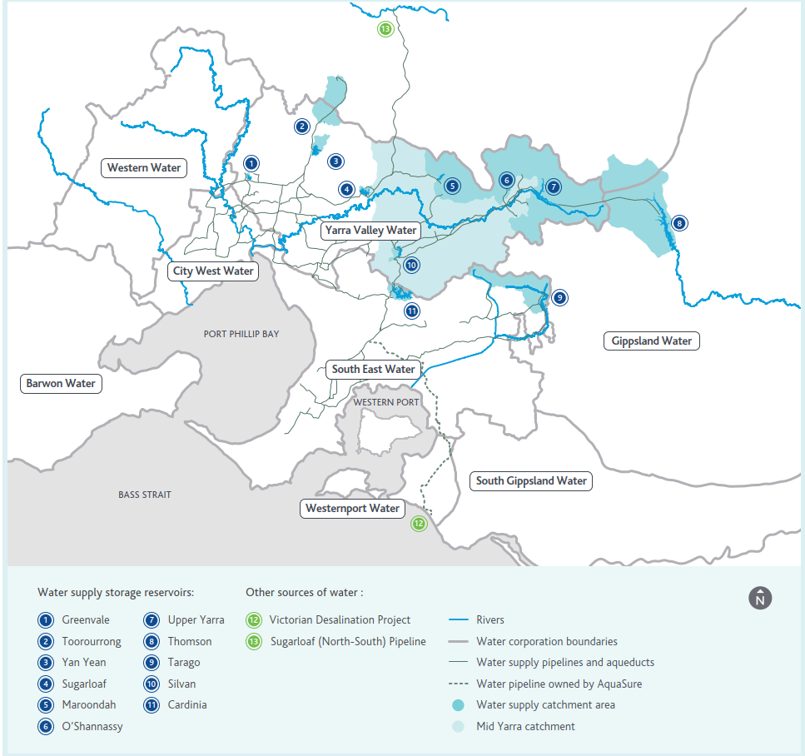Figure 1 Map of Melbourne’s water supply system, reproduced from Figure 8 of Melbourne Water (2017)

Most of Melbourne’s catchments have limited access, are completely forested and are subject to minimal human intervention. Several of these protected catchments are national parks and not subject to timber harvesting. Some catchments contain areas of state forest and parts of these areas are subject to timber harvesting each year. Timber harvesting is currently permitted in the state forest areas upstream of Thomson Reservoir, upstream of Tarago Reservoir and in the Bunyip River catchment. Timber harvesting is also currently permitted in parts of several subcatchments of the Yarra River: Armstrong Creek, McMahons Creek, Starvation Creek and Cement Creek.

Annual water yield from a forested catchment is the difference between annual precipitation and actual evapotranspiration (AET). In an energy limited catchment, where the annual precipitation always exceeds the annual potential evapotranspiration (PET), AET is often dependent upon the structure and density of the forest. Understanding effects of disturbances, such as timber harvesting and fires, on catchment yield therefore requires an understanding of how these disturbances change AET.

Studies of AET in eucalypt forests over the past decade have examined key drivers of AET and developed new methods for fine-scale spatial and temporal mapping of AET. Several studies have shown that mean overstorey sap velocity in eucalypt forests does not vary markedly with age or with stand density (confirming and extending earlier observations in the 1990s) so that annual transpiration (water used directly by the trees) is strongly correlated with overstorey sapwood area. At short timescales (hours to days), transpiration is mainly determined by meteorological variables (Gharun *et al.*, 2013; Metzen *et al.*, 2019). Conversely, at longer timescales (seasons to years), stand sapwood area is often the strongest predictor of AET (Macfarlane *et al.*, 2010; Buckley *et al.*, 2012; Mitchell *et al.*, 2012; Benyon *et al.*, 2017; Metzen *et al.*, 2019).

Benyon *et al.* (2015) summarises the drivers of changes in annual water yield from forested catchments. These authors surmise that changes in annual streamﬂow from forested catchments, lasting for years to decades or more, are associated with variation in forest density or cover in time and space. Such changes can be induced by:

* aging of the forest (Kuczera, 1987; Hornbeck *et al.*, 1993; Hudson *et al.*, 1997; Watson *et al.*, 1998b; Cornish and Vertessy, 2001; Andréassian, 2004; Lane *et al.*, 2007; Bren *et al.*, 2010)
* bushfire (Langford, 1976; Fernández *et al.*, 2006; Nolan *et al.*, 2015)
* insect attack (Watson *et al.*, 1998b, 2001; Cornish and Vertessy, 2001; Hélie *et al.*, 2005; Fernández *et al.*, 2006) and
* various forms of forest harvesting and regeneration (Cornish, 1993; Hornbeck *et al.*, 1993; Hudson *et al.*, 1997; Watson *et al.*, 1998b; Cornish and Vertessy, 2001; Lane and Mackay, 2001; Fernández *et al.*, 2006; Lane *et al.*, 2007; Bren *et al.*, 2010; Webb *et al.*, 2012; Hawthorne *et al.*, 2013).

As a forest ages after disturbance, it changes from a very dense young forest to a mature forest (around 120 years) that exhibits large gaps in the overstorey canopy. It is the change in the density of forest stands with age that produces a marked difference in AET and thus streamflow.

Bushfires in Melbourne’s catchments can have a strong influence on catchment yield, depending on fire severity and forest type and age. Obligate seeder eucalypt forests (eucalypt species that are usually killed by fire of moderate to high intensity and can only regenerate from seeds), such as mountain ash, occupy the wetter half of Melbourne’s catchments, which produce about 80% of the streamflow.

Many experimental studies investigating the hydrologic effects of forest disturbance on evapotranspiration and on catchment water yield have been carried out in eucalypt forests in Australia, particularly in the past two decades. This work was initiated following research in the 1970s and 1980s on the mountain ash forests that are dominated by that species (*Eucalyptus regnans*) and occupy much of Melbourne’s water catchments. Langford (1976) demonstrated that regenerating *E. regnans* forests burnt in the severe 1939 bushfires were using more water than the mature forests they replaced. Langford found there was an average 24% reduction in yield over 21 years following the fires, with yields diminishing beneath pre-fire levels within five years of the fires. Those findings have been supported by a large body of research (e.g. Kuczera, 1987; Vertessy *et al.*, 1993, 1995, 1996, 2001; Watson *et al.*, 1999, 2001) which has both confirmed the impacts and identified the causal processes. Kuczera (1987) derived a relationship between annual water yield and age for catchments dominated by mountain ash forests, now known as the “Kuczera curve”, which is shown in Figure 2. Conversion of these forests from old to young by fire usually results in a long-term decrease in catchment water yield, followed by a slow recovery.

Resprouting eucalypts (eucalypt species that usually recover by resprouting of mature trees after fire) mainly occupy the drier 50% of Melbourne’s catchments and produce about 20% of the total streamflow. Because these forests do not undergo major long-term changes in structure or density after fire, streamflow does not change substantially and usually recovers quickly to pre-fire levels.

Using a longer calibration period, Brookhouse *et al.* (2013) re-analysed streamflow responses to the 1939 fires in three of the catchments originally used to develop the Kuczera curve. Results were qualitatively similar to Kuczera’s but maximum catchment water yield reduction was less and occurred sooner with a faster recovery predicted, as shown in Figure 3. Their results suggest catchment-level evapotranspiration peaks 6 to 11 years earlier than indicated by the Kuczera curve, with a more rapid decline following the peak. Similar analysis of responses of other ash forest catchments to the 2003 fires in catchments in North East Victoria indicated that “a post-bushfire Kuczera-type response may be widespread in regenerating ash”, which was also supported by the plot-scale transpiration measurements of Buckley *et al.* (2012).

As discussed further in Section 4.2.1, more recent analyses have cautioned against the general applicability of the Kuczera curve to drier catchments (Bren *et al.*, 2010; McGuire and Bren, 2013), to disturbance caused by timber harvesting rather than bushfires (Watson *et al.*, 1999), and to catchments with different forest types, notably mixed-species eucalypt forest (Bren *et al.*, 2010; Webb *et al.*, 2012; McGuire and Bren, 2013).

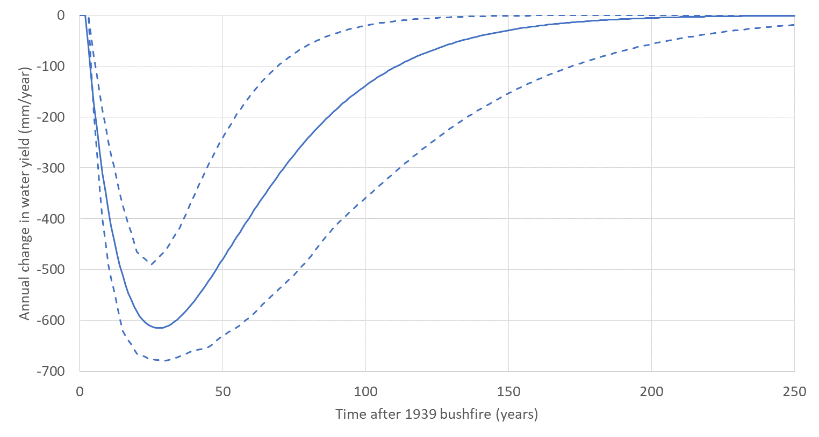

* Figure 2 Difference in annual catchment water yield with forest age derived by Kuczera (1987) for mountain ash forested catchments with mean annual rainfall of between 1600 and 1800 mm (Watson *et al.*, 1998a) (90% confidence limits shown as dashed lines)

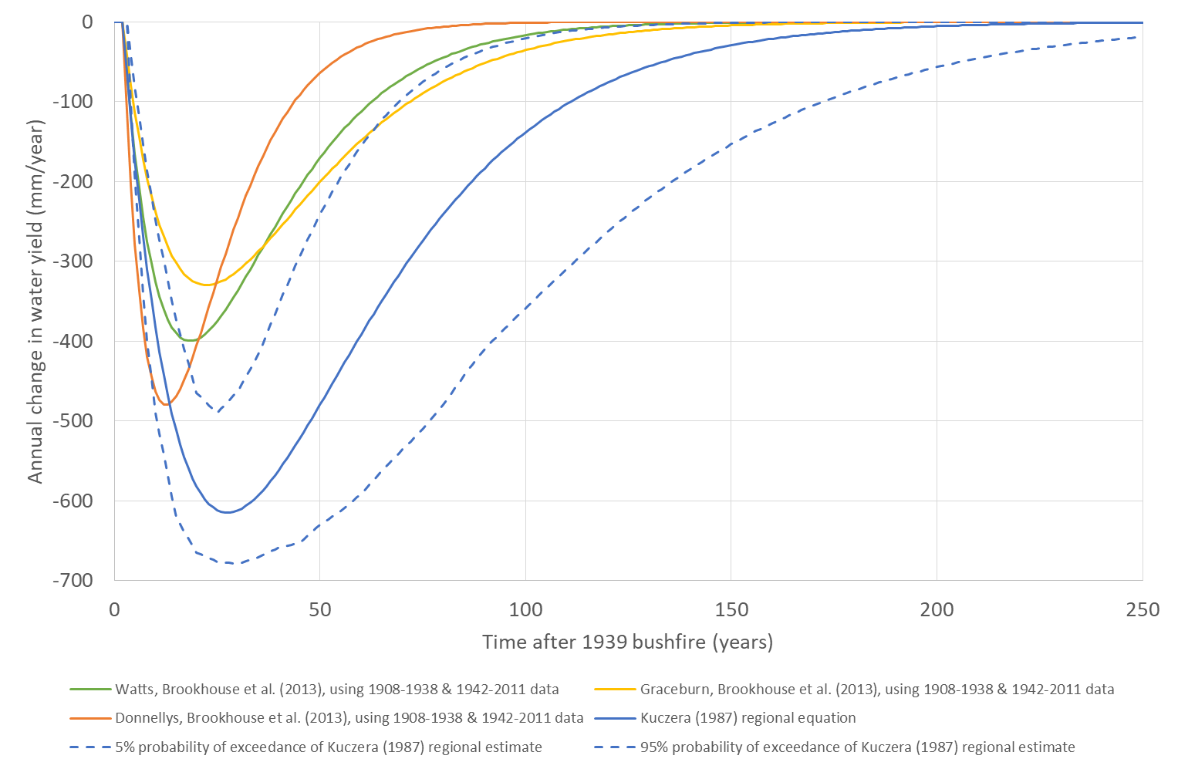

* Figure 3 Comparison between responses in catchment water yield with forest age for mountain ash catchments from Kuczera (1987) and from Brookhouse *et al.* (2013), based on re-analysis of streamflow data from the Watts, Graceburn and Maroondah catchments

# Overview of Wood and Water Study 2008 methods and findings

Catchment water yield (also referred to as catchment runoff, or streamflows) in Melbourne’s forested catchments is influenced by three main factors:

* climate variability and climate change – how the catchments respond to variations in rainfall, temperature, humidity, wind speed, solar radiation and other meteorological influences,
* bushfires and the recovery from bushfires – which modify the vegetation species and cover over time, and
* timber harvesting, in the locations where it is permitted.

These influences were investigated in WWS2008. This section provides an overview of WWS2008 and its findings.

WWS2008 was documented in the following six reports:

* Mein (2008) Potential impacts of forest management on streamflow in Melbourne’s water supply catchments Summary Report.
* Feikema *et al.* (2006) Hydrological studies into the impact of timber harvesting on water yield in state forests supplying water to Melbourne – Part 1 of Hydrological studies.
* Feikema *et al.* (2008) Hydrological studies into the impact of timber harvesting on water yield in state forests supplying water to Melbourne – Part 2 of Hydrological studies (Climate change and Bushfire).
* Walker (2008) Woodstock Modelling – Hydrological Studies into the Impact of Timber Harvesting on Water Yields and Options Aimed at Improving Water Yields in State Forests Supplying Water to Melbourne.
* Battad *et al.* (2007) Impacts of Forest Management Options on Water Yield, Central Gippsland and Dandenong Forest Management Areas.
* Salkin (2008) Modelling of Options for Management of Catchments supplying Water to Melbourne – Post 2006/07 Fire, Thinning and Reduced Rainfall.

The purpose of WWS2008 was to,

*estimate the impacts of different timber management regimes, bushfire, and climate change on water yield in Melbourne’s water supply catchments. Its aim [was] also to show how these regimes impact on timber yield from the associated Forest Management Areas*.

The scope of this review of WWS2008 is confined to the catchment water yield aspects of the trade-off between wood and water. Review of the timber yield component of WWS2008 is outside the scope of this current review.

WWS2008 used two modelling tools:

* the Macaque hydrological model, which was originally developed by Dr Fred Watson at the CRC for Catchment Hydrology (CRCCH) for the specific purpose of evaluating the impacts of forest disturbance on eucalypt forests. There were several improvements made to Macaque during WWS2008.
* the Woodstock model, which was used to optimise timber and water yields from a range of different forest management regimes in the state forest areas.

WWS2008 established Macaque models for each of the forested catchments where timber harvesting was permitted: Thomson, Tarago, Bunyip River, Armstrong Creek Main, Armstrong Creek East, Cement Creek, Starvation Creek and McMahons Creek. The Macaque models were run on a daily timestep, although most attention was paid to catchment water yields at annual, seasonal and monthly timesteps.

## Macaque model calibration

The Macaque models in each catchment were calibrated to monthly streamflows. In the Thomson and Tarago catchments, the historical monthly flows were obtained by undertaking a volume balance, based on changing water levels. For all other catchments the flows were obtained from gauged records. At the time, the observed monthly streamflow records for Thomson, Tarago, Bunyip, Armstrong Creek Main, McMahons Creek and Starvation Creek varied between 28 and 45 years in length. Shorter streamflow records were available for Cement Creek (2 years) and Armstrong Creek East (11 years).

The Macaque model calibrations employed split-sample fitting and validation, which demonstrated that these calibrations were relatively robust to variations in climatic conditions across the calibration periods that were available at the time of WWS2008. For the Thomson, the standard of calibration achieved was “Good” or “Very Good” for all calibration and validation periods when assessed against the (Moriasi *et al.*, 2007) criteria. Calibration results were more variable across other catchments, although a “Satisfactory”, “Good” or “Very Good” standard was achieved for most of the other catchments for the calibration and validation periods.

## Future scenario modelling

Modelling was undertaken in WWS2008 to represent the influences of bushfires, climate change and timber harvesting. The results from the Macaque modelling were applied in two different ways in WWS2008:

* for future bushfire and climate change scenarios, the time series of annual total streamflows at the outlet of each of the modelled catchments were analysed to estimate annual impacts; and
* for the timber harvesting scenarios, the Macaque outputs of annual runoff for multiple elementary spatial units that shared the same forest type and age were analysed to produce curves for the projected change in streamflow response. These streamflow response curves were then used as an input to Woodstock, which was used to provide projections of timber and catchment water yield. For each timber harvesting scenario, Woodstock performed a constrained optimisation of the area and age of timber harvested in each year of the projection, to maximise catchment water yield given a specified annual volume of saw logs harvested.

Table 1 summarises the Macaque and Woodstock model runs that were undertaken in WWS2008 to analyse influences of future potential bushfires, climate change and timber harvesting. Each of the Macaque model runs was undertaken by repeating the climate data from a single representative year 300 times. The representative years selected for each catchment (Salkin, 2008, p. 20) were:

Thomson 1989

Tarago 1958

Bunyip 1966

Yarra Tributaries 1988 (Cement, Starvation, McMahons and Armstrong Creeks).

The representative year varied between catchments because the selection was made, for each individual catchment, of a year that was close to the long-term average for rainfall and streamflow[1].

The future potential bushfire and climate change runs were undertaken in only three catchments: Thomson (as the largest harvesting catchment), Armstrong Creek Main (representing the wettest of the Yarra tributary subcatchments) and Starvation Creek (representing the driest of the Yarra tributary subcatchments). However, for assessing timber harvesting impacts, Macaque was used in each of the eight catchments to derive curves of catchment water yield versus vegetation age, which were then used as inputs to the Woodstock model.

The climate change projection scenarios considered “Slight”, “Moderate” and “Extreme” projections of climate change for 2050, based on assumptions adopted at the time by Melbourne Water and CSIRO (Howe *et al.*, 2005). For the climate change runs in each catchment, the 300 years of repeated “average” climate year were modified by adjusting the monthly rainfall totals by the projected percentage change for the selected scenario, and increasing the minimum and maximum daily temperatures by the projected change for the same scenario. The climate change scenarios were run with two forest-disturbance assumptions to test the influence on the recovery of catchment water yield after disturbance under each of the climate change scenarios. The disturbance scenarios considered were: 1) no future disturbance, and 2) 100% disturbance, effectively 100% mortality of all vegetation.

* Table 1 Summary of model runs undertaken in WWS2008

|  |  |  |
| --- | --- | --- |
| Influence investigated | Catchment | Number and brief description of model runs |
| Future potential bushfire | Thomson | Eight runs of Macaque, ranging from 0.1% to 47% forest mortality. |
| Armstrong Creek Main | Six runs of Macaque, ranging from 10% to 90% forest mortality. |
| Starvation Creek | Six runs of Macaque, ranging from 12% to 88% forest mortality. |
| Climate change | Thomson  Armstrong Creek Main  Starvation Creek | Three runs of Macaque per catchment, representing “Slight”, “Moderate” and “Extreme” climate change projections from Howe *et al.* (2005) with no future disturbance to forest cover.  Three runs of Macaque per catchment, representing “Slight”, “Moderate” and “Extreme” climate change projections from Howe *et al.* (2005) with 100% disturbance to forest cover (bushfire or clearing) at the beginning of the simulation period. |
| Timber harvesting | Thomson  Tarago  Bunyip  Armstrong Creek Main  Armstrong Creek East  Cement  McMahons Creek  Starvation Creek | One run of Macaque per catchment, which was used to fit curves of annual catchment water yield versus vegetation age.  Eleven runs of Woodstock were then undertaken to estimate water yield for each catchment under each timber harvesting regime. |

## Catchment water yield results

Eleven scenarios representing different timber harvesting regimes were undertaken in all of the Macaque model catchments (Thomson, Tarago, Bunyip River, Armstrong Creek Main, Armstrong Creek East, Cement Creek, Starvation Creek and McMahons Creek). Mein (2008) only presented the aggregate total water yield impacts across all catchments for a given scenario, rather than providing separate impacts for each individual catchment. Separate results for catchment water yield are provided for Thomson, Tarago, Bunyip and the combined Yarra tributary catchments in Salkin (2008).

WWS2008 (Table 5 of Mein, 2008) found that if timber harvesting were to cease completely in all catchments in 2009–10, the annual catchment water yield in 2050 would be 16 GL/year larger than the yield WWS2008 assessed assuming a continuation of status quo timber harvesting. WWS2008 stated that the cumulative increase in yield for the 40-year period (2009–10 to 2050) due to cessation of timber harvesting in 2009–10 would be 190 GL. WWS2008 identified that the increase in cumulative catchment water yield over the 40 year projection (to 2050) of 190 GL was approximately 1% of the total catchment water yield from the harvested catchments (assessed as 18,687 GL for status quo harvesting, Table 5 of Mein, 2008).

It should be noted that the eleven scenarios for different timber harvesting regimes that were investigated by WWS2008 assumed that there would be no future bushfires in any of the catchments.

WWS2008 ran several different scenarios to estimate the influence of other timber harvesting practices on projected catchment water yields: for example, changes in rotation periods and changes in thinning practices. These alternative timber harvesting scenarios produced catchment water yield results that were intermediate between continuation of status quo harvesting and cessation in 2009–10. Tables 5 and 6 of Mein (2008) illustrated the trade-offs between catchment water yield and cumulative saw log yields across the Central Gippsland and Dandenong FMA.

WWS2008 (Table 7 of Battad *et al.*, 2007) provides areas logged of ash and mixed-species eucalypt forest for each of the modelled scenarios. Key are the areas assumed under the status-quo simulation, for the Thomson and for all catchments. Table 9 of Battad *et al.* (2007) provides catchment water yields for the Thomson catchment, derived from Woodstock.

The broad conclusions from Mein (2008) were:

1. *The expected yield of the water supply catchments is increasing, due to the continued aging of the forest after the 1939 bushfires.*
2. *The impacts of changing timber management regimes on cumulative water yield are relatively small, modelled here as being all within -1.5% of the cease-logging regime.*
3. *The impact of climate change on water yield can be large. For every 1% decrease in long-term average rainfall, water yield is reduced by 2–3% in all catchments. [For the last 10 years the reduction in flows has been of the order of 30%]*
4. *The potential impact of bushfires is also major. A repeat of the 1939 bushfires would see a decrease of 15% of the inflow to the Thomson Dam over the following 50 years.*

As noted in Section 4, limited sensitivity analyses were undertaken with the Macaque model in WWS2008, and there was no formal assessment of the uncertainty of the catchment water yield estimates produced from the Macaque model. The estimates of percentage changes in yield for the bushfire and climate change scenarios were extrapolated from modelling undertaken for only three catchments that were directly modelled, and this introduces further uncertainties to the conclusions drawn from WWS2008.

# Assessment of recommendations from WWS2008

In the WWS2008 reports their authors articulated a number of recommendations for future work. There were three recommendations in the Summary Report (Mein, 2008) and three recommendations in the Part 2 Macaque modelling report (Feikema *et al.*, 2008).

The recommendations from WWS2008 represented a suitable starting point for considering the relevance and applicability of the findings of WWS2008, because they articulate the authors’ perceptions of the main issues that could be addressed at the time of the study.

This section of this review report:

* considers each of those recommendations in turn,
* considers new information, if any, that has arisen since WWS2008,
* assesses whether the recommendation remains relevant, or has been resolved, and
* assesses how that recommendation should be addressed in future.

## Analysis of recommendations from the WWS2008 Summary Report

### Assessment of combined effects of bushfire, climate change and timber harvesting on water supply from the forested catchments

The first recommendation from Mein (2008) was:

This project has not considered the combined effects of bushfires and climate change on water yield to Melbourne's reservoirs in a probabilistic way (e.g. Figure 6 is for bushfires of fixed size and duration). A Monte Carlo approach would be the best way to determine the risk of not meeting various levels on inflow in the next say 50 years due to these highly influential factors. Such an analysis could be done using (i) an historic climate sequence, (ii) a sequence adapted for slight climate change, (iii) moderate climate change, and (iv) severe. In say 50–100 realisations, a random sampling approach would determine whether bushfires occur in the next time period and, if so where and how large. A link between climate change and bushfire occurrence and severity would need to be part of the input.

As shown diagrammatically in Figure 4 (in this report), these three important factors can combine to influence catchment water yield. For example, climate change could increase the prevalence of days that are prone to bushfires although evidence for this is not yet conclusive (Bradstock *et al.*, 2014). Lindenmayer *et al.* (2011) have propounded a connection between timber harvesting, bushfire occurrence and climate change. If there are changes to the frequency, extent and severity of bushfires, then these will impact upon catchment water yield and water quality.

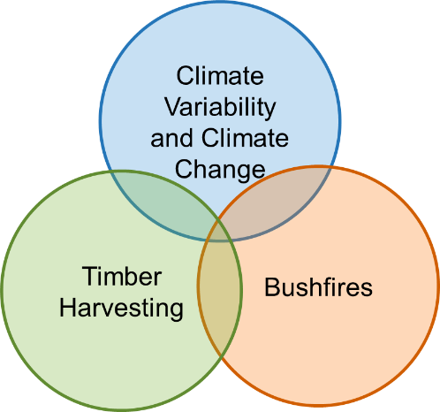

* Figure 4 Conceptual overview of the influences on catchment water yield and water quality from Melbourne’s forested catchments

As discussed in Section 3.2 and as shown in Figure 5 below, the Macaque and Woodstock models were run for a number of scenarios to separately analyse the projected influences of climate change, potential future bushfires and timber harvesting. All of the Macaque scenario runs used a 300-year simulation period, whereby daily climate data were repeated for a single representative year 300 times. Climate variability was therefore effectively ignored in the scenario runs undertaken for WWS2008. The discussion in Feikema *et al.* (2008) said that climate variability was ignored in the scenario runs because Feikema *et al.* (2006) had demonstrated the lack of sensitivity to inter-annual variability. Historical bushfires (prior to 2007) were considered in all of the scenario runs in all catchments, as these effectively set the initial conditions for forest age for all simulations.

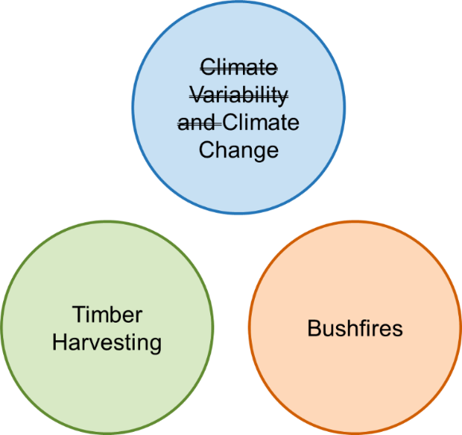

* Figure 5 Conceptual overview showing how WWS2008 constructed scenarios to separately examine the influences on catchment water yield from Melbourne’s forested catchments

The WWS2008 Summary Report (Mein, 2008) identified that the approach used in that study to isolate the effects of timber harvesting, climate change and bushfires was a limitation of the study, which, to our knowledge, has not been addressed in any detail since.

It is also noted here that limited sensitivity analyses were undertaken for the Macaque modelling in WWS2008, and also that no formal assessments of the uncertainty of the catchment water yield estimates were provided. Mein (2008) assessed the relative accuracy of changes in yield due to tree disturbance and bushfire as “likely to be of the order of ±5 to 10%”, although it is not apparent how this estimate of accuracy had been derived. It is therefore difficult to assess the significance of uncertainties in the modelling for uncertainties in the conclusions from WWS2008.

The estimates of percentage changes in yield for the bushfire and climate change scenarios were extrapolated from the three catchments that were directly modelled (Thomson, Armstrong Creek Main and Starvation Creek). This was not unreasonable, as Thomson dominated the contribution to catchment water yield of the forested catchments where timber harvesting occurs and Armstrong Creek and Starvation Creek span the range (from dry to wet) of the Yarra tributary subcatchments. However, there is probably a small degree of uncertainty introduced by extrapolating the potential future bushfire and climate change influences to the other catchments that were not modelled.

Since WWS2008, there has been additional research to characterise the interactions between climate change, bushfire occurrence and severity, timber harvesting and regeneration of eucalypt forests after disturbances.The following paragraphs summarise the literature investigating these interactions.

Taylor *et al.* (2014) found an increase in fire severity in mountain ash forests that were between 7 and 36 years of age. Price and Bradstock (2012) concentrated on the influence of time since fire in their conclusions, rather than time since logging. Subsequent analysis by Bradstock and Price (2014) found recent logging resulted in higher probability of crown fire in a range of forest types, including ash forest, during the 2009 Victorian fires. Attiwill *et al.* (2014) attempted to argue that logging would have no influence on fire severity. However, Bradstock and Price (2014) found the conclusions of Attiwill *et al.* (2014) to be “tenuous”, due to limitations in their analyses that did not discriminate clear drivers of fire severity, in weather and terrain, from time since disturbance. Bradstock and Price (2014) were also concerned that Attiwill *et al.* (2014) did not appropriately account for spatial autocorrelations in their analyses. Further investigations may be required to more accurately quantify the change in probability of bushfire occurrence with forest age.

Australian temperate forests are expected to be sensitive to changes in fire danger and frequency of severe drought under climate change (Bradstock, 2010). Increases in future drought and fire danger indices are predicted in Victoria’s forests (Bradstock, 2010; Clarke and Evans, 2019). Nolan *et al.* (2020) state that the unprecedented sizes and number of forest burnings in temperate Australian forests during the current (2019–20) fire season in Eastern Australia are “an indication that changes to the fire regime predicted under climate change, including more frequent and severe fires, may now be occurring”. Fairman *et al.* (2016) found that since 2003, forest fire frequency in Victoria has been around five times greater than in the previous 50 years, despite several advances in fire management, and has resulted in about 350,000 ha of eucalypt forest being burned twice or more by wildfire at short intervals (Fairman *et al.*, 2016).

Despite the increase in fire frequency in Victoria in the last 15 years, a study that analysed the relationship between bushfire frequency and climate trends across a broad area of south-eastern Australia found that,

*while warming and drying was widespread, the pronounced increase in ﬁre in the heavily populated forested regions along the coast and mountains of south-eastern Australia was not consistently related to the inﬂuence of warming and drying trends, evident in key components of the ﬁre danger index* (Bradstock *et al.*, 2014).

They conclude that it may be challenging to predict future changes in forest fire in Australia, because of the complexity of interactions between climatic inﬂuences on fuel and ﬁre spread and effects of changes to human populations and land use.

Successive fires in the same forest may result in a change in forest type. Where *E. delegatensis* (alpine ash) forest is burnt twice or more within 20 years, lack of natural seed supply after the second burn creates a risk that the forest will not regenerate (Bassett *et al.*, 2015). This indicates that important changes in vegetation, and potentially in catchment water yield, are likely if fire frequency increases as a result of warming temperatures and reducing rainfall. Bowman *et al.* (2014) and Fairman *et al.* (2016) concluded that increased frequency of high severity fires is likely to result in replacement of obligate seeder eucalypts with other vegetation types. Bowman *et al.* (2014) found that in *E. delegatensis* (alpine ash) forests, a single fire triggered mass regeneration but a second fire in quick succession killed 97% of the regenerating forest. Their research demonstrated vulnerability of long-lived obligate seeder species to population collapse, which would occur if there was to be an abrupt increase in the frequency of high severity fires.

Lindenmayer *et al.* (2011) described the concept of the “landscape trap”, using *E. regnans* (mountain ash) forests as an example, whereby

*entire landscapes are shifted into, and then maintained (trapped) in, a highly compromised structural and functional state as the result of multiple temporal and spatial feedbacks between human and natural disturbance regimes*.

Lindenmayer *et al.* (2011) hypothesised that logging in *E. regnans* forests has changed the age structure of this forest type from predominantly (up to 60–80%) old-growth (250–400 years) that existed 100–150 years ago, to predominantly (almost 99%) regrowth today. They argue that dense young *E. regnans* stands are more fire-prone and that the interacting effects of continued logging and increased wildfire frequency have “trapped” these forests in a perpetually young state, leading to a higher risk of repeated burns before reproductive maturity, which may ultimately cause a shift to an alternative vegetation state: for example, replacement of *E. regnans* with *Acacia dealbata* as the dominant species.

Field investigations have attempted to quantify the moisture content of fuel load in *E. regnans* forests with different disturbance histories to test the validity of the proposed “landscape trap”. Cawson *et al.* (2017) found that fuel moisture in the first few years following a bushfire was linked to the canopy cover that redevelops. Their results suggested that densely canopied eucalypt forests regenerating from high intensity bushfires (7 year old stands) have higher fuel moistures than older forests, reducing their susceptibility to fire. Conversely, more sparsely canopied forest regenerating from low intensity fires had lower moisture contents, increasing the susceptibility of the forest to fire.

Cawson *et al.* (2018) looked further at fuel in Victorian *E. regnans* (mountain ash) forests by comparing fuel properties in forests that were last burnt in the 1939, 1983 and 2009 bushfires. They found that regardless of how long it had been since the forest disturbance, fuel hazards were high or greater, meaning there was always enough fuel to sustain a fire, regardless of forest age.

Burton *et al.* (2019) examined fuel moisture in alternative stable states of an ash-type forest following bushfre (eucalypt versus non-eucalypt). They found that younger ash forest was moister and less susceptible to fire than older ash forest, which is contrary to Cawson *et al*. (2018) and highlights a lack of certainty about the effects of age on moisture status. They also found that a transition to non-eucalypt forest has the potential to cause both positive and negative flammability feedbacks following the state transition, depending on the composition of the non-eucalypt state. In summary, there is currently inconclusive evidence that timber harvesting creates a “landscape trap” in *E. regnans* forests.

Recent research also examines the potential for changes in actual evapotranspiration due to changes in forest type as a result of increased fire frequency; for example, conversion of eucalypt to acacia forest. One study (Pfautsch *et al.*, 2010) suggests that when acacia is a significant mid-story component of *E. regnans* forests, transpiration is increased, whereas a more recent study (Hawthorne *et al.*, 2018) indicates that complete replacement of *E. regnans* with acacia might reduce AET in the long term.

The studies discussed in this section have characterised the interactions between climate change, bushfire occurrence and severity, timber harvesting and regeneration of eucalypt forests after disturbances. There have been no studies that have attempted to assess the impacts on catchment water yield from interactions between factors. Further modelling could investigate the sensitivity of catchment water yield to the input relationships between climate change, bushfire occurrence and severity, disturbance of the forest by logging or previous fires, and transitions in forest types.

**In summary,** WWS2008 identified that the combined impacts of bushfires, climate change and timber harvesting were not assessed, and recommended future modelling to resolve this limitation on the conclusions of WWS2008. Mein’s recommendation was that the Monte Carlo simulation approach adopted should consider the feedbacks between climate change and bushfire frequency, extent and severity. Investigations since 2008 about the feedbacks between bushfires, climate change and timber harvesting have not clarified the combined impacts. However, an appropriately designed Monte Carlo simulation framework should be able to cope with simulating these feedbacks in an appropriate manner. More frequent high severity fires due to climate change, and/or the “landscape trap” propounded by Lindenmayer *et al.* (2011), may ultimately result in loss of ash eucalypt forest to acacia or other species, which may reduce (or increase) actual evapotranspiration and alter catchment water yields in future. If properly formulated, a Monte Carlo framework could allow for the probability that recurrent high severity fires may result in transition between forest types, and then include this effect in the probabilistic simulation of catchment water yield.

### Assessment of economic, social and environmental benefits and costs of options considered in WWS2008

The second recommendation from Mein (2008) was:

The next step envisaged by the White Paper is investigating ‘the economic, social and environmental benefits and costs of these options’. It is recommended that the eleven options considered in this Summary report be evaluated in terms of these additional factors.

To our knowledge, there has been limited assessment of the economic, social and environmental benefits and costs of supplying water from the forested catchments following the completion of WWS2008.

There have been significant changes to government policy, governance of the Yarra River catchment and the Melbourne water supply system since the completion of WWS2008, which could also have changed the economic, social, environmental and cultural benefits and costs of the options that were considered in WWS2008.

The Victorian Government passed the *Yarra River Protection Act* (2017), which gives Traditional Owners, environmental, agricultural industry and local community groups a voice in planning and management of the Yarra River. The voice of Traditional Owners has been facilitated by the establishment of the Birrarung Council (Neville, 2018).

Melbourne has seen significant population growth over recent decades, which is projected to continue into the future. Melbourne’s population is expected to grow from 4.5 million people in mid-2015 to 8 million people by 2051 and to potentially be as large as 10 million by 2065 (Melbourne Water, 2017). This is projected to result in an increasing demand for potable water, which may be increased further by climate change.

Melbourne’s forested water supply catchments represent an important part of Melbourne’s overall water supply system. Figure 6 shows a conceptual overview of Melbourne’s water supply system. On the left-hand side of the figure, timber harvesting, bushfires and climate influence the quality and yield of water that is available from catchments. As Melbourne’s catchments are largely protected, water quality is usually very good and minimal treatment is required for most of the water harvested. However, if there was a major bushfire that impacted upon one or more of the catchments, a deterioration of water quality could be experienced for months and up to a few years following the fire. A future bushfire could therefore act as a constraint on the use of water from one or more catchments for a period of time, and water quality would need to be actively managed to maintain the required standards.

The middle portion of Figure 6 represents two additional sources of water, namely the North–South Pipeline and the Victorian Desalination Plant, which were completed after WWS2008, in 2010 and 2012 respectively. Changes in water yield from the forested catchments now manifest as potential changes in the volumes of water that need to be supplied by desalination and, in times of critical human need, via the North–South Pipeline and Goulburn River from Lake Eildon[2]. The North–South Pipeline and Victorian Desalination Plant supplement water yield from Melbourne’s forested catchments but cannot fully replace runoff harvested from the catchments. In addition, it is understood that the per unit cost of water supplied from other sources to offset loss of catchment water yield can be as much an order of magnitude larger than the cost of water harvested from Melbourne’s catchments.The importance of water availability for growing populations from all potential sources in a changing climate is outlined in the Melbourne Water System Strategy (Melbourne Water, 2017).

All the factors shown in Figure 6 combine to influence the current and future supply of and demand for water for Melbourne.

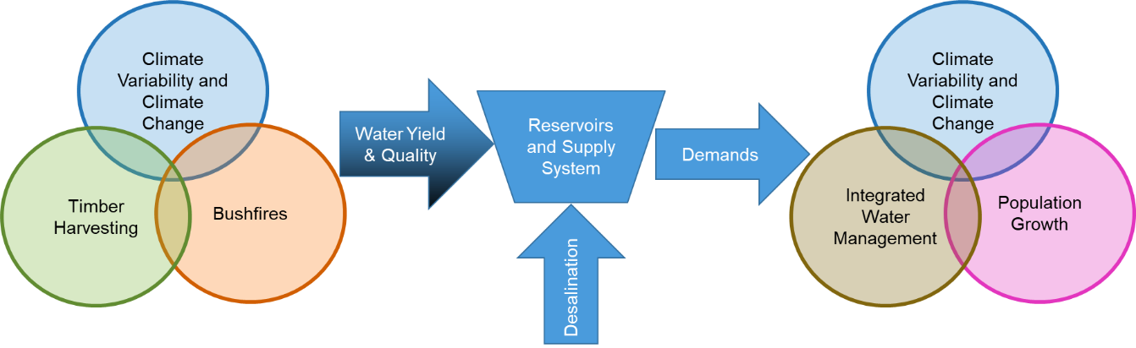

* Figure 6 Conceptual overview of Melbourne’s water supply system

Ecosystem accounting has been applied to investigate the trade-offs between economic and environmental outcomes in Victoria’s forested Central Highlands region (Keith *et al.*, 2017; Vardon *et al.*, 2019). An important input to these analyses of the impact of timber harvesting was the projected change in water volumes that would need to be supplied from other water sources under the different scenarios that are considered.

**In summary,** timber harvesting, bushfires and climate change, in combination with other factors such as population growth and integrated water management, must affect the volume and timing of additional water that will be required from other supply sources for Melbourne, and it is not possible in this review to assess their combined influences. The intent of the first and second recommendations from WWS2008 (Mein, 2008) remains valid. It should be possible to make an analysis of the cultural, economic, social and environmental costs and benefits of a range of possible scenarios affecting the various sources of water for Melbourne, including revised modelling of the change in water yield from forested catchments.

### Sustainability of increased yield from thinning treatments

The third recommendation from Mein (2008) was:

For the forest management scenarios, there remains significant uncertainty about the sustainability of increased yield from thinning treatments. Experimental areas [~~were~~] established under the Melbourne Water research program provided invaluable data on forest treatments, including the early data on the effect of thinning. It is recommended that hydrological measurements on these areas be recommenced to establish the extent to which the increased yields may have changed (relative to the control catchments).

Artificial thinning of forests by harvesting only some of the trees can reduce actual evapotranspiration and therefore increase streamflows. Thinning treatments include selective removal of trees uniformly throughout the forest; cutting and regenerating small patches of forest (for example, 30–40 m diameter patches); or cutting and retaining alternate strips of forest (for example, alternate 35 m wide strips have been used). WWS2008 included analysis of five different scenarios for thinning of the forests, at varying ages and in conjunction with various rotation lengths for timber harvesting.

Several experimental studies have been undertaken since WWS2008, testing the change in catchment water yield due to thinning in forested catchments, and updating the results of long-term paired catchment experiments reported in the 1990s. For example, Bren *et al.* (2010) documented a persistent catchment water yield decrease 8 to 23 years after selective harvesting followed by regeneration in a mature mountain ash catchment. In the final year of the study, 24 years after the selective logging, the catchment water yield reduction was no longer evident.

Hawthorne *et al.* (2013) also quantified long-term responses to various types of thinning in 37–45 year old *E. regnans* regrowth forest. They showed that streamflow increases after thinning were evident for up to 20 years, but were no longer detectable after about 30 years. Monitoring ceased for about 10 years in the late 1990s, and when it resumed in 2007–08 the streamflows had declined slightly in most treated catchments, relative to the control catchment, indicating that “the view of thinning as a net water gain may not hold if this trend continued”. Airborne ‘Light Detection And Ranging’ (LiDAR) measurements of vegetation structure indicated a partial recovery of vegetation in the thinned catchments. Webb *et al.* (2012) showed that in mixed-species forests in northern NSW, streamflows usually returned to pre-treatment levels within a few decades: a long-term Kuczera-type streamflow reduction was an exception, rather than the rule.

**In summary,** recent research has demonstrated that thinning can increase catchment water yields in the first few decades after treatment but these differences seem to disappear after 20 to 30 years.

## Analysis of recommendations from the WWS2008 Macaque modelling report

### Improved methods for understanding and modelling spatial variations in AET and improved methods for understanding and modelling response of vegetation to bushfire

Feikema *et al.* (2008) identified three specific areas where “limitations and uncertainties point to avenues for further research to improve our parameterisation and confidence in representing these systems”.

The first and third specific issues that they identified were:

Ground truthing of LAI [Leaf Area Index]. Macaque uses a single relationship of LAI over time for a given forest type, irrespective of growing conditions or location. Ground truthing of LAI, and preferably calibration of some form of remotely sensed data to enable a spatial representation over time, would provide a basis for examining the accuracy of the LAI representation within the model.

And

The response of vegetation to fire. Especially in the case of mixed species forests, there are very few, if any, studies that have investigated the transpiration characteristics of recently burnt trees when they start producing epicormic shoots following fire. The recovery of trees after a fire and the consequent evapotranspiration depends largely on the species response to fire and the degree to which the vegetation was burnt. A fire may severely scorch a tree, but not result in mortality. Experimental data to help understand how mixed species forests respond to fire would improve the representation of post-fire development of LAI within Macaque.

Since the completion of WWS2008 there have been several field investigation campaigns, which have provided improved understanding of spatial and temporal variations in AET across parts of Melbourne’s forested catchments and other similar forest types. This section discusses how those experimental studies pertain to the two recommendations from Feikema *et al.* (2008) and hence the findings from WWS2008.

Spatio-temporal maps of sapwood area at catchment scale, derived using forest inventory or LiDAR data, can be used to accurately map annual evapotranspiration. When this information is combined with maps of precipitation, it is possible to reliably predict annual or seasonal streamflows (Mitchell *et al.*, 2011; Benyon *et al.*, 2015; Jaskierniak *et al.*, 2015, 2016, 2019). The Macaque model used in WWS2008 requires two inputs – leaf area index and leaf conductance – to determine evapotranspiration, and the model simulates the changing influence of forest age on these inputs over time. However, more recent approaches have shown that a single variable, sapwood area index (SAI), can be used to predict annual AET and that this property can be mapped spatially and temporally using commonly collected forest inventory data and LiDAR.

The recommendations from Feikema *et al.* (2008) specifically address the need to revisit LAI. Since 2008, the collection of relevant remotely sensed data has improved, as also has the predictive capability of SAI over LAI. Therefore, future modelling of catchment water yield should transition to use SAI instead of LAI. Mitchell *et al.* (2011) observe that, “merging of detailed forest structural data and field-validated evapotranspiration fluxes offers promise in advancing our understanding and prediction of key ecohydrologic processes in forested catchments”. In Section 5.6 there is further discussion of recommended future modelling approaches.

In catchments dominated by forests of obligate reseeders, several studies completed since 2008 have confirmed the long-term “Kuczera curve”-type response of evapotranspiration and catchment water yield following forest disturbance. Mean sap velocities were found to be similar between old and young stands of *E. marginata* (jarrah) forest in south-west Western Australia but sapwood area was almost twice as much in the young stands, resulting in a similar difference in actual evapotranspiration rates (Macfarlane *et al.*, 2010). These results indicate that observations of substantially higher water use in regrowth stands are not confined to the ash-type eucalypt forests of eastern Australia. Buckley *et al.* (2012) measured and compared sap velocity and stand transpiration in plots of 7-year-old and 70-year-old *E. delegatensis* (alpine ash). Higher water use in the young regrowth is consistent with conversion of old forest to regrowth ash forest, resulting in a long-term streamflow decline followed by a gradual recovery.

About 50% of the forested area of Melbourne’s water supply catchment is mixed-species eucalypt forest. Further field experiments have improved the understanding of how evapotranspiration in mixed-species eucalypt forest differs from evapotranspiration in ash-type forests. Sapwood velocity was found to be spatially uniform across mixed-species eucalypt forest catchments (Mitchell *et al.*, 2012). However, structural attributes of mixed-species eucalypt forest exhibited considerable spatial variation, which resulted in considerable spatial variation in evapotranspiration. (Mitchell *et al.*, 2012) concluded that,

*variation in forest structure arising from changes in elevation in these south-facing catchments is a major determinant of forest water use and shows a threefold change in annual evapotranspiration across the elevation gradient*.

(Gharun *et al.*, 2013) found that LAI, which is related to forest structure, was a key predictor of evapotranspiration in mixed-species eucalypt forest. Aspect and drainage position were also identified by Metzen *et al.* (2019) as key controls on evapotranspiration from mixed-species eucalypt forest stands. Nolan *et al.* (2014, 2015), in resprouting mixed-species eucalypt forest, noted that moderate severity fire may stimulate additional seedling regrowth, causing a small increase in annual evapotranspiration for a few years, but a return to pre-fire conditions within 8 to 12 years.

Timber harvesting by clear fell followed by regeneration from seeds, which is the method that is typically employed in Victoria’s mixed-species eucalypt forests, may have effects on evapotranspiration and streamflow that are similar to the effects bushfire has in obligate seeder forests. In both forest types, removal of mature trees – by harvesting in mixed-species eucalypt forest, or by moderate or high intensity fire in obligate seeder forest – stimulates seed germination on the forest floor, and then dense regrowth, which increases annual evapotranspiration and reduces streamflow.

Using a longer calibration period, Brookhouse *et al.* (2013) re-analysed streamflow responses to the 1939 fires in three of the catchments originally used to develop the Kuczera curve (see Section 2). Results were qualitatively similar to Kuczera’s but maximum reduction in catchment water yield was less and it occurred sooner, with a faster recovery predicted. Their results suggest catchment-level evapotranspiration can peak 6 to 11 years earlier than indicated by the Kuczera curve, with a more rapid decline following the peak. Similar analysis, in other ash forest catchments in North East Victoria that were responding to the 2003 fires, indicated that “a post-bushfire Kuczera-type response may be widespread in regenerating ash”. This conclusion was also supported by the plot-scale transpiration measurements of Buckley *et al.* (2012).

Bren *et al.* (2010) observed an increase in catchment water yield for the first 8 years following timber harvesting. These experimental data confirm the Macaque modelling results from WWS2008 and Watson *et al.* (1999, 2001), which showed an initial increase in catchment water yield for the first few years after harvesting, followed by a long-term decline. Kuczera (1987) did not observe any increase in catchment water yield for the first few years following the 1939 bushfires. Tan *et al.* (2011) also did not observe any increase in catchment water yield in the O’Shannassy and Maroondah catchments following the 2009 bushfires. Feikema *et al.* (2013) reasoned that the water yield response of catchments containing ash-type forests is different in the first few years following a bushfire to the first few years following timber harvesting because intense bushfires would almost always occur during droughts, when soils would be expected to be drier, on average, than during timber harvesting operations, which can occur across a broader range of soil moisture conditions. However, Zhou *et al.* (2015) used conceptual runoff routing models to identify the bushfire contribution of catchment water yield increase in the 16 years following the “Ash Wednesday” 1983 fires. The bushfire contributions were between 7% and 12% for the Little Yarra River and between 26% and 37% for Starvation Creek, depending upon the rainfall runoff model that was applied.

McGuire and Bren (2013) argued that “Kuczera curves” have commonly been misapplied in forest hydrological studies, noting that Kuczera’s analysis of streamflow records (Kuczera, 1985, 1987) was confined to high rainfall catchments and so “for sites with lower annual rainfall the magnitude of the predicted change in flow exceeds the possible runoff, although the streams usually continue flowing” and that because rainfall is not a model input it “has little predictive ability for a given area” which “limits the practicality of application in a year-to-year scenario”. They also note that after the 1939 fires there was no detectable initial increase in streamflow, unlike in experimental timber harvesting studies, where there is always an initial catchment water yield increase for a few years after harvest and regeneration.

Models that include the initial increase in runoff in the first few years after timber harvesting, such as the Macaque modelling undertaken in WWS2008, would be consistent with the experimental data (Bren *et al.*, 2010; Webb *et al.*, 2012; Nolan *et al.*, 2014, 2015), in contrast to models that do not include this initial increase in runoff.

Several studies of streamflows in non-ash eucalypt forests indicate that the long-term catchment water yield decline after harvest and regeneration is largely confined to the ash forests. Bren *et al.* (2010) analysed streamflow changes for 34 years after timber harvest and regeneration in a mixed *E. regnans*, *E. obliqua* catchment and after selective logging in an adjacent *E. regnans* catchment. After clearfell and regeneration of a relatively low-rainfall (for mountain ash) catchment, catchment water yield increased for 8 years (peaking at +300 mm/year after 3 years) before declining below pre-harvest levels (minimum –200 mm/year) with no sign of recovery. After 34 years the cumulative changes in streamflow (accounting for the initial streamflow increase and subsequent long-term decline) totalled –1500 mm (just less than 50 mm/year) after clearfell logging. During the 1997–2010 drought, streamflow from the clearfelled and regenerated catchment often dried up for much of the year. This study shows that in drier catchments, while a Kuczera-type response to logging does occur, in absolute terms (mm per year of runoff) the response is smaller, although in drier catchments the percentage reduction due to logging may be greater than in wetter catchments. Hill *et al.* (2006, 2008) also noted the relationship between the likely magnitude of peak streamflow declines and mean annual precipitation. They argued that the Kuczera curve, which had been derived from analysis of streamflow data in relatively high precipitation catchments, should be adjusted for application in catchments that had lower mean annual rainfall rates.

Webb *et al.* (2012) analysed streamflow changes for six experimental mixed-species eucalypt forest catchments in northern NSW. Streamflow initially increased in five of the six catchments, by between 120 and 320 mm/year, but then in three of the catchments the catchment water yield reduced to below pre-harvest values within 2–7 years and in the other three catchments water yield returned to pre-harvest values. In the former three catchments, the water yield reduction was short-lived in one, and more persistent in the other two. The study concluded that:

*Contrary to earlier published findings, while this study confirms that Kuczera (1987) type catchment water yield reductions can occur in other forest types, this response appears to be the exception rather than the rule. These findings indicate that the use of catchment water yield models derived from Mountain ash results in other eucalypt forests is inappropriate and subject to error.*

**In summary,** the first and third recommendations from Feikema *et al.* (2008) identified that further ground truthing of spatial and temporal variations in leaf area index would help to reduce uncertainties in modelling. Research completed since WWS2008 indicate that future modelling of catchment water yield should transition to use sapwood area index instead of leaf area index. Further analysis of water yield at catchment scale, supported by plot-scale evapotranspiration measurements, suggests that catchment-level evapotranspiration for ash forests peaks 6–11 years earlier than indicated by the Kuczera curve, with a more rapid decline following the peak. Models that include the initial increase in runoff in the first few years after timber harvesting would be consistent with the experimental data, in contrast to models that do not include this initial increase in runoff. Whilst streamflow experimental data have identified streamflow reductions as forests age in mixed-species eucalypt forest, changes in evapotranspiration have been found to have considerable spatial variation, driven by forest structure. Impacts on catchment water yield in drier mixed-species eucalypt forest catchments have been found to be considerably more muted and shorter-lived than those in wetter catchments that are dominated by ash-type forests, and catchment models should take these differences into account.

### Improved methods for understanding and modelling response of forest growth and water use to changes in atmospheric CO2 concentrations

The second specific issue identified by Feikema *et al.* (2008) was:

Response of forest growth and water use to changes in CO2 (carbon dioxide) concentrations. The projected increase in CO2 concentration in the atmosphere may also impact on vegetation function. Increasing CO2 concentration may lead to increased plant growth both directly through increased photosynthetic rates and indirectly through improved water use efficiency. At plot and catchment scales, there is little clarity over whether elevated CO2 concentrations will suppress or enhance ET. For example, if elevated CO2 stimulates LAI, there may be no savings in water at the stand level. Given the lack of experimental data, there are very few physically-based models that incorporate the potential effects of changes in CO2. Further work on the effects of increased CO2 concentrations on tree and forest function is required to achieve some level of confidence before these responses can be incorporated into process-based models.

There is a large degree of uncertainty about how vegetation will respond to a warmer climate with higher atmospheric CO2 concentrations. On the one hand, rising temperature drives higher vapour pressure deficits and higher evaporative demand. This leads to higher potential evapotranspiration (PET) and reductions in runoff. On the other hand, as atmospheric CO2 concentrations increase, plant stomata close, increasing the water use efficiency of plants, which is likely to reduce evapotranspiration and increase runoff (Yang *et al.*, 2019). Offsetting these effects, additional vegetation growth associated with global greening in response to increased CO2, along with longer and warmer growing seasons and increasing LAI, leads to an increase in bulk canopy water demand, reducing runoff. Mankin *et al.* (2019) evaluated these competing effects over large areas, and summarised by stating that terrestrial vegetation will play a large and unresolved role in regional freshwater availability. Because of the effect of higher CO2 on increasing surface resistance, simple aridity indices such as the ratio of potential evapotranspiration to precipitation have been criticised (Greve *et al.*, 2019) as biasing estimates towards a higher degree of aridity than are likely.

It is unclear how eucalypt forests in Melbourne’s catchments will specifically respond to increased atmospheric CO2 concentrations. Field experiments to test the change in water use of forests under enhanced CO2 conditions are currently very expensive. Instead, it is recommended that the responses of actual and potential evapotranspiration rates in forested catchments be investigated within Global Climate Model (GCM) simulations. A Monte Carlo simulation framework, consistent with Mein's (2008) first recommendation, may be able to incorporate uncertainty in the way evapotranspiration responds to projected increases in CO2 concentrations, if appropriately formulated.

**In summary,** there remains much uncertainty about how vegetation will respond to the increasing atmospheric CO2 concentrations that are projected under climate change. Relatively recent publications, however, suggest that physiological effects on actual evapotranspiration are likely to counter-balance each other. An appropriately designed Monte Carlo simulation framework should be able to incorporate uncertainty in the evapotranspiration response to projected increases in CO2 concentrations.

# Analysis of relevant issues that have emerged since WWS2008

The previous section examined the six recommendations that were made in the WWS2008 reports (Mein, 2008; Feikema *et al.*, 2008). Since the completion of WWS2008, a number of relevant issues have emerged, through new data collection, new scientific research, and through changes in the condition of the catchments themselves.

This section of the report examines each of these relevant issues:

* areas of timber harvesting since 2008,
* effect of bushfires in Melbourne’s catchments since 2008,
* reassessment of model calibration with additional data collected since 2008,
* other models of catchment water yield from forested catchments since 2008,
* revisions to climate change projections for Victoria,
* development of improved modelling approaches.

## Areas of timber harvesting since WWS2008

The main purpose of WWS2008 was to predict how catchment water yield over time under the then current timber harvesting regime would differ from catchment water yield over time under alternative timber harvesting scenarios. This review has analysed timber harvesting since WWS2008 (Mein, 2008) to see if the harvesting rates have continued in line with the status quo scenario in 2008, or if they have taken an alternative trajectory. Mean annual rates of timber harvesting are expressed as an area of forest per year.

Since the completion of WWS2008, mean annual rates of timber harvesting in Melbourne’s water catchments have been similar to the rates projected in WWS2008 if the status quo logging scenario continued (Salkin, 2008). The rates of timber harvesting projected in WWS2008 are echoed in the *Management Standards and Procedures* (Department of Environment and Primary Industries, 2014a) under the *Code of Practice for Timber Production* (Department of Environment and Primary Industries, 2014b), which specify catchment harvesting limits expressed as a rolling average (notionally over a ten-year period). As shown in Table 2, the mean annual rate of harvesting over the period from 2009–10 to 2017–18 (inclusive) was 254 ha/year, which was 86 ha/year or 25% less than the annual rate of timber harvesting assumed by WWS2008. Areas of forest logged since 2009–10 were consistent with the rates of timber harvesting by catchment and species type represented in WWS2008 for the status quo timber harvesting scenario. Therefore, the status quo scenario in WWS2008 should have produced very slightly conservative (low) projections of annual catchment water yield in total across the catchments, because of the slightly conservative assumptions made about the annual area of forest harvested.

* Table 2 Annual rates of timber harvesting by catchment and forest type set in *Management Standards and Procedures* (Department of Environment and Primary Industries, 2014a) and assumed by WWS2008 (Salkin, 2008), and mean annual rates over the period 2009–10 to 2017–18 (inclusive)

|  |  |  |  |  |
| --- | --- | --- | --- | --- |
| Catchment | Forest Type | Annual rate of harvest in Code of Practice (DEPI, 2014a) and assumed by WWS2008 (Salkin, 2008) (ha/year) | Mean annual rate actually harvested over 2009/10 to 2017/18 (ha/year) | Difference in annual rates (ha/year) |
| Tarago | Ash type | 55 | 35 | –20 |
| Tarago | Mixed species | 23 | 20 | –3 |
| Thomson | Ash type | 150 | 140 | –10 |
| Thomson | Mixed species | 15 | 7 | –8 |
| Bunyip | Ash type | 15 | 10 | –5 |
| Bunyip | Mixed species | 15 | 0.4 | –14.6 |
| Yarra tributaries | Ash type | 52 | 31 | –21 |
| Yarra tributaries | Mixed species | 15 | 11 | –4 |
| Sum for all catchments | Ash type | 272 | 216 | –56 |
| Sum for all catchments | Mixed species | 68 | 38 | –30 |
| Sum for all catchments | Both Ash type and Mixed species | 340 | 254 | –86 |

**In summary,** annual average rates of timber harvesting, in terms of area logged, for the last decade have been similar to the rates of harvesting (in terms of area) that were projected for the continuation of status quo timber harvesting scenario in WWS2008, and set out in *Management Standards and Procedures* (Department of Environment and Primary Industries, 2014a). When considered across all catchments, the total area harvested has been about 25% lower than the rate that was projected in WWS2208 and subsequently mandated in the *Management Standards and Procedures.*

## Effects of bushfires in Melbourne’s catchments since 2008

Bushfires in 2009 affected 28% of Melbourne’s total forested catchment area, with severe fire affecting 11% of the total forested catchment area (see Table 3, reproduced from Feikema *et al.*, 2013). Severe fires burnt all of the Silver and Wallaby Creek catchments and most of the O’Shannassy, Tarago, Watts and Grace Burn catchments, although some of the fire was not high severity.

* Table 3 Catchments affected by 2009 bushfires (Feikema *et al.*, 2013)

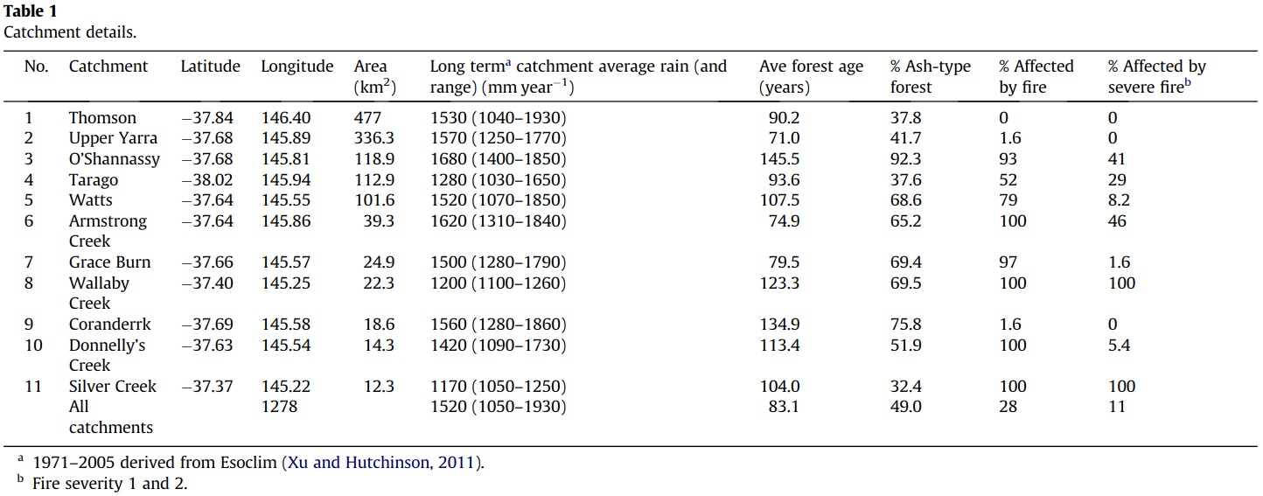

Tan *et al.* (2011) analysed streamflow data from the O’Shannassy and Maroondah catchments to test whether the increase in runoff predicted by Macaque modelling for the first two years following the 2009 bushfires (Feikema *et al.*, 2010) was evident in the observed streamflow data. Tan *et al.* (2011) found, “no clear indication of an increase in runoff following the 2009 bushfires. This is likely due to the relatively low (Maroondah) to moderate (O’Shannassy) burn severity and mortality.”. This streamflow result for Maroondah catchment is consistent with the Macaque model results from Feikema *et al.* (2010, 2013): that is, Tan *et al*. found streamflow increases in the Maroondah catchment were negligible (2–5%) for the first few years following the 2009 bushfire. However, for O’Shannassy catchment, the Macaque modelling in Feikema *et al.* (2010) predicted an initial runoff increase of 15–40%, but the Tan *et al.* (2011) analysis did not detect that in the streamflow data.

Benyon and Lane (2013) used an extensive field survey to test for a link between forest survival, which is linked to future yield response, and five classes of fire severity. They collected data from 307 field plots in Maroondah, O’Shannassy and Wallaby Creek catchments, and examined the correlation between satellite-derived burn severity, and forest survival and health 1 and 2 years after the 2009 fires, by qualitatively assessing seedling regeneration density. In the ash forests, seedling mortality was near 100% in the two highest burn-severity classes and near zero in the two lowest burn-severity classes. In the moderate burn-severity class, seedling mortality was mostly either near 100% or near zero. In this class, mortality tended to be higher in senescing stands of mature trees. They found that the likelihood of survival of mature trees was high in mixed-species eucalypt forest. In fire-killed ash stands, the density of seedling regeneration varied markedly between the three catchments. Seedling regeneration was sparse in Maroondah, sparse to moderate in O’Shannassy, and generally it was dense in Wallaby Creek. Sparse regeneration was an indicator that there might not be a long-term streamflow decline after the 2009 event, as would be predicted by the Kuczera curve and the Macaque model, or that streamflow might be only somewhat reduced.

Feikema *et al.* (2010, 2013) modelled impacts of the 2009 bushfires on streamflow yield across all eleven of Melbourne’s water supply catchments, including those that are protected and those that are subject to timber harvesting. By applying Macaque models of the catchments, they projected the fires’ potential impacts over the next 100 years, using satellite-based mapping of fire severity to predict the fires’ likely effects on forest age. They said:

*Under average rainfall conditions, total reduction in post-ﬁre streamﬂow after 100 years was estimated to be between 12 and 24 GL/year, or between 1.4% and 2.8% of mean annual streamflow. Lower than expected predicted changes in catchment water yield were because (i) a low proportion of the catchments was affected by severe ﬁre, and tree mortality within the ﬁre area was relatively low, and (ii) the average pre-ﬁre age of the forest canopy (93 years, in the ﬁre affected areas) means it is not considered mature, and so the baseline (no-ﬁre) streamﬂow used for reference is lower than would be expected with an older, mature forest which uses less water*.

**In summary,** catchment water yields in the O’Shannassy, Tarago, Watts, Armstrong Creek, Wallaby Creek and Silver Creek catchments are likely to be impacted by the recovery of the forests from the 2009 bushfires, over coming decades. These reductions in catchment water yield should be accounted for in water supply planning for Melbourne. If future modelling occurs, initial tree ages used in the modelling should be consistent with the fire severity, extent and mortality mapped after the 2009 fires.

## Modelled impact on catchment water yield of cessation of logging since WWS2008

WWS2008 applied the Macaque model to project the hydrological impacts of timber harvesting on catchment water yield. The Macaque modelling was used to estimate, in each catchment, the annual evapotranspiration for a forest of a given type and age since last disturbance. Feikema *et al.* (2006) derived separate evapotranspiration versus age curves in each catchment for each of the (up to nine) different forest types. Woodstock then used these curves, of catchment water yield versus age, to maximise catchment water yield constrained by the required saw log volume to be supplied for each particular scenario (Battad *et al.*, 2007; Salkin, 2008).

The only relevant new modelling undertaken since WWS2008 is that described in Taylor *et al.* (2018, 2019).Taylor *et al.* (2019) developed a model of the impact of timber harvesting on catchment water yield in the Thomson catchment, based upon direct implementation of the Kuczera curve (Kuczera, 1987). The computational framework was similar to the RAFIS and BISY models (Mannik *et al.*, 2009; Tan *et al.*, 2015), but the RAFIS and BISY models explicitly allow for variation in the evapotranspiration curves with forest type and mean annual rainfall, which may have not been incorporated in the Taylor *et al.* modelling.

Figure 4 of Taylor *et al.* (2019) presents a time series of projected mean annual catchment water yield from the Thomson catchment for continuation of status quo timber harvesting, against two hypothetical scenarios: cessation of logging in 1995 and cessation of logging in 2019. The figure shows that increases in catchment water yields accelerate during the first few decades after the assumed cessation of timber harvesting, and then catchment water yields gradually stabilise. Considering the cessation in 2019 scenario only, the Taylor *et al*. figure shows an increase of 20 GL/year in annual catchment water yield by 2064 for the Thomson (45 years after cessation). Over those 45 years (2019–2064), the cumulative increase in catchment water yield for the Thomson was projected to be approximately 420 GL (Taylor *et al.*, 2019).

Table 5 of Mein (2008) presents changes in catchment water yield only for all catchments combined. Salkin (2008) tabulates projected impacts for several scenarios for the Thomson catchment only. In WWS2008, changes in annual and cumulative catchment water yields for the Thomson were derived by subtracting the catchment water yields for continuation of status quo logging (Salkin’s scenario A) from the yields if timber harvesting were to cease in 2009–10 (Salkin’s scenario J), which are shown in Table 25 of Salkin (2008). For the Thomson, WWS2008 projected a change of 7.2 GL/year in annual catchment water yield by 45 years after cessation of timber harvesting in scenario J (that is, by 2055), and a cumulative change in Thomson catchment water yield of 124 GL over the first 45 years if timber harvesting ceased in 2009–10. By contrast, for the same catchment, Taylor *et al*. (2019) estimated that by 45 years after cessation of timber harvesting there will be a 23 GL/year change in annual yield – more than triple the estimate in WWS2008 for the same number of years after the cessation of harvesting. Similarly, Taylor *et al*. (2019) estimated a 420 GL change in cumulative yield for the Thomson catchment for the first 45 years after cessation of timber harvesting – again more than three times the estimate in WWS2008 for an equivalent duration(124 GL).

Neither the Macaque models used in WWS2008 nor the models developed by Taylor *et al.* (2018, 2019) were available for this review, so our assessments of both models were limited to the information that was presented in the publications produced for both studies. However, it appears likely that WWS2008 and Taylor *et al.* (2018, 2019) made a number of different assumptions in their respective modelling, which could account for the differences in estimated impact of timber harvesting on catchment water yield in the Thomson catchment:

1. Taylor *et al.* (2018, 2019) applied the Kuczera (1987) curve, which does not include the initial increase in runoff that has been observed in the first few years after logging.
2. It appears from the text of the paper that Taylor *et al.* (2018, 2019) applied the Kuczera (1987) curve to estimate the change in catchment water yield for all forest types across the catchment, despite the fact that the Kuczera curve is only applicable to *E. regnans*, and other forest types have more muted responses to disturbance. As other forest types make up a considerable proportion of the total area that is subject to timber harvesting in the Thomson catchment (mainly *E. delegatensis* and mixed-species eucalypt forest), uniform application of the Kuczera (1987) curve without accounting for the change in shape of the curve with forest type would have over-estimated the impact, if Taylor *et al.* (2018, 2019) made this assumption in their modelling.
3. Mean annual precipitation sets an upper limit on the mean annual actual evapotranspiration that can occur from any part of the catchment. In lower rainfall parts of the catchment, precipitation would limit the net impact of timber harvesting but this limitation was ignored in Taylor *et al.* (2018, 2019). In contrast, Macaque accounts for water volumes in a physical manner, such that evapotranspiration for any area of the model is limited to the volume of water stored in that part of the hillslope.
4. The Woodstock model in WWS2008 used a constrained optimisation to project those areas to harvest that maximise catchment water yield, whilst supplying the saw log volume for a given scenario. It was not clear how the Taylor *et al.* (2018, 2019) model decided on the ages of the forest to log across the forecast period.

WWS2008 applied the more physically based Macaque model to estimate the change in catchment water yield with forest age, which avoided several limitations of the more recent Taylor *et al.* (2018, 2019) approach. WWS2008 (Feikema *et al.*, 2006) used curves relating leaf area index to forest age, applicable to each of the nine forest types that were modelled in the Thomson catchment. For each species those curves were calibrated to field data and correlated with remote sensing of Normalised Difference Vegetation Index. The Macaque models in WWS2008 produced increased runoff for the first 3–4 years after timber harvesting; in simulating catchment water yield WWS2008 included that additional yield generated during those first few years.

Figure 7, produced in this review, shows differences in catchment water yield with forest age, for the most common forest types in the Thomson catchment; that is, *E. regnans* and *E. delegatensis*. These curves were derived by applying Equation (3) and coefficients from Table 7.9, both from Feikema *et al.* (2006) for the Thomson catchment, to calculate the modelled change in annual catchment water yield in a 250 year old forest of the same type. When compared to the Kuczera (1987) curve applied by Taylor *et al*. (2018, 2019) for ash forests, also shown in Figure 7, the key differences are:

* the Kuczera (1987) curve demonstrates a peak decline in catchment water yield that is larger than the peak of the curve for *E. delegatensis* that was fitted by WWS2008 to Macaque model outputs;
* the WWS2008 curves fitted to Macaque outputs for both ash forest types show an earlier peak (around 12 years, compared with 28 years for the Kuczera curve) and faster recovery in catchment water yield, across forest ages between about 12 and 90 years; and
* the WWS2008 curves include the increase in catchment water yield during the first three years after timber harvesting, which were ignored in the Kuczera (1987) curve because it was derived primarily in catchments recovering after bushfire.

The shape of the streamflow declines from WWS2008 are more consistent with the curves calculated by Brookhouse *et al.* (2013) than the older Kuczera (1987) curve. Brookhouse *et al.* (2013) reanalysed streamflow data from three gauged catchments in Melbourne, and found that catchment-level evapotranspiration declined more rapidly than was calculated by Kuczera (1987), peaking 6 to 11 years earlier than had been identified by Kuczera.

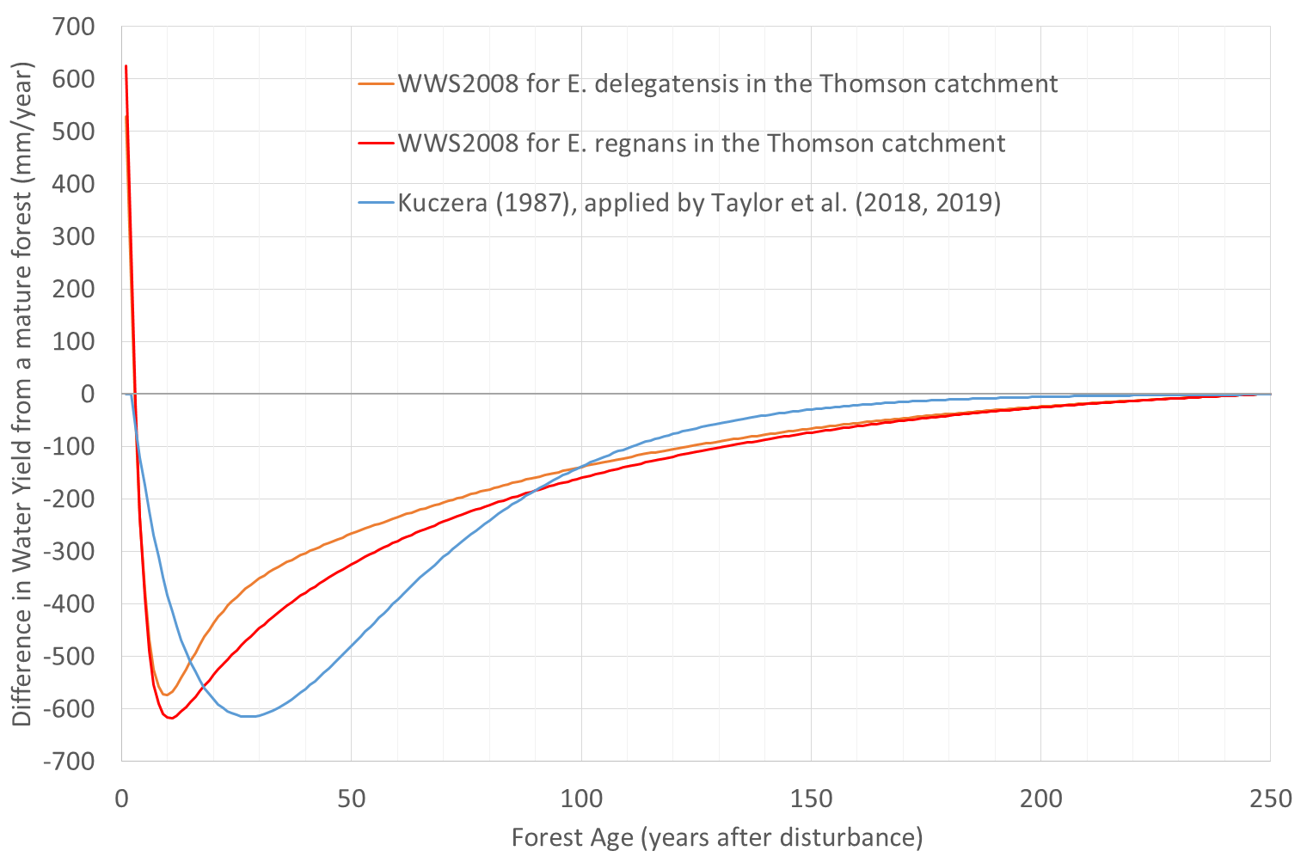

* Figure 7 Difference in annual catchment water yield with age, compared with a mature forest, for *E. regnans* and *E. delegatensis* forest used in WWS2008 for the Thomson catchment (fitted to Macaque model outputs), compared with the Kuczera (1987) curve, which was applied by Taylor *et al.* (2018, 2019) for all species of ash in the Thomson catchment

The implications of the differences in the annual catchment water yield projections with forest age become more apparent when considering the cumulative impact on catchment water yield over time after disturbance. Figure 8, produced in this review, shows cumulative total catchment water yield (in ML) from one hectare of forest in the Thomson catchment. The cumulative difference in catchment water yield over the first 45 years after disturbance, derived by Taylor *et al*. (2019) from the Kuczera (1987) curve, was 217 ML/ha. By comparison, the cumulative differences in catchment water yield over the same 45 year period derived from the WWS2008 Macaque modelling results were 191 ML/ha and 162 ML/ha for *E. regnans* and *E. delegatensis* respectively. These differences in annual and cumulative catchment water yields per unit area of forest would explain some of the apparent differences between the catchment water yield modelling results from Taylor *et al.* (2018, 2019) and WWS2008, if Taylor *et al.* used the Kuczera curve for all ash forests in the Thomson catchment.

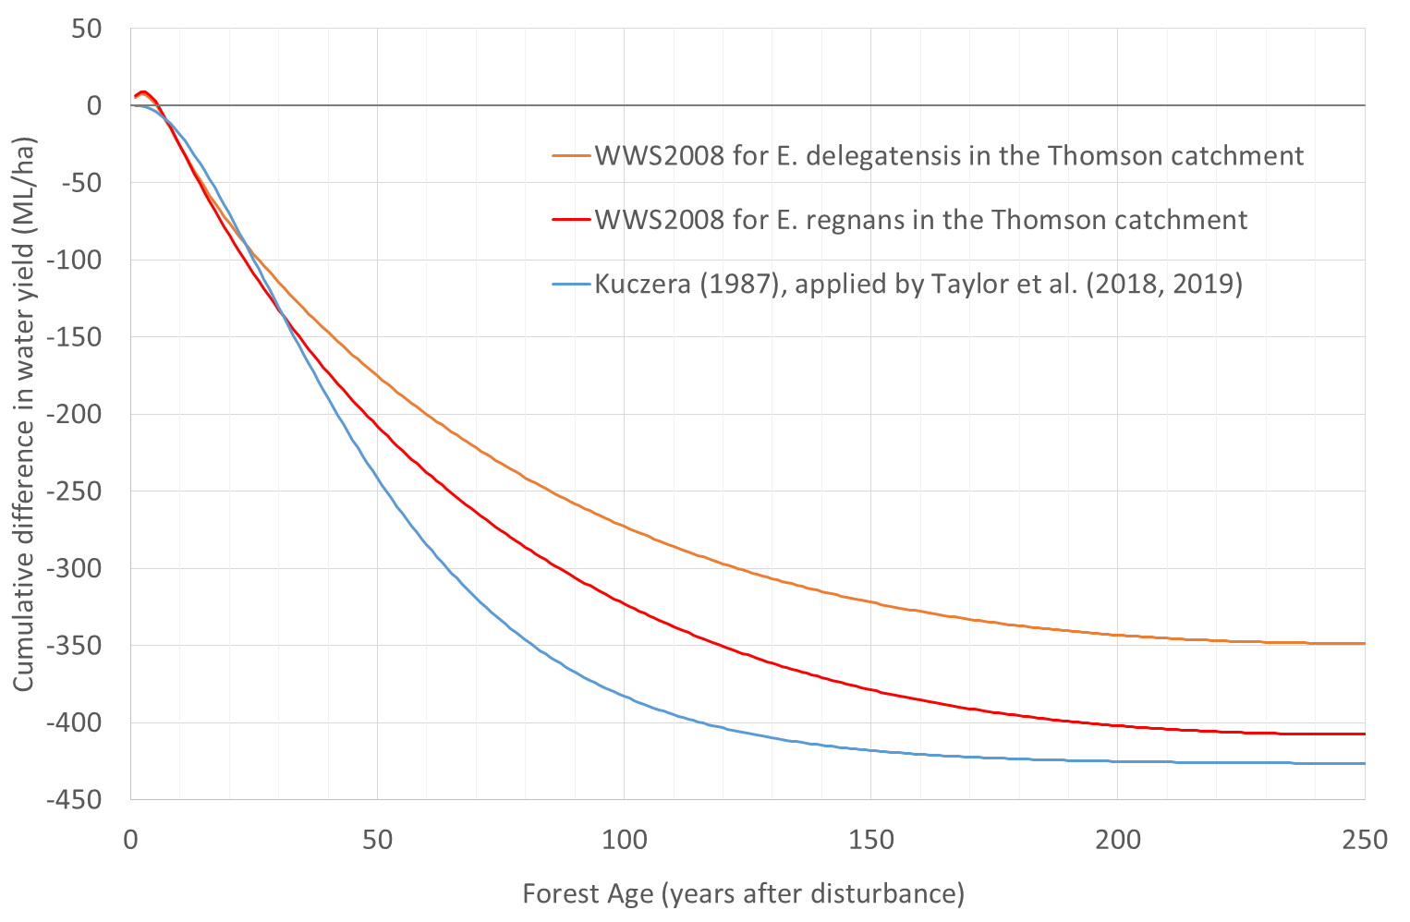

* Figure 8 Difference in cumulative catchment water yield with age, compared with a mature forest, for *E. regnans* and *E. delegatensis*, as used in WWS2008 for the Thomson catchment (fitted to Macaque model outputs), compared with the Kuczera (1987) curve, which was applied by Taylor *et al.* (2018, 2019) for all species of ash in the Thomson catchment

WWS2008 and Taylor *et al.* (2019) used different approaches for calculating how changes in timber harvesting affected catchment water yield as a percentage of baseline estimates of streamflow. Table 4 shows that for the year 2050 (40 years after cessation of logging), WWS2008 projected that catchment water yield would change by 2.6%, if compared to the then current estimate of long-term average inflow to the Thomson catchment. This would increase to 3% of inflow, if compared to a more recent estimate of long-term average inflow. The conclusion of Mein (2008) quotes the impact on cumulative yield to 2050 at “less than 1.5%”, which is consistent with the first row of Table 5 (1.2% change).

Using a more contemporary estimate of long-term inflow to Thomson Reservoir over 40 years would produce a 1.6% change in cumulative catchment water yield. Taylor *et al.* (2019) (see fourth row of Table 4) used an estimate of the mean annual catchment water yield from the AWRA-L model from only the ash forest portion of the Thomson catchment, so the impact of timber harvesting on mean annual catchment water yield at 2064 on this basis would be 18.2%. However, AWRA-L would provide an estimate of runoff which is uncertain and impossible to verify with streamflow gauging. If the modelled impact of timber harvesting was compared to the long-term inflow to Thomson from recorded data, the percentage impact from timber harvesting would be 9.4% (see last row of Table 4). If the cumulative impact from Taylor *et al.* (2019) (see last row of Table 5) was computed from mean annual inflows to the Thomson Reservoir since 1997, the percentage impact would be 4.1%. The percentage impacts from Taylor *et al.* (2019) are likely to be over-estimated, due to conservative assumptions that were made in modelling the impacts of timber harvesting on catchment water yield.

* Table 4 Estimation of percentage changes in mean annual catchment water yield resulting from timber harvesting scenarios, modelled from WWS2008 and Taylor *et al.* (2019)

|  |  |  |  |  |
| --- | --- | --- | --- | --- |
| Basis of modelled impact on catchment water yield | Mean annual catchment water yield impact (GL/year) | Basis of catchment water yield estimate | Mean annual catchment water yield (GL/year) | Percentage impact |
| Difference between cease logging in 2009–10 and continuation of status quo to 2055 (scenarios A and J), for Thomson with historical rainfall (Salkin, 2008, Table 25) | –7.2 | Catchment water yield for Thomson for historical rainfall (Salkin, 2008, Table 25) | 275 | –2.6% |
| –7.2 | Long-term (1913–2018) mean inflow to Thomson Reservoir from recent Melbourne Water data | 242 | –3.0% |
| Difference between cease logging in 2009–10 and continuation of status quo to 2050 (scenarios A and J), for all catchments with historical average rainfall (Mein, 2008, Table 5) | –16 | Catchment water yield for Thomson, Tarago, Bunyip and Yarra tributaries with historical rainfall (Mein, 2008, Table 5) | 431 | –3.7% |
| Taylor (2019) difference between cease logging in 2019 and status quo at 2064 | –23 | Taylor (2019) estimate of inflows from ash forest portion of Thomson catchment only (from AWRA-L model) | 125 | –18.2% |
| –23 | Long-term (1913–2018) mean inflow to Thomson Reservoir from recent Melbourne Water data | 242 | –9.4% |

It should be noted that the catchment water yields derived by Feikema *et al.* (2006) using the Macaque model were calibrated to 45 years of gauged streamflow data for the Thomson catchment. This review has used a three-part split sample calibration and validation approach to demonstrate the robustness of the calibration of the Macaque model, at least for the period of streamflow data that the model was calibrated to. Table 6 shows that the Macaque model for the Thomson achieved very good calibration for both Nash–Sutcliffe Coefficient of Efficiency and mean bias for 12 of the 14 possible metrics, and good calibration for the remaining two, when assessed against the Moriasi *et al.* (2007) criteria. These criteria are commonly applied to assess the suitability of rainfall runoff model calibration. Similar calibration to gauged streamflow data has not yet been published for the Taylor *et al.* (2018, 2019) model for timber harvesting impacts[3].

* Table 5 Estimation of percentage changes in cumulative catchment water yield from timber harvesting scenarios, modelled from WWS2008 and Taylor *et al.* (2019)

|  |  |  |  |  |
| --- | --- | --- | --- | --- |
| Basis of modelled impact on catchment water yield | Cumulative catchment water yield impact (GL) | Basis of catchment water yield estimate | Cumulative catchment water yield (GL) | Percentage impact |
| Difference between cease logging in 2009–10 and continuation of status quo to 2050 (scenarios A and J), for Thomson catchment with reduced average rainfall (Salkin, 2008, Table 27) | –109 | Catchment water yield for Thomson for reduced rainfall (Salkin, 2008, Table 27) | 9259 | –1.2% |
| –109 | Mean annual inflow to Thomson Reservoir for 1997–2018 from recent Melbourne Water data over 40 years | 6923 | –1.6% |
| Taylor (2019) difference between cease logging in 2019 and status quo at 2064 | –316 | Mean annual inflow to Thomson Reservoir for 1997–2018 from recent Melbourne Water data over 45 years | 7788 | –4.1% |

* Table 6 Calibration and validation performance metrics for the Macaque model from Feikema *et al.* (2006) and comparison with performance criteria from Moriasi *et al.* (2007), where G = Good and VG = Very Good

|  |  |  |  |  |  |  |  |
| --- | --- | --- | --- | --- | --- | --- | --- |
| Performance metric | Calibration on periods 1 & 2 | Validation on period 3 | Calibration on periods 1 & 2 | Validation on period 3 | Calibration on periods 1 & 2 | Validation on period 3 | Calibration on whole record |
| Coefficient of Efficiency | 0.799 (VG) | 0.763 (VG) | 0.75 (VG) | 0.847 (VG) | 0.81 (VG) | 0.736 (G) | **0.788 (VG)** |
| % Bias | 0.6% (VG) | –12.1% (G) | –5.3% (VG) | –0.5% (VG) | –6.2% (VG) | 1.9% (VG) | –**3.6% (VG)** |

**In summary,** Taylor *et al.* (2018, 2019) projected increases in catchment water yield in the Thomson catchment, after a theoretical cessation of logging, which are greater than those predicted by WWS2008 for the closest comparable scenario. It is difficult to be certain without access to their model, but from the material presented in Taylor *et al.* (2018, 2019) it appears that several simplifying assumptions were made, all of which were likely to over-estimate the impact of timber harvesting on catchment water yield in the Thomson catchment.

## Response of Victorian catchments to climate variability and climate change

Climate variability and change fundamentally influence catchment water yield from Melbourne’s water supply catchments, both directly and indirectly. This section discusses those influences as well as the advances in our understanding since WWS2008. The discussion focusses on our understanding of large-scale climate variability and change and their impacts on rainfall and other meteorological factors. This section draws particularly on research from, and associated with, climate research initiatives since 2008, including the Victorian Climate Initiative (VicCI, 2013–2017), The Victorian Drought Risk Inference Project (VicDRIP, 2016 and ongoing) and the Victorian Water and Climate Initiative (VicWaCI, 2017 – ongoing).

Victoria’s climate is characterised by high interannual variability and the influence of large-scale climate drivers that are associated with coupled interactions between the ocean, the atmosphere and the land surface. These drivers include the El Niño Southern Oscillation (ENSO), Indian Ocean Dipole (IOD), Southern Annular Mode (SAM) and decadal variability associated with the Interdecadal Pacific Oscillation (IPO), and they are affected by both natural and human-induced impacts. Hope *et al.* (2017) outline observations of increasing surface air pressures in recent decades, which are associated with greater air subsidence that results in higher sea-level pressures. Figure 9 shows the trend in winter mean sea-level pressure from 1980 to 2016. The increased pressures have acted to deflect rain-bearing systems southward away from Victoria, particularly in the cool season (Hope *et al.*, 2017).

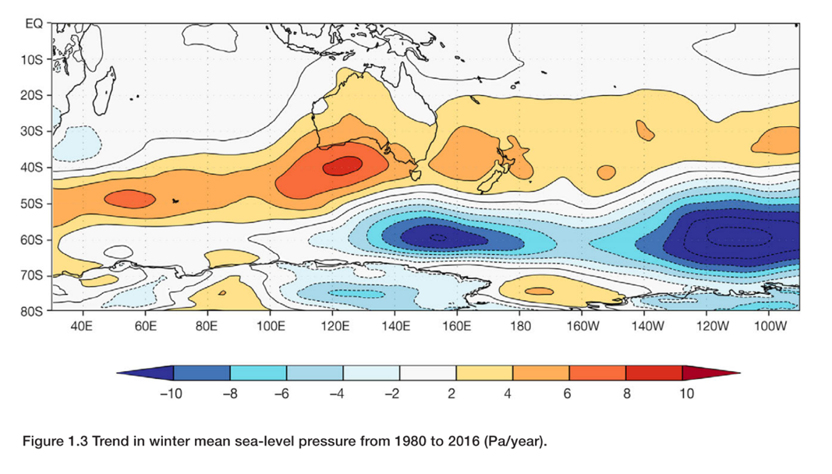

* Figure 9 Trend in winter mean sea-level pressure from 1980 to 2016 (Pa/year) (Hope *et al.*, 2017)

In the period 1960–2018, seasonal rainfall declined in most parts of Victoria in winter, spring and autumn (Figure 10) by up to 40 mm/decade. Summer rainfall has increased by a small margin in northern Victoria and reduced by a small amount in southern Victoria. Rainfall records for Melbourne’s four primary water supply catchments reflect these broader observations.

The additional observations and research in the decade since the publication of WWS2008 have led to a deeper understanding of dynamical variability and changes in the climate system and their hydrological impacts. Additional meteorological and inflow data have facilitated improved model calibration and evaluation. The Millennium drought continued during 2008–09 and then, after a period of around 13 dry or moderately dry years, the drought broke in 2010–11 with widespread heavy rainfall under the influence of two La Niña events. This was followed by a mixture of moderate years and drier years. However, the decline in cool season rainfall is likely to persist and possibly intensify in the longer term (Hope *et al.*, 2017).

Figure 11 shows total annual inflows into the Thomson Reservoir, as well as total inflows into Melbourne’s four major storages. Average inflows following the Millennium drought have rebounded somewhat, but have not returned to pre-1997 levels. Mean annual inflows into the Thomson for 1997–2018 were 31% below the 1913–2018 mean. Taken across a slightly longer period, the 1975–2018 mean inflows into the Thomson remain 15% below the long-term mean. For the combined total of Melbourne’s four major harvesting storages (Thomson, Upper Yarra, , O’Shannassy and Maroondah), the mean annual inflows were 31% and 14% below the long-term mean, for the 1997–2018 and 1975–2018 periods respectively. The mean annual precipitation for the Thomson was 11% and 5% below the long-term mean for 1997–2018 and 1975–2018 respectively. Therefore, for the Thomson, the percentage reductions in inflows were about three times the percentage reductions in rainfall.

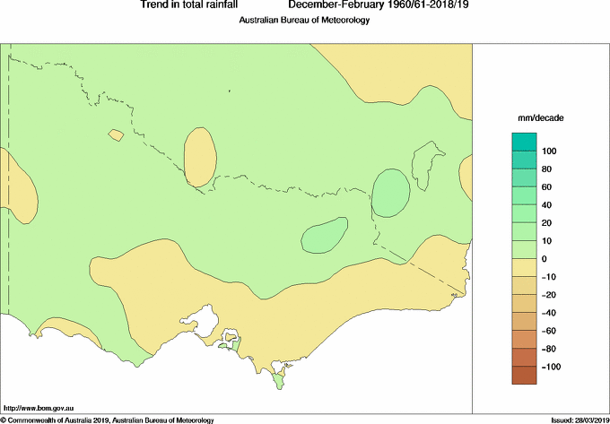 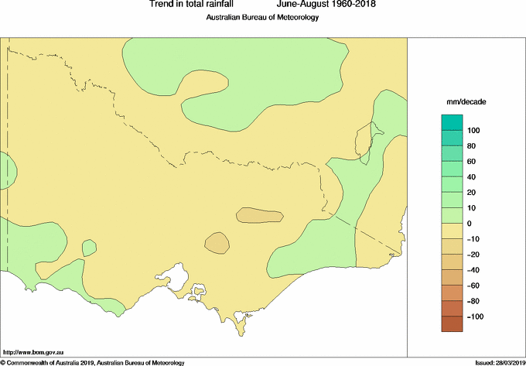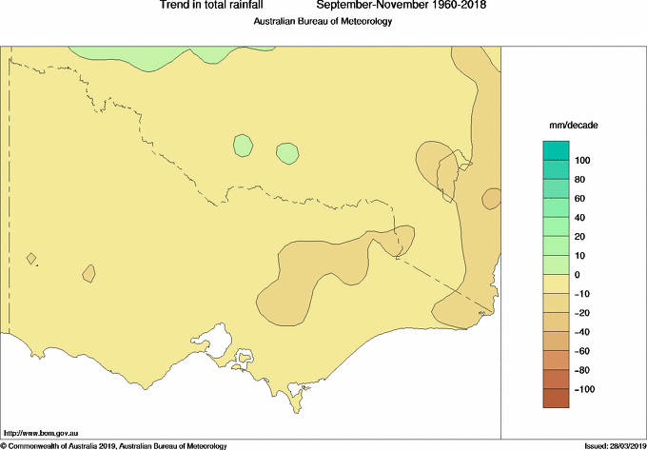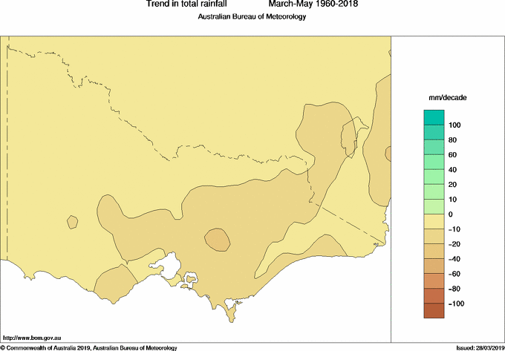

Figure 10 Trends in seasonal rainfall over Victoria for 1960–2018/19 for (a) December–February, (b) March–May, (c) June–August and (d) September–November. (Figure courtesy of the Australian Bureau of Meteorology.)

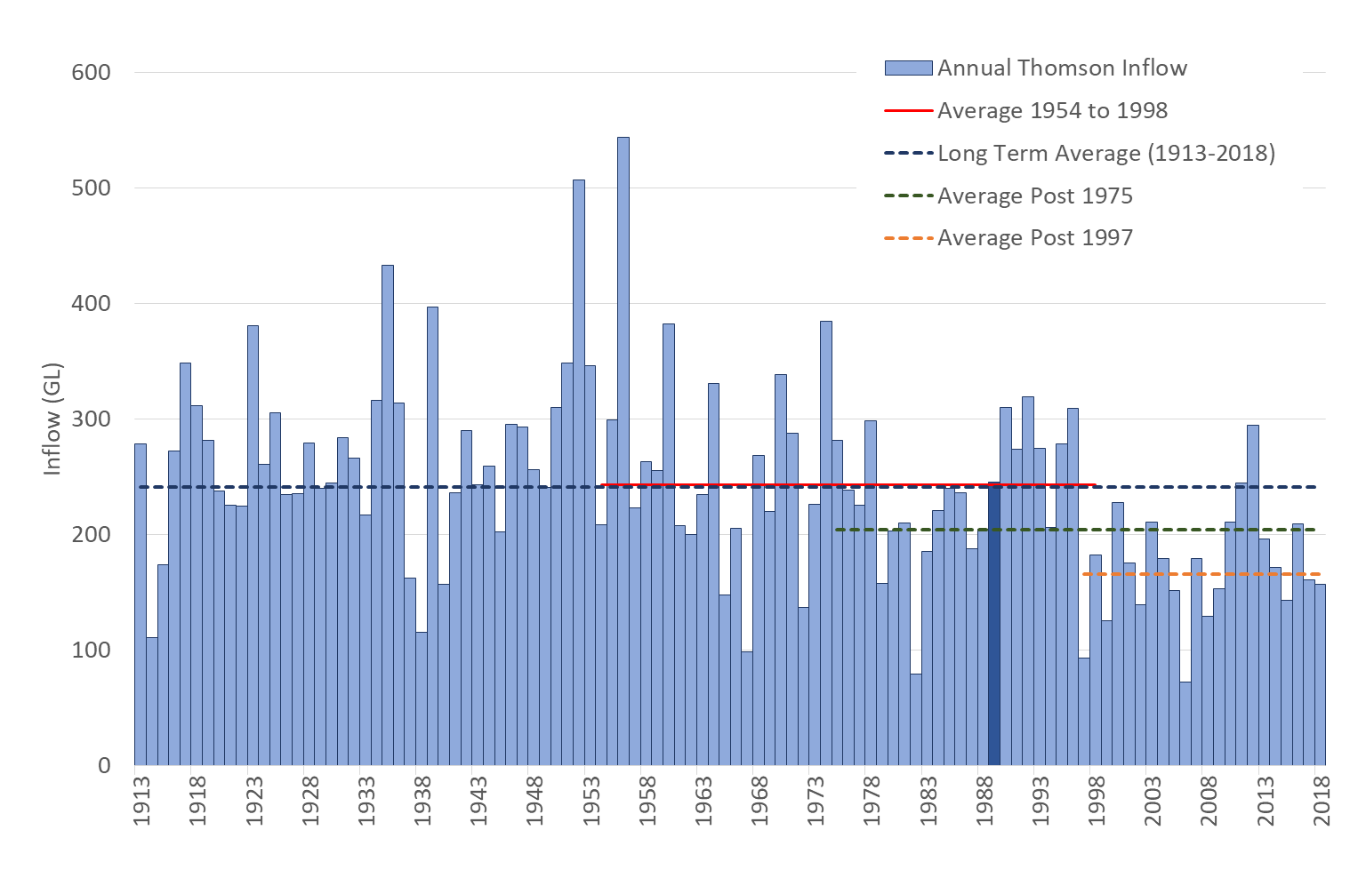

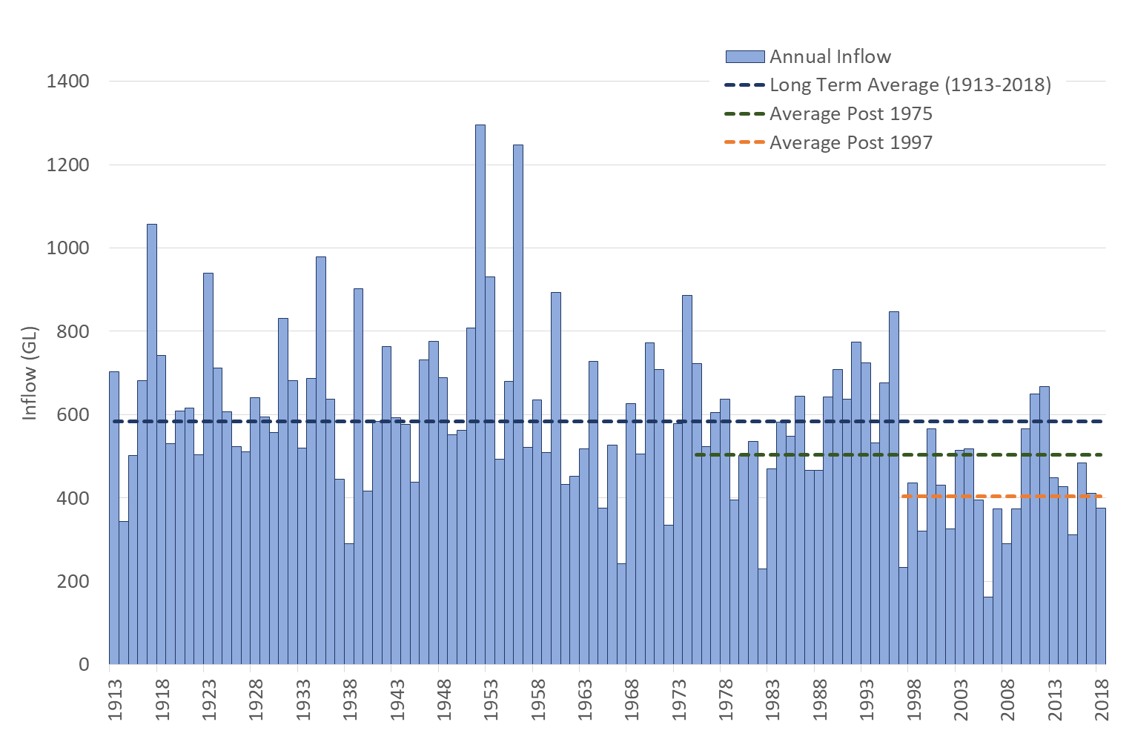

* Figure 11 Annual inflows to (top) Thomson Reservoir and (bottom) combined for Thomson, Upper Yarra, O’Shannassy and Maroondah reservoirs, showing averages for the whole period (1913–2018), 1975–2018 and 1997–2018. The Thomson plot (top) also shows the average for 1954–1998, which was used for calibration of the Macaque models, and it highlights 1989. That was the representative year that was repeated 300 times in the Macaque model scenario simulations (see Salkin, 2008, p. 20) (Data supplied by K.S. Tan, Melbourne Water, pers. comm.)

The climate change simulations in WWS2008 found that the modelled percentage reductions in catchment water yield were several times the projected percentage reductions in mean annual rainfall under the climate change scenarios that they considered. From WWS2008, for the Thomson catchment, the ratios of mean annual catchment water yield to rainfall change for the year 2050 were about 8, 3.8 and 3.1 for the “slight”, “moderate” and “extreme” climate change scenarios, respectively.

Lumped conceptual rainfall runoff models have been applied to investigate how changes in mean annual rainfall translate into changes in catchment water yield, with specific applications in Melbourne’s forested catchments; Zhou *et al*. (2015) investigated the Starvation Creek and the Little Yarra River catchments, and Taylor *et al.* (2019) investigated the Thomson catchment.

Zhou *et al.* (2015) ran three different conceptual rainfall runoff models to separate out the influence of bushfire from climate change. For the Starvation Creek catchment, they found that climate variability was responsible for declines in catchment water yield of between 29% and 36% for the dry period 1999–2004, when there was a reduction of 13% in mean annual rainfall. For the Little Yarra River catchment, they found that climate variability was responsible for declines in catchment water yield of between 16% and 31% for the dry period 1999–2000, when there was a reduction of 11% in mean annual rainfall. Their results show that the ratio of decline in catchment water yield to rainfall was between 2.3 and 2.8 times for Starvation Creek and between 1.4 and 2.7 times for the Little Yarra River, although these ratios were estimated across relatively short periods of 2 and 5 years in the two catchments. In the Taylor *et al.* (2019) lumped conceptual rainfall runoff model simulations, the ratios of mean annual catchment water yield to rainfall change across that paper’s six projections to the year 2090 ranged between 0.4 and 18 times, due to the additional influence of the projected increase in PET under climate change.

Whilst there was consistency in the direction of change of catchment water yield between the different catchments and different models applied in these three studies (i.e. WWS2008 and the studies by Zhou *et al*. and Taylor *et al*.), there was some variation in the magnitude of change in catchment water yield relative to the change in mean annual rainfall.

Recent analyses of streamflows and climatic conditions have revealed shifts in the runoff response to rainfall for a large proportion of the catchments in South-Eastern Australia. Catchment rainfall runoff partitioning has changed from the partitioning that was previously encountered during shorter droughts; significantly less runoff than expected is occurring in many catchments (Saft *et al.*, 2015, 2016a, 2016b). Tan and Neal (2018) have made specific investigations of potential changes in the rainfall‑runoff response, using rainfall runoff regression modelling to examine long-term changes in the relationship between streamflow and rainfall in catchments supplying Melbourne’s four major reservoirs. Averaged across all catchments, the ratio of streamflow to rainfall was 12% lower during and after the 1997–2009 drought than it was before the drought. Statistically significant changes in the streamflow to rainfall ratio occurred in the Upper Yarra and Thomson catchments but not in Maroondah or O’Shannassy. The Tan and Neal study found that,

*30–85% of the changes in annual rainfall-runoff responses post-1997 were attributed to seasonal and multi-year rainfall variance, highlighting the importance of understanding changes in serial correlation of dry years, and changes in seasonal rainfall patterns during and after drought*

and that “changes in rainfall-runoff behaviour post-1997 would have been greater if the 1939 bushfires had not occurred”. This evidence of a possible change in state of the runoff response to rainfall following the Millennium drought may or may not be reflected by lumped conceptual rainfall runoff models, such as those applied by Taylor *et al.* (2019) and Zhou *et al.* (2015), and the Macaque model applied in WWS2008.

The climate change simulations undertaken with the Macaque model in WWS2008 assumed that there was no change in forest species across the catchment, as a result of climate change. Similarly, conceptual rainfall runoff models, such as those applied by Taylor *et al.* (2019), Zhou *et al.* (2015) and Henley *et al.* (2019), assume that the AET response in the model is unchanged from how it was represented over the historical period of streamflow used for calibration, which implicitly assumes no change in forest type or runoff response in the climate change simulations.

However, climate change is projected to change the potential for eucalypts to regenerate across the Central Highlands of Victoria (Mok *et al.*, 2012). Modelling by Mok *et al.* found that increases in temperature and decreases in winter and spring precipitation, as are projected to occur by 2050 with climate change, decreased the ability of *E. pauciflora* (snow gum) and *E. delegatensis* (alpine ash) to regenerate. However, for the 2050 climate change projection with 2.6°C increase in temperature and 15% decline in mean annual precipitation, they found that regeneration potential for *E. obliqua* (messmate stringybark, or messmate) and *E. regnans* (mountain ash) were enhanced, on the whole, across most landscapes due to projected reductions in snow and frost. The highest climate change scenario that Mok *et al.* (2012) modelled, the 2080 high climate change projection with 4.3°C increase in mean temperature and 22% decline in mean annual precipitation across the region, was identified as being beyond a “tipping point” where regeneration potential for all five eucalypt species would be negatively impacted across most landscapes.

Mok *et al.* (2012) only modelled the impacts of changes in temperature and precipitation on regeneration potential, without considering whether changes in bushfire frequency, extent and severity would influence the regeneration potential of each of the eucalypt species. From a catchment water yield perspective the implications of this modelling are that over the coming few decades there could be a transition in the distribution of dominant forest species across the catchments. Regeneration potential could decrease for *E. pauciflora* (snow gum) and *E. delegatensis* (alpine ash), and they could be replaced by *E. obliqua* and *E. regnans* which will be able to regenerate across a wider range of elevations under current climate.

Neither the effects of potential changes in species distribution under climate change, nor potential shifts in the rainfall‑runoff response following sustained periods of low rainfall, have been tested in previous modelling of catchment water yield under climate change in Melbourne’s catchments. Projections of changes in catchment water yield under climate change from previous studies should be considered in light of this caveat.

WWS2008 (Feikema *et al.*, 2008) modelled the impact of climate change on catchment water yield from the Thomson catchment under “slight”, “moderate” and “extreme” climate projections for 2050 (Howe *et al.*, 2005). The projected declines in mean annual rainfall for the three scenarios modelled by WWS2008 were 1.6%, 7% and 14% respectively. Assuming no disturbance of the vegetation, the projected differences in cumulative catchment water yield from the Thomson catchment over the 42 years to 2050 (i.e. 42 years after the WWS2008 modelling) were 13%, 27% and 42% for the “slight”, “moderate” and “extreme” projections, respectively (see Figure 4.6 of Feikema *et al.*, 2008). If the percentage change due to the “moderate” projection from WWS2008 was to be applied to the long-term mean annual runoff into Thomson Reservoir of 242 GL/year (see Table 4, this review), the reduction in mean annual catchment water yield would be 65 GL/year.

Since WWS2008, updated projections for climate change are available based on revised GCM and downscaling approaches. These include the Climate Change in Australia projections (CSIRO and Bureau of Meteorology, 2015). The current ‘Guidelines for Assessing the Impact of Climate Change on Water Supplies in Victoria’ (Department of Environment Land Water and Planning, 2016) use the projected changes in streamflow developed during the VicCI (Potter *et al.*, 2016). Hope *et al*. (2017) concluded that,

*This [cool season rainfall] decline is likely to persist and possibly intensify in the longer term, and will occur more evenly across the whole cool season rather than primarily in the early part, as was the case during the Millennium Drought. This change is associated with changes in the global-scale circulation, which are at least partly attributable to anthropogenic influences.*

The Victorian Climate Projections 2019 include high resolution dynamical downscaling at 5 km resolution (Clarke *et al.*, 2019). Updated projections agree in broad terms with previous projections, stating,

*Victoria is projected to continue becoming drier in the long term in all seasons except summer, for which models indicate that both increases and decreases in average rainfall are possible. In a multi-model analysis, it has been found that models that better capture the synoptic-scale weather patterns also project drier future in some seasons* (Grose *et al.*, 2017).

Since climate models are designed and expected to simulate long-term trends but not the precise sequence of variability on daily to decadal timescales, it is possible that a step change in climate has already occurred in recent decades that is not evident in climate model simulations. It is also possible that more severe declines in rainfall and streamflow will occur than are projected by most models.

Taylor *et al.* (2019) modelled declines in mean annual catchment water yield for the ash-type forest portion of the Thomson catchment, applying representative climate futures for projected climate change for 2030, 2060 and 2090. For the “consensus” and “driest” GCM projections, they found that mean annual runoff declined appreciably by 2090, with more variable results for 2030 and 2060. Under the “wettest” GCM projections, they projected little change in mean annual catchment water yield (in their RCP4.5 scenario) or, conversely, increases in catchment water yield (in their RCP8.5 scenario) for 2060 and 2090.

For year 2090, Taylor *et al*. modelled declines of between 0.4% and 39% in mean annual catchment water yield for the Thomson catchment under the RCP4.5 scenario, produced by projected declines in rainfall of between 1% and 22% across the three representative climate futures. For the RCP8.5 scenario at 2090, they modelled changes in runoff varying between an increase of 15% and a decline of 55%, produced by projected changes in mean annual rainfall between +21% and –26%. The projected declines in mean annual catchment water yield for the ash-type forest portions of the Thomson catchment under the “consensus” projection for 2090 were 20% and 18% for RCP4.5 and RCP8.5 respectively. Changes in rainfall and PET due to climate change would influence the other parts of the Thomson catchment as well as the ash-type forest, so if the same percentage declines were projected for the whole catchment and applied to the mean annual runoff into Thomson Reservoir of 204 GL/year (based upon 1975 to 2018), the consensus climate change projection for 2090 for catchment water yield would be 37 GL/year (RCP8.5) or 41 GL/year (RCP4.5).

Mein (2008) and Taylor *et al.* (2019) provided different interpretations of the relative impacts of timber harvesting and projected climate change because (a) the WWS2008 estimate of timber harvesting impact was roughly one-third of the estimate in Taylor *et al.* (2019) (see Section 5.3);   
(b) Taylor *et al.* (2019) used more recent projections for changes in rainfall and PET than WWS2008, which may have been a little less severe than those used in WWS2008 (Howe *et al.*, 2005); and (c) Mein (2008, p. ii) compared the impacts of timber harvesting and climate change across all catchments, whereas Taylor *et al.* (2019) compared the timber harvesting and climate change impacts for the estimated yield from only the ash-type forest portion of the Thomson catchment.

With regard to (a), as discussed in Section 5.3, it is possible that simplifying assumptions made by Taylor *et al.* (2019) in the timber harvesting scenarios have systematically over-estimated its impact, although it is difficult to be definitive about this without access to their model. With regard to (b), the representative climate futures adopted by Taylor *et al.* (2019) are likely to better represent changes in rainfall and evapotranspiration projections due to climate change projections, as currently understood, than the older climate projections adopted for WWS2008. However, the lumped conceptual rainfall runoff model structure adopted by Taylor *et al.* (2019) probably does not adequately represent spatial variations in AET and the relationship with forest age. It therefore should be considered as providing context to the simulations of logging impact, which were the main focus of their paper. With regard to (c), WWS2008 considers total catchment water yield from the Thomson and all the study catchments because water yield from all parts of the catchment(s) will be impacted by climate change and total catchment water yield can be verified using gauged streamflow data and water volume balances. By comparison, estimates of runoff from AWRA-L can be poor, when validated against gauged flows, because AWRA-L adopts the same set of parameters across the whole of Australia, ignoring the particular vegetation and hydrological characteristics of the Thomson catchment. The uncertainty in AWRA-L modelled estimates of runoff for part of the catchment should be acknowledged when applying these as a basis for comparison.

**In summary,** Melbourne’s catchments experience a high degree of year to year variability, and are influenced by numerous ocean–atmosphere mechanisms. Observed trends in rainfall, temperature, CO2, Hadley cell expansion, subtropical ridge, storm track and the Southern Annular Mode have significant impacts on the meteorology of Victoria. Key areas of uncertainty are decadal and lower frequency variability, and the strength and seasonality of the future drying trend. Observations are currently tracking on the drier end of the projected distributions of cool season rainfall. Better performing climate models project a drier future than the full ensemble of models.

In a multidecadal context, there is a high degree of uncertainty about global Greenhouse Gas mitigation and therefore future climate change, and this is a substantial component of uncertainty (Hawkins and Sutton, 2009). There also remains uncertainty in how vegetation and catchments respond to higher CO2, changing rainfall, increasing temperatures, changing potential evapotranspiration, and changes to the spatio-temporal patterns of meteorological variables. However, declining rainfall and runoff are evident in observations and climate model simulations. Although there remains a large degree of uncertainty in future projections, further declines in catchment water yield from Melbourne’s catchments are likely, due to climate change.

## Reassessment of model calibration with additional data

The Macaque model calibrations employed split-sample fitting and validation, which demonstrated that the calibrations were relatively robust to variations in climatic conditions across the calibration periods that were available at the time of WWS2008. “Satisfactory”, “Good” or “Very Good” calibrations were achieved for most of the other catchments for the calibration and validation periods, when assessed against the Moriasi *et al.* (2007) criteria (refer to Table 6, this review). Model calibration was “Unsatisfactory” on some of the performance statistics, for the Bunyip catchment, as the Macaque model under-estimated flows prior to about 1968 and then over-estimated flows for 1969–1987.

As shown in Figure 12, by now considerably more years of gauged flow records are likely to be available for calibrating future models than were available to Feikema *et al.* (2006). Water resources system models for the Thomson, Tarago and Bunyip systems should have monthly inflow time series, based upon volume balances for the reservoirs, which would allow for considerably longer periods for calibration. Extending the period available for calibration and validation of the catchment models should provide increased confidence in the robustness of the model calibration, and allow for more accurately defined assessments of uncertainty of the model predictions.

Analysis of streamflows from several catchments after the Millennium drought has revealed variations in catchment response across Victoria. Several Victorian catchments have shown evidence of a change in rainfall‑runoff response, with streamflows not recovering as much as would have been expected given rainfalls recorded since 2009 (Saft *et al.*, 2016a; Tan and Neal, 2018). Future modelling should make use of additional streamflow data sets available for calibration and evaluation. In particular, it may be important to evaluate the models’ capability in adequately capturing changes in the rainfall‑runoff generation response under long-term climatic variations and change.

**In summary,** any new modelling of catchment water yield from Melbourne’s catchments should include re-calibration to the longer streamflow data sets that are now available, particularly to confirm that the models can adequately capture changes in the rainfall‑runoff generation response under long-term climatic variations and climate change.





* Figure 12 Gantt chart showing periods of observed streamflow (top) that were used in WWS2008 (Feikema *et al.*, 2006) to calibrate the Macaque models, and (bottom) that should now be available for calibration of future models

## Development of improved modelling approaches

Future studies should quantify how climate variability and climate change, timber harvesting and bushfires combine to influence the runoff from catchments and hence the volumes of water that need to be supplied from other sources. Such modelling should be able to produce projections of catchment water yield, for a range of scenarios, for 250 years, in order to capture the time for ash-type forests to reach full maturity.

A revised modelling approach could consider:

* spatial variation in terrain, species type, forest age, soils, geology and climate across the forested catchments,
* revision to the algorithms used to spatially interpolate climate-forcing data, including precipitation, temperature, solar radiation, wind speed and relative humidity, across the forested catchments,
* the natural climate variability using a sufficiently large number of randomly generated climate sequences that accurately characterise the scale of observed natural climate variability,
* the projected influence of climate change on the randomly generated future climate sequences, using approaches that are consistent with the latest projections from the Intergovernmental Panel on Climate Change (IPCC) and the Victorian Water and Climate Initiative (VicWaCI),
* the range of possible future bushfires across the catchments, by representing a range of randomly generated bushfires that vary in spatial extent and severity, whose frequency is dependent on stochastic climate factors,
* various scenarios for timber harvesting regimes (including cessation of timber harvesting in some or all catchments).

In addition, the analysis and overall modelling approach could also consider, to the extent that they are relevant to the key outcomes from the study:

* how climate change and sequences of timber harvesting and bushfire would interact to influence the spatial extent of different forest types,
* changes in the way catchment runoff generation responds to decadal or multi-decadal shifts in climate,
* an assessment of the uncertainty of the model assumptions, structure and parameters on the model outcomes, using at least a sensitivity analysis, and preferably a formal uncertainty analysis.

Some other improvements that could be incorporated in future modelling, include:

* a systematic and objective linkage between model uncertainty and conclusions,
* calibration using up-to-date records of monthly gauged flows and reconstructed inflows to reservoirs, using split-sample calibration and evaluation periods, over the full period of record that is now available,
* adoption of contemporary software engineering practices, that are able to leverage high performance and/or cloud computing resources, in order to facilitate the large number of simulations that are likely to be required,
* an initial model design phase, to set out the relative levels of emphasis and focus that should be given to each of the modelling tasks, as set out in the bullet point lists above. The model design phase could include some initial runs of all or part of the modelling system, to provide initial guidance on those factors in the modelling that will make a material difference to the key outcomes of the study.

Design of future models may be informed by the considerations set out in the remainder of this section. Macaque is a very detailed process-based model, which was designed to represent much of the spatial and temporal variability in evapotranspiration response from vegetation. Some of the disadvantages of applying Macaque are relatively long run-times, the very large number of parameters for which values had to be selected or calibrated, and uncertainty introduced in attempting to project how some or all of those parameters would respond to climate change.

Simpler models, which include curves of evapotranspiration response to vegetation age, have been applied to estimate changes in annual catchment water yield in response to aging vegetation. Such models have the advantage of being considerably faster to run than Macaque (Mannik *et al.*, 2009; Mannik *et al.*, 2013; Tan *et al.*, 2015; Taylor *et al.*, 2018; Taylor *et al.*, 2019). However, as they lack some of the connections to physical processes possessed by models like Macaque, they may be less accurate in representing some catchment responses. In particular, care is needed when deriving appropriate curves of evapotranspiration versus age for different forest types (notably mixed-species eucalypt forest) and climatic zones (particularly lower rainfall areas).

As outlined earlier (section 5.4), lumped conceptual rainfall runoff models have been applied to investigate impacts of bushfires and climate change on catchment water yields (Zhou *et al.*, 2015; Taylor *et al.*, 2019)). Being lumped models, they have not incorporated spatial variations in evapotranspiration across catchments, nor temporal variations in evapotranspiration with forest age. For forested catchments, where appreciable spatial variations in evapotranspiration with forest type and appreciable temporal variations in evapotranspiration with forest age and type have been demonstrated, it would appear to be difficult to demonstrate that robust projections of catchment water yield can be consistently attained. Future application of conceptual models for forested catchments should therefore consider implementing a semi-distributed or distributed spatial framework, in order to capture at least some of the spatial and temporal variations in evapotranspiration that have been identified by field data.

As noted in section 4.2.1, the Macaque model used in WWS2008 requires two inputs to determine evapotranspiration (leaf area index (LAI) and leaf conductance) and the model simulates the changing influence of forest age on these inputs over time. However, more recent approaches have shown that a single variable, sapwood area index, can be used to predict annual AET (Benyon *et al.*, 2015; Jaskierniak *et al.*, 2019) and that this property can be mapped spatially and temporally using commonly collected forest inventory data and LiDAR. A new modelling approach, currently being developed at the University of Melbourne, uses the “self-thinning line” (that is, a relationship that defines plant mortality as a result of competition in crowded stands; Trouvé *et al.*, 2017) to drive future changes in stand sapwood area. The estimated changes in sapwood can be used with daily precipitation and vapour pressure deficit (a function of temperature and humidity) to model evapotranspiration and streamflow.

**In summary,** whilst investigations since 2008 about the feedbacks between bushfires, climate change and timber harvesting have produced variable results, an appropriately designed Monte Carlo simulation framework should be able to cope with simulating these feedbacks in an appropriate manner. The effects of potential changes in species distribution under climate change have not been tested in previous modelling of catchment water yield under climate change in Melbourne’s catchments. More frequent high severity fires due to climate change, and/or the “landscape trap” propounded by Lindenmayer *et al.* (2011), may ultimately result in loss of ash eucalypt forest to acacia or other species, which may reduce AET and increase catchment water yields in future. Further modelling would be required to provide more reliable projections of changes in catchment water yield under climate change that address these uncertainties. The Monte Carlo framework should therefore be designed to allow for the probability that climate change and/or recurrent high severity fires may result in transition between forest types, and then include this effect in the probabilistic simulation of catchment water yield. This section has outlined ideas about how such modelling should be designed.

# Conclusions and recommended future investigations

Given developments over the last 11 years and the current state of knowledge about Melbourne’s forested catchments, our assessment of four broad conclusions that were made in the WWS2008 Mein (2008) Summary Report are as follows:

1. *The expected yield of the water supply catchments is increasing, due to the continued aging of the forest after the 1939 bushfires.*

Inflows to Melbourne’s reservoirs over the 1997–2018 period were 31% below the long-term mean due to mean annual rainfall being about 11% below average. Some of Melbourne’s forested catchments were affected by high severity fires in 2009. Had rainfall been at the long-term mean and there had been no bushfires, this conclusion would have remained valid. However, future catchment water yields will depend upon future climatic conditions and bushfires. Feikema *et al.* (2013) provides reasonable projections of catchment water yield from those catchments that were severely affected by the 2009 bushfires, estimating that the total reduction in catchment water yield for all of Melbourne’s catchments, over coming decades, is projected to be between 12 and 24 GL/year.

1. *The impacts of changing timber management regimes on cumulative water yield are relatively small, modelled here as being all within* –*1.5% of the cease-logging regime.*

WWS2008 considered climate change, timber harvesting and bushfires in isolation. The WWS2008 Summary Report (Mein, 2008) recommended that a Monte Carlo approach should be undertaken to assess the combined effects of bushfires and climate change on catchment water yield to Melbourne’s reservoirs. Until further modelling is undertaken, WWS2008 still represents the most reliable projections of changes in catchment water yield from Melbourne’s forested catchments between the current timber harvesting regime and scenarios for cessation of logging across the catchments. Mein (2008) calculated that by 40 years after the cessation of logging, there would be an annual increase of 16 GL/year in catchment water yield and a cumulative increase of 190 GL in catchment water yield over a 40 year period. It is recommended that the values of these increases in catchment water yield be incorporated into an analysis of cultural, economic, social and environmental costs and benefits under a range of future plausible scenarios. Annual average rates of timber harvesting, in terms of area logged, for the last decade have been similar to the rates of harvesting (in terms of area) that were projected for the continuation of status quo timber harvesting scenario in WWS2008. Taylor *et al.* (2018, 2019) produced higher projected increases in catchment water yield due to cessation of logging for the Thomson catchment than those that were predicted by WWS2008 for the closest comparable scenario. It is difficult to be certain without access to their model, but from the material presented in Taylor *et al.* (2018, 2019) it appears that several simplifying assumptions were made, which were all likely to have over-estimated the impact of timber harvesting on catchment water yield in the Thomson catchment.

1. *The impact of climate change on water yield can be large. For every 1% decrease in long-term average rainfall, water yield is reduced by 2*–*3% in all catchments. [For the last 10 years the reduction in flows has been of the order of 30%.]*

The observation that proportional reductions in mean annual catchment water yield are between two and three times the proportional reductions in mean annual precipitation remains reasonably consistent with observed streamflow and rainfall data in Melbourne’s catchments, and results from several modelling studies (Zhou *et al.*, 2015; Taylor *et al.*, 2019). Uncertainties in projected changes in precipitation, temperature and PET are considerable, particularly for projections that are several decades into the future. In addition, previous modelling has not explicitly considered changes in forest types, which may be induced by climate change or more frequent high severity bushfires, and so may not adequately represent changes in rainfall‑runoff generation response that have been observed across many Victorian catchments. Further modelling would be required to provide updated projections of catchment water yield under climate change for Melbourne’s forested catchments; such modelling should consider the overlapping effects of climate change, timber harvesting and bushfires.

1. *The potential impact of bushfires is also major. A repeat of the 1939 bushfires would see a decrease of 15% of the inflow to the Thomson Dam over the following 50 years.*

The conclusion remains valid that a future high severity bushfire, which affected a significant area of one or more catchments, would have a significant future impact on catchment water yield. Further modelling would be required to provide updated projections of the impact of future bushfires. Such modelling should consider the overlapping effects of bushfires, climate change, climate variability and timber harvesting.

Any future studies should quantify how climate variability and climate change, timber harvesting and bushfires combine to influence catchment water yield and hence the volumes of water that need to be supplied from other sources. It is therefore recommended that an analysis be conducted of the cultural, economic, social and environmental costs and benefits under the range of possible scenarios, including revised modelling of the change in catchment water yield.

Whilst investigations since 2008 about the feedbacks between bushfires, climate change and timber harvesting have produced variable results, an appropriately designed Monte Carlo simulation framework (as outlined in Section 5.6) should be able to cope with simulating these feedbacks in an appropriate manner. The effects of potential changes in species distribution under climate change have not been tested in previous modelling of catchment water yield under climate change in Melbourne’s catchments. More frequent high severity fires due to climate change, and/or the “landscape trap” propounded by Lindenmayer *et al.* (2011), may ultimately result in loss of ash eucalypt forest to acacia or other species, which may reduce AET and increase catchment water yields in future.

Further modelling would be required to provide more reliable projections of changes in catchment water yield under climate change that address these uncertainties. The Monte Carlo framework should therefore be designed to allow for the probability that climate change and/or recurrent high severity fires may result in transition between forest types. Combinations of these factors should be explicitly considered, to provide quantitative estimates of uncertainty in future catchment water yields.

Recommendations from Feikema *et al.* (2008) specifically address the need to revisit leaf area index. Since 2008, the collection of relevant remotely sensed data and the predictive capability of sapwood area index over leaf area index have improved. Therefore, future modelling of catchment water yield should transition to use sapwood area index instead of leaf area index.

Future modelling should rely upon the latest relevant research on spatial and temporal variations in AET with forest age and forest type. Attention should be paid to recent analyses demonstrating a potential change in the shape of the Kuczera curve for ash-forested catchments, and variations in the shape of the AET versus forest age with mean annual rainfall and forest type. It is recommended that future modelling includes re-calibration to the longer streamflow data sets that are now likely to be available, particularly to confirm that the models can adequately capture changes in the rainfall‑runoff generation response under long-term climatic variations and projected climate change.

Melbourne’s catchments experience a high degree of year to year variability, and are influenced by numerous ocean–atmosphere mechanisms. In a multidecadal context, there is a high degree of uncertainty about global temperature mitigation and therefore future climate change, and this is a very substantial component of uncertainty (Hawkins and Sutton, 2009). There also remains much uncertainty about how vegetation and catchments respond to higher CO2, changing rainfall, increasing temperatures, changing PET, and changes to the spatio-temporal patterns of meteorological variables. Given these large and epistemic uncertainties, it is not possible on the basis of existing research to tightly constrain future yield projections. Although there remains a large degree of future uncertainty, it is generally accepted that further declines in catchment water yield to Melbourne’s catchments due to climate change are likely.

The recommendations are focussed purely on the terms of reference for this review and therefore do not consider any other further work that may be needed. Such consideration could include the cost of undertaking any further analysis relative to the added value that might be provided.

# References

Andréassian V. 2004. Waters and forests: from historical controversy to scientific debate. *Journal of hydrology* **291** (1–2): 1–27

Andrews D. 2019. Securing the future for forestry industry workers (Press release) Available at: https://www.premier.vic.gov.au/securing-the-future-for-forestry-industry-workers/

Attiwill PM, Ryan MF, Burrows N, Cheney NP, McCaw L, Neyland M, Read S. 2014. Timber harvesting does not increase fire risk and severity in wet eucalypt forests of southern Australia. *Conservation Letters* **7** (4): 341–354 DOI: doi.org/10.1111/conl.12062

Australian Government Department of Agriculture. 2015. Regional Forest Agreements – an overview and history Available at: https://www.agriculture.gov.au/forestry/policies/rfa

Bassett OD, Prior LD, Slijkerman CM, Jamieson D, Bowman DMJS. 2015. Aerial sowing stopped the loss of alpine ash (Eucalyptus delegatensis) forests burnt by three short-interval fires in the Alpine National Park, Victoria, Australia. *Forest Ecology and Management* **342**: 39–48 DOI: 10.1016/j.foreco.2015.01.008

Battad D, Sutton M, Miller V, Villanueva G, Li C. 2007. Impacts of Forest Management Options on Water Yield, Central Gippsland and Dandenong Forest Management Areas

Benyon RG, Lane PNJ. 2013. Ground and satellite-based assessments of wet eucalypt forest survival and regeneration for predicting long-term hydrological responses to a large wildfire. *Forest Ecology and Management* **294**: 197–207 DOI: 10.1016/j.foreco.2012.04.003

Benyon RG, Lane PNJ, Jaskierniak D, Kuczera G, Haydon SR. 2015. Use of a forest sapwood area index to explain long-term variability in mean annual evapotranspiration and streamflow in Moist Eucalypt Forests. *Water Resources Research* **51** (7): 5318–5331 DOI: 10.1002/ 2015WR017321

Benyon RG, Nolan RH, Hawthorn SND, Lane PNJ. 2017. Stand-level variation in evapotranspiration in non-water-limited eucalypt forests. *Journal of Hydrology* **551**: 233–244 DOI: 10.1016/j.jhydrol.2017.06.002

Bowman DMJS, Murphy BP, Neyland DLJ, Williamson GJ, Prior LD. 2014. Abrupt fire regime change may cause landscape-wide loss of mature obligate seeder forests. *Global Change Biology* **20** (3): 1008–1015 DOI: 10.1111/gcb.12433

Bradstock R, Penman T, Boer M, Price O, Clarke H. 2014. Divergent responses of fire to recent warming and drying across south-eastern Australia. *Global Change Biology* **20** (5): 1412–1428 DOI: 10.1111/gcb.12449

Bradstock RA. 2010. A biogeographic model of fire regimes in Australia: Current and future implications. *Global Ecology and Biogeography* **19** (2): 145–158 DOI: doi.org/10.1111/j.1466-8238.2009.00512.x

Bradstock RA, Price O. 2014. Logging and fire in Australian forests: errors by Attiwill et al. (2014). *Conservation Letters* DOI: 10.1111/conl.12086

Bren L, Lane P, Hepworth G. 2010. Longer-term water use of native eucalyptus forest after logging and regeneration: The Coranderrk experiment. *Journal of Hydrology* **384** (1–2): 52–64 DOI: 10.1016/j.jhydrol.2010.01.007

Brookhouse MT, Farquhar GD, Roderick ML. 2013. The impact of bushfires on water yield from south-east Australia’s ash forests. *Water Resources Research* **49** (7): 4493–4505 DOI: 10.1002/wrcr.20351

Buckley TN, Turnbull TL, Pfautsch S, Gharun M, Adams MA. 2012. Differences in water use between mature and post-fire regrowth stands of subalpine Eucalyptus delegatensis R. Baker. *Forest Ecology and Management* **270**: 1–10 DOI: 10.1016/j.foreco.2012.01.008

Bureau of Meteorology. Climate Glossary Available at: http://www.bom.gov.au/climate/glossary/elnino.shtml [Accessed 20 October 2019a]

Bureau of Meteorology. Indian Ocean influences on Australian climate Available at: http://www.bom.gov.au/climate/iod/ [Accessed 20 October 2019b]

Bureau of Meteorology. Southern Annular Mode and the Australian climate Available at: http://www.bom.gov.au/climate/sam/ [Accessed 20 October 2019c]

Burton J, Cawson J, Noske P, Sheridan G. 2019. Shifting states, altered fates: Divergent fuel moisture responses after high frequency wildfire in an obligate seeder Eucalypt forest. *Forests* **10** (5): 436–452 DOI: 10.3390/f10050436

Cawson JG, Duff TJ, Swan MH, Penman TD. 2018. Wildfire in wet sclerophyll forests: the interplay between disturbances and fuel dynamics. *Ecosphere* **9** (5) DOI: 10.1002/ecs2.2211

Cawson JG, Duff TJ, Tolhurst KG, Baillie CC, Penman TD. 2017. Fuel moisture in Mountain Ash forests with contrasting fire histories. *Forest Ecology and Management* **400**: 568–577 DOI: 10.1016/j.foreco.2017.06.046

Clarke H, Evans JP. 2019. Exploring the future change space for fire weather in southeast Australia. *Theoretical and Applied Climatology* **136** (1): 513–527 DOI: doi.org/10.1007/s00704-018-2507-4

Clarke JM, Grose M, Thatcher M, Hernaman V, Heady C, Round V, Rafter T, Trenham C, Wilson L. 2019. *Victorian Climate Projections 2019 Technical Report*. CSIRO: Melbourne, Australia.

Commonwealth of Australia. 1992. National Forest Policy Statement, A new focus for Australia’s forests (First Edition)

Commonwealth of Australia. 1995. National Forest Policy Statement, A new focus for Australia’s forests (Second Edition)

Cornish PM. 1993. The effects of logging and forest regeneration on water yields in a moist eucalypt forest in New South Wales, Australia. *Journal of Hydrology* **150** (2–4): 301–322

Cornish PM, Vertessy RA. 2001. Forest age-induced changes in evapotranspiration and water yield in a eucalypt forest. *Journal of Hydrology* **242** (1–2): 43–63

CSIRO and Bureau of Meteorology. 2015. Climate Change in Australia: Projections for Australia’s Natural Resource Management Regions, Technical Report. Australia. Available at: https://www.climatechangeinaustralia.gov.au/en/publications-library/technical-report/

D’Ambrosio L. 2019. Protecting Victoria’s forests and threatened species (Press release) Available at: https://www.lilydambrosio.com.au/media-releases/protecting-victorias-forests-and-threatened-species/

Department of Environment and Primary Industries. 2014a. Management Standards and Procedures for timber harvesting operations in Victoria’s State Forests 2014 Available at: https://www.forestsandreserves.vic.gov.au/__data/assets/pdf_file/0023/29309/Management-Standards-and-Procedures-for-timber-harvesting-operations-in-Vics-State-forests-2014.pdf

Department of Environment and Primary Industries. 2014b. Code of Practice for Timber Production 2014 Available at: https://www.forestsandreserves.vic.gov.au/__data/assets/pdf_file/0016/29311/Code-of-Practice-for-Timber-Production-2014.pdf

Department of Environment Land Water and Planning. 2016. Guidelines for Assessing the Impact of Climate Change on Water Supplies in Victoria. Melbourne, Australia.

Fairman TA, Nitschke CR, Bennett LT. 2016. Too much, too soon? A review of the effects of increasing wildfire frequency on tree mortality and regeneration in temperate eucalypt forests. *International Journal of Wildland Fire* **25** (8): 831–848 DOI: 10.1071/WF15010

Feikema P, Lane P, Peel M, Sherwin C, Freebairn A, Salkin O. 2006. Hydrological studies into the impact of timber harvesting on water yield in state forests supplying water to Melbourne – Part 1 of Hydrological studies

Feikema P, Lane P, Sherwin C. 2008. Hydrological studies into the impact of timber harvesting on water yield in state forests supplying water to Melbourne – Part 2 of Hydrological studies (Climate change and Bushfire)

Feikema P, Sherwin C, Lane P. 2010. Estimates of long-term impacts of the 2009 wildfires on streamflow in the Melbourne water supply catchments

Feikema PM, Sherwin CB, Lane PNJ. 2013. Influence of climate, fire severity and forest mortality on predictions of long term streamflow: Potential effect of the 2009 wildfire on Melbourne’s water supply catchments. *Journal of Hydrology* **488**: 1–16 DOI: 10.1016/j.jhydrol.2013.02.001

Fernández C, Vega JA, Gras JM, Fonturbel T. 2006. Changes in water yield after a sequence of perturbations and forest management practices in an Eucalyptus globulus Labill. watershed in Northwestern Spain. *Forest Ecology and Management* **234** (1–3): 275–281 DOI: 10.1016/j.foreco.2006.07.008

Gharun M, Turnbull TL, Adams MA. 2013. Validation of canopy transpiration in a mixed-species foothill eucalypt forest using a soil-plant-atmosphere model. *Journal of Hydrology* **492**: 219–227 DOI: 10.1016/j.jhydrol.2013.03.051

Greve P, Roderick ML, Ukkola AM, Wada Y. 2019. The Aridity Index under global warming. *Environmental Research Letters* **14** (22): 124006 DOI: 10.1088/1748-9326/ab5046

Grose MR, Risbey JS, Moise AF, Osbrough S, Heady C, Wilson L, Erwin T. 2017. Constraints on Southern Australian rainfall change based on atmospheric circulation in CMIP5 simulations. *Journal of Climate* **30** (1): 225–242 DOI: 10.1175/JCLI-D-16-0142.1

Hawkins E, Sutton R. 2009. The Potential To Narrow Uncertainty In Regional Climate Predictions. *Bulletin of the American Meteorological Society* **90** (8): 1095–1107 DOI: 10.1175/2009BAMS2607.1

Hawthorne SND, Benyon RG, Lane PNJ. 2018. Changes in evapotranspiration components following replacement of Eucalyptus regnans with Acacia species. *Hydrological processes* **32** (2): 241–252 DOI: 10.1002/hyp.11410

Hawthorne SND, Lane PNJ, Bren LJ, Sims NC. 2013. The long term effects of thinning treatments on vegetation structure and water yield. *Forest Ecology and Management* **310**: 983–993 DOI: 10.1016/j.foreco.2013.09.046

Hélie JF, Peters DL, Tattrie KR, Gibson JJ. 2005. Review and synthesis of potential hydrologic impacts of mountain pine beetle and related harvesting activities in British Columbia: Mountain Pine Beetle Initiative Working Paper 2005-23. Victoria, British Columbia, Canada.

Henley BJ, Peel MC, Nathan R, King AD, Ukkola AM, Karoly DJ, Tan KS. 2019. Amplification of risks to water supply at 1.5 °C and 2 °C in drying climates: a case study for Melbourne, Australia. *Environmental Research Letters* **14** (8): 1–9 DOI: 10.1088/1748-9326/ab26ef

Hill PI, Mordue A, Nathan R, Daamen C, Williams K. 2006. Spatially explicit modeling of the hydrologic response of bushfires at the catchment scale. In *30th Engineers Australia Hydrology and Water Resources Symposium*Launceston, Tasmania, Australia.

Hill PI, Mordue A, Nathan RJ, Daamen C, Williams K, Murphy R. 2008. Spatially explicit modelling of the hydrologic response of bushfires at the catchment scale. *Australian Journal of Water Resources* **12** (3): 281–290 DOI: 10.1080/13241583.2008.11465354

Hope P, Timbal B, Hendon HH, Ekström M, Potter N. 2017. A synthesis of findings from the Victorian Climate Initiative (VicCI) Available at: https://www.water.vic.gov.au/__data/assets/pdf_file/0030/76197/VicCI-25-07-17-MR.pdf

Hornbeck JW, Adams MB, Corbett ES, Verry ES, Lynch JA. 1993. Long-term impacts of forest treatments on water yield: a summary for northeastern USA. *Journal of Hydrology* **150** (2–4): 323–344 DOI: 10.1016/0022-1694(93)90115-P

Howe C, Jones RN, Maheepala S, Rhodes B. 2005. Melbourne Water Climate Change Study: Implications of potential climate change for Melbourne’s water resources. Melbourne, Australia. Available at: https://www.melbournewater.com.au/sites/default/files/Climate_Change_Study.pdf

Hudson JA, Crane SB, Blackie JR. 1997. The Plynlimon water balance 1969-1995: the impact of forest and moorland vegetation on evaporation and streamflow in upland catchments. *Hydrology and Earth System Sciences* **1** (3): 409–427 DOI: 10.5194/hess-1-409-1997

Jaskierniak D, Kuczera G, Benyon R. 2016. Predicting long-term streamflow variability in moist eucalypt forests using forest growth models and a sapwood area index. *Water Resources Research* **52** (4): 3052–3067 DOI: 10.1002/2015WR018029

Jaskierniak D, Kuczera G, Benyon RG, Haydon S, Lane PNJ. 2019. Top-down seasonal streamflow model with spatiotemporal forest sapwood area. *Journal of Hydrology* **568**: 372–384 DOI: 10.1016/j.jhydrol.2018.10.075

Jaskierniak D, Kuczera G, Benyon R, Wallace L. 2015. Using tree detection algorithms to predict stand sapwood area, basal area and stocking density in Eucalyptus regnans forest. *Remote Sensing* **7** (6): 7298–7323 DOI: 10.3390/rs70607298

Keith H, Vardon M, Stein JA, Stein JL, Lindenmayer D. 2017. Ecosystem accounts define explicit and spatial trade-offs for managing natural resources. *Nature Ecology & Evolution* **1** (11): 1683–1692 DOI: 10.1038/s41559-017-0309-1

Kuczera G. 1985. Prediction of water yield reductions following a bushfire in ash-mixed species eucalypt forest. Melbourne, Australia.

Kuczera G. 1987. Predction of water yield reductions following a bushfire in ash-mixed species eucalypt forest. *Journal of Hydrology* **94**: 215–236 DOI: 10.1016/0022-1694(87)90054-0

Lane PNJ, Mackay SM. 2001. Streamflow response of mixed-species eucalypt forests to patch cutting and thinning treatments. *Forest Ecology and Management* **143** (1–3): 131–142 DOI: 10.1016/S0378-1127(00)00512-0

Lane PNJ, Feikema PM, Sherwin CB, Peel MC, Freebairn A. 2007. Physically-based prediction of water yield from disturbed forested water supply catchments. In *MODSIM 2007 International Congress on Modelling and Simulation. Modelling and Simulation Society of Australia and New Zealand*, Oxley L, , Kulasiri D (eds).2953–2959. Available at: http://www.mssanz.org.au/MODSIM07/papers/53_s52/Physically-baseds52_Lane_.pdf

Langford KJ. 1976. Change in yield of water following a bushfire in a forest of Eucalyptus regnans. *Journal of Hydrology* **29** (1–2): 87–114 DOI: 10.1016/0022-1694(76)90007-X

Lindenmayer DB, Hobbs RJ, Likens GE, Krebs CJ, Banks SC. 2011. Newly discovered landscape traps produce regime shifts in wet forests. *Proceedings of the National Academy of Sciences of the United States of America* **108** (38): 15887–15891 DOI: 10.1073/pnas.1110245108

Macfarlane C, Bond C, White DA, Grigg AH, Ogden GN, Silberstein R. 2010. Transpiration and hydraulic traits of old and regrowth eucalypt forest in southwestern Australia. *Forest Ecology and Management* **260** (1): 96–105 DOI: 10.1016/j.foreco.2010.04.005

Mankin JS, Seager R, Smerdon JE, Cook BI, Williams AP. 2019. Mid-latitude freshwater availability reduced by projected vegetation responses to climate change. *Nature Geoscience* **(in press)** DOI: 10.1038/s41561-019-0480-x

Mannik R, Murphy R, Herron A. 2009. Combined impact of the 2003 and 2006/07 bushfires on streamflow

Mannik RD, Herron A, Hill PI, Brown RE, Moran R. 2013. Estimating the change in streamflow resulting from the 2003 and 2006/2007 bushfires in southeastern Australia. *Australian Journal of Water Resources* **16** (2): 107–120 DOI: 10.7158/w10-830.2013.16.2

McGuire D, Bren L. 2013. The curse of the curves: misuse of simple hydrologic models in forestry. In *Institute of Foresters of Australia National Conference*Canberra; 176–184.

Mein R. 2008. Potential impacts of forest management on streamflow in Melbourne’s water supply catchments Summary report

Melbourne Water. 2017. Melbourne Water System Strategy. Melbourne, Australia. Available at: https://www.melbournewater.com.au/about-us/strategies-achievements-and-policies/melbourne-water-system-strategy

Metzen D, Sheridan GJ, Benyon RG, Bolstad P V, Griebel A, Lane PNJ. 2019. Spatio-temporal transpiration patterns reflect vegetation structure in complex upland terrain. *Science of the Total Environment* **694**: 133551 DOI: 10.1016/j.scitotenv.2019.07.357

Mitchell PJ, Benyon RG, Lane PNJ. 2012. Responses of evapotranspiration at different topographic positions and catchment water balance following a pronounced drought in a mixed species eucalypt forest, Australia. *Journal of Hydrology* **440**: 62–74 DOI: 10.1016/j.jhydrol.2012.03.026

Mitchell PJ, Lane PNJ, Benyon RG. 2011. Capturing within catchment variation in evapotranspiration from montane forests using LiDAR canopy profiles with measured and modelled fluxes of water. *Ecohydrology* **5** (6): 708–720 DOI: doi.org/10.1002/eco.255

Mok HF, Arndt SK, Nitschke CR. 2012. Modelling the potential impact of climate variability and change on species regeneration potential in the temperate forests of South-Eastern Australia. *Global Change Biology* **18** (3): 1053–1072 DOI: 10.1111/j.1365-2486.2011.02591.x

Moriasi DN, Arnold JG, Van Liew MW, Bingner RL, Harmel RD, Veith TL. 2007. Model evaluation guidelines for systematic quantification of accuracy in watershed simulations. *American Society of Agricultural and Biological Engineers* **50** (3): 885–900

Neville L. 2018. New body to protect and promote the Yarra River (Press release) Available at: https://www.premier.vic.gov.au/new-body-to-protect-and-promote-the-yarra-river/

Nolan RH, Boer MM, Collins L, de Dios V, Clarke H, Jenkins M, Kenny B, Bradstock RA. 2020. Causes and consequences of eastern Australia’s 2019-20 season of mega-fires. *Global change biology* DOI: 10.1111/gcb.14987

Nolan RH, Lane PNJ, Benyon RG, Bradstock RA, Mitchell PJ. 2014. Changes in evapotranspiration following wildfire in resprouting eucalypt forests. *Ecohydrology* **7** (5): 1363–1377 DOI: 10.1002/eco.1463

Nolan RH, Lane PNJ, Benyon RG, Bradstock RA, Mitchell PJ. 2015. Trends in evapotranspiration and streamflow following wildfire in resprouting eucalypt forests. *Journal of Hydrology* **524**: 614–624 DOI: 10.1016/j.jhydrol.2015.02.045

Pfautsch S, Bleby TM, Rennenberg H, Adams MA. 2010. Sap flow measurements reveal influence of temperature and stand structure on water use of Eucalyptus regnans forests. *Forest Ecology and Management* **259** (6): 1190–1199 DOI: 10.1016/j.foreco.2010.01.006

Potter N, Chiew F, Zheng H, Ekstrom M, Zhang L. 2016. Future hydroclimate projections for Victorian river basins Available at: https://data.csiro.au/collections/#collection/CIcsiro:18071v1

Price OF, Bradstock RA. 2012. The efficacy of fuel treatment in mitigating property loss during wildfires: Insights from analysis of the severity of the catastrophic fires in 2009 in Victoria, Australia. *Journal of Environmental Management* **113**: 146–157 DOI: doi.org/10.1016/j.jenvman.2012.08.041

Saft M, Peel MC, Western AW, Perraud JM, Zhang L. 2016a. Bias in streamflow projections due to climate-induced shifts in catchment response. *Geophysical Research Letters* **43** (4): 1574–1581 DOI: 10.1002/2015GL067326

Saft M, Peel MC, Western AW, Zhang L. 2016b. Predicting shifts in rainfall-runoff partitioning during multiyear drought: Roles of dry period and catchment characteristics. *Water Resources Research* **52** (12): 9290–9305 DOI: 10.1002/2016WR019525

Saft M, Western AW, Zhang L, Peel MC, Potter NJ. 2015. The influence of multiyear drought on the annual rainfall-runoff relationship: An Australian perspective. *Water Resources Research* **51** (4): 2444–2463 DOI: 10.1002/2014WR015348

Salkin O. 2008. Modelling of Options for Management of Catchments supplying Water to Melbourne - Post 2006/07 Fire, Thinning and Reduced Rainfall

Tan K, Neal B. 2018. Changes in annual rainfall-runoff responses in Melbourne’s major water supply catchments. In *Hydrology and Water Resources Symposium (HWRS 2018): Water and Communities*.

Tan KS, Flower DJM, Flowers DM. 2011. An event runoff coefficient approach for assessing changes in short-term catchment runoff following bushfires. *34th IAHR Congress 2011 - Balance and Uncertainty: Water in a Changing World, Incorporating the 33rd Hydrology and Water Resources Symposium and the 10th Conference on Hydraulics in Water Engineering* (July): 1522–1529 Available at: https://search.informit.com.au/documentSummary;dn=344015843764033;res=IELENG

Tan KS, Nathan R, Brown R, Chan H, Rhodes B, Haydon S. 2015. Rapid assessment of forest fire impacts on streamflow for Melbourne. *The Art and Science of Water - 36th Hydrology and Water Resources Symposium, HWRS 2015*: 478–485 Available at: https://search.informit.com.au/documentSummary;dn=816482297513136;res=IELENG

Taylor C, Blair DP, Keith H, Lindenmayer DB. 2018. Resource Conflict Across Melbourne’s Largest Domestic Water Supply Catchment. Canberra, Australia. Available at: https://doi.org/10.25911/5beb630e45d35

Taylor C, Blair D, Keith H, Lindenmayer D. 2019. Modelling water yields in response to logging and Representative Climate Futures. *Science of the Total Environment* **688**: 890–902 DOI: 10.1016/j.scitotenv.2019.06.298

Taylor C, Mccarthy MA, Lindenmayer DB. 2014. Nonlinear Effects of Stand Age on Fire Severity. *Conservation Letters* **7** (4): 355–370 DOI: 10.1111/conl.12122

Trouvé R, Nitschke CR, Robinson AP, Baker PJ. 2017. Estimating the self-thinning line from mortality data. *Forest Ecology and Management* **402**: 122–134 DOI: 10.1016/j.foreco.2017.07.027

Vardon M, Keith H, Lindenmayer D. 2019. Accounting and valuing the ecosystem services related to water supply in the Central Highlands of Victoria, Australia. *Ecosystem Services* **39**: 101004 DOI: 10.1016/j.ecoser.2019.101004

Vertessy RA, Benyon RG, O’Sullivan SK, Gribben PR. 1995. Relationships between stem diameter, sapwood area, leaf area and transpiration in a young mountain ash forest. *Tree Physiology* **15** (9): 559–567 DOI: 10.1093/treephys/15.9.559

Vertessy RA, Hatton TJ, Benyon RG, Dawes WR. 1996. Long-term growth and water balance predictions for a mountain ash (Eucalyptus regnans) forest catchment subject to clear-felling and regeneration. *Tree Physiology* **16** (1–2): 221–232 Available at: https://academic.oup.com/treephys/article/16/1-2/221/1658158

Vertessy RA, Hatton TJ, O’Shaughnessy PJ, Jayasuriya MDA. 1993. Predicting water yield from a mountain ash forest catchment using a terrain analysis based catchment model. *Journal of Hydrology* **150** (2–4): 665–700 DOI: 10.1016/0022-1694(93)90131-R

Vertessy RA, Watson FGR, O’Sullivan SK. 2001. Factors determining relations between stand age and catchment water balance in mountain ash forests. *Forest Ecology and Management* **143** (1–3): 13–26 DOI: 10.1016/S0378-1127(00)00501-6

Victorian Environmental Water Holder. 2019. Yarra system Available at: http://www.vewh.vic.gov.au/rivers-and-wetlands/central-region/yarra-river

Walker B. 2008. Woodstock Modeling – Hydrological Studies into the Impact of Timber Harvesting on Water Yields and Options Aimed at Improving Water Yields in State Forests Supplying Water to Melbourne

Watson F, Vertessy RA, McMahon T, Rhodes B, Watson I. 2001. Improved methods to assess water yield changes from paired-catchment studies: application to the Maroondah catchments. *Forest Ecology and Management* **143** (1–3): 189–204 DOI: 10.1016/S0378-1127(00)00517-X

Watson FGR, Grayson RB, Vertessy RA, McMahon TA. 1998a. Large-scale distribution modelling and the utility of detailed ground data. *Hydrological Processes* **12** (6): 873–888 DOI: 10.1002/(SICI)1099-1085(199805)12:6<873::AID-HYP660>3.0.CO;2-A

Watson FGR, Vertessy RA, McMahon TA, Rhodes BG, Watson IS. 1998b. The hydrologic impacts of forestry on the Maroondah catchments. Cooperative Research Centre for Catchment Hydrology, Canberra. Available at: https://ewater.org.au/archive/crcch/archive/pubs/pdfs/technical1999_1.pdf

Watson FR. 1999. Large scale, long term, physically based modelling of the effects of land cover change on forest water yield.University of Melbourne. Available at: https://minerva-access.unimelb.edu.au/handle/11343/39486

Watson FR, Vertessey RA, Grayson RB. 1999. Large-scale modelling of forest hydrological processes and their long-term effect on water yield. *Hydrological Processes* **13**: 689–700 DOI: 10.1002/(SICI)1099-1085(19990415)13:5<689::AID-HYP773>3.0.CO;2-D

Webb AA, Kathuria A, Turner L. 2012. Longer-term changes in streamflow following logging and mixed species eucalypt forest regeneration: The Karuah experiment. *Journal of Hydrology* **464**–**465**: 412–422 DOI: 10.1016/j.jhydrol.2012.07.034

Yang Y, Roderick ML, Zhang S, McVicar TR, Donohue RJ. 2019. Hydrologic implications of vegetation response to elevated CO2 in climate projections. *Nature Climate Change* **9** (1): 44–48 DOI: 10.1038/s41558-018-0361-0

*Yarra River Protection Act*. 2017.State of Victoria. Available at: http://www.legislation.vic.gov.au/Domino/Web_Notes/LDMS/PubLawToday.nsf/e84a08860d8fa942ca25761700261a63/ae01f54d9a6b2bb1ca25835500045aab!OpenDocument&Highlight=0,Act

Zhou Y, Zhang Y, Vaze J, Lane P, Xu S. 2015. Impact of bushfire and climate variability on streamflow from forested catchments in southeast Australia. *Hydrological Sciences Journal* **60** (7–8): 1340–1360 DOI: 10.1080/02626667.2014.961923

1. Glossary

|  |  |
| --- | --- |
| *Acacia dealbata* | Commonly known as silver wattle, blue wattle or mimosa, this is a tree or shrub growing up to 30 m tall. *Acacia dealbata* is typically a pioneer species after fire, which can also form understorey vegetation in another forest type. |
| AET | The actual evapotranspiration that occurs, influenced by available energy, available water and vegetation. |
| Ash species | Comprises mountain ash (*Eucalyptus regnans*), alpine ash (*Eucalyptus delegatensis*), and shining gum (*Eucalyptus nitens*). |
| BISY | Bushfire Impacts on Streamflow Yield model (Hill *et al.*, 2006, 2008; Mannik *et al.*, 2009, 2013). |
| BNHCRC | Bushfire and Natural Hazards Cooperative Research Centre. |
| BOM | Bureau of Meteorology. |
| Climate scenario | There are four climate scenarios presented in the Guidelines for Assessing the Impact of Climate Change on Water Supplies in Victoria (Department of Environment Land Water and Planning, 2016). The low, medium and high climate change scenarios represent the range (10th to 90th percentile) of modelled outcomes from global climate models under the RCP8.5 emissions scenario. The fourth climate scenario is a step climate change scenario derived independently of the GCMs. |
| CO2 | Carbon dioxide. |
| CRCCH | Cooperative Research Centre for Catchment Hydrology. |
| DELWP | Department of Environment, Land, Water and Planning. |
| DSE | Department of Sustainability and Environment. |
| *Eucalyptus delegatensis* | Commonly known as alpine ash, gum-topped stringybark or white-top, this tree typically grows 40 to 50 m tall. |
| *Eucalyptus nitens* | Commonly known as shining gum, this tree typically grows to 60 m tall. |
| *Eucalyptus obliqua* | Commonly known as messmate stringybark or messmate, but also known as brown top, brown top stringbark, stringybark or Tasmanian oak, this tree typically grows to 90 m tall. |
| *Eucalyptus pauciflora* | Commonly known as snow gum or white sallee, this tree typically grows 4 to 8 m tall, occasionally reaching 20 m in height. |
| *Eucalyptus regnans* | Commonly known as mountain ash, swamp gum, or stringy gum, this is the third tallest tree in the world, regularly growing to 85 m in height. |
| *Eucalyptus sieberi* | Commonly known as silvertop ash or black ash, this tree typically grows 15 to 30 m tall. |
| ENSO | El Niño Southern Oscillation. Periodic variation of winds and sea surface temperatures over the tropical eastern Pacific Ocean, which affects the climate in the tropics and subtropics (Bureau of Meteorology). |
| ET | Evapotranspiration. The sum of interception, transpiration and soil evaporation. |
| FMA | Forest Management Area. Designated land area assigned by Department of Sustainability and Environment (DSE) for management and administrative purposes. |
| GHG | Greenhouse Gas. |
| IOD | Indian Ocean Dipole. Sustained changes in the difference between sea surface temperatures of the tropical western and eastern Indian Ocean (Bureau of Meteorology). |
| Kuczera curve | Curve representing the change in streamflow with forest age (Kuczera, 1987). |
| LAI | Leaf Area Index. Unit leaf area per unit ground area, e.g. m2 of leaf per m2 of ground area. |
| Macaque | Macaque hydrological model, which was specifically developed by Dr Fred Watson at the CRC for Catchment Hydrology (CRCCH) (Watson, 1999). |
| Millennium drought | Prolonged period of dry conditions that affected much of southern Australia, from late 1996 to mid-2010. |
| Mixed species | Forest typically comprised of a mixture of mainly non-ash species, mainly messmate (*E. obliqua*), silvertop (*E. sieberi*), mountain grey gum (*E. cypellocarpa*), manna gum (*E. viminalis*) and a suite of associated species. |
| MoU | Memorandum of Understanding. Document signed by Victoria and the Commonwealth of Australia that “set out actions to be undertaken by the Australian and Victorian governments to ensure that long term extensions and updates to the Victorian RFA framework can be undertaken by 31 March 2020”. |
| MSEF | Mixed-Species Eucalypt Forest. |
| Obligate seeder | Plants that can only regenerate after fire from seed. This includes ash species, *E. regnans*, *E. delegatensis*, *E. nitens* and *E. pauciflora.* |
| PET | The potential maximum ET determined by the climate, especially solar radiation, temperature, humidity and wind. |
| RAFIS | Rapid Assessment of Fire Impacts on Streamflow model (Tan *et al.*, 2015). |
| RFAs | Regional Forest Agreements. Agreements between the Australian government and states that establish the framework for the management of forests in an RFA region. |
| SAI | Sapwood Area Index. The ratio of sapwood cross-sectional area to ground area: often a strong predictor of mean annual transpiration, actual evapotranspiration and streamflow in moist eucalypt forests (Benyon *et al*., 2015). |
| SAM | Southern Annular Mode. North–south movement of the westerly wind belt that circles Antarctica, dominating the middle to higher latitudes of the southern hemisphere (Bureau of Meteorology). |
| Surface resistance | Bulk resistance of all transmission mediums such as crop, soil and others (Li *et al.*, 2013). |
| Transpiration | Water taken up from the soil by vegetation and evaporated to the atmosphere, mainly through the leaves. Often the largest component of actual evapotranspiration in forests. |
| VEWH | Victorian Environmental Water Holder. |
| VicCI | Victorian Climate Initiative. |
| VicDRIP | Victorian Drought Risk Inference Project. |
| Victorian Water Grid | Water grid network, connecting sources such as dams, reservoirs, irrigation districts and the desalination plant via infrastructure including pipes and pumps, and natural elements like rivers. |
| VicWaCI | Victorian Water and Climate Initiative. |
| WWS2008 | The *Wood and Water Study* (2008), which comprised a group of studies undertaken by a team of researchers over 2006, 2007 and 2008. |
| Yield | Streamflow or runoff generated from a particular catchment area. |

1. Brief for this Review

1. The long-term average would have been assessed, for each catchment, based upon the rainfall and streamflow data that were available to WWS2008, at the time the project was undertaken.
2. Lake Eildon water allocation can only be used when Melbourne’s water storages are less than 30% full on 30 November of any year, see https://www.melbournewater.com.au/water/securing-our-water-supply/how-water-sector-taking-action/north-south-pipeline
3. Taylor *et al.* (2019) present statistics for calibration of their SimHyd model, which was used for estimating climate change impacts, but do not present calibration statistics for their timber harvesting impact model. The calibration statistics for the SimHyd modelling were likely to be artificially high, as they were computed by comparison with results from another model (AWRA-L), rather than from calibration to gauged streamflow.