|  |
| --- |
| FACT SHEET: ENVIRONMENT |
| VICTORIAN BUDGET 2017/18 |

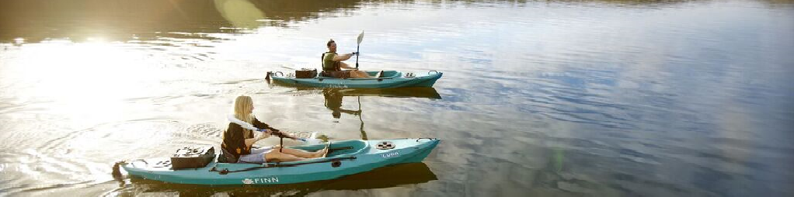

The Victorian Budget 17/18 provides important funding to ensure we protect our native plants and animals through our new biodiversity plan, provide educational opportunities for young people to engage in and learn about our environment, and improve our parks and reserves.

## Protecting Victoria’s biodiversity

**$86.3 million** over four years plus **$20 million** per year ongoing from the Sustainability Fund to implement Victoria’s new biodiversity plan. This includes:

* **$65.5 million** for targeted on ground biodiversity actions;
* **$5.8 million** for measuring and reporting on progress against targets;
* **$5.4 million** for native vegetation regulations reform and reporting;
* **$2.5 million** for marine environment targeted actions;
* **$2.5 million** for Flora and Fauna Guarantee Act reform implementation;
* **$2 million** for the Strategic Management Prospects decision support system;
* **$1.8 million** for new approaches for managing endangered species and our sensitive sub-alpine environments under climate change; and
* **$800,000** for intensive management of iconic plants and animals.

## Environment education opportunities – $5.8 million and $4.4 million

Our youngest Victorians will also benefit from the 2017-18 Budget, with **$5.8 million** over two years to continue the ‘Kids Free’ policy for zoos and **$4.4 million** over two years to continue and expand the ResourceSmart Schools program to assist schools to embed sustainability in everything they do.

## Improving our parks and reserves - $54.6 million

**$54.6 million** will improve our parks and reserves so they sustain and grow Victoria’s regional visitor economies, improve the health of our ecosystems and conserve Aboriginal and historic cultural heritage. It includes:

* **$31.8 million** over four years and **$1.5 million ongoing** to unlock the benefits of parks for all Victorians. Of this:
* Parks Victoria will receive **$23.7 million** in output funding over four years to strengthen frontline service delivery, as well as **$8.1 million** in asset funding to improve business and asset management systems and enhance communication and education programs to:
  + - ensure safe and equitable community access to parks and the benefits they provide;
    - sustain and grow regional visitor economies;
    - improve ecosystem health and provision   
      of ecosystem services; and
    - conserve Aboriginal and historic cultural heritage; and ensure Traditional Owners are meaningfully engaged in the management of Country.
* **$22.8 million** over two years to enhance Victoria’s liveability through improvements to the parks and reserves estate, specifically:
* **$20.5 million** provided for the delivery of three new parks in Cranbourne, Werribee and Kororoit Creek; and
* **$2.3 million** provided to protect the Anglesea Heath.

## Towards a healthy and resilient marine and coastal future - $7.2 million

**$7.2 million** over two years to improve the management of Victoria’s marine and coastal environments.

This funding provides:

* **$2 million** to continue grants to coastal   
  Crown land managers to address risks to public safety on coastal land;
* **$2 million** to enable volunteer involvement, including boosting the Coastcare program and its Summer by the Sea and community grants components;
* **$1.8 million** for asset maintenance of critical coastal protection assets, such as beaches, groynes and seawalls;
* **$1.1 million** for additional measures that   
  will support marine and coastal health; and
* **$300,000** for greater traditional owner involvement in planning and management.

## Creating jobs

**200 direct jobs** (50 per year) and **1600 indirect jobs** (400 per year).are expected to be created from the **$65.5 million** for on ground biodiversity actions.

Up to **60 full time positions,** will be created from the Parks Victoria funding.

**5.5 full time positions** will be created from   
the $7.2 million marine and coastal funding.

## Building on momentum

This funding builds on 2016-17 Budget of **$54 million** over four years for initiatives that deliver on-ground action to improve our environment including:

* support for on-ground action and projects   
  by community groups and a boost to the Victorian Landcare Program in its 30th year;
* weed and pest control in priority areas including on public land and in peri-urban areas; and
* working with Trust for Nature to protect and rehabilitate private land.

The 2016-17 Budget also provided **$20 million** over four years in capital funding for Parks Victoria to undertake works to renew critical infrastructure and meet visitor needs in Victoria’s parks.

In addition to the funding provided in the 2016-17 Budget, **$15 million** was provided to help Parks Victoria to manage critical risks in their facilities and services and support routine operating costs.

## Find out more

Keep up to date on key environment initiatives   
at [www.environment.vic.gov.au](http://www.environment.vic.gov.au)

As grant programs open, information will be available at www.delwp.vic.gov.au/grants

|  |  |
| --- | --- |
| © The State of Victoria Department of Environment, Land, Water and Planning 2017  LogoThis work is licensed under a Creative Commons Attribution 4.0 International licence. To view a copy of this licence, visit http://creativecommons.org/licenses/by/4.0/ |  |