Aboriginal cultural heritage and Traditional Owner rights

  - Good Governance Fact Sheet No. 1
  - for Committees of Management
  - of Crown land reserves in Victoria

DELWP is committed to Aboriginal self-determination, cultural safety, and working in partnership with Traditional Owners and Aboriginal Victorians

Traditional Owners and care for Country: DELWP website information
Victoria has a strong and proud Aboriginal history, comprising of complex ownership and land stewardship systems stretching back many thousands of years. It is important for all committees of management to be well-informed about Aboriginal self-determination, cultural safety and working in partnership with Traditional Owners and Aboriginal Victorians, including:

- Aboriginal cultural heritage
- Native Title and Traditional Owner Rights, including Recognition and Settlement Agreements (RSAs)
- Treaty (or treaties) and the Yoo-rrook (truth) Justice Commission

A key starting point for information is the Aboriginal Self-Determination section of the DELWP website. It includes links to various resources, such as “DELWP’s Traditional Owner and Aboriginal Community Engagement Framework”. The Framework emphasises:

- “ … the deep spiritual connection Traditional Owners have to their Country, as well as an acknowledgement of the significant responsibility DELWP has as a land and natural resource manager to support self-determination and create opportunities for Traditional Owners to care for Country … “

The DELWP website also includes Pupangarli marnmarnepu ‘owning our future’: DELWP’s Aboriginal Self-Determination Reform Strategy 2020-25.

Aboriginal Cultural Heritage Fact Sheets published by Aboriginal Victoria
Throughout Victoria, even in the most intensively developed regions, the landscape holds the imprint of thousands of generations of Aboriginal people. During that time, the people living in these regions left physical evidence of their activities that now survive as cultural heritage places and objects.

Underpinning these material aspects of Aboriginal cultural heritage are intangible places where there may be no physical evidence of past cultural activities. These include places of spiritual or ceremonial significance, places where traditional plant or mineral resources occur, or trade and travel routes.

The Aboriginal Culture and Heritage section of the Aboriginal Victoria website includes a series of Aboriginal Cultural Heritage Fact Sheets on specific topics including:

- Aboriginal scar trees
- Aboriginal freshwater middens
- Aboriginal burials
- Aboriginal surface scatters
- Aboriginal rock art
- Aboriginal historical places

Communicating with Traditional Owners
It’s important for all committees of management to understand and appreciate the significance of Aboriginal cultural heritage in their local area and for their reserves, including local history and the laws and regulations for recording, protecting and managing Aboriginal cultural heritage.

All committees of management are encouraged to contact their local Traditional Owners to seek opportunities to learn about Aboriginal cultural heritage and partner with Traditional Owners on any land management requirements.

Traditional Owners in different areas of Victoria
For links to contact details of Victorian Traditional Owner groups, see:

- A map of formally recognised Traditional Owners* is available through the Welcome to Country and Acknowledgement of Traditional Owners section of the Aboriginal Victoria website.

* Note: Some areas of Victoria do not yet have a particular formally recognised Traditional Owner group. For cultural heritage matters, Traditional Owner groups with responsibilities for managing and protecting Aboriginal cultural heritage under the Aboriginal Heritage Act 2006 are known as Registered Aboriginal Parties (see further details below). For areas not covered by a Traditional Owner/Registered Aboriginal Party, committees should seek advice from Aboriginal Victoria regarding engagement and heritage protection.

There are 3 ways in which the Victorian Government formally recognises Traditional Owners of a particular Country:

- Registered Aboriginal Party – Aboriginal Heritage Act 2006. The Victorian Aboriginal Heritage Council can appoint a Traditional Owner corporation as a Registered Aboriginal Party under the Aboriginal Heritage Act. Registered Aboriginal Parties (RAPs) are responsible for managing Aboriginal cultural heritage within their appointed areas. See: a list of Victoria's current Registered Aboriginal Parties on the Aboriginal Heritage Council website.

- Native Title Determination – Native Title Act 1993 (Cth). Native title is a bundle of rights, including property rights, held by Aboriginal and Torres Strait Islander peoples under their traditional laws and customs, which pre-dates colonisation and is recognised by Australian law. Native title applies to public land and waters, except where native title has been ‘extinguished’. Native title is determined by the Federal Court of Australia or, on appeal, by the High Court. See: Native Title section of the DELWP website.

- Recognition and Settlement Agreement – Traditional Owner Settlement Act 2010. The Traditional Owner Settlement Act provides a framework for the recognition of Traditional Owner rights and settlement of native title claims in Victoria. Recognition and Settlement Agreements apply to public land and waters, with some exceptions. See: Traditional Owner Settlement Act 2010 section of the DELWP website. This page includes a summary of the interaction with the Native Title Act 1993 (Cth) and a link to details of Current Agreements with Traditional Owners.

Treaty (or treaties)
A treaty is an agreement between states, nations or governments. This can include an agreement between Indigenous peoples and governments. The Victorian Government is working toward a treaty or treaties with Aboriginal Victorians. The treaty section of the Aboriginal Victoria website explains that:

- “Treaty is an opportunity to recognise and celebrate the unique status, rights, cultures and histories of Aboriginal Victorians. It's an opportunity to address wrongs and redefine relationships between the State, Aboriginal Victorians and non-Aboriginal Victorians.”

Truth telling, truth listening and the Yoo-rrook Justice Commission
The Truth and Justice section of the Aboriginal Victoria website explains that:

- “In pursuing treaty, the government is committed to acknowledging the truth of Victoria’s history and laying the foundations for new, positive relationships between the State, Aboriginal Victorians and non-Aboriginal Victorians.”

The Victorian Government has established the Yoo-rrook Justice Commission as the nation’s first truth-telling process. Yoo-rrook is the Wemba Wemba / Wamba Wamba word for truth. The Yoo-rrook Justice Commission will investigate both historical and ongoing injustices committed against Aboriginal Victorians since colonisation by the State and non-State entities, across all areas of social, political and economic life. In doing so, the Commission will engage Victoria’s Aboriginal and non-Aboriginal community to achieve its aims of truth telling and truth listening.

For more information, see the Truth-telling section of the website of the First Peoples’ Assembly of Victoria.

The Aboriginal Heritage Act 2006 and the Victorian Aboriginal Heritage Register
The Aboriginal Heritage Act 2006 provides for the protection of Aboriginal cultural heritage in Victoria. It covers all types of land tenures, including Crown land. For further details, see the Aboriginal Heritage Legislation section of the Aboriginal Victoria website. This page includes a link to the Victorian Aboriginal Heritage Register, a register of Aboriginal places and objects.

Many thousands of Aboriginal objects and places have been recorded on the Register. For advice on accessing the Register, consult the Victorian Aboriginal Heritage Register page on the Aboriginal Victoria website.

Much of Victoria’s landscape has not been surveyed for Aboriginal cultural heritage and as such, Aboriginal heritage places may be present that do not appear on the Register. Through contact with local Traditional Owners, committees of management should seek information about cultural heritage sites on the reserves they manage that may not yet have been included on the Register.

Before proceeding with any development work or other activities that disturb the ground or vegetation in a way that could impact on Aboriginal cultural heritage, committees of management must ensure that any approvals required under the Aboriginal Heritage Act 2006 and Aboriginal Heritage Regulations 2018 have been obtained. For details, see: Aboriginal Victoria website pages on Cultural heritage management plans, permits, agreements and tests.

Recognition and Settlement Agreements
A Recognition and Settlement Agreement (RSA) under the Traditional Owner Settlement Act 2010 can include:

- Land Agreement – formalises the handing back of parks and reserves of significance to the Traditional Owner group to be jointly managed with the State
- Land Use Activity Agreement – provides a simplified regime to guide consultation and negotiation with Traditional Owners for activities that have a substantial impact on Traditional Owner rights in public land within the agreement area
- Natural Resource Agreement – provides for access to, and sustainable use of, natural resources and Traditional Owner participation

See: Traditional Owner Settlement Act 2010 section of the DELWP website. This page includes a summary of the interaction with the Native Title Act 1993 (Cth) and a link to details of Current Agreements with Traditional Owners. Another DELWP page summarises all jointly managed land through the agreements.

All committees of management of Crown land reserves are expected to know the details of any Recognition and Settlement Agreement covering the geographic areas on or near the reserve and be aware of the committee’s responsibilities for working with Traditional Owners under the Agreement.

Contact with Traditional Owners and information from DELWP staff and Aboriginal Victoria
All committees of management are encouraged to be in contact with their local Traditional Owners to seek opportunities to learn about Aboriginal cultural heritage and partner with Traditional Owners on any land management requirements for their reserves. Communication with Traditional Owners will assist committees to understand and implement the requirements of legislation and agreements, including:

- The Aboriginal Heritage Act 2006
- Traditional Owner Settlement Act 2010

In addition to knowledge and understanding gained through communication with local Traditional Owners, committees can seek further information and advice from the First Peoples – State Relations Group of Aboriginal Victoria on 1800 762 003.

In relation to Traditional Owner rights under the Native Title Act or the Traditional Owners Settlement Act, when required, such as with processes for developing the reserve, or the consideration of a lease or licence, staff from DELWP regional offices are available to provide information and assist with any procedural rights assessment required. An enquiry to DELWP can also be lodged through the Crown Land Kiosk.

Mirring – Country: DELWP’s Aboriginal Cultural Identity

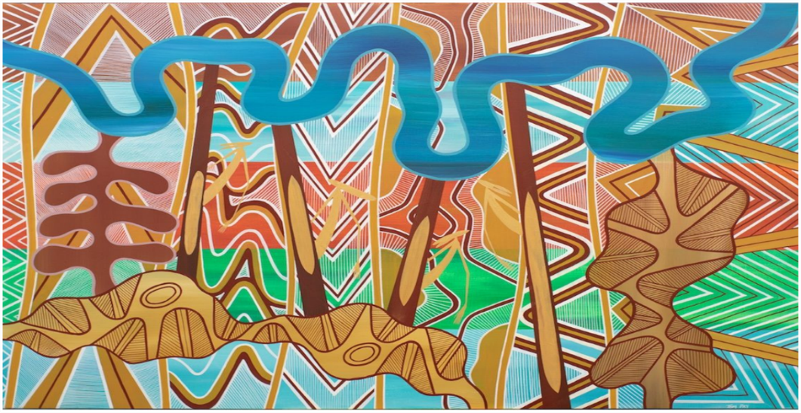

Mirring – Country: DELWP’s Aboriginal Cultural Identity, a commissioned piece created by artist Thomas Day, a Gunditjmara, Yorta Yorta and Wemba Wemba man.

This artwork is featured in various DELWP publications (including the cover of the Committee of Management Guidelines).

The Artist’s description in full:

“The painting depicts country.

“The background colours represent the landscapes with sea country at the bottom flowing into the forest and grasslands country then we see the desert country flowing into the wetlands and into the mountain country.

“The foreground designs represent scars that have been left within the landscape by our old people, serving as reminders but more importantly guides to show places of importance.

“The four scar trees represent the four directions of north, east, south and west with spirits peeking behind them. This represents our ancient connection and our inherent responsibility to protect country.

“The boldest designs represent what is visible to us today with the powerful river standing out, the other designs represent markings to signify ceremony.

“Each white line signifies our ongoing connection to country by representing our generations that is our bloodline.”

