delwp.vic.gov.au

Technical Report Series

|  |
| --- |
| Managing Climate Change Risk  Guidance for Board Members and Executives of Water Corporations and Catchment Management Authorities |
|  |
| June 2019 |

|  |  |
| --- | --- |
|  |  |

|  |  |  |  |
| --- | --- | --- | --- |
|  |  |  |  |
|  |  |  |  |

|  |
| --- |
| Acknowledgment  We acknowledge and respect Victorian Traditional Owners as the original custodians of Victoria's land and waters, their unique ability to care for Country and deep spiritual connection to it. We honour Elders past and present whose knowledge and wisdom has ensured the continuation of culture and traditional practices.  We are committed to genuinely partner, and meaningfully engage, with Victoria's Traditional Owners and Aboriginal communities to support the protection of Country, the maintenance of spiritual and cultural practices and their broader aspirations in the 21st century and beyond. |
| © The State of Victoria Department of Environment, Land, Water and Planning 2019  LogoThis work is licensed under a Creative Commons Attribution 4.0 International licence. You are free to re-use the work under that licence, on the condition that you credit the State of Victoria as author. The licence does not apply to any images, photographs or branding, including the Victorian Coat of Arms, the Victorian Government logo and the Department of Environment, Land, Water and Planning (DELWP) logo. To view a copy of this licence, visit <http://creativecommons.org/licenses/by/4.0/>  ISBN 978-1-76077-694-7 (pdf/online/MS word)  Disclaimer  This publication may be of assistance to you, but the State of Victoria and its employees do not guarantee that the publication is without flaw of any kind or is wholly appropriate for your purposes and therefore disclaims all liability for any error, loss or other consequence which may arise from you relying on any information in this publication. |

|  |
| --- |
| Managing Climate Change Risk  Guidance for Board Members and Executives of Water Corporations and Catchment Management Authorities |

June 2019

Acknowledgements

|  |  |  |  |
| --- | --- | --- | --- |
|  |  |  |  |

The input from water entities and other stakeholders during the development of these guidance notes is greatly appreciated.

Contents

Executive Summary 1

1. Introduction 2

1.1 Why has this Guidance Note been prepared? 2

1.2 Who does this Guidance Note apply to? 2

1.3 Overview of the Guidance Note 2

1.4 Disclaimer 2

2. Where does the obligation to manage the risks associated with climate change come from? 3

2.1 The legislative framework – managing risks to the delivery of an entity’s functions 3

2.2 What risks does climate change create? 4

3. What is the extent of a board member’s duty? 7

3.1 Functions of the board and functions of the entity 7

3.2 Managing the direct risks to the delivery of the entity’s functions 7

3.3 Managing risks across timeframes 8

3.4 Managing the indirect risks to the entity 8

4. How can board members discharge their duty with due diligence? 9

4.1 Checklist of key steps to be taken at board meetings 9

4.2 Detailed actions to be taken to address these risks diligently 9

5. How can entities plan and act when there is uncertainty? 11

5.1 Managing uncertainty 11

5.2 Scenario planning 11

5.3 Adaptation pathways 12

6. Further information 13

6.1 Climate Change information 13

6.2 Pilot Water Sector Climate Change Adaptation Action Plan 13

6.3 Water Sector Climate Change Adaptation Action Plan - for release in 2021 13

6.4 Training for water entity board members 14

7. Conclusion 14

8. Feedback 14

9. Appendices 14

# Executive Summary

This Guidance Note has been prepared to assist the members of the boards of Victoria’s water corporations and catchment management authorities (Victoria’s ‘water entities’) - and the senior executives reporting to those boards - in understanding the scope of their responsibilities in relation to climate change.

Whilst this Guidance Note does not create any obligations for board members and executives, it does provide a clear articulation of existing obligations and describes steps for effective decision making to assist in discharging those obligations. It also points to information available to assist board members and executives in discharging their responsibilities, including the actions being undertaken to deliver the *Pilot Water Sector Climate Change Adaption Action Plan* (Pilot Plan) released by the Minister for Water in 2018. This Guidance Note is one of the actions.

The members of the boards of Victoria’s water entities are required to set the strategic planning of the entities they preside over and to manage the affairs of the entity. They are also required to develop, implement and keep under review a risk management strategy (*Financial Management Act 1994* Section 44B). They are also required to inform the responsible minister and relevant department of “known major risks” to the “effective operation of the entity” and systems that it has in place to address those risks (*Public Administration Act 2004* Section 81). Water entities’ senior executives report to and advise boards in relation to their functions and responsibilities.

Water and catchment management is - in and of itself - an exercise in risk management. Climate change amplifies the spatial, temporal and volumetric risks to water supply, as well as risks to the infrastructure that stores, treats and transports water and removes waste water. Climate change also presents a range of risks to the health of our catchments, waterways, coasts and estuaries. This is in addition to a multitude of risks that indirectly affect them, such as the safety of staff working outside during increasing numbers of extreme weather events (including heatwaves) and emerging risks that will only arise as a consequences of climate change (such as the movement of townships or agricultural centres).

Water entities’ responsibilities in relation to climate change risk requires both immediate action and long-term planning. Given the uncertainty around climate change and its impacts, long-term planning is complex, and this Guidance Note provides some approaches to assist in that planning process.

In developing this Guidance Note, the Department of Environment, Land, Water and Planning (DELWP) extends a thank you to the board members and executives of Victoria’s water entities who have provided feedback on earlier drafts.

Please also note that DELWP will be providing development for board members to support the material provided in this document.

# Introduction

## Why has this Guidance Note been prepared?

In August 2018, the Hon Lisa Neville, MP, Minister for Water, released the *Pilot Water Sector Climate Change Adaptation Action Plan*.

Twenty actions are set out in the *Pilot Plan*. This Guidance Note has been prepared to deliver against Action 17: to develop and deliver guidance material for water industry boards and executives on climate change risks and duties of care.

## Who does this Guidance Note apply to?

This Guidance Note has been prepared for the board members of Victoria’s water corporations and catchment management authorities (‘water entities’) and for the senior executives who report to those boards. It sets out their duties in relation to climate change and describes the process to help discharge those duties with due diligence.

## Overview of the Guidance Note

This Guidance Note is broken up into four key sections:

* **Where the obligation to manage climate change risks comes from.** This section provides an overview of the legal framework which gives rise to the duty of water entity board members to manage risks that affect their statutory responsibilities. Climate change presents a risk to the delivery of a range of functions of water entities and, as a result, addressing this risk should be part of each board’s risk management profile.
* **The extent of a board member’s duty in relation to climate change.** The responsibility of boards to manage climate change risks arises in relation to the delivery of the entity’s functions. It follows that to manage climate change risks, board members must be clear about the functions of the entity they direct and the risks that climate change presents to delivering those functions. As a guide for board members, this note provides a general overview of the:
  + functions of water entities, and
  + types of risk climate change poses to the delivery of those functions - both positive and negative.
  + **How board members can discharge their duties with due diligence.** Once board member obligations in relation to climate change are understood, the next key question is: ‘*What process do you step through to discharge your duty with due diligence?*’ This Guidance Note sets out processes that can be used to manage climate change risk. It is important to note that the members of a board are not required to deliver the functions of the entity directly, but to ensure that those functions are strategically planned for and managed by the entity. This includes oversight of risk management.
  + **How entities can plan and act when there is uncertainty.** While the science shows that climate change is happening, what remains uncertain is the extent and impact this change will have on the delivery of each water entities’ functions into the future. This Guidance Note provides reference materials and proposed methodologies to assist board members to discharge their duties with due diligence given the uncertainty around climate change.

## Disclaimer

While this document refers to legislative and other legal frameworks, it is not legal advice. This Guidance Note has been prepared as a practical guide to assist members of water entity boards understand the extent of their responsibilities in relation climate change and to describe a process that can be used to discharge that responsibility. Where an entity requires legal advice in relation to any matters arising in this Guidance Note, they are encouraged to seek that advice. In addition, each entity must consider their own circumstances in effectively discharging their obligations. This Guidance Note is provided for general guidance only.

# Where does the obligation to manage the risks associated with climate change come from?

## The legislative framework – managing risks to the delivery of an entity’s functions

Victorian water entities perform their functions in compliance with a range of statutory responsibilities, including those set out in the:

* *Public Administration Act 2004*
* *Financial Management Act 1994*
* *Water Industry Act 1994*
* *Water Act 1989*
* *Catchment and Land Protection Act 1994*
* *Climate Change Act 2017, and*
* *Emergency Management Act 2013[1]*

The duties of public sector boards in relation to risk are set out in the *Public Administration Act 2004[2] and the Financial Management Act***[3]***.* Under this framework, risk management is a clear accountability for board members of water entity boards and the executives of those organisations. As a result, the board members of public-sector entities - and water entities more specifically - **must manage the risks to their ability to deliver against their functions.**

In addition, under each of the *Water Act 1989*, *Water Industry Act 1994*, and *Catchment and Land Protection Act 1994,* the responsible Minister can issue a Statement of Obligations specifying the obligations that the water authorities or catchment management authorities have in relation to their statutory functions. Boards are required to comply with these obligations, which currently includes a requirement around climate change.

A memorandum of opinion[4] prepared by Noel Hutley, Senior Counsel and Sebastian Hartford-Davis (the “Hutley opinion”)[5] was made public by the Centre for Policy Development and Future Business Council in 2016 and which was updated again in 2019[6]. This opinion found a clear duty of care for Australian company directors in relation to climate change. Hutley’s opinion is that:

* climate change risks would be regarded as foreseeable by courts, and relevant to a director’s duty of care and diligence to the extent that those risks intersect with the interests of the company (for example, by presenting corporate opportunity or risks[7] to the company or its business model).
* company directors are not legally restricted from taking into account climate change and related economic, environmental and social sustainability risks, where those risks are, or may be, material to the interests of the company.
* company directors certainly can, and in some cases should, be considering the impact on their business of climate change risks: directors who fail to do so now could be found liable for breaching their duty of care and diligence in the future.

In other words, the risks arising from climate change are real and foreseeable and give rise to a duty for Australian company directors to manage those risks with due diligence.

The text in the box titled “risk management” (below) is an extract the Victorian Public Sector Commission website and summarises the role of public entity boards – including water entities – in relation to the risk. This site sets out in detail the director responsibilities in relation to risk management strategies.[8]

Risk Management

**Extract from the VPSC website**(<https://vpsc.vic.gov.au/governance/board-obligations/risk-management/>: Please refer to the Minister for Finance’s **mandatory Victorian Government Risk Management Framework** for details https://www.dtf.vic.gov.au/sites/default/files/document/VGRMF%20-%20July%202018%20update_0.pdf)

A public entity board must comply with statutory obligations under the legislation that affects it, relevant government policies and ministerial directions.

A board should also develop and approve a risk management plan suited to the size and needs of the public entity and its risk profile. It must inform the responsible minister of major risks to the public entity and the applicable risk management procedures in place to mitigate them.

## What risks does climate change create?

Traditionally, the public sector has used the terms “mitigation” and “adaptation” to describe their responsibilities in relation to climate change: you *mitigate* the impact of your functions on climate change by reducing your own emissions[9] and you *adapt* to future predicted climate changes by adapting your infrastructure and management approaches to the actual or expected climate and its effects[10]. However, the Hutley opinion has structured the responsibility of board directors around taking action to address:

* **Physical Risks**, and
* **Transition Risks**.

This terminology has been adopted across the private and public sectors[11] and is used in this Note to describe water entities’ duties in relation to climate change risks.

### Physical Risks

Hutley’s opinion described the physical risks as those risks that arise due to changing weather events (such as flooding, rising sea levels, and extreme heat) and states that a director of an entity is responsible for foreseeing, adapting or mitigating certain *effects* of these risks. Hutley’s opinion is that a board member must:

1. **be vigilant** – monitor if there is there a foreseeable risk to the interests of the organisation from changing weather patterns, and
2. assess the ability of the entity to deal with increasing occurrences of changing weather events – including such things such as the loss of power supply.

How board members, with the support of senior executives, can approach that is detailed in Section 5.

Climate Change Hazards – “Physical Risks”

**Summary from the Water Sector Pilot Climate Change Adaptation Action Plan**   
(https://www.climatechange.vic.gov.au/victorias-climate-change-framework?_ga=2.216563153.615413939.1559000242-1808771345.1542859861)

The Water Sector Pilot Climate Change Adaptation Action Plan listed the physical risks likely to affect the water agencies to include:

temperature increases more heatwaves

lower average rainfall more droughts

more intense rainfall more flash floods

more storm events impact on assets / infrastructure / staff

more bushfire weather impacts on water quality (post fires and blue-green algae)

sea level rises reduced snow melt

The potential impact of these physical changes on the ability of water agencies to perform the statutory functions is also set out in the Pilot Adaptation Action Plan.

### Transition Risks

Hutley’s opinion used the term “transition risk” to describe the “indirect financial risks that might arise from the transition to a lower carbon economy” (which may or may not occur in unpredictable ways) and listed these risks to include:

* changes in regulatory policy (e.g. moving to zero emissions, see paragraphs below)
* technological innovation (e.g. advances in energy storage efficiency)
* social adaptation (including changing consumer preferences – which might include changes to where people live);
* changes to energy, land-use, urban and infrastructure (including transport and buildings) and industrial systems; and
* climate-related litigation relating to the failure of organisations to mitigate impacts of climate change, failure to adapt to climate change, and the insufficiency of disclosure around material financial risks.

Hutley opined that board members need to consider the impact of transitional risks on actions planned to be taken by the organisation and to assess the impact of these risks on the ability to deliver projects into the future.

Water corporations have seen one of the transition risks Hutley describes. The Victorian Government’s water policy “Water for Victoria” (2016) commits water corporations to demonstrating a pathway to net-zero emissions and to pledge an interim emission reduction target to be achieved by 2025. The latter was formalised by the Minister for Water via the *Statement of Obligations (Emissions Reduction)* issued in March 2018.

### Opportunity Risks Arising from Transition

By taking action to reduce emissions there may be attendant opportunities - or benefits - to the water sector. For example, by understanding and managing energy use, water entities may be able to cut operating costs and/or reduce energy supply disruptions. More energy efficient equipment (e.g. pumps, lighting, and vehicles) and investment in clean energy, may also help reduce the risk of increasing energy costs. In terms of office-based operations, upgrading buildings’ thermal performance may increase protection from climate impacts (e.g. increased and more numerous hot days) and also make staff more comfortable, healthy and productive. In addition, being progressive on climate change adaptation may provide an opportunity to export water related technologies and policy reform around the world.

Transition Risks

**Extract from Victoria’s Climate Change Framework  
(**[**https://www.climatechange.vic.gov.au/victorias-climate-change-framework?_ga=2.216563153.615413939.1559000242-1808771345.1542859861**](https://www.climatechange.vic.gov.au/victorias-climate-change-framework?_ga=2.216563153.615413939.1559000242-1808771345.1542859861)**)**

**Our approach to climate change action:** To achieve our vision for Victoria in 2050, we need to reduce our emissions and prepare for the impacts of climate change. The most effective way of doing this is to all work together, to share our knowledge and experience, and to form partnerships to drive further action.

**Driving emissions reductions:** There are many ways we can reduce emissions. In Victoria, four pillars underpin our transition to net zero emissions while maintaining economic prosperity:

* Increase energy efficiency and productivity across the economy, including in our homes, offices, industry and transport.
* Move to a clean electricity supply by increasing renewable energy generation.
* Electrify our economy and switch to clean fuels by increasing the use of electricity to power our homes, cars and public transport and using biofuels and gas in freight, air travel and industry.
* Reduce non-energy emissions and increase carbon storage through industrial processes improvements and improving carbon storage in trees, plants and soil.

# What is the extent of a board member’s duty?

## Functions of the board and functions of the entity

The role of the members of a board of an entity is separate from the role of the entity itself. Under both the *Catchment and Land Protection Act 1994* (Section 16) [12] and the *Water Act 1989* (Section 95), the boards of the entities are responsible for:

* strategic planning of the entity, and
* managing the affairs of the entity, including ensuring the performance of the functions and carrying out of the duties of the entity.

In this respect, the members of a board are not required to deliver the functions of the entity directly, but to ensure that those functions are strategically planned for and managed by the entity. This includes oversight of risk management.

## Managing the direct risks to the delivery of the entity’s functions

The scope of the duty to address the risks arising from climate change extends to the responsibilities of a board member of a water entity set out in the enabling legislation and specified in the Statement of Obligations.

The core functions of catchment management authorities and water corporations are set out in the *Catchment and Land Protection Act 1994* and the *Water Act 1989*. As of 2019 these may include, but are not limited to:

|  |  |
| --- | --- |
| Water corporations | Catchment management authorities |
| * water supply services | * Regional planning and coordination e.g. through the preparation of regional catchment strategies and waterway strategies |
| * sewerage services | * prepare special area plans |
| * trade waste and related services | * provide guidance on land-use conditions |
| * waterway management | * waterway management |
| * drainage (regional) | * drainage (regional) (limited responsibilities) |
| * floodplain management | * floodplain management |
| * irrigation | * integrated catchment management |
| * licensing | * promote community awareness of the importance of land and water resources, their sustainable use, conservation and rehabilitation |
| * salinity mitigation services | * make recommendations on the funding for the implementation of catchment management strategies and special area plans |
| * recreational area management | * emergency management, particularly as it relates to flooding |
| * water storage management | * Coordinate, support and report on Landcare and other community based natural resource activities across its region |
| * water metering | * promote the co-operation of land and water management |
| * emergency management |  |

***The objective of water entity is to deliver these functions. The obligation in relation to climate change arises in relation to the risks to the delivery of the relevant entity’s functions.***

Climate change risk will amplify existing risks to the entity (such as increased preparedness to physical risks such as flood and fire, and changing approaches to energy due to transition risks) and create new, unexpected risks (such as the movement of human settlements). For this reason, it is likely that water entities will report climate change risk as an element of its existing risks as well as a stand-alone risk.

## Managing risks across timeframes

The responsibility of a board member to manage the risks associated with climate change may extend beyond the direct term of their position on the board of that entity.

Water corporations are required to plan intergenerationally and “*need to ensure that water resources are conserved and properly managed for sustainable use and for the* ***benefit of present and future generations***” (section 93(a), *Water Act 1989,* emphasis added). The Act also requires water corporations to *“integrate both long term and short term economic, environmental, social and equitable considerations*” (section 93(c)). As the effects of climate change increase over time, this will require boards of water corporations to consider the long-term future impacts of climate change in the decisions they make now. This is supported by the terms of the Statement of Obligations for water corporations which requires consideration of climate change in their Water Strategies across a 50-year planning horizon (2015 clauses 6-1 and 6-2).

Similarly, the objectives of the *Catchment and Land Protection Act 1989* include maintaining and enhancing “long-term” land productivity.[13] This objective creates a long-term perspective on the role of Catchment Management Authority boards.

As a result, management of the functions of water entities includes enabling the delivery of those functions into the future and beyond the timeframe of a member’s position on the relevant board.

## Managing the indirect risks to the entity

In addition to the direct risks that climate change will present to the delivery of the entities’ functions, climate change is likely to create other less direct risks to water entities, such as risks to:

* the health and safety of staff – i.e. staff working in hotter conditions and driving during flash floods
* financial management – as the costs of inputs may rise due to the physical or transitional risks of climate change (e.g. the cost of energy)
* staff responding to increased emergency management incidents – the accumulated toll on staff including health and safety as well as the economic, social, reputational, legal and environmental consequences
* insurance – increasing costs due to the impact of increasing extreme weather events on infrastructure and systems
* inter-dependency risks disruption to supply chain that impacts the delivery of water entity services e.g. fuel, electricity, chemicals

These risks will also require consideration and management by water entity board members.

# How can board members discharge their duty with due diligence?

## Checklist of key steps to be taken at board meetings

The Hutley opinion emphasises that directors must be proactive and inquisitive and obtain advice from management or experts where required. This requires a robust process of information gathering and deliberation with independent judgement brought to bear in a process of critical elevation of contemporary information (including advice from management and/or independent experts as required).

A useful framework that can be used by board members of water entities (and senior executives) to assist in discharging their responsibilities in relation to climate change is the Five Es[14]:

* **Educate** - maintain a credible core of contemporary knowledge of the water entity’s operations, finance position, regulatory environment and broader industry context. This must be continuous and dynamic in the context of evolving norms.
* **Enquire** - of both management and independent experts with appropriate experience and expertise.
* **Examine** - the information provided (which should be in a form that is comprehensive, but relevant and digestible).
* **Evaluate** - the issue at hand critically. Actively apply independent judgement to the issue, weighing all relevant facts and fair criteria, in good faith and for proper purposes.
* **Express** - your view constructively.

The satisfaction of their duties, diligence and skill will be unique to the size, resources and functions of each entity, and the circumstances in which relevant decisions arise.

## Detailed actions to be taken to address these risks diligently

The steps to discharging the obligation to manage climate change related risks is undertaken in the same way as the process to address any risk, and can be summarised as follows:

* **Good governance**, which requires that board members:
  + discuss the risk at the board level – identify, then assess, manage and monitor the risk
  + divulge any conflict of interests in relation to the risk
  + seek information on both physical and transitional risks from qualified staff or consultants
  + document advice; and
  + synthesise information
* **Strategy, financial planning and material risk management**, which requires that directors consider:
  + what are the foreseeable risks?
  + what is the materiality of the risk?
  + how do we stress test the risk?
  + how do we plan for a range of scenarios?
  + what is our policy?
  + what is our target?
  + how do we test our assumptions over time? What are the triggers for changing strategy?
  + what are the insurance impacts?
* **Risk management oversight**, which requires that board members discuss and assess:
  + what are the variables – what are the metrics, what are the assumptions? how do we prioritise?
  + how do we engage stakeholders, employees, and customers on climate change?
  + how do we influence stakeholders, employees and customers to act based on the information provided to them, especially if they have a different perception of our climate change risk and policies?
* **Communication of plans and projects** which includes ensuring that relevant matters are reported in:
  + Annual reports
  + Corporate Plans
  + Financial statements
  + Emissions targets reports, and
  + Public statements – i.e. Public disclosures of risks[15]
* **Seek and assess reports on progress of the delivery of actions** which requires requesting reports and updates from senior executives.
* **Review effectiveness of actions** which requires both data and personal judgement
* **Seek new information,** and
* **Repeat the cycle**

A clearly documented decision-making process for managing the risks arising from climate will also assist in protecting the reputation of water entities, as it will demonstrate that due diligence was applied in discharging the duty to manage climate change risks.

# How can entities plan and act when there is uncertainty?

## Managing uncertainty

Risk is defined as “the effect of uncertainty on objectives”[16]. Managing risk is about managing the uncertainty. An “effect” is a deviation from the expected which can be either negative (threat risk) or positive (opportunity risk). The Task Force on Climate Related Financial Disclosure[17] (TCFD) lists both threats (which the TCFD calls “risks”) and opportunities in relation to climate change; a sample of which is provided at Appendix B.

Uncertainty within the context of climate change arises because:

1. The rate of greenhouse gas emissions over the coming years is unknown (as actions to curb emissions is led by the governments of sovereign states which change, and the adoption of new technology, which is unpredictable) and the consequential extent of climate change is also unknown, especially in the long-term,
2. our understanding of the effects of climate change is based on models, which are based on hypothesis and which are inexact, and
3. the link between changes in the climate (the tipping points and feedback loops) adds an additional layer of uncertainty to predicting climate futures.

Imperfect information and uncertainty, however, is an insufficient reason for inaction: the boards of water entities are still required to make decisions when information is incomplete, so long as the board has endeavoured to have as much information before it as is reasonably possible in the circumstances. This is often referred to as the “Precautionary Principle” and is widely applied in environmental science as a common-sense approach that avoids unreasonable delays in taking action to prevent serious or irreversible harm to the environment.[18]

There are a number of approaches than can be used to manage uncertainty. Scenario planning and adaptation pathways are two options which are discussed in more detail below. Australian Standard AS 5334:2013 *Climate change adaptation for settlements and infrastructure – a risk-based approach* also provides a useful framework for assessing long term risks often associated with climate change.

## Scenario planning

The TCFD defines scenario analysis as a means of evaluating *“a range of hypothetical outcomes by considering a variety of alternative plausible future states (scenarios) under a given set of assumptions and constraints”.*

Scenarios[19] are neither forecasts nor predictions that provide a full description of the future but are - instead - hypothetical constructs which can be qualitative (relying on descriptive narratives) or quantitative (relying on numerical modelling) or a combination of both.

The TCFD proposes that scenarios have the following characteristics:

* **plausible**: the events in the scenarios should be possible and the narrative credible.
* **distinctive**: each scenario should focus on a different combination of key factors. Multiple scenarios should be used to explore how different permutations and/or temporal development of the same key facts can yield very different outcomes.
* **consistent**: each scenario should have strong internal logic. The goal of scenario analysis is to explore the way that factors interact, and each action should have a reaction.
* **relevant**: each scenario (and set of scenarios) should contribute insights into the future that relate to strategic and/or financial implication of climate-related risks and opportunities.
* **challenging**: scenarios should challenge conventional wisdom and simplistic assumptions about the future. Scenarios should try to explore alternatives that will significantly alter the basis for business-as-usual assumptions.”

The Guidelines for Assessing the Impact of Climate Change on Water Supplies in Victoria provide four plausible future climate scenarios. Three of these scenarios (low, medium and high climate change scenarios) were developed by CSIRO based on the RCP8.5 emissions scenario (as presented in Section 3 of the Guidelines). The fourth scenario represents a step-change in the climate.[20]

DELWP will continue to revise and review the use of climate change scenarios which water entities can use for planning and risk management.[21]

## Adaptation pathways

To reduce the likelihood of maladaptive decision-making in preparing for climate change, planning for multiple adaptation pathways – or futures – is being developed as a decision-making tool.

RMIT University has been working with the Goulburn Broken Catchment Management Authority and the Corangamite Catchment Management Authority to describe a process for developing adaptation pathways for natural values managers.[22] The text box “Adaptation Pathways” provides an extract from that work.

Adaptation Pathways

**Extract From: Exploring ‘Adaptation Pathways’ planning through an NRM lens: RMIT University, Centre for Urban Research, Karyn Bosomworth et al, August 2018  
(http://cur.org.au/cms/wp-content/uploads/2018/09/exploring-adaptation-pathways-compressed.pdf)**

“The future is uncertain, so multiple future visions need to be explored and discussed. Visions are statements of what we’re hoping for in the long term. We write a vision or visions to communicate to others what we are trying to achieve and to provide boundaries for the plan’s actions. A long-term vision or the parallels between multiple visions is an anchor point for the plan and therefore can be used to guide actions and communicate with a broader audience (Roorda et al. 2014). The envisioning process is crucial to allow participants to get out of the ‘dictatorship of the present’ and encourage them to develop and exchange perspectives on the future. The process should enable individuals to gain a sense of opportunity (and hope), as they imagine themselves playing an active role in the envisioned future (Roorda et al. 2014).

It is important to emphasise that visions are unlikely to remain static. A vision should be a values-rich story that continues to evolve as people experience their emerging future and reprioritise their values over time (Meadows, 1994). It is also worth encouraging people to work with a vision that does not have to be perfectly word-smithed; it can be a collection of words, a diagram a single word, or a statement, around which the planning team can develop a narrative”

In addition, the Water Services Association of Australia (WSAA) released Climate Change Adaptation Guidelines (“the Guidelines”) in 2016. The Guidelines were designed to help water entities with all stages of the adaptation process, from initial appreciation of the issues, through to the implementation, monitoring and improvement of response actions. A summary of the approach described by the WSAA is included in Appendix C.

# Further information

## Climate Change information

Information that is currently available on climate change includes, but is not limited to:

* Victoria’s Climate Change Adaptation Action Plan 2017-2020, DELWP[23]
* The Guidelines for Assessing the Impact of Climate Change on Water Supplies in Victoria, DELWP, provide future climate scenarios and projections for long term rainfall, runoff and inflows (note the Statement of Obligations for water corporations 2015, requires water corporations to comply with the guidelines as issued by DELWP, as does the Minister’s Letter of Expectations)[24]
* Australian Standard AS 5334:2013 Climate change adaptation for settlements and infrastructure – a risk-based approach
* Climate Change Adaptation Guidelines 2016, Water Services Association of Australia (WSAA), developed specifically for the Australian water sector (see adaptation decision framework in Appendix 3)
* Victorian Climate Initiative, DELWP, CSIRO and the Bureau of Meteorology[25]
* Australian Climate Futures, projections for Australia’s NRM regions, Commonwealth government[26]
* Climate change and variability, Bureau of Meteorology website, Australian Government
* CoastAdapt website, commissioned by the Australian Government via the National Climate Change Adaptation Research Facility (NCCARF)[27]
* Sustainable water strategies prepared by DELWP under the *Water Act 1989* (Vic)
* Water Resource plans in the Murray Darling Basin, prepared by DELWP in accordance with the *Water Act 2007* (Cth)
* Urban Water Strategies, prepared by Water Corporations, under the *Water Act 1989*
* Regional catchment strategies prepared by CMAs under the *Catchment and Land Protection Act 1994*
* Regional Natural Resource Management Climate Change Strategies and Plans prepared by CMAs[28]

## Pilot Water Sector Climate Change Adaptation Action Plan

The Pilot Water Sector Climate Change Adaptation Action Plan released by the Minister for Water in 2018 includes 20 actions to enable the water sector to adapt to climate change. The delivery of those actions is to take place between September 2018 and December 2020. This work is being undertaken to improve the collective knowledge on the risks associated with climate change which can be integrated into water entities’ decision-making processes. Until these projects are completed, however, water entities will be expected to exercise due diligence in determining the best course of action. See Appendix E for the list of actions in the Pilot Plan.

## Water Sector Climate Change Adaptation Action Plan - for release in 2021

DELWP is commencing preparation of the statutory water sector Climate Change Adaptation Action Plan which the *Climate Change Act 2017* requires be finalised by October 2021.Consultation will be undertaken with water entities in the development of the final Plan and actions to further improve the ability of water entities to discharge their duty to manage the risk of climate change will be included.

## Training for water entity board members

The Victorian Public Sector Commission offers a number of modules for board members which are designed to help them discharge their duty of care with due diligence. All board members are encouraged to participate in these modules including the modules on:

* Decision Making
* Directors’ Duties and Responsibilities
* The board’s Legal Environment
* Risk – Issues for the board
* Strategy – The board’s role

In addition, DELWP will provide a director development session for the directors of all water entities in early 2020.

# Conclusion

Climate change presents risks – both threats and opportunities – to the delivery of water entity services. To quote Noel Hutley SC in his 2019 supplementary memorandum of opinion:

*“There are, at the present time, significant and well-publicised risks associated with climate change and global warming that would be regarded by a Court as foreseeable. Such risks require engagement from company directors in affected sectors, particularly in (at least) the banking, insurance, asset ownership / management, energy, transport, material/buildings, agriculture, food and forest product industries.*

*It is apparent that regulators and investors now expect much more from companies than cursory acknowledgement and disclosure of climate change risks. In those sectors where climate risks are most evident, there is an expectation of rigorous financial analysis, targeted governance, comprehensive disclosures and, ultimately, sophisticated corporate responses at the individual firm and system level. The effect of regulatory and investor intervention is that large scale firms will be expected to invest seriously in capabilities to monitor, manage and respond to climate change risks.*

*As time passes, it is increasingly obvious that climate change is and will inevitably affect the economy, and it is increasingly difficult in our view for directors of companies of scale to pretend that climate change will not intersect with the interests of their firms. In turn, that means that the exposure of individual directors to “climate change litigation” is increasing, probably exponentially, with time.”*

# Feedback

The input from water entities and other stakeholders during the development of these guidance notes is greatly appreciated. Please address any ongoing feedback to Annabel Moony, Senior Manager, Sector Governance, Water and Catchments (Annabel.Moony@delwp.vic.gov.au).

# Appendices

1. Reference material and recommended reading
2. TCFD climate-related threats and opportunities
3. WSAA climate change adaptation decision framework
4. Victorian water corporations’ risk management framework
5. Pilot Water Sector Climate Change Adaptation Action Plan – List of Actions
6. Reference material and recommended reading

**The obligation to manage risks associated with climate change**

**Public and Private Sector Accountabilities**

* The Centre for Policy Development and The Future Business Council “Climate Change and Directors’ Duties” memorandum of option, Mr Noel Hutley SC and Mr Sebastian Hartford-Davis for Minter Ellison, Solicitors, 7 October 2016, and Supplementary Memorandum of Opinion, 26 March 2019
* Taskforce on Climate Related Financial Disclosures – final Report Recommendations of the Task Force on Climate-Related Financial Disclosures – June 2017
* Centre for International Climate Research, Climate Finance which sets out the “shades of climate risk” and which categorizes climate risks for investors.[29]
* Public Authority Directors’ Duties and Climate Change: Managing the latent financial and governance risks discussion paper. Centre for Policy Development, January 2019[30]

**The extent of a directors’ duty of care in relation to climate change**

**Water Entity Specific Responsibilities:**

* Project Report, Climate Change Adaptation Guidelines, Water Services Association of Australia, 2016

**Exercising due diligence**

**Conduct of directors:**

* Code of Conduct for Directors of Public Entities, Victorian Public Sector Commission
* Board Obligations – Victorian Public Sector Commission
* Victorian Public Sector Commission training:
  + Public Sector Individual decision making – the issue of complexity, the importance of complex thinking skills, improving individual decision making
  + Collective decision making – director behavioural types and board decision making, dealing with ‘difficult’ people, traps in collective decision making, tools for improving collective decision making

**Working in uncertainty (i.e.: managing risk)**

**Climate Change Scenarios**

* Global Warming of 1.5ᵒC, Summary for Policy Makers, Intergovernmental Panel on Climate Change,
* Exploring ‘Adaptation Pathways’ planning through an NRM lens: RMIT University, Centre for Urban Research, Karyn Bosomworth et al, August 2018
* What’s the problem in adaptation pathways planning? The potential of a diagnostic problem-structuring approach Karyn Bosomworth et al, Environmental Science and Policy journal 76, 2018
* Robust Decision-Making in the Water Sector – A strategy for implementing Lima’s long-term water resources master plan, Nidhi Kalva et al, World Bank Climate Change Group October 2015
* Using Scenarios to Explore Climate Change: A Handbook for Practitioners, National Park Service, U.S. Department of the Interior, Climate Change Response Program, July 2013

1. TCFD climate-related threats and opportunities

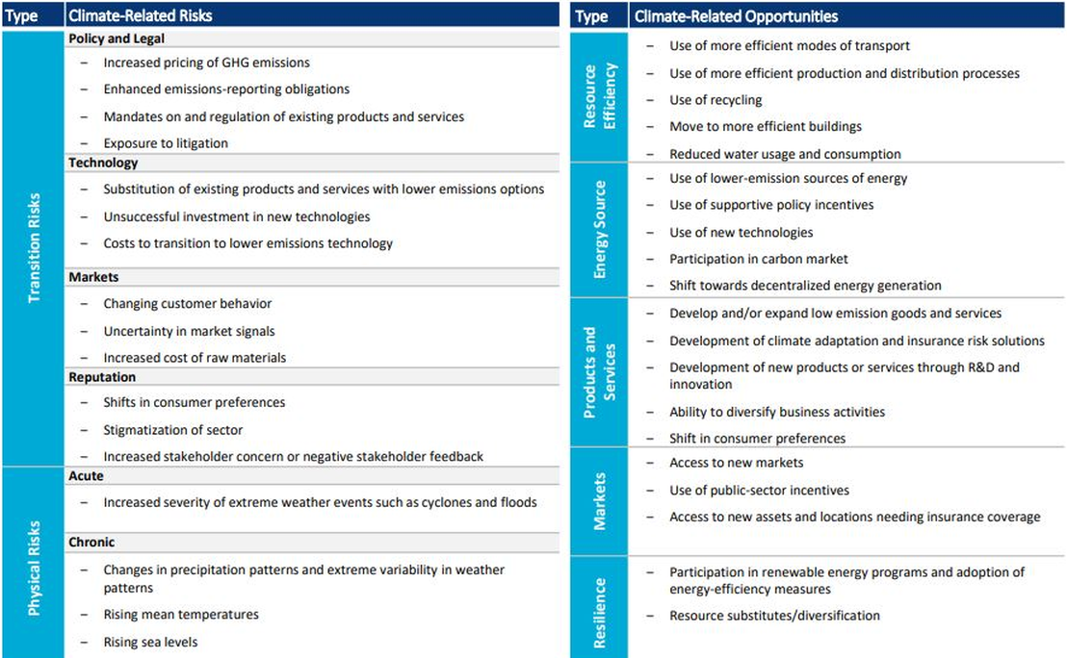

1. WSAA climate change adaptation decision framework

**Integrate adaptation considerations into governance structure**

The diagram below from the Water Services Association of Australia (WSAA) report “Climate Change Adaptation Guidelines” 2016 (page 7) sets out a series of steps that can be taken by a water entity board in relation to climate change. In the WSAA Guidelines, each of the numbered points in the right-hand column is supported by a chapter explaining how this step is taken. This report provides practical steps to understand the role of board directors in implementing climate change action.

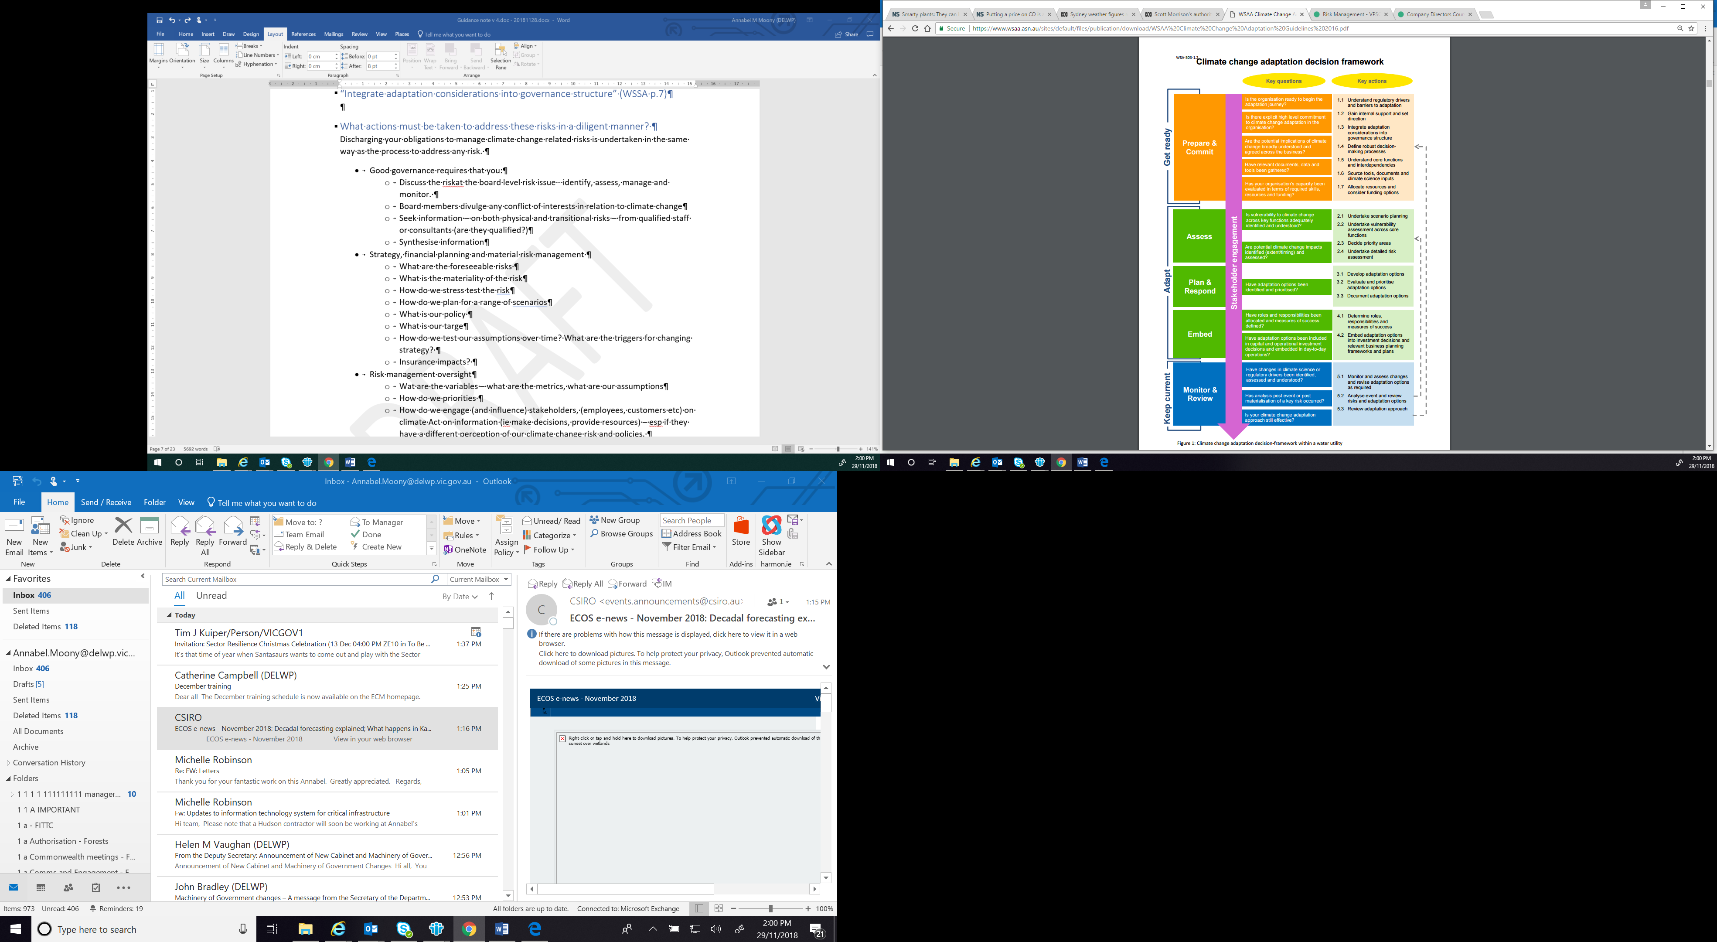

1. Victorian water corporations’ risk management framework

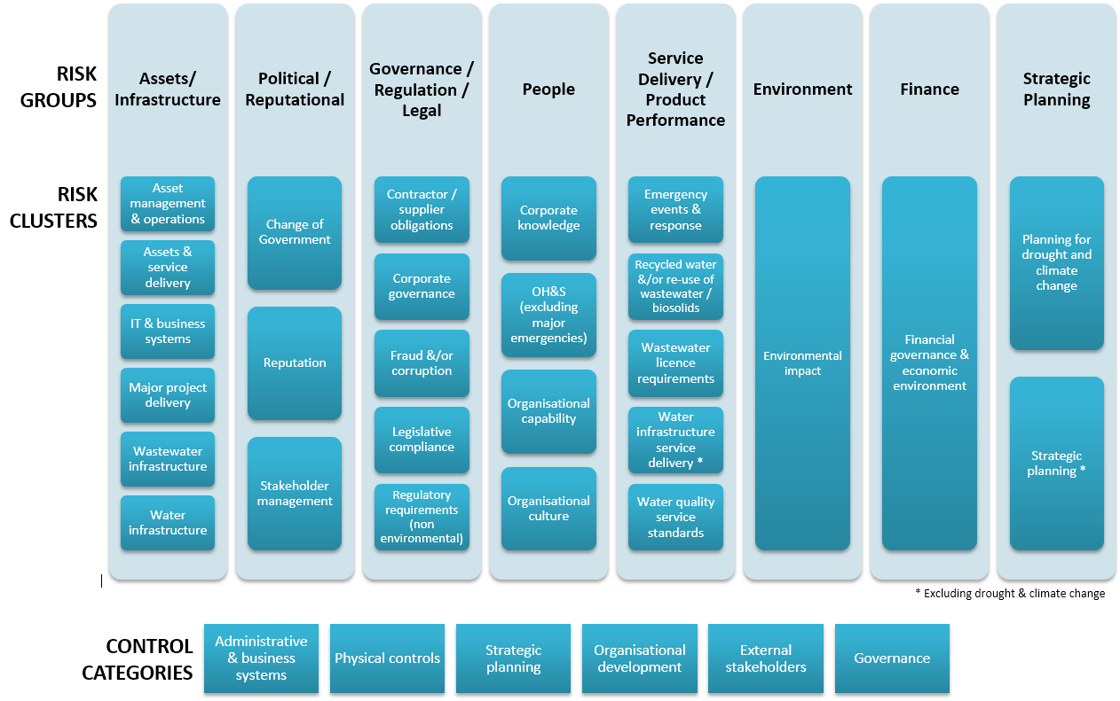

1. Pilot Water Sector Climate Change Adaptation Action Plan – List of Actions

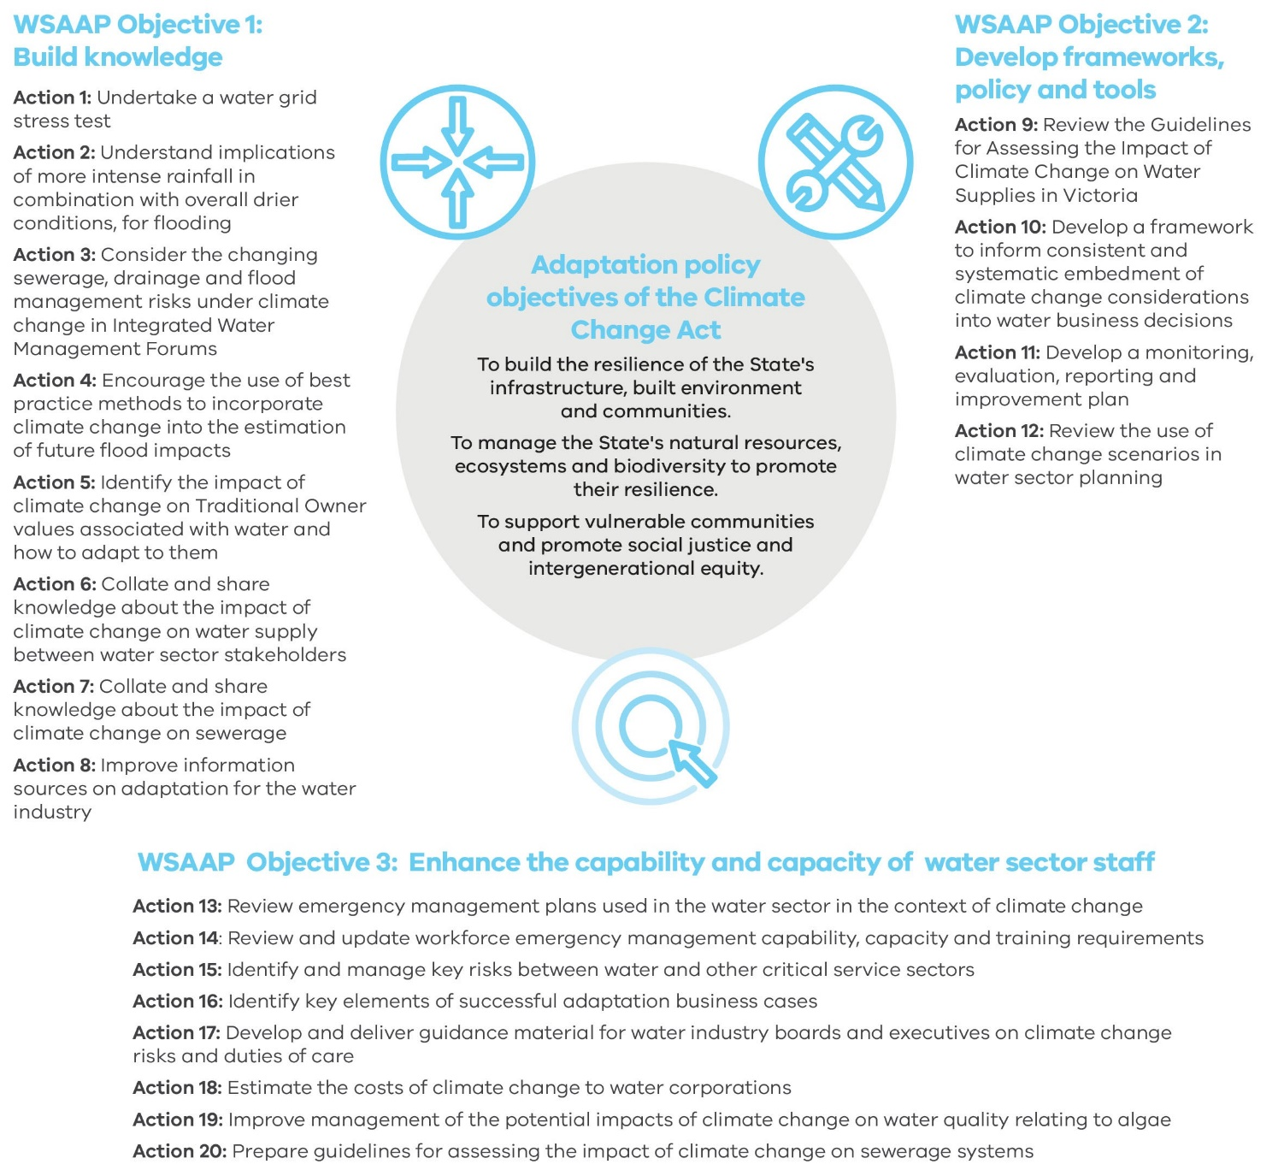

delwp.vic.gov.au

1. The *Emergency Management Act* requires that agencies:

   * Minimise the likelihood, effect and consequence of emergencies.
   * Manage the critical infrastructure cycle through a emergency management plan

  
2. Section79(1) - Duties of directors, *Public Administration Act 2004* (Vic)
3. Section 44B - Asset registers and risk management strategies, *Financial Management Act 1994.* Note that the Standing Directions 2018 issued by the Minister for Finance under the *Financial Management Act 1994* include Clause 3.7. Managing Risk mandates the Responsible Body to apply the **Victorian Government Risk Management Framework**. The Risk Management Framework is also released by the Minister for Finance and describes the minimum risk management requirements that agencies are required to meet to demonstrate they are managing risk effectively, including inter-agency and state-significant risks. Clause 3.1.1 sets out the mandatory requirements., including any consistencies with AS/NZA ISO 31000:2009 Risk Management – Principles and Guidelines. This includes identifying current and emerging risks, implementing appropriate measures to manage the risk and appropriate monitoring and reporting.
4. Note that the Hutley advice was prepared with the caveat that it was not “providing legal advice tailored to any particular individual director, company, sector or circumstance”. This opinion - written in relation to section 180 of the Corporations Act 2001 (Cth) - found a clear duty of care for Australian company directors in relation to climate change. Given that the duties of public sector boards in the *Public Administration Act 2004* are framed in language consistent with that of the *Corporations Act 2001*, the Hutley opinion advice is also relevant to public sector entities. It is arguable, in fact, that the legislative obligations of public sector entities are stronger than the obligations of the private sector under the Corporations Act 2001 and thus the Hutley opinion advice is applicable to directors of public sector water agencies as a minimum standard rather than best practice
5. “Climate Change and Directors’ Duties” The Centre of Policy Development and the Future Business Council, Memorandum of Opinion, Mr Noel Hutley SC and Mr Sebastian Hartford-Davis, for Minter Ellison, 7 October 2016 <https://cpd.org.au/wp-content/uploads/2019/03/Noel-Hutley-SC-and-Sebastian-Hartford-Davis-Opinion-2019-and-2016_pdf.pdf>
6. Hutley’s opinion noted that since 2016 “the developments that have occurred suggest that we are now observers of a profound and accelerating shift in the way that Australian regulators, firms and the public perceive climate risk. There has been a series of coordinated interventions by Australian regulators, which will require in practice that increased attention be given to both the assessment and disclosure of climate risk.”
7. Hutley’s language and that of other commentators is to refer to “risks and opportunities”, rather than “threats and opportunities” which accords with *AS/NZS ISO 31000:2009 Risk management - principles and guidelines* and is accepted language within the Victorian water sector risk management community. See additional discussion in Section 5.
8. https://vpsc.vic.gov.au/governance/board-obligations/
9. <https://www.ipcc.ch/working-group/wg3/?idp-437>
10. *Climate Change Act 2017*, Section 3 defines ‘adaptation’ but not ‘mitigation’ and uses ‘transition to a net zero greenhouse gas emissions economy’.
11. See Final Report – Recommendations of The Task Force on Climate Related Financial Disclosures (TCFD) issued in June 2017 and the Victorian Climate Change website: https://www.climatechange.vic.gov.au/__data/assets/pdf_file/0021/55254/DELWPClimateChange_Framework.pdf
12. Under the Catchment and Land Protection Act, the CMA boards are also specifically responsible for deciding on the policies of the entity.
13. Catchment and Land Protection Act 1994, Section 4 Objectives of Act: “The following are the objectives of this Act—

    (a) to establish a framework for the integrated and co-ordinated management of catchments which will—

    (i) maintain and enhance long-term land productivity while also conserving the environment [emphasis added]; and

    (ii) aim to ensure that the quality of the state's land and water resources and their associated plant and animal life are maintained and enhanced …” [emphasis added].
14. The ‘5Es’ framework developed by Sarah Barker, Special Counsel, MinterEllison
15. The Task Force on Climate Related Financial Disclosures (TCFD) has prepared a report on how to disclose these risks: https://www.fsb-tcfd.org/publications/final-recommendations-report/
16. AS/NZS ISO 31000:2009 *Risk Management – principles and guidelines*
17. <https://www.fsb-tcfd.org/> The TCFD was established in 2015 under the auspices of the G20 Finance Ministers and Central Bank Governors to review how the financial sector can take account of climate-related risks. Its final report was published in June 2017.
18. See Section 25(2) of the *Climate Change Act 2017*.
19. https://www.climatechangeinaustralia.gov.au/en/climate-campus/modelling-and-projections/using-projections/application-ready-data/hydrology-case-study/
20. https://www.water.vic.gov.au/__data/assets/pdf_file/0014/52331/Guidelines-for-Assessing-the-Impact-of-Climate-Change-on-Water-Availability-in-Victoria.pdf
21. See Water Sector Pilot Adaptation Action Plan 2018 Action 12.
22. Exploring ‘Adaptation Pathways’ planning through an NRM lens: RMIT University, Centre for Urban Research,

    Karyn Bosomworth et al, August 2018
23. https://www.climatechange.vic.gov.au/__data/assets/pdf_file/0024/60729/Victorias-Climate-Change-Adaptation-Plan-2017-2020.pdf
24. https://www.water.vic.gov.au/__data/assets/pdf_file/0014/52331/Guidelines-for-Assessing-the-Impact-of-Climate-Change-on-Water-Availability-in-Victoria.pdf
25. https://www.water.vic.gov.au/climate-change/climate-and-water-resources-research/victorian-climate-initiative
26. https://www.climatechangeinaustralia.gov.au/en/climate-projections/climate-futures-tool/introduction-climate-futures/
27. https://coastadapt.com.au
28. More information available at http://nrmclimate.vic.gov.au/
29. <https://www.cicero.oslo.no/en/CF-scenarios-and-shades>
30. <https://cpd.org.au/2019/02/public-authorities/>