Voluntary Committees of Management Newsletter
Edition 8 – March 2015

Foreword
Welcome to the eighth edition of the Voluntary Committees of Management Newsletter.
In honour of those committee members who have made outstanding contributions to management of Crown land reserves over the last 12 months, we are seeking nominations from committees for the inaugural Committee of Management Volunteer Week Awards, to be presented during National Volunteer Week 11- 15 May 2015. A nomination form is included with this edition.
This is a great opportunity to recognise the achievements of an individual member, a group of committee members or even the entire committee. Nominations are now open until 31 March 2015.
The Department of Environment, Land, Water and Planning is extremely appreciative of the work Committees of Management do on behalf of the community and I thank you all for your continued commitment to managing Victoria’s valuable public land.

Peter Beaumont
Executive Director
Land Management Policy

Call for nominations
Port Phillip: https://www.facebook.com/DELWPPortPhillip Gippsland: https://www.facebook.com/DELWPGippsland Barwon South West: https://www.facebook.com/DELWPBarwonSouthWest Grampians: https://www.facebook.com/DELWPGrampians Hume: https://www.facebook.com/DELWPHume Loddon Mallee: https://www.facebook.com/DELWPLoddonMallee

Committees of Management Volunteer Week Awards will be presented 11- 15 May, 2015.
It is important to recognise and highlight all the great work by committees of management do across Victoria.
You can help celebrate and acknowledge the significant achievements of committee members by nominating individuals or multiple committee members for a Volunteer Week Award by 31 March 2015.
We invite you to nominate committee members who have made an outstanding contribution to the work of the committee over the last 12 months. To make a nomination, all that is required is submission of a nomination form to awards@delwp.vic.gov.au
More information on the awards and the nomination process can be found at www.delwp.vic.gov.au/crown-land-management
Committees of Management Awards Nominations FAQs
1. Why is the Department of Environment, Land, Water and Planning introducing these awards?
The inaugural Committee of Management Awards, to be made during National Volunteer Week, have been developed to draw attention to, and publically recognise, committee members who are making an extraordinary voluntary contribution to the management of Crown land reserves across Victoria.
2. Who is eligible to be nominated for an award?
Any current member of the committee of management.
3. How do we know who to nominate?
The awards recognise volunteer committee of management members who have made an outstanding contribution to the management of a Crown land reserve over the last 12 months. For example, those who have provided significant voluntary effort, such as participating in on-ground works, applying for grants, writing reports, or those whose dedication has been of significant benefit to the management of the C reserve.
The nomination can be for an individual’s significant contribution or a significant contribution by a group of committee members. Committee member cannot nominate themselves for an individual award.
4. Can an entire committee be nominated?
Yes: the awards can be used to showcase the accomplishments of an entire committee over the last 12 months.
5. How do we nominate someone?
Nominations should be put forward after consultation between committee members and endorsement of the nominee(s) by the Chair.
6. Who can submit a nomination?
Any current committee member can complete the form and send it to awards@delwp.vic.gov.au or by post (see the nomination form).
7. When are award nominations due?
Nominations for the 2015 Committee of Management Awards must be received by the Department of Environment, Land Water and Planning by Tuesday 31 March 2015.
8. The committee does not have a scheduled meeting before the nomination deadline. Can we still make a nomination(s)?
Yes. Consultation on who to nominate and endorsement of nominees can be done informally by phone or email.
9. When will the awards be made?
Awards will be presented during National Volunteer Week 11- 15 May 2015.

Model policy to assist committees
There are many great aspects to being on a committee of management, but the paper work is not one of them! To assist, the department has issued a model policy on Conflict of Interest for small voluntary (‘category 3’) committees. Adopting the model policy will enable your committee to meet its legal obligation to have a policy of this type.
The policy is available from the Information for committees of management page on the DELWP website or contact your local regional office.

Greener spaces, cooler places
Vegetation can help reduce the urban heat island effect through shade and transpiration, as well as providing habitat for wildlife and improving amenity.
DELWP is keen to work further with committees of management to increase the vegetation cover on Crown land in urban and peri-urban areas. If your committee of management is in the Greater Melbourne area and is interested in exploring options on how we could do this we would welcome your ideas. The greenerspaces.portphillip@delwp.vic.gov.au email address is the best way to provide feedback. The email address will be active from the 9th of March 2015.

Celebrating 52 Years of Service
Meet Jack Rae. At 86 years of age, Jack certainly isn’t letting his age slow him down. Jack is the owner and manager of a cattle exporting and grazing enterprise and has both an extensive range of skills and a seemingly endless list of involvement in community service. His volunteering pursuits range from being an active member of the Akoonah Park Committee of Management for 52 years to being the Chief Marshall at the City of Casey Riding the Bounds event for the previous 25 years and a Councillor of the Royal Agricultural Society of Victoria for 44 years. Impressively, Jack was awarded an Order of Australia Medal in 1999.
We put a few questions to Jack to find out about his role at the Akoonah Park Committee of Management and to see what makes him tick. We’ve provided his answers below.
Current role and responsibilities: Chairman – I feel responsible to give all the team members the opportunity to have their point of view, to share ideas and welcome discussion to enable arriving at a shared decision for the benefit of the community.
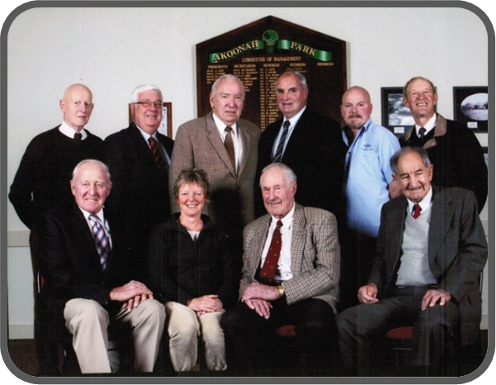
Biggest achievement whilst working as part of the committee: To me probably our biggest achievement for the Akoonah Park Committee would have to be the successful weekly market which has become a major community occasion for so many people. The market attracts so many people each and every Sunday from within and outside of the area. It has become a weekly tradition. The continued growth and popularity of this market has been due in a large part to the team that oversees the running and management. It’s all about a team that works well together. The result is the success of our market which has enabled this committee to have the funds to maintain and improve the Akoonah Park Reserve for the benefit of the community.

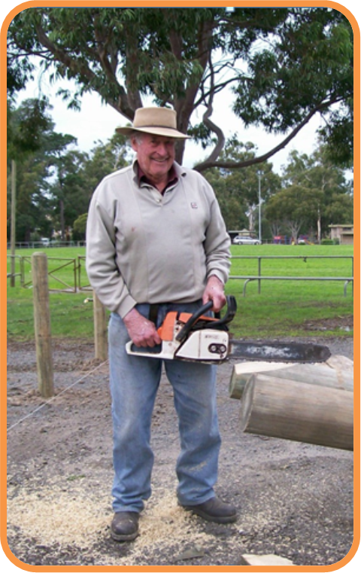
Why do you enjoy being part of the Akoonah Park Committee of Management?
My life has always been about working and getting along with people to achieve something positive for the community. The job is made so much easier when everyone understands and respects the other person’s point of view. I enjoy the bond that develops from the close working relationship with my fellow committee members. A successful committee is to have everyone working towards the same common goal.

Congratulations to Jack for his impressive contribution of 52 years of service. Keep up the great work!

ILLEGAL DUMPING ALERT:
AVOID THE DANGERS OF ACCEPTING FILL ON COMMITTEE MANAGED LAND
Accepting fill material onto public land may seem like a good idea, but if it contains waste, it may ruin your land, pose a public or environmental safety risk and make you liable to fines, prosecution and massive clean-up costs to remove it.
Clean soil is often required for landscaping, levelling of land or land reclamation works. The recent importation of contaminated soil to the foreshore at Apollo Bay is a timely reminder to all Committees of Management to be extremely cautious when accepting fill on Crown Land.
In Victoria, it is an offence under the Environment Protection Act 1970 to allow any waste to be placed on your land, even if it is mixed with soil. By accepting fill material containing bricks, concrete, asbestos and other wastes, you may have participated in illegal dumping.
Below: Areas of the Apollo Bay Foreshore closed during the clean-up
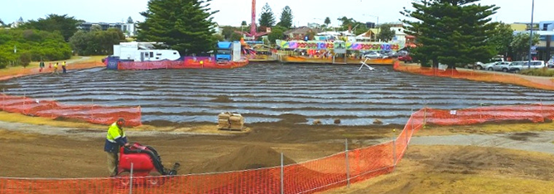
Whilst the asbestos has been removed from the Apollo Bay foreshore the Environment Protection Authority (EPA) investigation continues. Cost to the committee to undertake testing, remediation works and fencing to date are in the tens of thousands of dollars.

If you are unsure if you can or cannot accept fill, ask your local council, EPA office or Department of Environment, Land, Water and Planning (DELWP) office.

Follow these tips prior to accepting any fill material:
- Check if filling is permitted and what Council, EPA or DELWP approvals are required.
Committees may be ordered to remove unapproved fill and pay the cost of taking it to a lawful waste facility.
- Check the credentials of anyone who offers your free or cheap fill and never accept fill from an unknown source.
Operators may dump fill of suspect material of an unknown origins, leaving the Committee with a contaminated site and significant clean-up cost. Always check where the fill is coming from and what activities were conducted at the site that may have caused contamination (for a full list of sites that have high potential for contamination see the EPA General Practice Note Potentially Contaminated Land June 2005).

- Ask the supplier to prove that the fill isn’t contaminated.
Request that the material is sampled and analysed for potential contaminates before accepting it. Always ask to see the original laboratory results, or organise samples to be undertaken independently by the Committee.

- Supervise and inspect all loads of incoming fill.
Supervise delivery of all loads of fill – one load of contaminated fill could contaminate all other loads. Make sure it does not contain any bricks, concrete, asphalt, wood, asbestos, metal or plastic. Check the soil does not smell of chemicals or have any discolouration. Record registration details and ask drivers for proof of employment.
For more information contact the EPA (1300 372 842) or your local DELWP Office.
A new resource to help with Fairy Grass
Across Victoria, lakes, wetlands, dams and creeks are drying as high evaporation rates and patchy rainfall take their toll. Drying water bodies are at an increased risk from algal blooms, and low oxygen levels can cause fish and eel deaths. As water levels reduce, commercial fishing and recreational boating opportunities decrease, and public amenity declines. Fairy Grass can also rapidly colonise large areas and become a nuisance. All of these can result in management concerns for public land managers.
In last drought, Fairy Grass became a significant problem in some areas of the state, and is now re-appearing as dry conditions persist. Fairy Grass or Common Blown–grass (Lachnagrostis filiformis), is a native grass which commonly colonises damp bare areas on the edge of water bodies. The grass which looks quite attractive in its early stages, soon presents as a mobile and irritating pest when the seed heads mature. These seed heads detach from the plant and drift on air currents, coming to rest against fences, shedding and homes.
Enjoying this newsletter? Want to contribute to Edition 9?

DELWP is seeking contributions for Edition 9 and would also welcome any feedback on the frequency of the newsletter and its content. Please send any comments, suggestions or articles and photos to imogen.munro@delwp.vic.gov.au

Affected landholders often seek assistance from public land managers to address Fairy Grass impacts to their private assets. To assist Committees of Management and members of the public understand the lifecycle and issues associated with Fairy Grass, the Department of Environment Land Water and Planning (DELWP) has produced a new information sheet ‘Dealing with Fairy Grass’. The information sheet documents the issues, identification and management options when Fairy Grass seed heads becomes mobile. The information sheet is available through the DELWP Customer Service Centre on 136 186.
Your committee’s ABN
In 1999 all committees of management of Crown land reserves in Victoria were allocated an Australian Business Number (ABN) by the Australian Tax Office. Since that time many committees have become incorporated and the Australia Business Register requires names to be amended. For example if ‘Smiths Reserve Committee of Management’ became incorporated since 1999 the Australian Business Register must be updated so that the registered name is ‘Smiths Reserve Committee of Management Incorporated’.
To check your committee’s ABN go to http://abr.business.gov.au/
To amend your committee’s name you will need to complete a Change of Registration form (Nat2943) and submit by post along with proof of your authority to represent the committee, such as your letter of appointment.

Grant name | Purpose | Amount | Key dates | Website
DELWP and NARCO Landfill Relief Program 2014-2015 | This program is a partnership between the State Government and the National Association of Charitable Recycling Organisations (NACRO) to provide funding that can help offset the cost of dumped rubbish on charitable recyclers. | Assessed on application | January 1 2014 -  30 June 2015 | http://www.nacro.org.au/policy/landfill-relief-program/
ANZAC Centenary Major Grants Program | projects which commemorate, honour and remember the service and sacrifice of Victoria's World War I veterans and their communities | $20,000- $100,000 | Ongoing | Victorian Veteran’s Council
Victorian Veteran’s Council ANZAC Centenary Community Grants program | Preservation of WW1 history | Up to $20,000 | Current round closes 3 February 2014  Future round planned 18 February – 26 May 2015 | http://www.dpc.vic.gov.au/index.php/veterans/veterans-grants/victorian-veterans-council-anzac-centenary-community-grants-program
Community Infrastructure Fund | Delivering liveable communities and neighbourhoods in precincts likely to experience population growth | Up to $1,000,000 | Ongoing | http://www.dpcd.vic.gov.au/home/grants/all-grants/community-infrastructure-fund
Country Football and Netball Program | assist country football and netball clubs, associations, umpiring organisations to develop facilities | Up to $100,000 | Ongoing | http://www.dpcd.vic.gov.au/home/grants/all-grants/country-football-and-netball
Restoring Community War Memorials and Avenues of Honour Grants Program | Restore/ improve local war memorials, honour rolls, avenues of honour | Up to $20,000 | Ongoing | http://www.dpc.vic.gov.au/index.php/veterans/veterans-grants/commemorative-grants-restoring-war-memorials-and-avenues-of-honour
Food & Fibre Marketing Cooperatives Grant | Encourage the establishment of cooperative groups of farmers and value chain participants, using the collective capability of the groups to generate better access to markets and customers for the products of their food and fibre activities | Up to $50, 000 | Closes 30 June 2015 | http://www.depi.vic.gov.au/agriculture-and-food/food-and-fibre-industries/food-and-fibre-marketing-cooperatives-grants

List of available grants
For all grants, more information can also be obtained by calling the Grants Info Line on 1300 366 356 between 8.30 am and 5.00 pm Monday to Friday (excl. public holidays).
Federal government grants: http://www.business.gov.au/grantfinder/grantfinder.aspx Grants Victoria: http://www.vic.gov.au/grants.html

