**Wetland values**

Criterion 4 of the Montréal Process is concerned with soil and water resources. Specifically, this criterion is listed as ‘Conservation and maintenance of soil and water resources’.

Wetlands are ‘still-water’ environments, usually occurring where water collects in depressions in the landscape from either surface water or groundwater. Wetlands can include swamps, lakes, peatlands, mangroves, saltmarshes, bogs, billabongs and mudflats. Some wetlands are dependent on groundwater for their existence; others depend on surface water run-off or large floods from adjacent rivers. The 2013 inventory of Victoria’s wetlands[1] recorded 23,739 natural wetlands covering 604,322 hectares and 11,060 artificial wetlands covering 170,613 hectares. Some wetlands naturally have water in them all the time, while others naturally dry out for short or long periods of time. Within Victoria’s RFA regions, wetland covers 1,774,707 hectares (Table 39).

Table 39: Area of wetland in Victoria’s RFA regions

|  |  |
| --- | --- |
| RFA | Wetland area (ha) |
| Central Highlands | 3,332 |
| East Gippsland | 87,701 |
| Gippsland | 1,578,375 |
| North East | 31,565 |
| West | 73,732 |
| Total | 1,774,707 |

Source: WETLANDDIR spatial layer

**The Ramsar Convention**

The Ramsar Convention on Wetlands of International Importance Especially as Waterfowl Habitat (the Ramsar Convention) is an international intergovernmental treaty which was adopted in the Iranian city of Ramsar in 1971 and came into force in 1975. Australia was one of the first countries to become a Contracting Party to the Ramsar Convention and designated the world's first Wetland of International Importance, Cobourg Peninsula Aboriginal Land and Wildlife Sanctuary, in 1974. As a Contracting Party to the Ramsar Convention, Australia has a commitment to protect designated areas according to the convention (Department of Sustainability, Environment, Water, Population and Communities [DSEWPaC] 2012).

The Ramsar Convention is embarking on its Fourth Strategic Plan 2016–2024. The strategic plan focuses on three strategic goals and one operational goal which supports them (Table 40). Each goal has associated targets, tools/actions/resources, key actors, indicators and baselines (Ramsar 2016).

Table 40: Strategic and operational goals for Ramsar’s Fourth Strategic Plan 2016–2024

|  |  |
| --- | --- |
| Strategic goals | Operational goal |
| Goal 1: Addressing the Drivers of Wetland Loss and Degradation | Goal 4: Enhancing Implementation |
| Goal 2: Effectively Conserving and Managing the Ramsar Site Network |
| Goal 3: Wisely Using All Wetlands |

There are five Ramsar-declared wetlands within the Victorian RFA regions (Figure 15, 41). These are:

* Corner Inlet
* The Gippsland Lakes
* The Glenelg Estuary and Discovery Bay
* Port Phillip (Western Shoreline) and Bellarine Peninsula
* Western District Lakes.

The Gippsland Lakes has the largest area and extends across East Gippsland and Gippsland RFAs, while Corner Inlet in Gippsland RFA has the second-largest area and is also a shorebird site (Figure 15; Table 44).

The characteristics of Victoria’s Ramsar wetlands, within RFA regions and the respective management authority, are outlined in Table 41. While the original RFAs did not include clauses specifically on wetland values, they include commitments from the Victorian Government to address water and catchments, outlining the associated legislative and policy framework, involving the adoption of an integrated catchment management approach to water resource management (DELWP 2016).

**Non-Ramsar wetland areas in RFA regions and the extent in terrestrial ecosystems and in the CAR reserve system**

A full summary of the extent of wetlands in each RFA region, by land type, including terrestrial ecosystems and the extent in the CAR reserve system, is presented in Appendix 6.

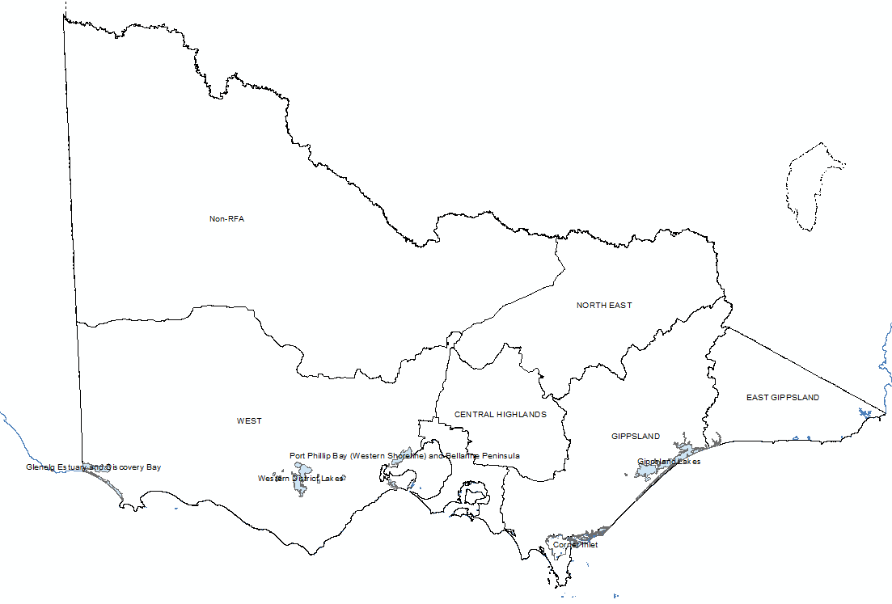

Figure 15: Ramsar wetland distribution across RFA regions

Source: VSDL RAMSAR25 spatial layer.

Table 41 Ramsar wetlands in the Victorian RFA regions

| Name | Listing date | Location | RFA region | Area (ha) | Description | Reserved/owned | Managed by |
| --- | --- | --- | --- | --- | --- | --- | --- |
| Corner Inlet | 1982 | The Corner Inlet is the most southerly marine embayment and tidal mudflat system of mainland Australia and is located 260 kilometres south-east of Melbourne near Yarram. | Gippsland | 67,235 | Corner Inlet:   * has shallow intertidal mudflats which support the world's most southerly population of white mangroves (*Avicennia marina*), as well as extensive areas of saltmarsh and seagrass * is an important feeding and nesting area for many waterbirds and one of the most important areas in Victoria for [migratory shorebirds](https://www.water.vic.gov.au/waterways-and-catchments/rivers-estuaries-and-waterways/wetlands/migratory-shorebirds) * supports a range of native fish species. | Reserved in the Corner Inlet Marine and Coastal Park and Nooramunga Marine and Coastal Park | Parks Victoria |
| The Gippsland Lakes | 1982 | The Gippsland Lakes are located 300 kilometres from Melbourne, south of the Eastern Highlands and to the east of the La Trobe valley. Ninety Mile Beach lies to the south. | East Gippsland, Gippsland | 119,393 | The Gippsland Lakes consists of a series of lakes and fringing wetlands. It is the largest estuarine lagoon system in Australia.  The lakes are important for waterbirds, including migratory shorebirds, fish such as Black Bream (*Acanthopagrus butcheri*) and threatened species such as the nationally vulnerable Growling Grass Frog (*Litoria raniformis*). | Reserved in Gippsland Lakes National Park and public reserves | Parks Victoria |
| The Glenelg Estuary and Discovery Bay | 2018 | The Glenelg Estuary and Discovery Bay is situated approximately 340 kilometres west of Melbourne on the border with South Australia. | West | 22,289 | Glenelg Estuary and Discovery Bay:   * has diverse aquatic habitats, including intertidal sandy beaches, estuarine habitat, freshwater swamps and permanent lakes * supports nationally threatened coastal saltmarsh, and eight nationally or internationally listed species of conservation significance, such as the critically endangered Eastern Curlew and the endangered Australasian Bittern * provides feeding, spawning and nursery habitat for 28 fish species * supports 24 bird species that migrate annually from the northern hemisphere * has rare geological and geomorphic features. | Reserved in Lower Glenelg National Park, Discovery Bay Coastal Park and the Nelson Streamside Reserve | DELWP, Glenelg Hopkins Catchment Management Authority and Ramsar Coordinating Committee |
| Port Phillip (Western Shoreline) and Bellarine Peninsula | 1982 | The site is made up of a number of wetlands stretching from Point Cook in Melbourne's south-western suburbs to the north shore of Corio Bay north of Geelong and extending to the Bellarine Peninsula and Mud Islands. There are six sections of the site, as follows: Point Cook–Cheetham, Werribee–Avalon, Point Wilson – Limeburner’s Bay, Lake Connewarre, Swan Bay and Mud Islands. | West | 22,645 | The site supports:   * international migratory shorebirds, flying from as far away as Russia and Alaska * very large numbers of waterbirds, on both its natural and artificial wetlands, with annual numbers likely to be in excess of 300,000 * 12 threatened fauna species and one threatened vegetation community * breeding colonies of several species including Royal Spoonbills (*Platalea regia*), Pied Cormorant (*Phalacrocorax varius*) and White-faced storm Petrels (*Pelagodroma marina*) * important habitat for over 50 fish species.   The site also provides:   * winter feeding habitat for the nationally listed critically endangered Orange-bellied Parrot (*Neophema chrysogaster*) * an important drought refuge through its wetlands for waterbirds when inland lakes and wetlands dry out.   Notable vegetation includes saltmarsh, seagrass and mangroves. | Multi-tenure | DELWP, [Parks Victoria](http://parkweb.vic.gov.au/) and [Melbourne Water](https://www.melbournewater.com.au/Pages/home.aspx) |
| Western District Lakes | 1982 | Western District Lakes consists of nine lakes on the Victorian Volcanic Plain between Winchelsea and Camperdown approximately 150 kilometres southwest of Melbourne. Lake Corangamite, one of the nine lakes, is the largest permanent saline lake in Australia but also supports localised groundwater-fed freshwater habitat. | West | 32,675 | The site supports large numbers of waterbirds, including migratory shorebirds and a breeding colony of the Australian Pelican (*Pelecanus conspicillatus*) at Lake Corangamite when conditions are favourable.  Lake Beeac is very significant for Banded Stilt (*Cladorhynchus leucocephalus*) and Red-necked Avocet (*Recurvirostra novaehollandiae*).  Threatened species at the site include Salt Tussock Grass (*Poa sallacustris*) and Spiny Pepper-cress (*Lepidium aschersonii*) which are both listed as nationally vulnerable. | Consists of conservation reserves | [Parks Victoria](http://parkweb.vic.gov.au/)  The [Corangamite Catchment Management Authorit](http://www.ccma.vic.gov.au/Home.aspx)y |

Source: DELWP (2019b)

Wetland area in Victoria was examined using the CAR reserve extent for 2018 (Table 42). The West RFA region contains the largest area of wetland of all the regions, estimated at 102,739 hectares in 2018. The North East and Central Highlands RFAs only contain nationally important wetlands, while in East Gippsland, Gippsland and the West, 2.8 per cent, per cent, 79 per cent and 70 per cent of the wetland area respectively is contained within a Ramsar site.

Table 42: Extent of wetlands in CAR reserves, 2018

|  |  |  |  |  |  |
| --- | --- | --- | --- | --- | --- |
| Land Type | Ramsar  Wetlands  (ha) | Nationally  Important  Wetlands  (ha) | | | Sum of Area  (ha) |
| CENTRAL HIGHLANDS |  | 3,332 | | | 3,332 |
| Dedicated Reserve |  |  | | 242 | 242 |
| Informal |  | 1,715 | | | 1,715 |
| Prescription |  | 7 | | | 7 |
| Prescription - MOG |  | 0 | | | 0 |
| Private land |  | 720 | | | 720 |
| Unprotected Public Land |  | 648 | | | 648 |
| EAST GIPPSLAND | 2,054 | 71,500 | | | 73,554 |
| Dedicated Reserve | 594 | 58,163 | | | 58,757 |
| Immediate Protection Areas |  | 292 | | | 292 |
| Informal |  | 6,063 | | | 6,063 |
| Prescription |  | 71 | | | 71 |
| Prescription - MOG |  | 11 | | | 11 |
| Private land | 17 | 2,671 | | | 2,688 |
| Private Land Covenants |  | 16 | | | 16 |
| Unprotected Public Land | 1,443 | 4,212 | | | 5,655 |
| GIPPSLAND | 71,772 | | 19,031 | | 90,803 |
| Dedicated Reserve | 35,842 | | 9,363 | | 45,205 |
| Informal |  | | 101 | | 101 |
| Prescription |  | | 145 | | 145 |
| Prescription - MOG |  | | 10 | | 10 |
| Private land | 1,531 | | 5,779 | | 7,311 |
| Private Land Covenants | 33 | |  | | 33 |
| Unprotected Public Land | 34,366 | | 3,632 | | 37,998 |
| Non-RFA | 69,502 | | 164,801 | | 234,303 |
| Dedicated Reserve | 46,570 | 68,458 | | | 115,029 |
| Informal | 876 | 22 | | | 899 |
| Private land | 602 | 47,630 | | | 48,232 |
| Private Land Covenants | 0 | 324 | | | 324 |
| Unprotected Public Land | 21,453 | | 48,366 | | 69,819 |
| NORTH EAST |  | | 21,161 | | 21,161 |
| Dedicated Reserve |  | 2,694 | | | 2,694 |
| Informal |  | 815 | | | 815 |
| Prescription |  | 15 | | | 15 |
| Private land |  | 463 | | | 463 |
| Unprotected Public Land |  | 17,174 | | | 17,174 |
| WEST | 71,785 | | 30,953 | | 102,738 |
| Dedicated Reserve | 29,632 | 12,818 | | | 42,451 |
| Informal |  | 1,249 | | | 1,249 |
| Prescription |  | 213 | | | 213 |
| Prescription - MOG |  | 14 | | | 14 |
| Private land | 5,792 | 10,180 | | | 15,972 |
| Private Land Covenants |  | 139 | | | 139 |
| Unprotected Public Land | 36,361 | 6,340 | | | 42,701 |
| Grand Total | 215,114 | 310,777 | | | 525,891 |

Source: Ramsar data is from the RAMSAR25 spatial layer, while the nationally important wetland data is from WETLANDDIR in the VSDL/CSDL. The CAR data is unpublished Statewide_CAR_update_20191223

**Nationally important wetlands**

Nationally important wetlands are wetlands that are a good example in a particular area, an important habitat for native species, or that have outstanding heritage or cultural significance. Nationally important wetlands are listedin the *Directory of important wetlands in Australia*.[2] The criteria for determining nationally important wetlands in Australia, and hence their eligibility for inclusion in the Directory, are those agreed to by the Australian and New Zealand Environment and Conservation Council (ANZECC) Wetlands Network in 1994.

A wetland may be considered nationally important if it meets at least one of the following criteria:

1. It is a good example of a wetland type occurring within a biogeographic region in Australia.
2. It is a wetland which plays an important ecological or hydrological role in the natural functioning of a major wetland system/complex.
3. It is a wetland which is important as the habitat for animal taxa at a vulnerable stage in their life cycles or provides a refuge when adverse conditions such as drought prevail.
4. The wetland supports 1 per cent or more of the national populations of any native plant or animal taxa.
5. The wetland supports native plant or animal taxa or communities which are considered endangered or vulnerable at the national level.
6. The wetland is of outstanding historical or cultural significance.

There are 159 wetlands in Victoria listed in the Directory. The nationally important wetlands are listed according to RFA region in Table 43. Of the nationally important wetlands, there are:

* 3 in Central Highlands RFA
* 8 in North East RFA
* 24 in Gippsland RFA
* 18 in the East Gippsland RFA
* 38 in West RFA.

Table 43: Nationally important wetlands in Victoria by RFA

|  |  |  |  |  |
| --- | --- | --- | --- | --- |
| East Gippsland | Gippsland | Central Highlands | North East | West |
| Thurra River | Corner Inlet | Central Highlands Peatlands | Lake Hume | Dergholm (Youpayang) Wetlands |
| Bemm, Goolengook, Arte and Errinundra Rivers | Lake Dartmouth | Yarra River | Mt Buffalo Peatlands | Lake Connewarre State Wildlife Reserve |
| Tamboon Inlet Wetlands | Davies Plain | Big River | Lake Dartmouth | Mundi-Selkirk Wetlands |
| Genoa River | Raymond Island Marsh 2 |  | Wongungarra River | Woorndoo-Hopkins Wetlands |
| Snowy River | Nuniong Plateau Peatlands |  | Wonnangatta River | Long Swamp |
| Sydenham Inlet Wetlands | Mitta Mitta River |  | Howqua River | Lower Lough Calvert & Lake Thurrumbong |
| Suggan Buggan and Berrima Rivers | Raymond Island Marsh |  | Ryan’s Lagoon | Lake Connewarre State Wildlife Reserve |
| Mallacoota Inlet Wetlands | Russells Swamp |  | Black Swamp | Kooraweera Lakes |
| Lower Snowy River Wetlands System | Billabong Flora and Fauna Reserve |  |  | Yambuk Wetlands |
| Rooty Break Swamp | Anderson Inlet |  |  | Mount William Swamp |
| Benedore River | Wongungarra River |  |  | Glenelg Estuary |
| Nuniong Plateau Peatlands | Macleod Morass |  |  | Lake Muirhead |
| Ewing's Marsh (Morass) | Jack Smith Lake State Game Reserve |  |  | Widderin Swamps |
| Tea Tree Swamp (Delegate River) | Wonnangatta River |  |  | Werribee–Avalon Area |
| Lake Bunga | Shallow Inlet Marine & Coastal Park |  |  | Stonyford-Bungador Wetlands |
| Lake King Wetlands | Deep Water Morass |  |  | Lake Corangamite |
| Upper Buchan River | Tambo River (Lower Reaches) East Swamps |  |  | Lake Buninjon |
| Lake Tyers | Lake Wellington Wetlands |  |  | Princetown Wetlands |
|  | Bald Hills State Wildlife Reserve |  |  | Cundare Pool/Lake Martin |
|  | Lake Victoria Wetlands |  |  | Lower Aire River Wetlands |
|  | Caledonia Fen |  |  | Lake Wendouree |
|  | Lake King Wetlands |  |  | Tower Hill |
|  | Lindenow Wildlife Sanctuary |  |  | Hately’s Lake Swamp |
|  | Bosses/Nebbor Swamp |  |  | Lake Condah |
|  |  |  |  | Point Cook & Laverton Saltworks |
|  |  |  |  | Lake Linlithgow Wetlands |
|  |  |  |  | Banongill Network |
|  |  |  |  | Swan Bay & Swan Island |
|  |  |  |  | Cobden-Terang Volcanic Craters |
|  |  |  |  | Nerrin Nerrin Wetlands |
|  |  |  |  | Lindsay-Werrikoo Wetlands |
|  |  |  |  | Saint Marys Lake |
|  |  |  |  | Lake Gnarpurt |
|  |  |  |  | Boiler Swamp System |
|  |  |  |  | Red Rock Lakes & The Basins |
|  |  |  |  | Glenelg River |
|  |  |  |  | Lerderderg River |
|  |  |  |  | Lower Merri River Wetlands |

Source: WETLANDDIR spatial layer in the VSDL/CSDL

**Victorian Waterway Management Strategy**

The Victorian Waterway Management Strategy (DELWP 2019) provides theframework for government, in partnershipwith the community, to maintain or improvethe condition of rivers, estuaries and wetlandsso that they can continue to provideenvironmental, social, cultural and economicvalues for all Victorians. The framework isbased on regional planning processes anddecision-making, within the broader system of integrated catchment management in Victoria.

In Victoria, there are 10 catchment management regions (see Figure 16) and each has a Catchment Management Authority (CMA) to coordinate integrated management of land, water and biodiversity.



Figure 16: The 10 catchment management regions in Victoria

**Waterway condition indices**

The condition of waterways in Victoria is periodically assessed by DELWP using the Index of Stream Condition (ISC), Index of Wetland Condition (IWC) and the pilot Index of Estuary Condition (IEC). The IWC was initially developed in 2005 to assess the condition of naturally occurring wetlands in Victoria. In the period 2009–11, the IWC was used to benchmark the condition of almost 600 high-value wetlands and 240 additional wetlands selected to represent a range of different wetland types. The assessment found that 24 per cent of high-value wetlands were in excellent condition, 32 per cent in good condition, 30 per cent in moderate condition, 13 per cent in poor condition and 1 per cent in very poor condition. Overall, a higher proportion (65 per cent) of wetlands on public land were in good or excellent condition than those on private land (39 per cent).

This was the first time a systematic, statewide assessment of wetland condition had been undertaken in Victoria. The IWC measures six parameters to assess wetland condition (Victorian Department of Sustainability and Environment [DSE] 2012b):

1. Hydrology (river-flow characteristics);
2. Biota (life forms, weeds, altered process, vegetations structure and health);
3. Physical form (extent, changes in bathymetry);
4. Soils (disturbance);
5. Water properties (nutrients, salinity; and
6. Wetland catchment (land-use intensity, buffer width, buffer continuity).).

Statewide resource condition assessment will occur through the Indices of Condition programs (ISC, IWC and IEC) every eight years, subject to available funding. The Waterway Condition Indices will be used to:

* provide statewide information on the condition of Victoria’s rivers, estuaries and wetlands;
* provide high-quality baseline information on environmental values and threats to values to inform regional planning and priority setting; and
* help assess the overall, long-term effectiveness of the Victorian Waterway Management Program.

**The *Environment Protection and Biodiversity Conservation Act 1999***

The EPBC Act aims to protect and manage MNES (i.e. nationally and internationally important flora, fauna, ecological communities and heritage places). The MNES of relevance to wetlands are:

* declared Ramsar wetlands of international importance;
* listed threatened species;
* threatened ecological communities; and
* migratory species.

The EPBC Act establishes a process for identifying Ramsar wetlands and encourages best-practice management through nationally consistent management principles. It provides automatic protection for Ramsar wetlands by ensuring an assessment process is undertaken for proposed actions (including forestry operations) that will, or are likely to, have a significant impact on the ecological character of a declared Ramsar wetland. This process allows the Commonwealth Minister for the Environment to grant or refuse approval to take an action, or to impose conditions on the taking of an action.

The exemption from Commonwealth assessment and approval requirements under section 38 of the EPBC Act for forestry operations in RFA areas does not apply to forestry operations within Ramsar wetland sites.

**Migratory shorebirds**

Migratory shorebirds visit Victoria each summer to feed on invertebrates on the mudflats in coastal and inland wetlands. Each year they travel from their breeding areas in the tundra regions of the northern hemisphere and back again along particular routes known as flyways. Along the way they stop at suitable wetlands to feed and build reserves of fat for the next stage of their journey.

The conservation of wetlands which provide suitable habitat for breeding along the migratory route and at their non-breeding summer destinations in Victoria and elsewhere is critical to migratory shorebirds’ survival and requires international cooperation. A number of international agreements are in place to protect migratory shorebirds and other migratory waterbird species.

Shallow Inlet, Corner Inlet, Western Port, the Western Shoreline of Port Phillip Bay and the Bellarine Peninsula and Discovery Bay (Table 44) have been recognised for their importance to migratory shorebirds through listing as shorebird sites on the East Asian – Australasian Flyway (Figure 17) Site Network (Figure 18).



Figure 17: The East Asian – Australasian Flyway

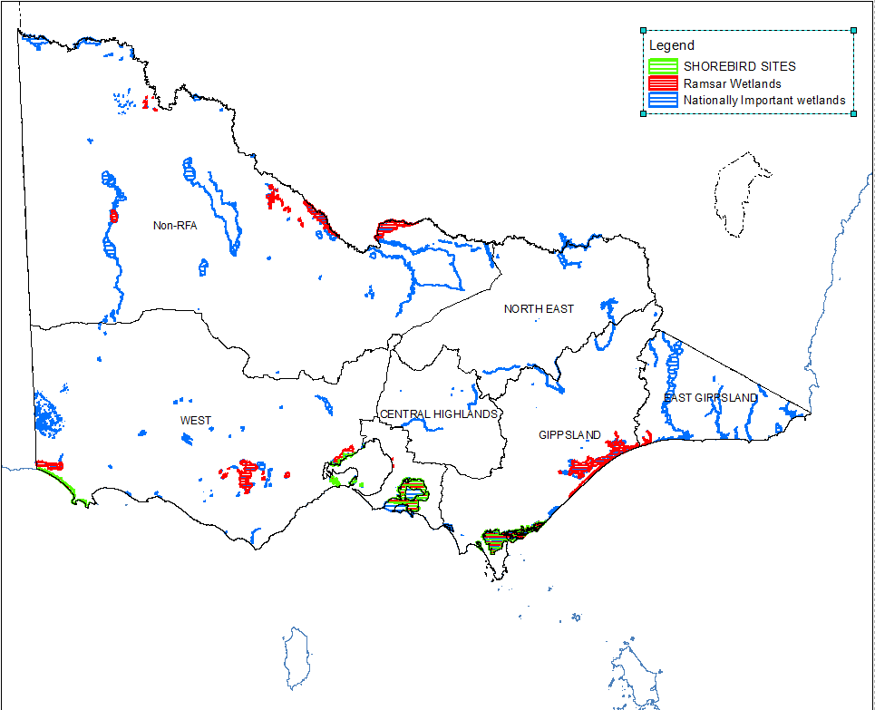

Figure 18: Victorian Flyway shorebird sites, wetlands and Ramsar network across RFAs

Source: Analysis derived from spatial layers: SHOREBIRD, RAMSAR25 and WETLANDDIR, all available within data.vic.gov.au.

Table 44: Shorebird network across wetlands and RFAs

|  |  |  |
| --- | --- | --- |
| RFA | Shorebird site | Wetland name |
| Gippsland | Corner Inlet | Corner Inlet |
| Shallow Inlet | Shallow Inlet Marine and Coastal Park |
| West | Port Phillip (Western Shoreline) and Bellarine Peninsula | Point Cook and Laverton Saltworks |
| Werribee–Avalon Area |
| Lake Connewarre State Wildlife Reserve |
| Swan Bay and Swan Island |
| Discovery Bay | Glenelg Estuary |
| Long Swamp |

Source: Shorebird spatial layer from Victorian Spatial Data Library.

**Indicator 4.1a: Area of forest land managed primarily for protective functions**

There are 134 declared special water supply catchment areas (formerly known as proclaimed water supply catchments) within Victoria (Department of Jobs, Precincts and Regions [DJPR] 2019). The relationship of water quality and quantity with different levels of catchment planning is the basis for catchment planning and management under the provisions of the *Catchment and Land Protection Act 1994* (Vic.) (formerly the *Soil Conservation and Land Utilization Act 1958*). Under this Act, special water supply catchment areas are declared ‘special areas’ and are officially recognised as designated catchments for water supply purposes. This process highlights to the community, land managers and planners the importance of the catchment for water supply purposes.

An underlying principle of catchment planning is the recognition of water production as a valid land-use activity. Water in streams, drainage lines and storages is extremely vulnerable to deterioration and therefore requires a high level of protection. Many water quality problems can be minimised if land use is consistent with the capability of the land – that is, the ability of the land to sustain a proposed use.

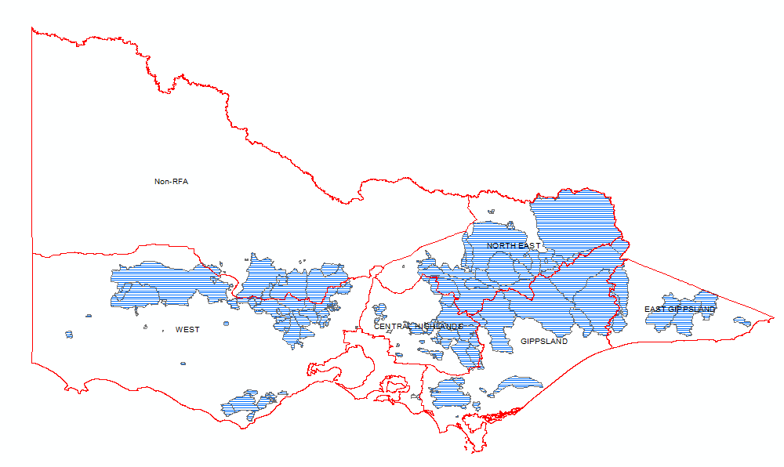

Figure 19: Proclaimed water supply catchments in Victoria across the RFAs

Data source: Information derived from the PWSC100 spatial layer.

The CRA for the Gippsland, North East and West RFA regions captured information regarding rivers and catchment basins, their area as a percentage of the RFA, and the corresponding forest cover as a percentage of land tenure (Table 45). This information was presented in the Water and Catchments chapter of each CRA. It revealed a significantly greater percentage forest cover on public land than freehold, with the West RFA region demonstrating lower forest coverage on public land than the Gippsland and North East regions.

Table 45: Basins and rivers across RFA regions (CRA)

| RFA | AWRCaBasin | Major rivers in RFA region | per cent in RFA region | Land tenure | Total area (ha) | per cent forest cover |
| --- | --- | --- | --- | --- | --- | --- |
| East Gippsland |  | Betka, Cann, Brodribb, Rocky, Buchan, Bemm, Tambo, Boggy Creek | NOT REPORTED | | | | |
| Gippsland | Up per Murray River | Mitta Mitta,  Cobungra,  Bundarra | 30 | Public land | 75 per cent | 98 |
| Freehold | 25 per cent | 27 |
| Total | 302,300 | 80 |
| Goulburn River | Goulburn,  Black | 1 | Public land | 100 per cent | 100 |
| Freehold |  | 0 |
| Total | 18,400 | 100 |
| Snowy River |  | <1 | Public land | 100 per cent | 98 |
| Freehold |  | 0 |
| Total | 1,820 | 98 |
| Tambo River | Tambo,  Timbarra,  Nicholson | 81 | Public land | 71 per cent | 99 |
| Freehold | 29 per cent | 27 |
| Total | 340,190 | 78 |
| Mitchell River | Mitchell,  Wonnangatta,  Dargo | 90 | Public land | 74 per cent | 98 |
| Freehold | 26 per cent | 21 |
| Total | 470,950 | 78 |
| Thomson River | Thomson,  Macalister,  Avon | 91 | Public land | 67 per cent | 97 |
| Freehold | 33 per cent | 19 |
| Total | 544,900 | 71 |
| Latrobe River | Latrobe,  Morwell, | 65 | Public land | 19 per cent | 66 |
| Freehold | 81 per cent | 30 |
| Total | 331,420 | 37 |
| South Gippsland | Tarwin,  Tarra,  Albert | 89 | Public land | 23 per cent | 80 |
| Freehold | 77 per cent | 19 |
| Total | 555,000 | 33 |
| Bunyip River | Lang Lang | 12 | Public land | 2 per cent | 11 |
| Freehold |  | 2 |
| Total |  | 3 |
| Central Highlands | Goulburn | Acheron, Big, Goulburn | NOT REPORTED | | | | |
| Thomson | Thomson |
| Latrobe | La Trobe |
| Yarra | Blue Jacket Creek, Yarra River |
| Bunyip | Bunyip |
| North East | Upper Murray River | Mitta Mitta | 71 | Public land | 69 per cent | 93 |
| Freehold | 31 per cent | 23 |
| Total | 709,294 | 72 |
| Kiewa River | Kiewa | 100 | Public land | 52 per cent | 87 |
| Freehold | 48 per cent | 16 |
| Total | 196,051 | 53 |
| Ovens River | Ovens, King, Buffalo | 92 | Public land | 53 per cent | 96 |
| Freehold | 47 per cent | 16 |
| Total | 719,860 | 58 |
| Broken River | Broken | 24 | Public land | 37 per cent | 96 |
| Freehold | 63 per cent | 14 |
| Total | 181,870 | 45 |
| Goulburn River | Goulburn, Howqua, Jamieson, Delatite | 28 | Public land | 36 per cent | 90 |
| Freehold | 64 per cent | 15 |
| Total | 458,826 | 42 |
| Mitchell River | Wongungarra, Wonnangatta | 9 | Public land | 100 per cent | 100 |
| Freehold | 0 per cent | 0 |
| Total | 51,109 | 100 |
| Thomson River | Barkly | <1 | Public land | 100 per cent | 100 |
| Freehold | 0 per cent | 0 |
| Total | 224 | 100 |
| West | Goulburn River | Goulburn River | 6.4 | Public land | 2 717 | 45.8 |
| Freehold | 105,409 | 13.6 |
| Total | 108,125 | 14.4 |
| Campaspe River | Campaspe River  Coliban River | 13.1 | Public land | 7,930 | 85.6 |
| Freehold | 46,954 | 21.3 |
| Total | 54,884 | 30.6 |
| Loddon River | Loddon River | 8.1 | Public land | 21,464 | 86.6 |
| Freehold | 101,253 | 16.2 |
| Total | 122,717 | 28.5 |
| Avoca River | Avoca River | 2.9 | Public land | 10,081 | 95.7 |
| Freehold | 25,186 | 17.4 |
| Total | 35,267 | 39.8 |
| Wimmera – Avon River | Wimmera, Avon | 31.1 | Public land | 151,692 | 80.6 |
| Freehold | 599,461 | 8.5 |
| Total | 751,152 | 23.1 |
| Yarra River |  | 5.2 | Public land | 2,256 | 6.2 |
| Freehold | 19,094 | 2.5 |
| Total | 21,350 | 2.9 |
| Maribyrnong River | Maribyrnong River | 89.6 | Public land | 9,312 | 79.7 |
| Freehold | 119,205 | 15.1 |
| Total | 128,517 | 19.8 |
| Werribee River | Werribee River, Lerderderg River | 93.9 | Public land | 53,051 | 83.4 |
| Freehold | 133,976 | 9.7 |
| Total | 187,027 | 30.6 |
| Moorabool River | Moorabool River, Little River | 98.6 | Public land | 36,142 | 51.6 |
| Freehold | 184,098 | 10.1 |
| Total | 220,240 | 16.9 |
| Barwon River | Barwon River, Leigh River | 98.9 | Public land | 46,442 | 70.4 |
| Freehold | 335,521 | 7.8 |
| Total | 381,963 | 15.4 |
| Lake Corangamite | Woady Yaloak River | 100 | Public land | 59,028 | 21.5 |
| Freehold | 359,060 | 5.6 |
| Total | 418,088 | 7.8 |
| Otway Coast | Gellibrand River, Curdies River, Aire River | 100 | Public land | 141,991 | 90.9 |
| Freehold | 238,572 | 24.6 |
| Total | 380,563 | 49.3 |
| Hopkins River | Hopkins River, Merri River | 100 | Public land | 43,380 | 43.7 |
| Freehold | 951,806 | 2.7 |
| Total | 995,186 | 4.5 |
| Portland Coast | Moyne River, Eumeralla River, Fitzroy River | 100 | Public land | 64,234 | 83.5 |
| Freehold | 332,588 | 7.4 |
| Total | 396,822 | 19.8 |
| Glenelg River | Glenelg River, Wannon River | 100 | Public land | 308,636 | 86.3 |
| Freehold | 942,419 | 13.6 |
| Total | 1,251,055 | 31.5 |
| Millicent Coast | (no permanent surface water supplies) | 34.6 | Public land | 46,303 | 80 |
| Freehold | 271,887 | 11.4 |
| Total | 318,191 | 21.4 |

a Australian Water Resource Council

Source: Data derived from the CRAs accessed via the ABARES website

**Indicator 4.1b: Management of the risk of soil erosion in forests**

This indicator aims to evaluate soil properties, compliance with soil disturbance standards, and current disturbances, to assess whether levels are acceptable for sustainable forest management. Soil quality is critical to regulation processes in forest ecosystems, including plant production and ecological and hydrological functions.

A regulatory framework has been established in Victoria to support river health and soil conservation in public forests (Table 46). The framework includes legally binding instruments, recognised and enforceable by law. As outlined in the VSOFR, categories 1 to 4 in Table 46 demonstrate how each instrument assists with soil conservation and river health.

Considerable changes have been made to elements of the regulatory framework, including:

* review and update of the *Code of Practice for Timber Production 2007* to the *Code of Practice for Timber Production 2014* – this included streamlining the environmental regulatory framework for harvesting managers, harvesting entities and operators conducting and planning timber harvesting operations (DEPI 2014a)
* revocation of Sustainable Forests (Timber Harvesting) Regulations 2006 in 2014 (no longer in operation)
* replacement of *Management procedures for timber harvesting, roading and regeneration in Victoria’s State forests 2009* with *Management Standards and Procedures for timber harvesting operations in Victoria’s State forests 2014* (DEPI 2014b); this document was supplemented by ‘*Planning Standards for timber* harvesting operations *in Victoria’s State forests 2014*’ (DEPI 2014c).

In terms of assessment of risk to soil attributes timber production and bushfire management are the only forest activities with legally binding and systematic requirements. The relationship between these two activities and soil conservation and river health is well-documented (Weston and Attiwill 1990).

Table 46: Instruments that address forest-related soil attributes in Victoria

|  |  |  |  |  |
| --- | --- | --- | --- | --- |
| Instrument | Legally binding | Public land tenure | Forest activity | Categorya |
| *Catchment and Land Protection Act 1994* | Yes | All | All | 3 |
| *Heritage Rivers Act 1992* | Yes | All | Timber production, mining, grazing, roading, clearing, water regulation | 2, 3 |
| *Land Conservation (Vehicle Control) Act 1972* | Yes | All | Vehicle use, general recreation | 2 |
| *Water Act 1989* | Yes | All |  | 3 |
| *Environment Protection Act 1970* | Yes | All | All | 3 |
| Forests (Recreation) Regulations 2010 | Yes | State forest | General recreation | 2 |
| National Parks (Park) Regulations 2003 | Yes | National and state parks | General recreation | 2 |
| *Code of practice for timber production 2014* | Yes | All | Timber production | 1 |
| *Code of practice for bushfire management on public land 2012* | Partially | All | Bushfire management | 1 |
| Forest management plans | Partially | State forest | All | 4 |
| *Management Standards and Procedures for timber harvesting operations in Victoria’s State forests 2014* | Partially | State forest | Timber production and roading | 1 |
| *Planning Standards for timber harvesting operations in Victoria’s State forests 2014* | Partially | State forest | Timber production and roading | 1 |
| Native forest silviculture guidelines | No | State forest | Timber production | 4 |
| Mining and exploration guidelines | No | All | Mining | 4 |

Data source: DELWP (2018).

aDescription of categories:

Category 1 specifies requirements to assess risk to soil attributes, and standards and procedures for forest activities to control risks to soil attributes

Category 2 specifies controls over the type and location of forest activities for soil conservation or river-health purposes, e.g. the prohibited use of vehicles in declared erosion hazard areas

Category 3 provides for the administration of soil conservation or river health, e.g. the *Catchment and Land Protection Act 1994* provides for the establishment of special areas (including special water supply catchment areas) and establishes management responsibilities

Category 4 provides guidance on soil conservation methods.

*Timber production*

The *Code of Practice for Timber Production 2014* (the Code) (DEPI 2014a), lists mandatory actions for timber harvesting activities in native forests and plantations in Victoria. The *Management Standards and Procedures for timber harvesting operations in Victoria’s State forests 2014* (the MSP) (DEPI 2014b) are designed to help interpret the Code for timber harvesting and related activities in State forests. They are a secondary source of mandatory prescriptions for forest management.

The Code outlines the mandatory actions relating to water quality, river health and soil protection (Table 47). Specific thresholds relating to these actions with respect to slope, buffer width and filter strips can be found in the MSP.

These prescriptions have been modelled across the state and are reflected in the FMZ spatial layer. In this way, VicForests operationally excludes areas as defined under the Code, such as slopes greater than 30 degrees, or buffers and filter strips around water bodies to the dimensions specified. These areas are listed as ‘Code Exclusions’ in reference to the CAR reserve and can complement the informal protected area in relation to the JANIS criteria.

Table 47: Mandatory actions relating to water quality, river health and soil protection, as outlined by the *Code of practice for timber production 2014*

|  |  |
| --- | --- |
| Code | Mandatory actions |
| 2.2.1.1 | Planning and management of timber harvesting operations must comply with relevant water quality, river health and soil protection measures specified within the MSP. |
| 2.2.1.2 | Management actions to protect waterways, river health and soil must be appropriate to the waterway class, soil category, and potential water quality risk posed by timber harvesting operations at each site. |
| 2.2.1.3 | Additional measures to protect water quality and aquatic habitat (including widening buffers or filter strips) must be adopted within coupes where there is a high local risk due to:   * Local topography; * The intensity and magnitude of the timber harvesting operation; * Events such as wildfire that reduce the effectiveness of protection measures; or * The location of the timber harvesting operation in a declared Special Water Supply Catchment or any other water supply protection area. |
| **Protecting waterways and aquatic and riparian habitat** | |
| 2.2.1.4 | Use buffers and filters of effective width in forest adjacent to aquatic and riparian habitats to protect them from microclimate changes, sedimentation and disturbance. |
| 2.2.1.5 | Where practical exclude roads and snig tracks from aquatic and riparian habitats. |
| 2.2.1.6 | Where crossings are required, minimise the extent of habitat damage, constriction to stream flow and barriers to fish and other aquatic fauna. |
| 2.2.1.7 | Remove temporary crossings immediately after harvesting or any subsequent regeneration work is complete using a technique that minimises soil and habitat disturbance. |
| **Minimising water pollution** | |
| 2.2.1.8 | Use drainage, artificial structures, buffers and filters of effective width to slow and disperse surface flows and deposit sediment before reaching waterways. |
| 2.2.1.9 | Locate coupe infrastructure, roads and other activities that generate sediment or other potential pollutants in places where risk of entry into waterways is lowest unless otherwise sanctioned. |
| 2.2.1.10 | Minimise the extent and duration of soil disturbance adjacent to or within waterways. |
| 2.2.1.11 | Use management practices such as modified harvesting techniques, scheduling, wet weather suspensions or progressive rehabilitation to minimise the potential for sediments and other pollutants to move into streams. |
| 2.2.1.12 | Design, construct and maintain roads, crossings, coupe infrastructure and drainage structures to withstand foreseeable rainfall events and traffic conditions, and protect water quality. |
| 2.2.1.13 | Ensure chemical use is appropriate to the circumstances and takes into account the maintenance of water quality. |
| **Maintaining soil productive capacity** | |
| 2.2.1.14 | Minimise potential for soil erosion or mass movement by planning and using operational methods and restrictions appropriate to the assessed soil erosion risk and slope. |
| 2.2.1.15 | Locate coupe infrastructure and roads to minimise soil erosion and degradation. |
| 2.2.1.16 | Use appropriate equipment, harvesting techniques and operational management to minimise soil rutting, mixing or compaction. |
| 2.2.1.17 | Limit the area of soil affected by coupe infrastructure and roads to the minimum required to safely complete timber harvesting operations to the required standard. |
| 2.2.1.18 | Employ topsoil conservation techniques in timber harvesting areas affected by coupe infrastructure and roads. |
| 2.2.1.19 | During timber harvesting operations maintain effective drainage of coupe infrastructure and roads. |
| 2.2.1.20 | Minimise the time soil is left unvegetated, except at coupe infrastructure sites that are required in the longer term. |
| 2.2.1.21 | Ensure chemical use is appropriate to the circumstances and takes into account the maintenance of soil productive capacity. |

The Forest Audit Program (FAP) provides an independent, objective assessment of VicForests’ level of compliance with the environmental regulations for timber production in State forests. The FAP addresses mandatory compliance elements, based on the Code and the MSP. Since 2015–16, FAP audits have largely focused on Code compliance priorities relating to:

* environmental values in State forests, particularly those relating to soils, water, waterways and biodiversity (Table 48)
* design, construction, maintenance and closure of in-coupe roads.

These audits relate to compliance priorities that have a higher risk of environmental harm, and the coupes selected for audit have features (e.g., waterways) that are associated with these higher risk elements. Therefore, the audit results are not representative of all VicForests’ operations and should not be extrapolated.

Table 48: Environmental compliance themes and their respective elements for the Forest Audit Program

|  |  |
| --- | --- |
| Environmental compliance theme | Compliance elements |
| Protection of water flows, water quality and river health | Classifying waterways present in the coupe and applying at least the minimum width of filters and/or buffers required  Applying seasonal closures to reduce the risk of sediment mobilisation during wet weather in water supply catchments  Undertaking appropriate design, construction and maintenance of in-coupe roads, road drainage and waterway crossing |
| Protection of forest soils | Assessing and understanding soil erosion hazard within the coupe  Not harvesting in excessively steep areas  Applying seasonal closures to reduce the risk of sediment mobilisation during wet weather in water supply catchments  Undertaking appropriate construction, maintenance, closure and/or removal of in-coupe roads, road drainage and road or snig track waterway crossings |
| Protection of biodiversity values | Retaining trees and other habitat within the gross coupe and/or harvested area, including old-growth elements and trees with or with potential to form hollows  Not undertaking harvesting activities or roading within sensitive vegetation communities (e.g. heathlands, montane riparian thickets, rainforest stands)  Identifying listed, threatened species of native flora and fauna which have been recorded within or adjacent to the coupe and applying the management measures prescribed by the MSPs and PS  Not harvesting in SPZs established to protect important native fauna habitats (e.g. for Leadbeater’s Possum, Long-footed Potoroos, Owls)  Maintaining passage for fish or other aquatic fauna along permanent streams  Managing the risk of entry or spread of weeds and soil-borne or other diseases |

Independent auditors are commissioned by DELWP for the FAP and audit reports are made public, to inform the community of the standard of environmental management applied to State forests.

Prospective coupes for the audit are selected from a list of coupes included in VicForests’ current Timber Release Plan. A risk-based selection process is used by the auditors to identify the target coupes, based on some of this information. Coupes are short-listed for selection where they are identified in coupe planning as having one or more of these characteristics:

* A waterway crossing was to be constructed to access the coupe.
* Modelled rainforest vegetation was identified as being present within the gross coupe area.
* At least 400 metres of in-coupe road was to be constructed to provide access to landing(s) or through the coupe.
* Soil erosion hazard in the A or B horizon was high.
* Average coupe slope was 15° or greater.

Selection is randomised but weighted towards coupes with high potential for risk to soil, water quality and/or biodiversity values. Specifically, the environmental compliance elements (Table 48) specific to each compliance theme are addressed by the FAP. For the period 2015–18 (Table 49), 90 coupes were audited across four of the five RFAs with at least six coupes required to be located within Melbourne water’s water supply catchment areas. As shown in Table 49, since 2015, audits have been restricted to the Central Highlands, East Gippsland, Gippsland and North East RFAs. The West RFA was audited more frequently before 2015–16, when DELWP’s predecessors still managed commercial timber harvesting, specific to this area.

Table 49: Number of coupes audited between 2015–18 across RFA regions

|  |  |  |  |  |  |  |  |  |  |
| --- | --- | --- | --- | --- | --- | --- | --- | --- | --- |
| Year | Audit criteria relevant to protection of forest soils | Average level of compliance with criteria relevant to protection of forest soils | Audit criteria relevant to protection of water flows, water quality and river health | Average level of compliance with criteria relevant to protection of water flows, water quality and river health | RFA | | | | |
| Central Highlands | East Gippsland | Gippsland | North East | West |
| 2015–16 | Breakdown not available | | | | 28 | 0 | 0 | 2 | 0 |
| 2016–17 | 21 | 83 per cent | 39 | 85 per cent | 20 | 0 | 10 | 0 | 0 |
| 2017–18 | 19 | 87 per cent | 40 | 90 per cent | 12 | 10 | 3 | 5 | 0 |

Source: DELWP Forest Audits and Standards- Matthew P Zanini (2011-2018)

*Bushfire management*

The VSOFR has identified the Bushfire Rapid Risk Assessment Team (BRRAT) program as a source of information regarding the impact of bushfires on soil stability (Commissioner for Environmental Sustainability Victoria 2019). BRRATs carried out rapid assessment of the major risks to human life, infrastructure and property following the 2009 bushfires, as well as investigating the impact on the natural environment on public land.

The teams comprise multi-disciplinary members, deployed to level 2 or 3 incidents while the incident is still under way (scope of level 2 and 3 incidents are described by Emergency Management Victoria (EMV 2015)). The results of each deployment need to be reported within seven days. The reports focus on providing alerts to government agencies about the magnitude of potential post-emergency risks, where more detailed rehabilitation and/or recovery planning is required.

Table 50 is a summary of the erosion risks and mitigation options that were described by the BRRAT program following deployment to fires between 2013 and 2017.

*The team includes a flooding and erosion discipline specialist who assesses risks caused by water quality, flooding and erosion post-fire. The specialist also makes recommendations for mitigation actions to ameliorate these risks. These assessments are used to assist land managers in identifying and minimising future (immediate and long-term) negative impacts.*

Commissioner for Environmental Sustainability Victoria 2019, pg. 120.

These deployments also highlighted 162,000 hectares at risk of erosion and potential mitigation options in 2013; in 2014, 330,130 hectares were highlighted. Since 2015, identified areas decreased significantly.

Table 50: Summary of some of the highlighted erosion risks and mitigation options identified by BRRAT deployments, 2012–13 to 2017–18

|  |  |  |  |  |  |  |  |
| --- | --- | --- | --- | --- | --- | --- | --- |
| Fire | Risk description | Risk level | Likelihood | Consequence | Suggested mitigation work | Season | Area (ha) |
| 2017 Timbarra | Flash-flooding and debris flow impacting on Timbarra Road | Moderate | Possible | Important | Alert local government to risk and road closure during high rainfall events | 2017–18 | 8,693 |
| 2016 Wye River – Jamieson track | Landslide Great Ocean Road | Moderate | Possible | Serious | Immediate geotechnical investigation; Otways post-fire hydrology study | 2015–16 | 2,515 |
| 2015 Lancefield | Soil erosion leading to poor water quality affecting Pyalong water supply | High | Likely | Serious | Containment line rehabilitation; sediment retainers in gullies | 2014–15 | 3,055 |
| 2014 Orbost complex | Soil erosion leading to poor water quality in the Brodribb River catchment | Moderate | Likely | Important | East Gippsland Water to activate its Water Quality Contingency Plan | 2013–14 | 174,600 |
| 2014 Grampians northern complex | Land and infrastructure impacted by landslide | Medium | Likely | Important | Restricted access to high-risk areas of the park; signage and education/awareness for park users | 2013–14 | 54,790 |
| 2014 Mallee complex | Landforms impacted by wind erosion | Moderate | Almost certain | Important | Assessment of sand dune and lunette vegetation cover; control-line rehabilitation | 2013–14 | 100,750 |
| 2013 Baw Baw Heyfield group | Debris flows impact water quality flows to Lake Glenmaggie | High | Likely | Major | Southern Rural Water informed of risks to water quality; Southern Rural Water implement treatment options and monitoring | 2012–13 | 87,600 |
| 2013 Grampians Victoria Valley | Land and infrastructure impacted by landslide | High | Almost certain | Important | Restricted access to high-risk areas of the park; signage and education/awareness for park users | 2012–13 | 35,900 |
| 2013 Alpine bushfires | Landslide Great Alpine Road | Extreme | Almost certain | Major | Closure of Great Alpine Road and geotechnical assessment | 2012–13 | 38,500 |

Data source: VSOFR (2019, p. 121)

**Indicator 4.1c: Management of the risks to soil physical properties in forests**

Activities that may affect soil health or structure include timber harvesting and regeneration, bushfire management (including burning), roading, mining and some recreation activities, (such as four-wheel driving). Repeated use of recreational vehicles on designated four-wheel-driving tracks, heavy vehicles along the same path and inappropriate use of four-wheel drives and machinery required in bushfire management and timber harvesting all have the potential to pose more serious risks if appropriate mitigation and remedial works are not put in place.

*Review of compliance audits in State forests*

Observations made during the 2016–17 and 2017–18 audits (across 60 coupes in all RFAs, except the West; see Table 49) suggest that the method of assessing soil erosion risk in the MSPs warrants review and possible revision. The coupes in these audits with apparently erodible soils have been assessed as having low water quality risk using the method described in the MSPs. In both cases, the soils’ high permeability seems to have dominated the water quality risk classification, despite evidence that they are relatively easily eroded. DELWP responds to these matters via the Office of the Conservation Regulator with announcements made via the Forests and Reserves page of the department’s website. Further work is being considered by the department in line with erosion management protocols.

*Access restrictions to State forest*

A number of tracks and roads across Victoria’s State forests are temporarily closed during winter and spring, as part of an annual driver safety and road damage prevention program. Seasonal road closures are an important procedure that deliver a twofold environmental and safety benefit. The program helps to:

* limit the damage done to forest roads and tracks during the wet season
* ensure that dangerous and difficult-to-negotiate sections of road are closed off from motorists
* maintain water quality in rivers, creeks and reservoirs, by reducing the amount of erosion and silt washed away from roads and tracks.

DELWP consults with a range of stakeholders, including Four Wheel Drive Victoria, to identify sections of the road network that require closures. Most of the roads and tracks are reopened in time for the Melbourne Cup weekend, but the closure period can be extended if the conditions demand it. Table 51 presents the length of road or track seasonally closed within State forests across the five RFA regions for the period 2013 to 2019.

Under the *Catchment and Land Protection Act 1994*, areas within catchments warranting particular attention, such as those required for water supply, can be declared Special Areas by CMAs. These areas are for the protection of predominately town water but also water used for irrigation, stock, industrial and domestic, as well as for hydro-electric use. Furthermore, areas within these catchments are also seasonally closed to prevent erosion and run-off.

Table 51: Roads and tracks seasonally closed across RFA regions within State forests for period 2013–19

|  |  |  |  |  |  |  |  |  |  |  |  |  |  |  |  |
| --- | --- | --- | --- | --- | --- | --- | --- | --- | --- | --- | --- | --- | --- | --- | --- |
| RFA | 2013 | | 2014 | | 2015 | | 2016 | | | 2017 | | 2018 | | 2019 | |
| No. of Roads and Tracks | Total Length (km) | No. of Roads and Tracks | Total Length (km) | No. of Roads and Tracks | Total Length (km) | No. of Roads and Tracks | Total Length (km) | | No. of Roads and Tracks | Total Length (km) | No. of Roads and Tracks | Total Length (km) | No. of Roads and Tracks | Total Length (km) |
| East Gippsland | 60 | DATA NOT AVAILABLE | 60 | DATA NOT AVAILABLE | 57 | DATA NOT AVAILABLE | 53 |  | DATA NOT AVAILABLE | 53 | DATA NOT AVAILABLE | 53 | 366.8 | 53 | 367.9 |
| Gippsland | 58 | 62 | 63 | 62 |  | 61 | 62 | 532.3 | 62 | 530.1 |
| Central Highlands | 174 | 166 | 186 | 163 |  | 172 | 174 | 988.7 | 174 | 998.6 |
| North East | 79 | 81 | 93 | 91 |  | 91 | 92 | 1,015.4 | 94 | 1,006.2 |
| West | 61 | 64 | 70 | 63 |  | 63 | 62 | 254.5 | 62 | 253.7 |

Source: DELWP Assets and Data, State Roads and Crossings

**Indicator 4.1d: Management of the risks to water quantity from forests**

Water yield characteristics indicate the amount of water available for forest ecosystems and human use. In Victoria, many upstream catchments are in forested areas, meaning that changes to forest conditions affect water yields.

For the harvesting of timber in Victoria, the MSP details the procedures required for the protection of water supply areas. Procedures included in the 2014 MSP are outlined below.

*Apply the slope limits, seasonal closures, buffer and filter strip widths and other relevant management actions specified for timber harvesting operations and associated roading and regeneration in water supply protection**areas.*

*DEPI 2014b, pg. 30 (See* the conditions listed in Table 52, in the Bunyip, Thomson and Tarago special water supply catchmentsand the Yarra tributaries State forests,the area harvested must not exceed the following limits measured as a rolling average:

(a) Thomson – ash forests 150 ha/year, mixed species forests 15 ha/year

(b) Tarago – ash forests 55 ha/year, mixed species forests 23 ha/year

(c) Yarra Tributaries –ash forests 52 ha/year, mixed species forests 15 ha/year

(d) Bunyip –ash forests 15 ha/year, mixed species forests 15 ha/year.

In addition to Table 52, harvesting in the Learmonth Creek special water supply catchment must not exceed 7 hectares per annum in Ash forests or 3 hectares per annum in mixed species forests, averaged over the previous 10-year period.

Table 52: Water supply protection areas

| RFA | Catchment | Status | Slope  limit (degrees) | Seasonal closure | Stream buffers | Filter strips | Comments |
| --- | --- | --- | --- | --- | --- | --- | --- |
| North East | **Benalla – Mansfield FMA** | | | | | | |
| Lake Eildon | SWSC |  | 1 June ‐ 31 Oct |  |  |  |
| Upper Goulburn  (Upper Delatite) | SWSC & SAP |  | Refer to section 3.2 table 2 in Appendix 5 the Planning Standards for prescriptions  applicable to water supply protection area SMZs. | | | |
| Lake Nillahcootie | SWSC |  | Refer to section 3.2 table 2 in Appendix 5 the Planning Standards for prescriptions  applicable to water supply protection area SMZs. | | | |
| Ryans Creek | SWSC & SAP;  DC |  | Refer to section 3.2 table 2 in Appendix 5 the Planning Standards for prescriptions  applicable to water supply protection area SMZs. | | | |
| Part in Central Highlands | **Central FMA** | | | | | | |
| Sunday Creek | SWSC | 30 |  | 20m | 10m |  |
| Kilmore | SWSC & SAP | 30 |  | 20m, 40m, 60m | 10m | Buffers in accordance with *Notice of*  *Determination of Land Use, Plan No. 1633.* |
| Upper Goulburn | SWSC | 30 |  | 20m | 10m |  |
| Part of Central Highlands | **Dandenong FMA** a | | | | | | |
| Bunyip River | SWSC & SAP | 25 | 1 May – 30 Nov | 20m | 10m | 60 m buffer upstream of weir. |
| Britannia Creek | SWSC & SAP | 30 | 1 July – 30 Sept | 20m | 10m |  |
| Tomahawk Creek |  | 30 | 1 July – 30 Sept | 20m | 10m |  |
| McCrae’s Creek | SWSC & SAP | 30 | 1 July – 30 Sept | 20m | 10m | 60 m buffer upstream of weir. |
| Micks Creek | SWSC & SAP |  |  |  |  | Harvesting excluded. |
| Healesville | SWSC & SAP |  |  |  |  | Harvesting excluded. |
| Armstrong Creek  East | Restricted |  |  |  |  | Harvesting excluded. |
| Learmonth Creek | Restricted | 25 | 1 May – 30 Nov | 40m b | 10m | Max 7 ha Ash and 3ha MS. |
| McMahons Creek | Restricted | 25 | 1 May – 30 Nov | 40mb | 10m | A maximum of 30 per cent of each of these  catchments is to be harvested over a 10 year  period.  There is to be harvesting in only 1 of the 4  restricted access catchments in any 1 year. |
| Starvation Creek | Restricted | 25 | 1 May – 30 Nov | 40m b | 10m |
| Cement Creek | Restricted | 25 | 1 May – 30 Nov | 40m b | 10m |
| Armstrong Creek  West | Restricted | 25 | 1 May – 30 Nov | 40m b | 10m |
| East Gippsland | **East Gippsland FMA** | | | | | | |
| Orbost  (Rocky River) | SWSC & SAP |  | Refer to section 3.2 table 2 in Appendix 5 the Planning Standards for prescriptions  applicable to water supply protection area SMZs. | | | |
| Betka River | SWSC |  | Refer to section 3.2 table 2 in Appendix 5 the Planning Standards for prescriptions  applicable to water supply protection area SMZs. | | | |
| Gippsland | **Gippsland FMA**b | | | | | | |
| Thomson River | SWSC & SAP | 30 | 1 May – 30 Nov |  |  |  |
| Tyers River | SWSC & SAP | 30 | 1 June – 31 Oct |  |  |  |
| Tanjil River | SWSC & SAP | 30 | 1 June – 31 Oct |  |  |  |
| Tarago River | SWSC & SAP | 30 | 1 May – 31 Oct |  |  |  |
| Bunyip River | SWSC & SAP | 25 | 1 June – 30 Nov |  |  |  |
| Loch River | SWSC | 30 | 1 July – 30 Sept |  |  |  |
| Drouin | SWSC | 30 | 1 July – 30 Sept |  |  |  |
| Glenmaggie | SWSC |  | 1 June – 31 Oct | 40 m Macalister below Caledonia  40 m Wellington below Carey  40 m Barkley below Mt Skene Creek  40 m of Glenmaggie Creek below east and west branches | | |
| Mirboo North | SWSC & SAP |  |  | Buffer of 100 m around the off‐take weir  Buffer from the banks of streams, watercourses and spring  areas. 40 m buffer on the Little Morwell River and 20 m for  other water courses. | | |
| Tarra River | SWSC |  | 1 June – 31 Oct |  |  |  |
| North East | **North East FMA** | | | | | | |
| Lake Hume  (Northern) | SWSC |  | 1 July – 30 Sept |  |  |  |
| Mount Tabor Creek | DC |  | 1 July – 30 Sept |  | 40 ha maximum annual area harvested. | |
| Black Dog Creek | DC |  | 1 July – 30 Sept |  | 30 ha maximum coupe size. | |
| Bakers Gully Creek | SWSC; DC |  | 1 July – 30 Sept |  | 20 ha maximum coupe size. | |
| West Kiewa River | DC |  | 1 July – 30 Sept |  | 40 ha maximum coupe size. | |
| Musk Gully Creek | DC |  | 1 July – 30 Sept |  | 35 ha maximum coupe size. | |
| Diddah Diddah  Creek | SWSC; DC |  | 1 July – 30 Sept |  | 20 ha maximum coupe size. | |
| West | **Otway FMA**c | | | | | | |
| Lorne – St  Georges River |  | 25 | 1 May – 30 Nov | Max harvest 2.5 per cent per year and 15 per cent per  decade of total forested area of each catchment | | |
| Barham River | SWSC | 25 | 1 May – 30 Nov |
| Upper Barwon | SWSC | 25 | 1 June – 31 Oct | Max harvest 5 per cent per year and 25 per cent per  decade of total forested area of each  catchment. | | |
| Gellibrand  River | SWSC | 25 | 1 June – 31 Oct |
| Painkalac Creek | SWSC & SAP | 25 | 1 June – 31 Oct |
| Pennyroyal  Creek | SWSC | 25 | 1 June – 31 Oct |
| Matthews  Creek | SWSC | 25 | 1 June – 31 Oct |
| Gosling Creek | SWSC | 25 | 1 June – 31 Oct |
| Gippsland | **Tambo FMA** | | | | | | |
| Lake Hume  (Northern) | SWSC |  | 30 June – 1 Oct | In accordance with Plan No. S‐1275B | | |
| Mitchell River | SWSC |  | 30 June – 1 Oct | Seasonal closure applies above 900 m. | | |
| Nicholson River | SWSC & SAP | 30 |  | 200 m buffer around the Nicholson Reservoir and Water supply off‐take on the Nicholson River.  40 m buffer around Nicholson and Barmouth Rivers. 20 m buffer from banks of permanent streams & drainage lines Maps outlining above are shown on Plan No. S‐1411. Obtain  instruction on implementing plan from Operations Planning before marking. | | |

Notes: Where cells are blank, data was either not applicable or available.

a In addition to the above prescriptions for the Gippsland FMAs and the Dandenong FMA, refer to clauses 3.5.1.5 and 3.5.1.6 of the MSP.

b Major streams only.

c Within the Otway FMA, 20 degree and 15 degree slope limits will be applied in special water supply catchments in areas of Land Degradation Hazard Class 4 and 5 respectively.

Source: DEPI (2014b)

This indicator is informed from estimations of groundwater yield change in forested catchment areas in response to timber harvesting and fire, as estimated using EnSym – Environmental Systems Modelling platform[3].

EnSym derived data in Figure 20 to Figure 24 shows the annual change in water yield in response to both timber harvesting and fire (expressed as a percentage of the theoretical maximum), for Victorian catchments containing ash forests, by RFA region. Among the catchments, Tarago River, Kilmore and Kinglake catchments were estimated to have a significant reduction (>25%). Fire is a much greater agent for disturbance than timber harvesting. The reduction of water yield from catchments across all RFAs was largely attributed to fire. However, the impact of timber harvesting on the water yield reductions was also evident in East Gippsland, Gippsland and West RFA regions.

Figure 20: Annual change in water yield as a percentage of the theoretical maximum due to fire and timber harvesting in 2017 for Central Highlands RFA catchments

Figure 21: Annual change in water yield as a percentage of the theoretical maximum due to fire and timber harvesting in 2017 for East Gippsland RFA catchments

Figure 22: Annual change in water yield as a percentage of the theoretical maximum due to fire and timber harvesting in 2017 for Gippsland RFA catchments

Figure 23: Annual change in water yield as a percentage of the theoretical maximum due to fire and timber harvesting in 2017 for North East catchments

Figure 24: Annual change in water yield as a percentage of the theoretical maximum due to fire and timber harvesting in 2017 for West RFA catchments

The information provided in this indicator, as based on a statistical prediction model, demonstrates that there are several catchment areas in ash forests that are at risk of dramatic changes in water yield due to timber harvesting and wildfire. Note that this data provides a ‘coarse filter’, as estimated water yield could vary with topography, underlying surficial material, forest type and regional weather patterns.

Future analysis and reporting should encompass the causes of disturbances, whether natural or anthropogenic, the relative magnitude of changes in water yield from each type of disturbance, and the potential effects of climate change, in the interpretation of this indicator. For example, the potential effects of climate change on ash-type eucalypt forests include a highly likely increase in fire weather conditions, resulting in more frequent bushfires. When fires are more frequent, ash-type eucalypt forests change their composition to ash–acacia stands, which alters water yields. In particular, species-level physiological change may decrease catchment evapotranspiration and increase streamflow in ecosystems such as Mountain Ash forests (Hawthorne et al. 2018).

**Indicator 4.1e: Management of the risks to water quality in forests**

Many Victorian catchment areas are forested. River health is closely linked to the condition of forested catchments. The proportion of non-forest land in the catchment is also an important consideration due to the proportion of grazing land being closely linked to catchment condition.

Disturbances such as bushfire in forested catchments can damage river health. Monitoring activities help land managers develop and refine river-health programs, and thereby maintain the various benefits of river health for Victorians.

In Victoria, river health is monitored through the Index of Stream Condition (ISC). The ISC provides a snapshot of river health for 29,000 kilometres of major rivers and tributaries at six-year intervals from 1999. The ISC does not currently measure change in condition over time (that is, trend), because this requires consistency in the methodology used in assessments. To date, the emphasis has been on improving the assessment methods and increasing confidence in the results.

The ISC measures five parameters to assess river health for individual reaches:

* hydrology (river-flow characteristics;
* physical form (artificial barriers, in-stream large wood, bank;
* streamside zone (riparian or streamside vegetation condition;
* water quality (turbidity and chemical characteristics; and
* aquatic life (macroinvertebrate condition).

On the basis of their condition relating to these five parameters, individual streams are categorised as either ‘excellent’, ‘good’, ‘moderate’, ‘poor’ or ‘very poor’.

The 2010 ISC benchmark assessed approximately 29,000 kilometres of rivers and streams. The results showed that 12 per cent of river length was in excellent condition, 11 per cent in good condition, 43 per cent in moderate condition, 19 per cent in poor condition and 13 per cent in very poor condition (2 per cent of stream length had insufficient data to allow its condition to be determined (DSE 2012a)).

The 2010 ISC data was examined according to RFA region. Overall condition was summarised according to RFA (Figure 25 to Figure 29). East Gippsland demonstrated the greatest number of rivers in excellent condition, while the remaining four RFA regions had the largest number of rivers demonstrating moderate condition.

The Victorian Catchment Management Council used the three ISC reports to assess changes in stream condition in 2017.

*These were minimal over each of the three assessments. The report also indicates that Victoria’s current river condition is likely to be either stable or declining. However, this assessment is also based on outdated data, leading to a difficulty in evaluating recent status and trend of stream condition. The increasing impacts of climate change and population growth will make it harder to maintain current river conditions. Improvements to current conditions can be achieved through counteracting activities at local and regional scales, with management interventions in restoring riparian land and enhancing flow regimes.*

Victorian Catchment Management Council 2017, pg. 45

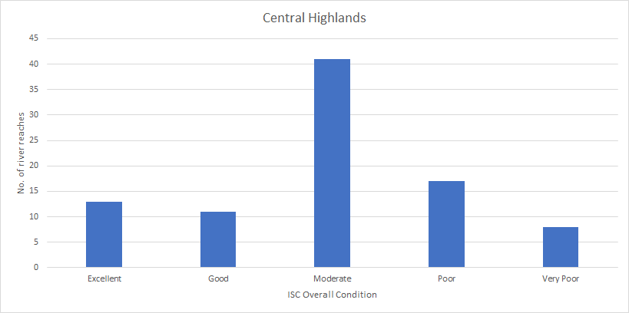

Figure 25: 2010 ISC Overall Condition scores for rivers in Central Highlands

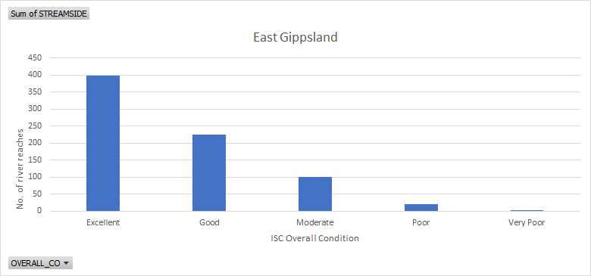

Figure 26: 2010 ISC Overall Condition scores for rivers in East Gippsland

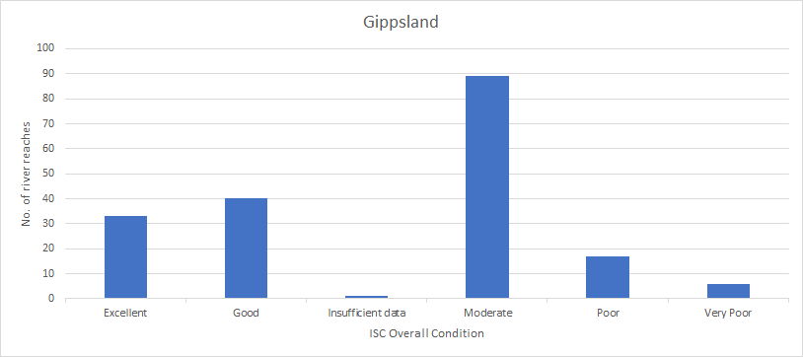

Figure 27: 2010 ISC Overall Condition scores for rivers in Gippsland

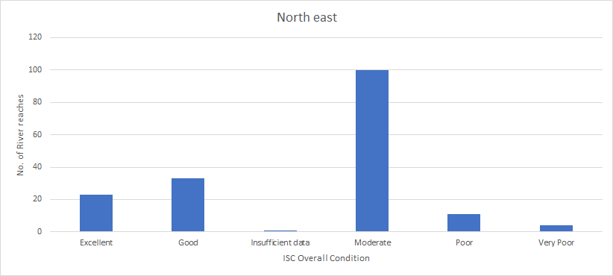

Figure 28: 2010 ISC Overall Condition scores for rivers in North East

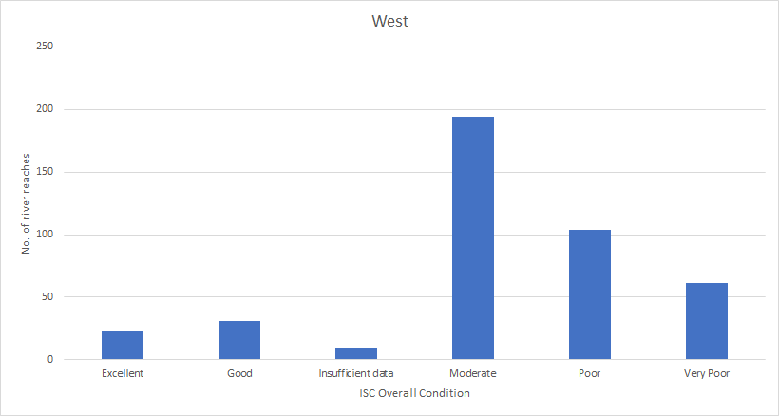

Figure 29: 2010 ISC Overall Condition scores for rivers in the West

One of the five ISC parameters used to measure river health is the Streamside Zone sub-index. Streamside Zone is measured by seven indicators (Table 53) and is represented by a score out of 10, with the higher scores indicating better condition. Figure 30 shows that the condition of the Streamside Zone is considerably better for the eastern RFAs, while the RFA in the west demonstrates large areas encompassing rivers with a low to mid-range Streamside Zone score. This may be due to higher proportion of non-forest land in western Victoria.

Table 53: Streamside Zone indicators

|  |  |
| --- | --- |
| Streamside Zone indicators | Description |
| Vegetation width | Width of woody vegetation along the river |
| Fragmentation | A measure of the quantity of gaps where there is no woody vegetation |
| Vegetation overhang | Percentage of the stream bank that has overhanging vegetation |
| Large trees | Older mature trees that are larger than a prescribed diameter (usually 80 cm) |
| Tree and shrub cover | The amount of vegetative cover in the shrub layer (<5 m in height) and tree layer (>5 m in height) |
| Structure | The amount of woody vegetation (where cover is >20 per cent) |
| Weeds | The percentage cover of willows and hawthorn in the tree layer |

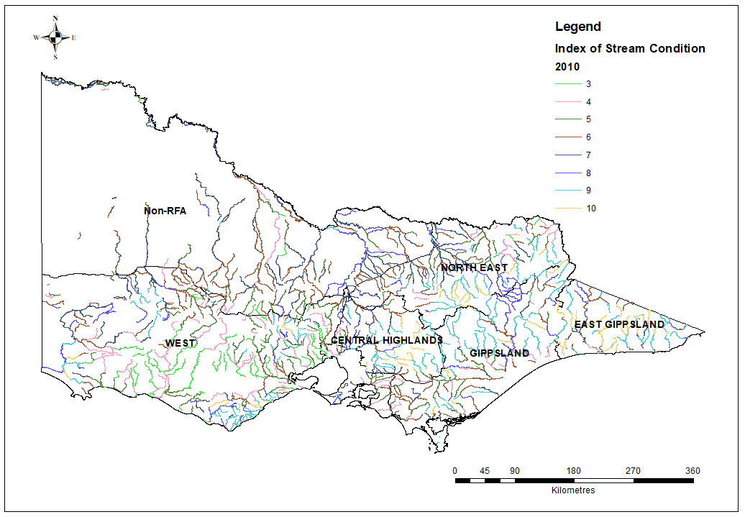

Figure 30: Streamside Index (1–10) across the five RFA regions for 2010

**Summary and future management of environmental values**

**Old-growth values**

Along with other environmental values, old-growth forests were one of the criteria for designing the CAR reserve system under the Victorian RFAs; their subsequent depletion due to bushfire has significant implications for the applications of the JANIS criteria.

It is acknowledged that old-growth forest figures given at the time of the CRAs were an estimate, and the area of old-growth forest was not subsequently monitored over time. This means that much of the data provided over the last 20 years has been modelled data only.

Modelled data suggested that the area of old growth has reduced by more than half since 2000 – from 840,000 hectares to 406,000 hectares in 2018. The largest losses of old-growth forest have been in the Gippsland and East Gippsland RFA regions. The decrease in the area of old-growth forest is predominantly due to the major bushfires in 2003, 2007, 2009 and 2013. Timber harvesting accounts for less than 1 per cent of the loss of old-growth forest since 2003. Old-growth forest in many EVCs in the West Victoria RFA region displays different characteristics from that in the eastern part of the state.

The Victorian Government has commissioned a comprehensive airborne data acquisition, using LiDAR across priority forested areas in eastern Victoria. This data will provide a valuable update to the understanding of the old-growth extent – particularly when matched with a new old-growth ground verification method which is being developed by DELWP – to inform future management of this value.

The modernised Victorian RFAs will protect all old-growth forest in Victoria in line with government policy.

**Wilderness values**

Assessments of wilderness were completed during the CRA process in the Central Highlands, East Gippsland, Gippsland and North East RFA regions. In these areas, 18 wilderness areas were identified and 95 per cent of the total area of significant high-quality wilderness was protected in the reserve system. There has been no wilderness identified in the Central Highlands or West Victoria RFA regions. Current protection levels for wilderness exceed the JANIS reservation targets, which were for 90 per cent or more wilderness to be protected in formal reserves. There are two IUCN Wilderness Areas within the Victorian RFA regions.

The IUCN Wilderness Area is derived from CAPAD, so may include wilderness outside formal reserves but otherwise protected through mechanisms recorded in CAPAD, such as informal reserves.

There are 286,853 hectares of wilderness in the Victorian RFA regions. There has been no significant change in the area of wilderness over the RFA period. Minor changes in area are attributed to changes in the accuracy of spatial data rather than changes to the actual area of wilderness itself.

Pest plant, animal and bushfire control occur as part of the management and conservation of wilderness values. Wherever possible, management strategies aim to minimise the effects of these activities on wilderness value.

The extension to the Victorian RFAs will provide for the continued protection of wilderness values through the ongoing maintenance of the CAR reserve system, protections as part of the Victorian forest management system, and their status as wilderness parks and wilderness zones under the *National Parks Act 1975* (Vic). Wilderness areas will continue to be protected in national parks and reserves.

**Endangered species values**

The Victorian RFAs provide for the protection of endangered species through the establishment of conservation reserves and the management of habitat in areas outside the reserve system, including the application of prescriptions in forest harvesting operations which may involve establishment of timber harvesting exclusion zones or modified harvesting procedures in sensitive areas such as steep slopes or riparian zones. These are given regulatory force under the *Code of Practice for Timber Production 2014.*

There are currently 196 threatened species and 32 non-threatened migratory birds listed under the EPBC Act that are known or likely to occur within the Victorian RFA regions. Almost all listed species (98.5 per cent) have a conservation advice and/or recovery plan to assist recovery. There are also 14 threatened ecological communities in the Victorian RFA regions listed under the EPBC Act. All have conservation advices, recovery plans or both in place to assist in management and recovery.

There are 14 listed threatening processes affecting threatened species in the Victorian RFA regions. National threat abatement plans have been prepared for eight listed processes. Since the commencement of the EPBC Act, 50 additional species known or likely to occur in the Victorian RFA regions have been listed as threatened under national legislation.

The national CAM provides a consistent approach to the assessment and listing of nationally threatened species, but it has not yet been given effect in Victorian law. However, the Victorian Government continues to meet the requirements of the CAM MOU, signed in 2018, by making best endeavours to establish a Single Operational List of threatened species. Additionally, the management of biodiversity outcomes in State forests is also addressed through the statewide biodiversity plan, *Biodiversity 2037*. This plan notes that 70 per cent of Victoria’s highest-value terrestrial biodiversity areas exist on the 40 per cent of land that is publicly owned. *Biodiversity 2037* sets targets for the future management of values. These include a net improvement in the outlook across all species by 2037, with the following expected outcomes:

* no vulnerable or near-threatened species will have become endangered
* all critically endangered and endangered species will have at least one option available for being conserved ex situ or re-established in the wild (where feasible under climate change) should they need it
* a net gain of the overall extent and condition of habitats across terrestrial, waterway and marine environments.

Future management of endangered species values will include engaging more with Traditional Owners; working with government agencies, private organisations and community groups; developing decision-support tools; expanding and improving data collection; and multi-year investment in the highest-priority projects. These commitments are in addition to the landscape-scale cross-tenure pest management projects run as part of the Weeds and Pests on Public Land Program, which have been operating for 15 years and will continue under the extended RFAs.

**National estate values**

The amended Victorian RFAs will continue to provide for the protection of national estate values through a combination of the National and Commonwealth Heritage Lists, the Victorian Heritage Register and the Heritage Codes of local planning schemes. The expiration and repeal of parts of the EPBC Act and the *Australian Heritage Council Act 2003* (Cth) relating to the Register of National Estate did not diminish protection of Commonwealth heritage places. These parts were superseded by stronger ongoing heritage protection provisions under national environment law.

For the past 20 years, the Victorian forest management system has provided for the protection of national heritage values of National Heritage places in accordance with National Heritage management principles. This will continue under the modernised Victorian RFAs and will incorporate new information and adapt to changing circumstances. There are 13 places on the National Heritage List and 17 places on the Commonwealth Heritage List within the Victorian RFA regions.

The Victorian RFAs will continue to ensure that the Victorian forest management system and CAR reserve system provide for the protection of national and Commonwealth heritage values. The Victorian RFAs will be modernised to reflect current heritage concepts and definitions consistent with the EPBC Act.

**World Heritage values**

There is one World Heritage property located within the Victorian RFA regions: Budj Bim Cultural Landscape in the West Victoria RFA region. All of the Budj Bim Cultural Landscape is Aboriginal-owned and/or managed and is administered to respect the customary and legal rights and obligations of the Gunditjmara Traditional Owners. This listing is the first time an Australian site has been recognised solely for its Aboriginal cultural values.

World Heritage properties in Victoria are managed cooperatively by the Victorian and Australian governments in accordance with the 2009 Australian World Heritage Intergovernmental Agreement.

Under the EPBC Act, World Heritage properties are MNES. The EPBC Act therefore provides protection for World Heritage properties by ensuring that an assessment process is undertaken for proposed actions (including forestry operations) that will, or are likely to, have a significant impact on the World Heritage values of a declared World Heritage property. The exemption of forestry operations in RFAs from other Commonwealth assessment and approval requirements under section 38 of the EPBC Act does not apply to operations within World Heritage properties. World Heritage values will continue to be managed and protected through assessment processes for proposed actions under the renewed Victorian RFAs.

**Biodiversity values**

Biodiversity values were fundamental in establishing a CAR reserve system under the Victorian RFAs and were a focus of the CRAs. The formal reserves in the CAR reserve system form part of the NRS, which aims to secure long-term protection for samples of Australia’s diverse ecosystems and the plants and animals they support.

At the time of the CRAs, the total CAR reserve system across the RFA areas totalled 1.93 million hectares. Addition of State forest to the reserve system, and the application of prescriptions from the *Code of practice for timber production*, have resulted in increases to the CAR reserve system through the life of the RFAs. In 2018, the CAR reserve system totalled nearly 3 million hectares, an increase of over 700 thousand hectares since the RFAs came into effect.

Victoria is undertaking improved mapping as part of the RFA modernisation program, to collect new field data on high-priority forest-dependent threatened species. This will inform future forest management. This includes landscape scale surveys for high-priority forest-dependent threatened species, and collection of new on-ground data. Surveys have commenced and will be completed by March 2020. The program also includes updating HDMs, developing population viability analysis for seven key forest-dependent taxa, modelling climate change vulnerability of forest ecosystems and undertaking integrated analysis. This increased information will ensure that an extended RFA will continue to support the management of biodiversity values.

Future RFA five-yearly reviews will be focused on outcomes and the objectives of the Victorian RFAs. Monitoring and reporting arrangements will be strengthened and streamlined, and where possible will indicate the impact of forest utilisation activities and the benefit of associated management prescriptions. This demonstrates that modernising the Victorian RFAs will maintain and enhance protections for biodiversity values.

**Wetland values**

Wetlands in Victorian RFA regions include Ramsar-declared wetlands, nationally important wetlands, and other wetlands. Overall, there are 1,774,707 hectares of wetland in Victorian RFA regions. Each category of wetland is described below.

There are five Ramsar-declared wetlands within the Victorian RFA regions: Corner Inlet, the Gippsland Lakes, the Glenelg Estuary and Discovery Bay, Port Phillip Bay (Western Shoreline) and Bellarine Peninsula, and Western District Lakes. The Gippsland Lakes has the largest area and extends across East Gippsland and Gippsland RFAs, while Corner Inlet in Gippsland RFA has the second-largest area and is also a shorebird site. All Ramsar-listed wetlands, including those in Victorian RFA regions, are protected by Part 3 of the EPBC Act.

While the original RFAs did not include clauses specifically on wetland values, they included commitments from the Victorian Government to address water and catchments, outlining associated legislative and policy framework and involving the adoption of an integrated catchment management approach to water resource management.

Nationally important wetlands are listed in the *Directory of important wetlands in Australia* and are wetlands that provide a good example in a particular area, are an important habitat for native species or have outstanding heritage or cultural significance. There are 159 nationally important wetlands covering 145,977 hectares in the CAR reserve system in Victoria. The East Gippsland RFA region contains the largest area of nationally important wetlands (71,499 hectares) in Victoria.

Wetland values are also protected by the Victorian Waterway Management Strategy, which provides the framework to maintain and improve the condition of rivers, estuaries and wetlands. DELWP monitors the condition of wetlands in Victoria using the IWC. In 2009–11, this was used to benchmark the condition of naturally occurring wetlands in Victoria.

The proposed amendments to the five Victorian RFAs have been drafted to ensure consideration of MNES, including Ramsar sites, and continued protection of the ecological character of Ramsar-listed wetlands through Victoria’s forest management system, in accordance with Australia’s obligations under the Ramsar Convention. Any extended RFA will also acknowledge that the EPBC Act does not exempt forestry operations within Ramsar wetlands.

Future RFA five-yearly reviews will be focused on outcomes reporting, and specifically reporting against the objectives of the Victorian RFAs.

1. Data accessible via data.vic.gov.au: <https://discover.data.vic.gov.au/dataset/victorian-wetland-inventory-current>
2. Directory of important wetlands in Australia was accessed in 2019. However, the directory has not been updated since 2005. See https://www.environment.gov.au/water/wetlands/australian-wetlands-database/directory-important-wetlands.
3. More descriptions of the software can be found at <https://ensym.biodiversity.vic.go.au/home/aboutensym>.