|  |
| --- |
| Voluntary Committees of Management Newsletter  Edition 10 – October 2016 |

Foreword

I’m pleased to bring you the second edition of the Voluntary Committees of Management Newsletter for 2016. This edition focuses on the work of committees across the state, and includes important updates, reminders and links.

It is fantastic to see the achievements of our committees being shared far and wide. I would like to thank you all for your hard work and enthusiasm in helping to manage our public land –it is a truly invaluable service, and benefits Victorians and visitors alike.

As a committee member, you are a land manager who is both directly involved with, and part of, a local community. Including the views of the community in government decision-making leads to better outcomes.

We’d love to hear your thoughts on a range of   
projects, policies and strategies we are seeking input on. DELWP has launched a combined online consultation website for all current consultation opportunities: haveyoursay.delwp.vic.gov.au/

We welcome the insights you and your committee can provide through this channel.

Many thanks to the committees who have provided updates for this edition of the newsletter, with special mention to Heyfield Wetlands CoM and Woolsthorpe Hall Committee for their great stories and photos.

This newsletter is intended to be a celebration of committees and their achievements, so I encourage all Committees of Management to share their photos and stories for inclusion and look forward to seeing updates from around the state for next edition.

**Kelly Crosthwaite**

Regional Director, Port Phillip Region



Wooleys South Beach (source: Crib Point Stony Point CoM Facebook Page)

**Hume:** <https://www.facebook.com/DELWPHume> **Port Phillip:** <https://www.facebook.com/DELWPPortPhillip> **Gippsland:** <https://www.facebook.com/DELWPGippsland> **Grampians:** <https://www.facebook.com/DELWPGrampians> **Loddon Mallee:** <https://www.facebook.com/DELWPLoddonMallee>

**Barwon South West:** <https://www.facebook.com/DELWPBarwonSouthWest>



**Another Pond at Heyfield Wetlands, Gippsland Region**

The Heyfield Wetlands Committee of Management has successfully completed an extension to the wetland system with the help of local contractors and grants from Heyfield & District Bank and Wellington Shire Council.

The grant money was used to provide diesel to contractors who in turn provided excavators, trucks and bulldozers at no cost to the committee.

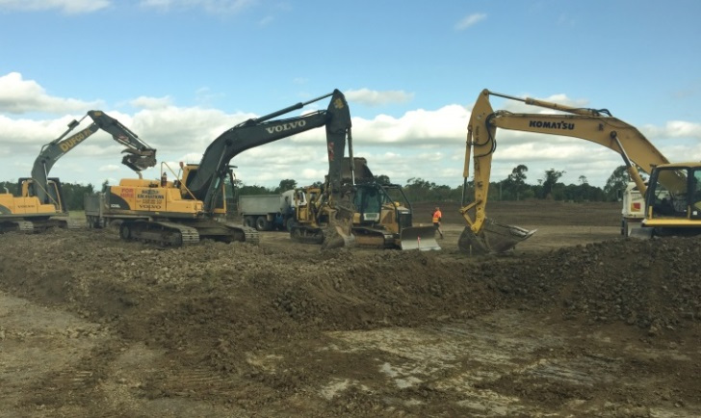

Machinery in action (source: Heyfield Wetlands CoM)

A week after the pond was completed it was tested with some heavy rain. The pond filled up and is working perfectly!

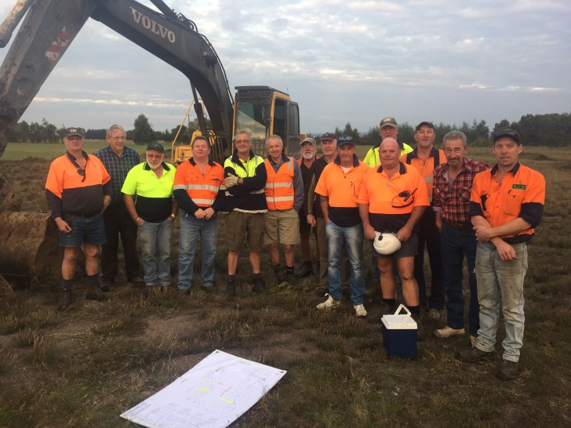

Hi Vis galore (source: Heyfield Wetlands CoM)

The committee, local contractors and other local providers that supported this project were featured in a fantastic article in the local Heyfield and District News (Issue 23).

**2016/17 Insurance Certificates**

DELWP provides public liability, professional indemnity and personal accident insurance for CoMs, other than category 4 CoMs. Remember these policies do not indemnify hirers or tenants of the reserve. The 2016/17 certificates of currency are available here: <http://www.depi.vic.gov.au/forestry-and-land-use/managing-land/managing-crown-land>

**Does your CoM have building insurance?**

Please remember that CoMs are responsible for arranging building and/or contents insurance, WorkSafe insurance and other relevant insurance not covered by DELWP. DELWP is interested in exploring opportunities to support CoMs responsible for managing buildings. If your committee is interested in participating in a project to consider insurance for significant buildings please contact Mr David Chinn, Manager Insurance on 9637 8247 or email [david.chinn@delwp.vic.gov.au](mailto:david.chinn@delwp.vic.gov.au)

Further information can be found in Chapter 11 of the *Committees of Management Responsibilities and Good Practice Guidelines 2015.* Find them here: <http://www.depi.vic.gov.au/forestry-and-land-use/managing-land/managing-crown-land/committee-of-management-guidelines>

**Woolsthorpe Hall Committee update**

The Woolsthorpe Hall Committee would like to celebrate their new members and new air-con. The committee welcomes Elizabeth, Rosie, Alistair, Carmel and Leon.

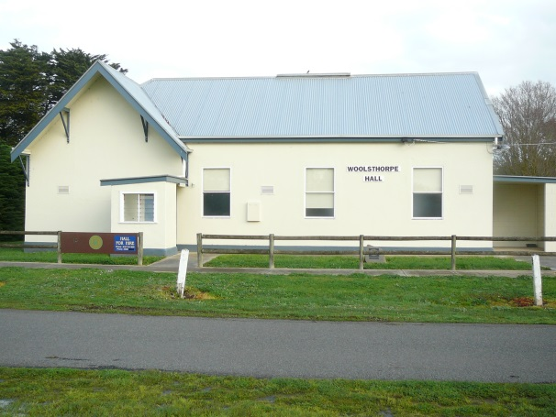

The Hall (source: Woolsthorpe Hall Committee)

The committee secured a grant through the Moyne Shire Council for a split-system air conditioner to provide a measure of comfort to attendees.

Some of those enjoying the new air-con are the Woolsthorpe Historical Society, who also has a permanent display in the hall, the Woolsthorpe Country Women’s and Progress Associations whom regularly meet at the hall.

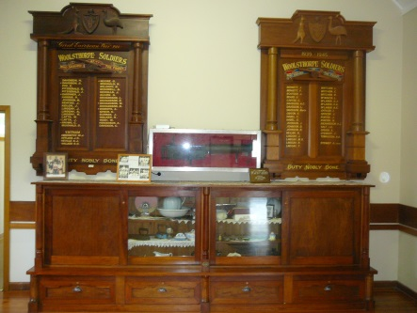

The Historical Society’s display (source: Woolsthorpe Hall CoM)

The committee has a published set of ‘conditions’ for persons and organisations wishing to hire the hall for functions, these conditions are designed to protect the hall and its assets.

The committee has recommended that this newsletter is published quarterly. What are your thoughts? Please contact [voluntary.committtees@delwp.vic.gov.au](mailto:voluntary.committtees@delwp.vic.gov.au)

**Have Your Say**

DELWP invites you to share your thoughts to help shape our future projects, policies and strategies. Committees may be interested in commenting on the current projects including: **Marine and Coastal Act Consultation Paper, Climate Change Adaptation Plan, and the Moolap Coastal Strategic Framework Plan**

Have your say here: <http://haveyoursay.delwp.vic.gov.au/>

**2015-16 Annual Financial Reports**

It’s that time of year again! Financial reports for Category 2 and 3 committees are due 25 November and the forms can be found on our website here: <http://www.depi.vic.gov.au/forestry-and-land-use/managing-land/managing-crown-land>

**Pokémon in our Reserves – Burke Road Billabong, Port Phillip Region**

The Burke Road Billabong Committee of Management has been embracing the Pokémon Go craze by putting up on their website photos of Pokémon found in the reserve. See more on their website: <http://www.brbreserve.org/>

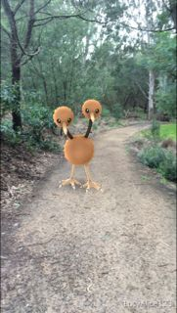

A Doduo on the trail (source: Burke Road Billabong CoM)

They were first told of the Pokémon in the reserve by the Chairperson’s daughter. Rare Pokémon have been found and there is even a Poké stop where players can stock up on the Poké balls needed to play.

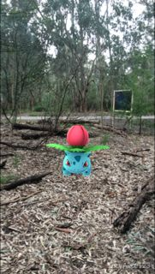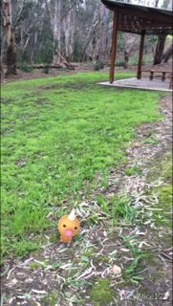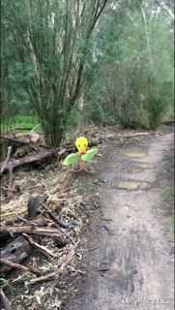

More Pokémon (source: Burke Road Billabong CoM)

The committee hopes the photos will encourage more visitors through the reserve to appreciate the fantastic revegetation work that the committee has undertaken and is rightly proud of.

**CoMs on Facebook – featuring Budgeree Hall**

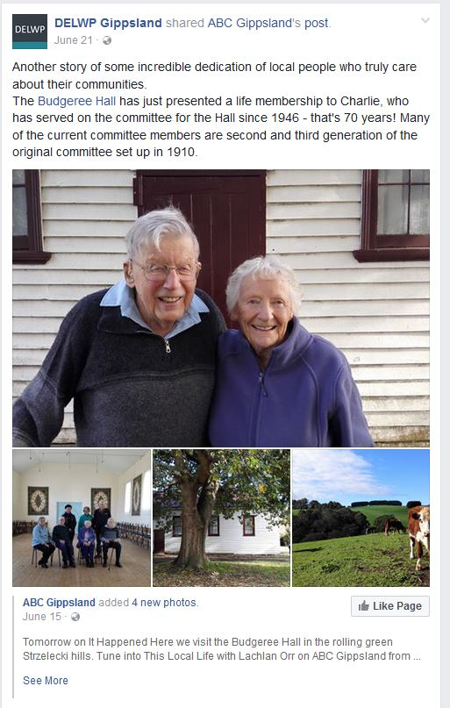

Budgeree Hall was the first committee to provide us a link to their Facebook page.

By providing details of your committee’s Facebook page with DELWP, we can share your group’s posts to help reach more people in your region (and beyond). It also celebrates all the fantastic work CoMs do managing land on behalf of all Victorians.

You can visit their page here:

<https://www.facebook.com/budgereehall/>

Send your Facebook page link to: [voluntary.committees@delwp.vic.gov.au](mailto:voluntary.committees@delwp.vic.gov.au)

Work for the Dole program to refresh Winslow Mechanics Institute

Winslow Hall is getting a face lift thanks to receiving $10,000 in funding from the Moyne Shire and Land Foundation.

The Winslow Mechanics Institute committee developed a prioritised works plan and, with the help of WestVic Staffing Solutions & Western District Employment Access, turned this into a Work for the Dole activity proposal. The works include painting inside and out, replacing doors and guttering, replacing a path and developing a barbeque area.

[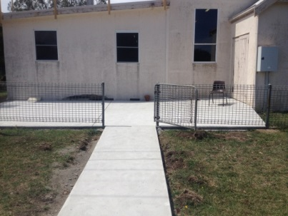](https://www.facebook.com/DELWPGippsland/photos/a.138670839540376.35599.138426989564761/861864387221014/?type=1)

Watch this space (source: Winslow Mechanics Institute CoM)

Six participants began in February for six months, working under the supervision of Gary Huebner from the Winslow Handyman.

It’s a win-win arrangement, with participants learning and gaining valuable work related skills whilst contributing to valuable community projects in their local area.

The Committee is now scoping Stage 2 of the works to use this program for another 6 months. They will be completing works on the hall’s kitchen, blinds, polishing the floor, and re-sowing the lawn.

Please contact your local coordinator if your committee is interested in working with Work for the Dole.

**Work for the dole**

Work for the dole participants can undertake activities that could be beneficial for committees. Participants cannot replace paid work positions or be work normally done by a paid employee.

More info and contact details available at <https://www.employment.gov.au/information-work-dole-host-organisations>

**Aboriginal Heritage Act 2006 amended**

Changes to the *Aboriginal Heritage Act 2006* came into effect on 1 Aug 2016. Committees need to be aware of the changes, especially if they are planning works that could harm Aboriginal heritage or providing interpretation of Aboriginal heritage.

The key changes are:

* To empower Registered Aboriginal Parties (RAPs) as protectors of their heritage through greater decision making roles and responsibilities. Activity Advisory Groups will be appointed for areas with no RAP.
* To improve certainty through provisions such as enabling land management agreements and requirements for cultural heritage management plans.
* To provide more stringent enforcement and compliance mechanisms.
* Aboriginal intangible heritage can be registered under the Act, allowing Traditional Owners to decide whether and how their traditional knowledge is used.

More detail is available on the Aboriginal Victoria website: <http://www.dpc.vic.gov.au/index.php/aboriginal-affairs/aboriginal-heritage-amendment-act-2016>

**New Dunkeld Community Centre opens**

The Dunkeld Memorial Hall has been the centre of the community hosting many dances, concerts, film nights and other community events over the years.

In 2007, the hall was starting to show signs of wear and tear and a survey was conducted within the Dunkeld and district community regarding the hall’s future. There was overwhelming support for a multi-purpose community facility.

As a result, a sub-committee of the Dunkeld Public Lands Committee was formed. In 2009, the Dunkeld Community Centre Committee was formed as a separate committee with sole responsibility for the hall.

Over the next six years, a great variety of activities took place to raise funds for the building. These included monster garage sales, raffles, performances, grape picking, and the very successful Serra Terror adventure walk, which has contributed over $150,000.

Share your stories in Edition 11!

DELWP is seeking contributions for Edition 10, and any feedback on the frequency and content of the newsletter. Please send any comments, suggestions or articles and photos to [voluntary.committees@delwp.vic.gov.au](mailto:voluntary.committees@delwp.vic.gov.au)

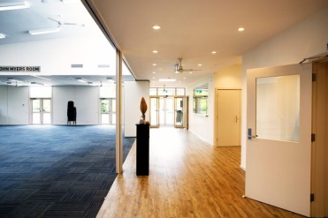

Inside Sterling Place (source: Jacob Kelly Architect)

The new Dunkeld Community Centre, named Sterling Place, was officially opened on Sunday 29 May 2015.

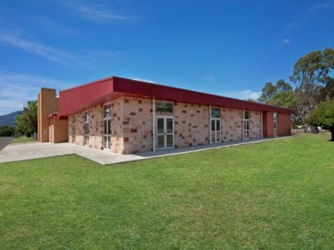

Sterling Place (source: Jacob Kelly Architect)

In 2015, the first full year of operation the centre hosted over 150 events attended by approximately 7,000 people. These included community meetings, state and local government meetings and seminars, performances, weddings and funerals, birthday parties, a sculpture exhibition and a variety of business events.

The Dunkeld Community Centre not only provides an attractive modern facility for the Dunkeld community but also provides economic benefit to the Dunkeld community.

|  |  |  |  |  |
| --- | --- | --- | --- | --- |
| Grant name | Purpose | Amount | Key dates | Website |
| Living Heritage Program | To support the repair and conservation of ‘at risk’ heritage places and objects identified as being of state significance and included in the Victorian Heritage Register. | Up to $200,000 | 7 November 2016 | <http://www.dtpli.vic.gov.au/heritage/about-heritage-in-victoria/living-heritage-program> |
| Boating Safety and Facilities Program | To assist with the development and upgrading of boating facilities including boat ramps, jetties, trailer parking, minor access dredging, selected infrastructure, boating development plans and boating communication projects. | Assessed on case by case basis | 7 November 2016 | <http://economicdevelopment.vic.gov.au/transport/ports/boating-safety-and-facilities-program> |
| Country Football and Netball Program | To assist country football and netball clubs, associations and umpiring organisations to develop facilities in rural, regional and outer metropolitan locations. | Up to $100,000 | 7 December 2016 | <http://www.sport.vic.gov.au/grants-and-programs/country-football-netball-program> |
| Victorian Veterans Council – Anzac Centenary Community Grants Program | To commemorate the service and sacrifice of World War I veterans and their communities: or inform and educate Victorians about the experiences of World War I veterans and their communities. | Up to $20,000 | 14 February 2017 | <http://www.dpc.vic.gov.au/index.php/veterans/veterans-grants/victorian-veterans-council-anzac-centenary-community-grants-program> |
| Restoring Community War Memorials and Avenues of Honour Grants Program | Supports communities in Victoria to ensure local war memorials, honour rolls and avenues of honour are restored to their origin al condition or improved to reflect the service history of the local community. | Up to $20,000 | 14 February 2017 | <http://www.dpc.vic.gov.au/index.php/veterans/veterans-grants/commemorative-grants-restoring-war-memorials-and-avenues-of-honour> |
| Community Sports Infrastructure Fund | Through local councils to help provide high-quality, accessible community sport and recreation facilities across Victoria | Up to $100,000 | Ongoing | <http://www.sport.vic.gov.au/community-sports-infrastructure-fund> |
| Melbourne Water Corridors of green funding | To improve river health through the corridors of green program. | Up to $20,000 | Ongoing | <http://www.melbournewater.com.au/getinvolved/applyforfunding/pages/corridors-of-green-funding.aspx> |
| Public Safety on Public Land – Major Projects | To improve public safety on public land through projects such as reconstruction or reinforcement of major structures, demolition of major structures, decontamination, control visitor access, or tree risk projects. | $20,000 and more | Contact your local DELWP representative | Applications must be made through your local DELWP representative. |
| Recreational Fishing – Small Grants Program | To support actions or programs which aim to boost participation in recreational fishing and related activities. | Up to $5,000 | Ongoing | <http://agriculture.vic.gov.au/fisheries/recreational-fishing/recreational-fishing-grants-program/small-grants-program> |