|  |
| --- |
| FACT SHEET: FOREST FIRE MANAGEMENT AND FORESTRY |
| VICTORIAN BUDGET 2017/18 |

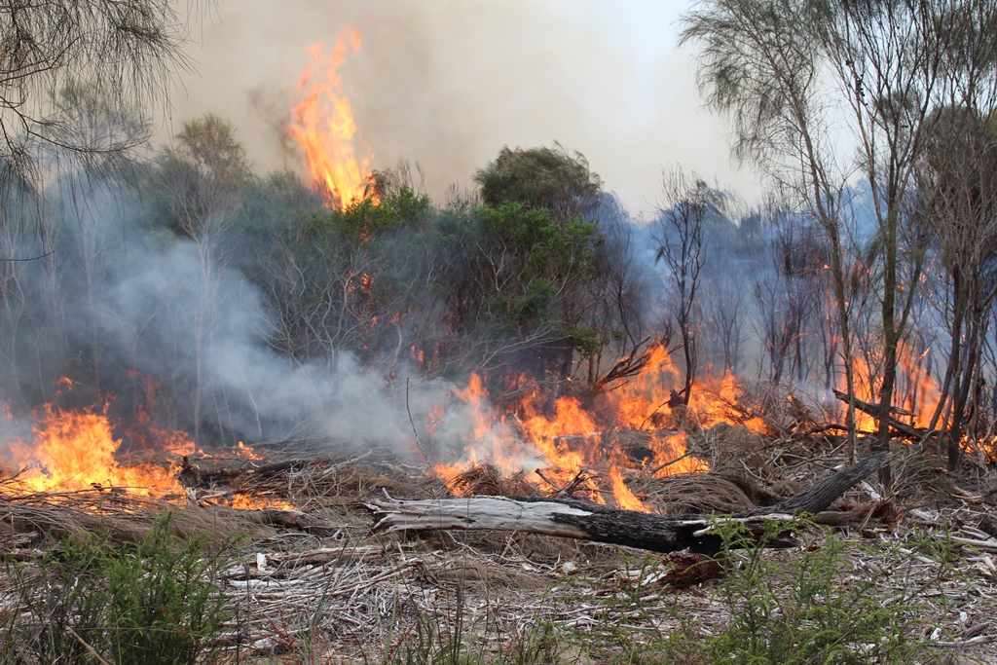

The Andrews Labor Government has committed **$309.4 million** in the 2017/18 Victorian Budget to fund **266 jobs** to reduce bushfire risk, refurbish forest-based assets, and protect our forests and wildlife through better compliance and enforcement.

## The funding provides:

* **$205.7 million** to continue an expanded program of bushfire mitigation on public land, improve forest access, egress and firefighter safety, build fire capacity and diversity;
* **$44 million** for roads, bridges and fire towers;
* **$30.3 million** to significantly boost to Victoria’s forestry and wildlife compliance operations;
* **$11.4 million** for targeted fuel management   
  on private land and roadsides to reduce bushfire risk;
* **$6 million** to build and refurbish forest-based assets;
* **$6 million** for application of bushfire science and risk modelling;
* **$4 million** for landscape bushfire risk planning; and
* **$2 million** for community-based fire management.

## Creating jobs

**266** **new roles** will help Victorian communities by reducing bushfire risk and helping to strengthen protection of forests and wildlife.

**231** **roles** have been created to help reduce bushfire risk, including:

* Frontline Forest and Fire Operations officers
* Forest management (road/bridge construction, hazardous tree removal, fire tower upgrades)
* Traineeships
* Community-based bushfire management
* Bushfire risk planning

To strengthen the protection of our forests and wildlife, **25** **new roles** will be created for frontline regulation and compliance officers.

**Six** **new roles** to manage data and intelligence to support frontline operations, and a further four new roles will manage upgrades to recreational facilities in State forests.

The Government will invest **$6 million** in local contracts to build or refurbish facilities such carparks, toilets and BBQs, improve and join up degraded paths and bike trails, remove dumped waste and install signs.

## Building on momentum

The funding will help deliver the Andrews Labor Government’s *Safer Together* bushfire prevention approach and additional forest regulation and compliance to better protect Victoria’s forests and wildlife.

This funding builds on the 2016-17 budget commitment of **$74 million** over four years and **$18 million** ongoing for bushfire preparedness and response.

## Find out more

Recruitment for these roles will commence in   
May 2017.

Information about *Safer Together* can be found   
at safertogether.vic.gov.au

|  |  |
| --- | --- |
| © The State of Victoria Department of Environment, Land, Water and Planning 2017  LogoThis work is licensed under a Creative Commons Attribution 4.0 International licence. To view a copy of this licence, visit http://creativecommons.org/licenses/by/4.0/ |  |