Committees of Management Newsletter
  - Edition 17 (Special Edition)

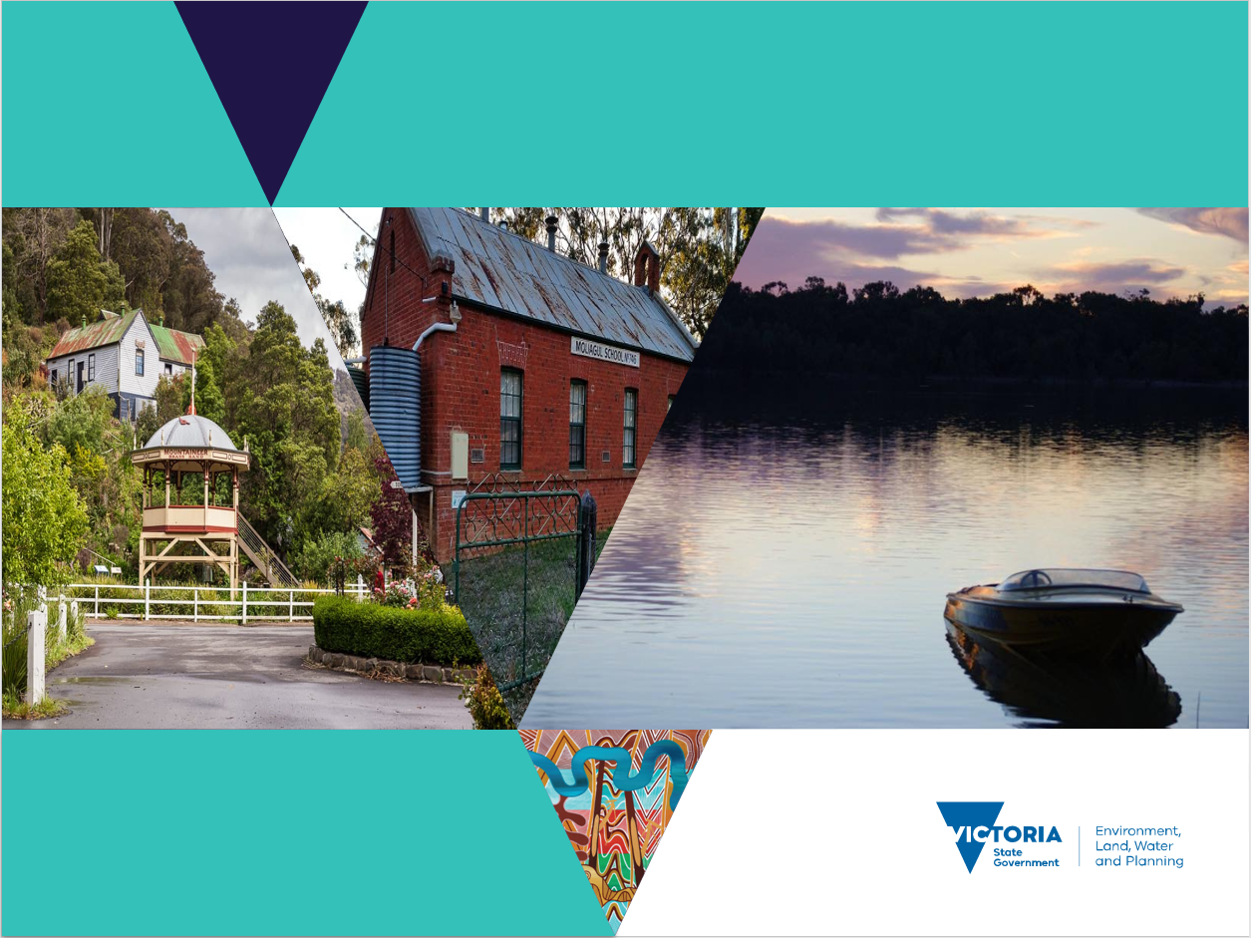

Committees of Management Reform Program

About the CoM Reform Program
Strengthening Victoria’s CoM Model to optimise public value from our portfolio of Crown land reserves in collaboration with the community and our partners.

In 2018 the Victorian Auditor General’s Office (VAGO) conducted a follow-up audit to its 2013-14 audit of the oversight and support of voluntary committees of management (CoMs). The audit identified a suite of issues to be addressed.
In response, the Department of Environment Land Water and Planning (DELWP) established a comprehensive program of work to identify and implement appropriate reform activity.
The purpose of the CoM Reform Program is to:
- Strengthen the governance and management of Crown land reserves managed by CoMs
- Strengthen the department’s oversight of CoMs governance and management of Crown land reserves
- Increase the department’s support to CoMs
- Respond to the intent of the 11 recommendations in the VAGO Report 2018
Those employed to drive this reform at a regional level are the Committees of Management Program Officers (COMPOs).
The CoM Reform Program has identified volunteer recognition, occasions for CoM members to network with each other, and opportunities undertake some training specific to the needs of committees as activities that will aid in the implementation of appropriate reform.
A number of these events have occurred across the regions with further offerings to be scheduled in the new year.
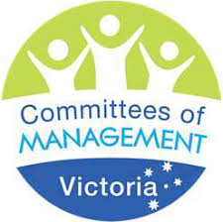

Committees of Management Program Officers
Barwon South West: gab.gadsden@delwp.vic.gov.au
Gippsland: deborah.milligan@delwp.vic.gov.au
Grampians: tracey.milne@delwp.vic.gov.au
Hume: rowan.overwater@delwp.vic.gov.au
Loddon Mallee: jason.torney@delwp.vic.gov.au
Port Phillip: emily.hylard@delwp.vic.gov.au

Recognition

Recognising our Volunteers
DELWP acknowledges the work you do on behalf of your community as a member of a committee of management, and thanks you for your continued commitment to managing the region’s valuable public assets.

DELWP acknowledges the work that is undertake on behalf of communities by the members of Crown land reserves committees of management. As thanks for the continued commitment to managing the state’s valuable public assets several Volunteer Recognition events have been held state-wide. These events have been a highlight of the CoM Reform Program and well received by the recipients and their respective communities.

For more information about the Recognition program contact your local COMPO.

Premier declares state of disaster across eastern Victoria
As you will all be aware Victoria has come face to face with significant additional risk as a result of the devastating bushfires that were burning across the Gippsland and Hume regions.

While the protection of lives, livelihoods and private property is paramount and takes precedence, we do acknowledge and appreciate the efforts volunteers and communities have undertaken in managing the protection of public land assets where possible. We recognise the added stress and burden that being a committee of management volunteer entails in these trying times and thank you all whole heartedly for your dedication to community.

Barwon South West Recognition
Did you know the Barwon South West region’s 200 committees of management are responsible for managing 520,000 hectares of state Crown land for the benefit of all Victorians? These volunteers support a broad range of public amenities and uses, such as halls, showgrounds, gardens, bushland, caravan parks, foreshores, sporting facilities, playgrounds, swimming pools, walking tracks and rail trails.

Over the past several months, our team has hit the road to recognise the hard work of committee of management volunteers across the Barwon South West region.
With nine whole committees and 10 individuals being nominated through this year's recognition program, around 100 people were recognised and presented with a certificate.

Committees and individuals recognised were from the following committees of management:
- Cavendish Recreational Reserve CoM
- Cobrico Public Hall Reserve CoM
- Curdies Inlet and Recreation Reserve CoM
- Dixie Hall and Tennis Courts Reserve CoM
- Dunkeld Public Lands Committee
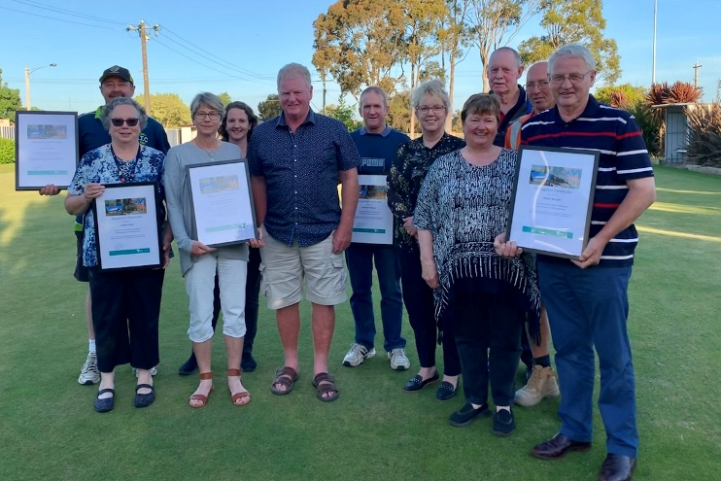
- Kawarren Recreation Reserve Committee
- Lake Elingamite Foreshore Committee
- Camperdown - Timboon Rail Trail CoM
- Narrawong Mechanics Hall Committee
- Pomborneit Recreation Reserve Committee
- Port Fairy to Warrnambool Rail Trail CoM
- Timboon Recreation Reserve CoM
- Victoria Lagoon Recreation Reserve Committee
- Waurn Ponds Memorial Reserve Committee
- Woolsthorpe Hall Committee.

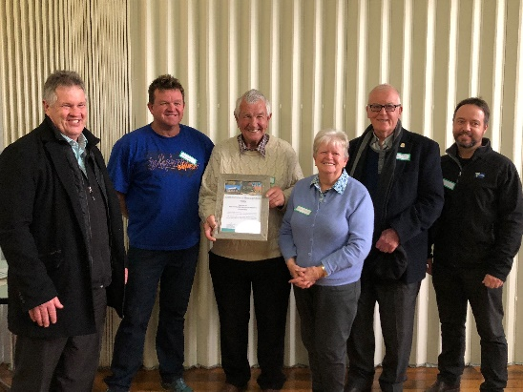
Thank you to all our Barwon South West Region committees of management for your tireless work to maintain and improve Crown land reserves that have been set aside for the benefit of your communities and all of Victoria.
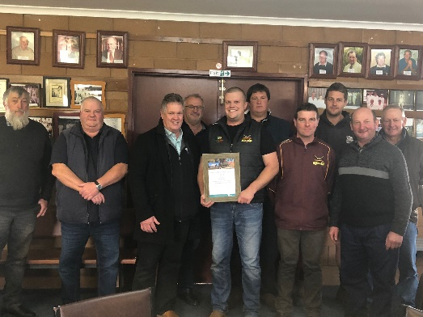
Waurn Ponds Memorial Reserve Committee

Pomborneit Recreation Reserve Committee

Gippsland Recognition

Six Recognition events have been held in Gippsland over the past few months. The Leongatha Recreation Reserve CoM was recognised for its service to the community, while four of their members were also presented with certificates. Stephen Wilson has been on the committee for 22 years while Aileen Clark, Glenn Wright and Frank Dekker have all served for 16 years.

Leongatha Recreation Reserve committee members with Tarnia Leeming and Carole Macmillan from DELWP
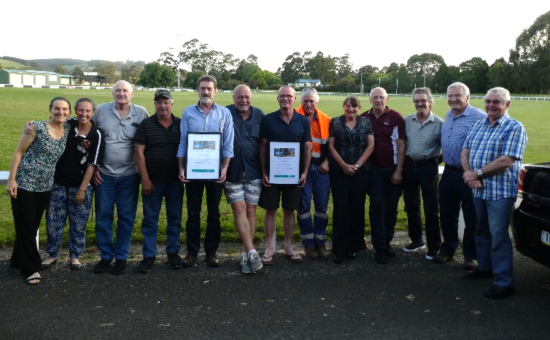

Boolarra Memorial Hall committee members

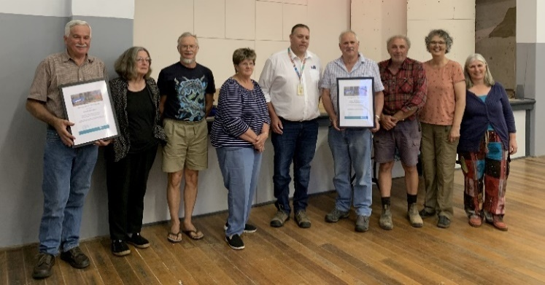
Russell McGlade from Boolarra Memorial Hall CoM was recognised for his outstanding contribution of 31 years of service. Cowwarr Recreation Reserve also celebrated two of their members: Ray Bebbington (30 years) and David Johnston (45 years).
Cowwarr Recreation Reserve committee members with Jeremy Neilson from DELWP

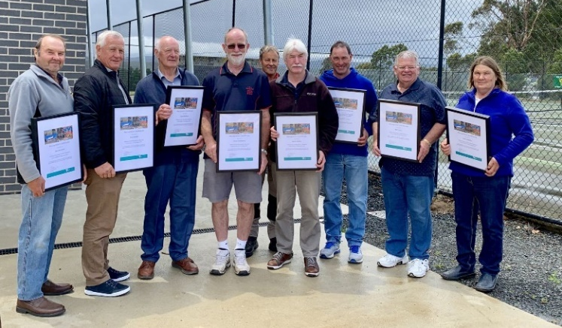
Willow Grove Recreation Reserve celebrated the service of David Balfour (47 years), Bill Taylor (40 years), Ron Mether (37 years), Max Roberts (31 years), Hank Fiddelaers (28 years), Norm Mether (22 years) and Denis Cervi (16 years).
Willow Grove Recreation Reserve committee members

The last event for 2019 was in December when the East Gippsland Rail Trail celebrated John Nelson (19 years), Andrew Sharpe (19 years) and Michael Oxer 16 years.
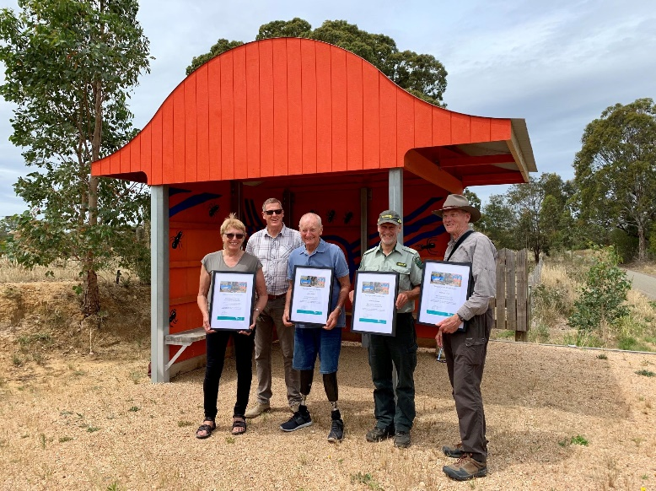
East Gippsland Rail Trail committee members

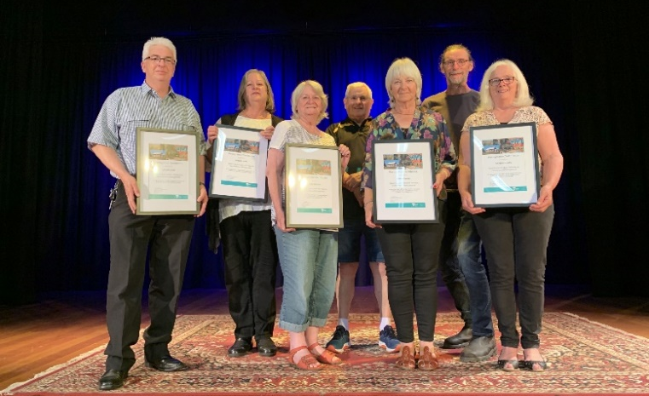
We then started 2020 with a recognition event at Neerim South Public Hall. Judy Gleeson, Sandra Hawke and Peter Hawke were recognised for leadership in succession planning, while Maggie and Lincoln Judd were recognised for leadership in the Hall Transformation Project. Congratulations and thank you to everyone!
Neerim South Public Hall committee members

Grampians Recognition
The Grampians region appreciates the tireless work committees of management do on behalf of their communities and thank them for managing the region’s valuable public land.
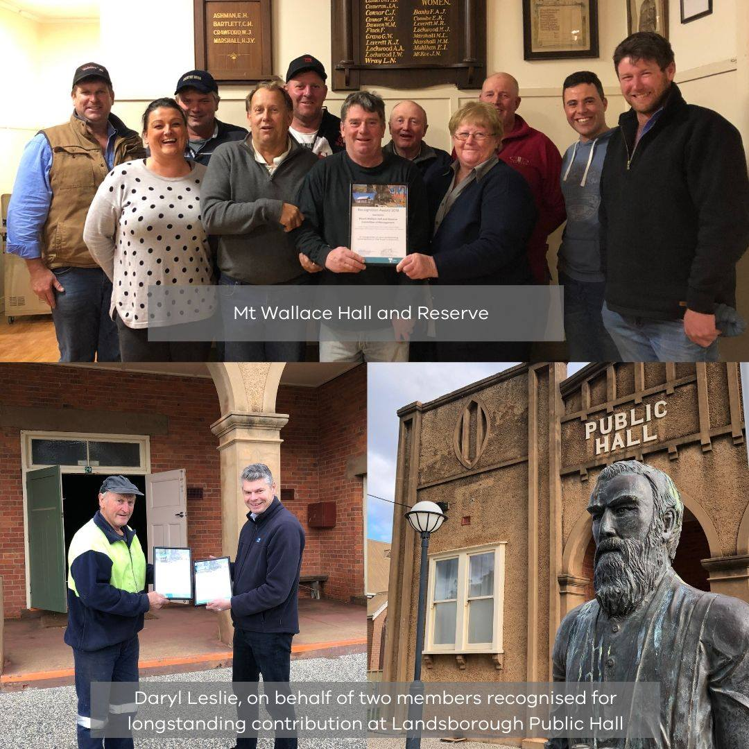
Last year members of the Trawalla and District Recreation Reserve Committee of Management and the Mt Wallace Hall and Reserve Committee of Management received their Committee of Management Awards, in recognition of the continued improvement to the hall and reserve.
Trevor and Donna Hart with Joan and Trevor Smith also received recognition awards for their incredible volunteer contribution. Over 1,000+ in-kind volunteer hours were provided to support the construction and project management of the new off grid community hub.
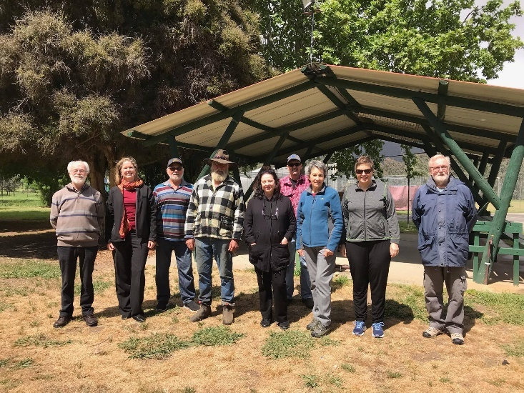
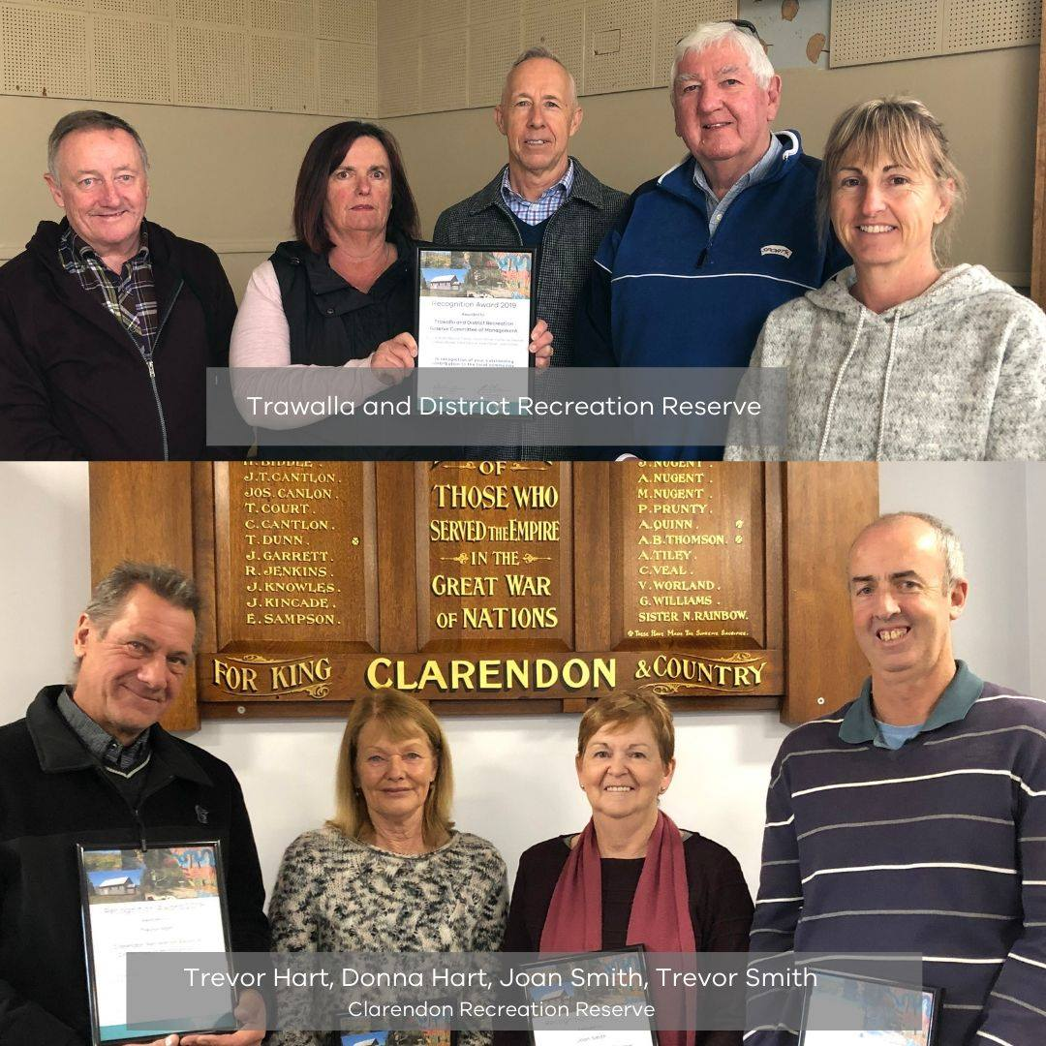
While Daryl Leslie, Chairperson of the Landsborough Public Hall Committee of Management, accepted awards on behalf of members recognised for their longstanding contribution to the committee.

Hume Recognition
Committees of Management and their volunteers across north east Victoria are being acknowledged for the vital service they provide to communities.
DELWP is holding ceremonies across the Hume region and will present 12 awards to Committees of Management and individual committee members for the important work they undertake by managing Crown land for the benefit of local communities.
“Committees of Management play a critical role in providing opportunities for residents to enjoy public land areas by maintaining and improving the sites, whether they are sporting facilities, caravan parks, camping sites and other areas,” DELWP Hume Regional Director, Clare Kiely said
“These awards not only recognise the Committees of Management and outstanding individual members, but specially the volunteers who give up their own time to manage public land for the benefit of the community.
“Seven committees and five individual members have been recognised, including the Mudgegonga Reserve Hall Committee, for its work to complete a major refurbishment of the site before the 10th anniversary of the Black Saturday bushfires. During the past 12 months the committee has undertaken significant refurbishment works at the site, including the installation of a plaque to commemorate the bushfires,” Ms Kiely said.

Other recipients include:
- Kiewa Memorial Park Reserve Committee (pictured above)
- Bernard Priestley from Toolangi Recreation Reserve Committee
- Nerida Kerr from Barnawartha Recreation Reserve Committee of Management
- Chiltern Park Recreation Reserve Committee of Management (whole Committee and individually Graeme Cassidy and Brian Cassidy)
- Benalla Showgrounds and Recreation Reserve Committee of Management
- Corryong Recreation Reserve
- Flowerdale Sports Club
- Moorngag Public Hall Committee
- Christine Peruzzo from the Peechelba Public Hall and Recreation Reserve Committee
“We work closely with more than 270 Committees of Management across the region and their role includes promoting the Crown land they manage, applying for grants, and undertaking maintenance works and upgrades.”

Loddon Mallee Recognition
The Loddon Mallee Region has 220 committees of management who take an active role in managing, maintaining and improving public assets in their communities.
The Land and Built Environment team of DELWP provides a direct link between the committees and the department and are grateful for their work in maintaining community assets on Crown land.
As appreciation for the work the volunteers undertake several Recognition events have been held across the region with individuals and whole committees being acknowledged.

Those committees recognised have included:
- Redesdale Recreation Reserve Committee
- Maryborough Benevolent Society
- Bendigo Historical Motor Cycle Club
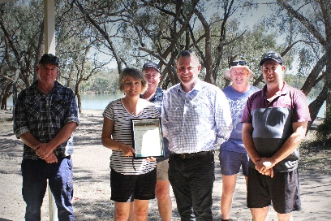
- Moliagul Reserves Committee
- Ouyen Lake Working Group Committee
- Green Lake Regional Park Committee
- Kyabram Racecourse and Recreation Reserve Committee
- Castlemaine Historical Society
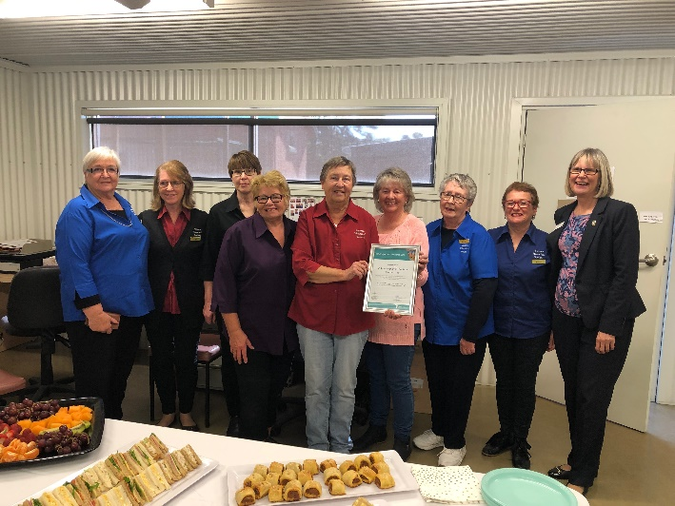
- Echuca Historical Society (pictured below with Loddon Mallee Regional Director Marg Allan)

The Green Lake Regional Park CoM have been recognised for their efforts over the last 8 years to gain government funding to repair the lake bed.

The CoM commenced soil testing to determine why the lake was losing water, then gained funding to prepare a business case. Armed with a confirmed strategy for repair they successfully sought further funding ensuring that the lake bed would be reconstructed under the $2 million Bringing Water Back to Green Lake project.

Ground works to repair the lake bed included removing stumps (which had penetrated the lake bed floor contributing to the seepage) and lining the base and sides with clay. Civil construction works took approximately four months.

Having the lake full again provides great community benefit as it is a vital asset to the area as a social hub and tourist attraction.

At the same time, the CoM continued to apply for grants to improve and maintain the infrastructure, including the addition of more power sites. Additionally, the local school, Tyrrell College, undertook construction projects, providing picnic tables and fire pits for the reserve.

Recently the CoM received planning approval to remove a dilapidated toilet block and construct a new facility in its place.

Green Lake Regional Park CoM Members Graham Jolly, Trudi Conlan, Darren Mott, Terry Cox and James Bailey with Adam Melis (Loddon Mallee Regional Manager)
Three members of the Kyabram Racecourse and Recreation Reserve committee were recently recognised for a combined 120 years of service to the community.
Leon Pettifer, Ian Purdey and Stuart Gemmill received certificates acknowledging their commitment and dedication to operating important recreation facilities for the community.
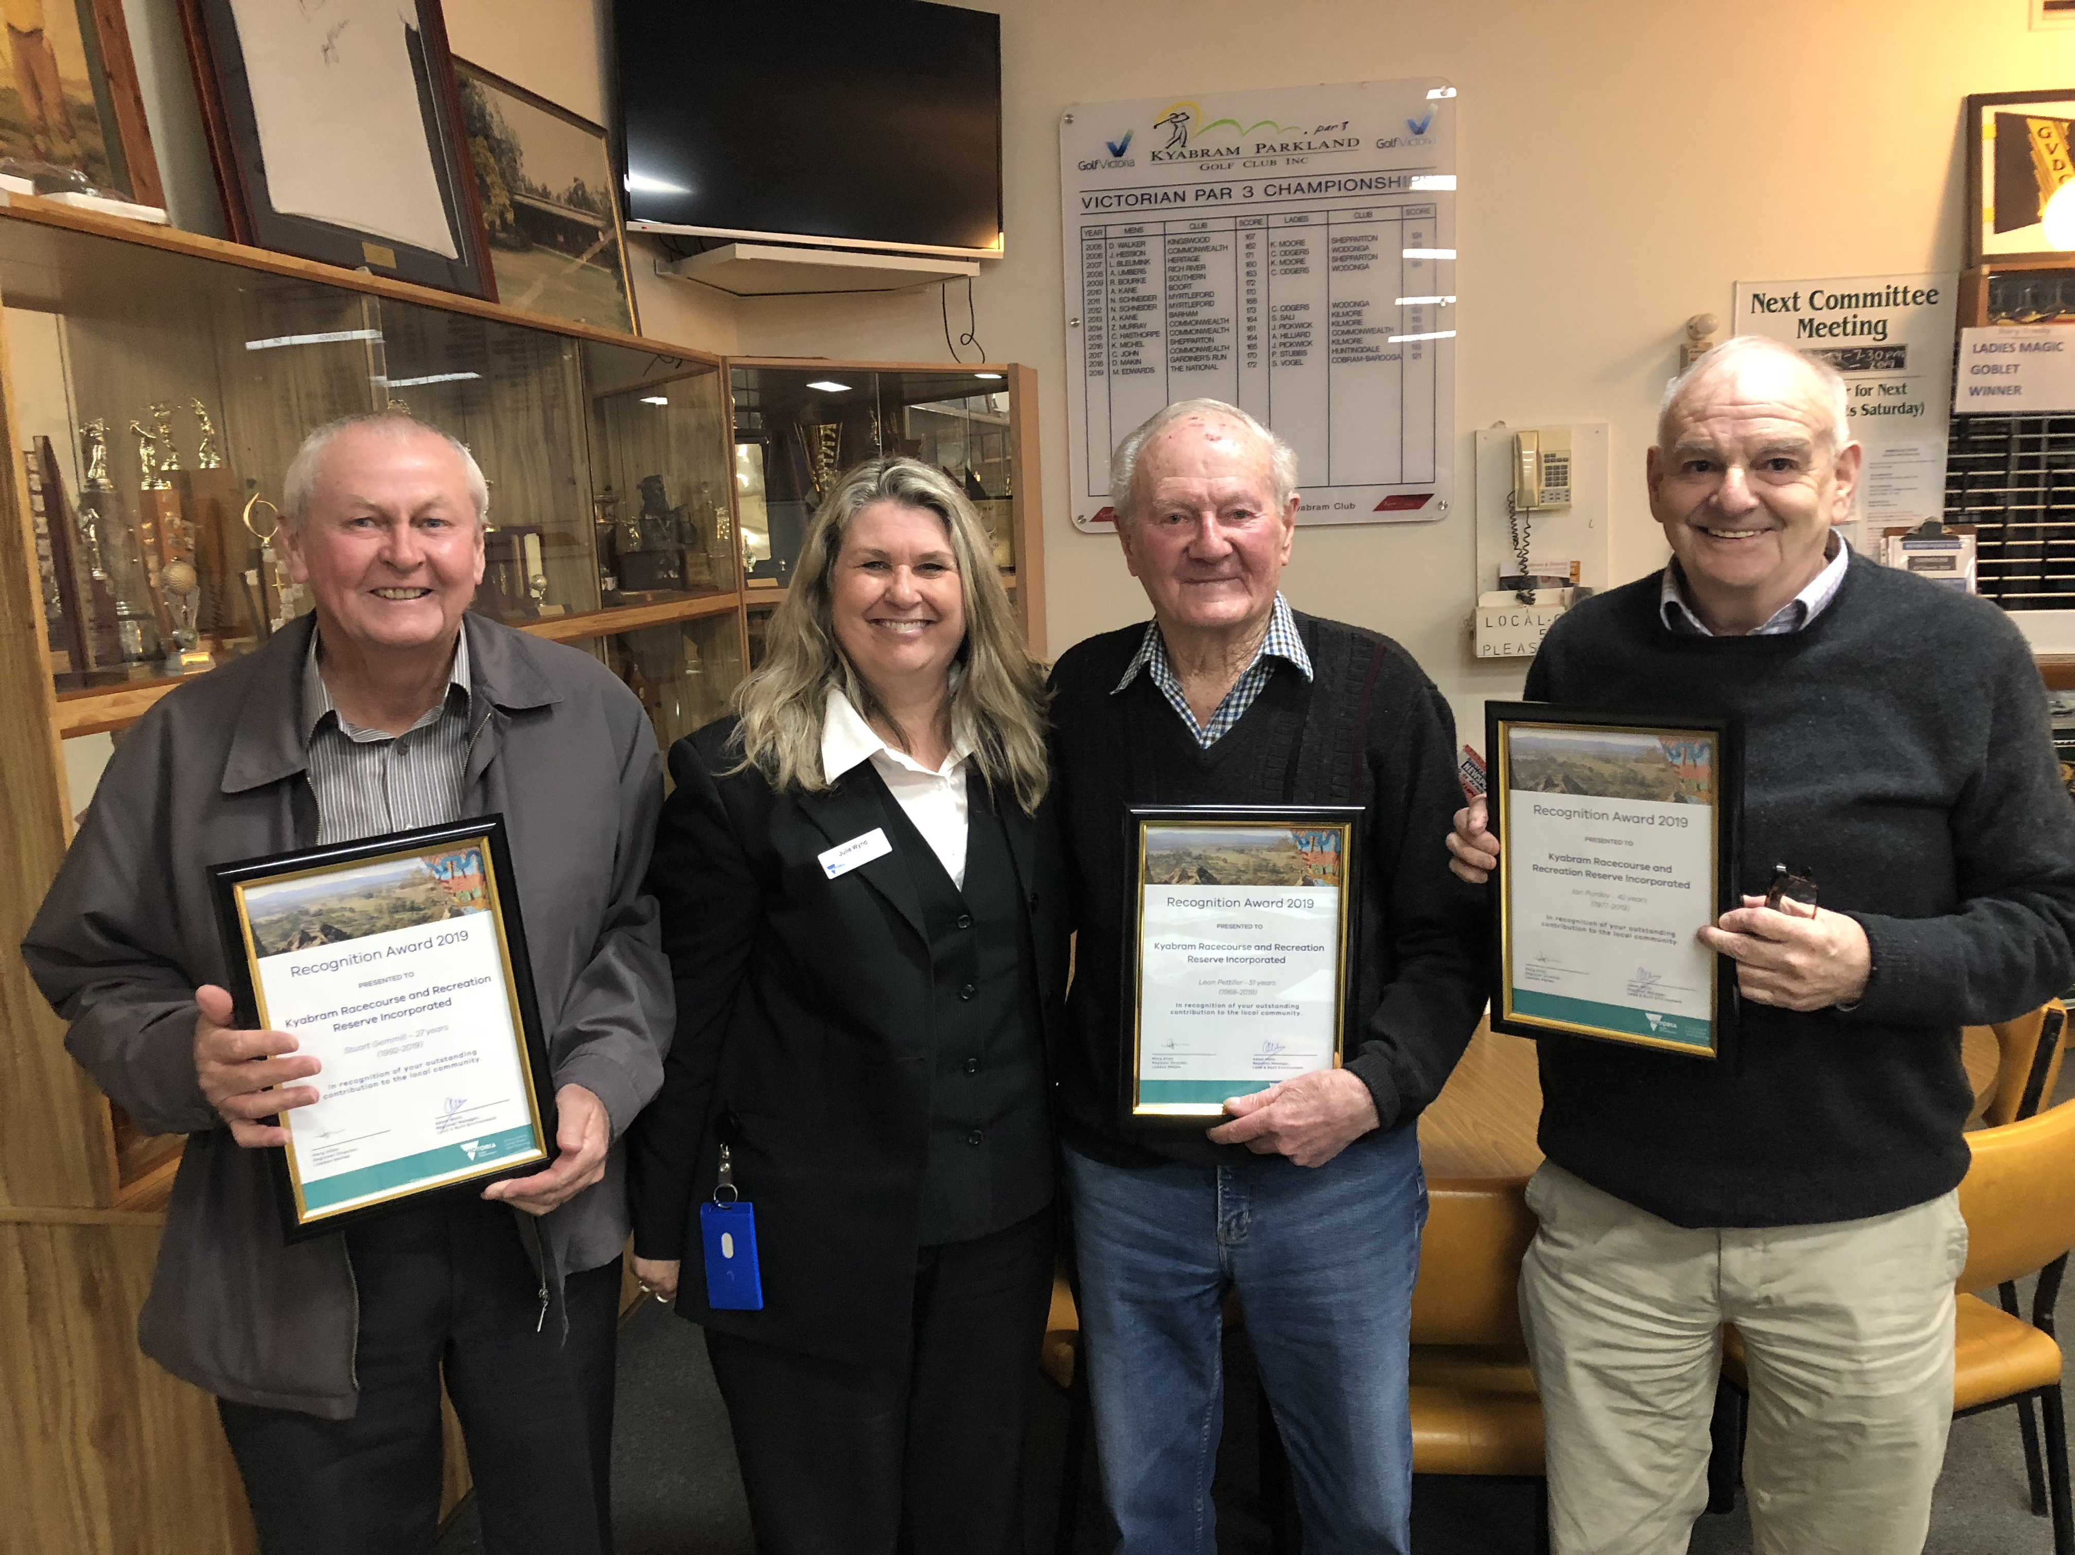
Stuart Gemmill, Julie Wynd (DELWP), Leon Pettifer and Ian Purdey
The Kyabram Racecourse and Recreation Reserve includes an 18-hole golf course, harness racetrack, small bore rifle club and other public facilities.
“Mr Pettifer has been a member of the volunteer committee for 51 years, ever since the combined committee was established,” said DELWP Land and Built Environment Program Officer Julie Wynd.
“He has helped the complex grow from a claypan to having wonderful facilities that are used and enjoyed by many local groups and members of the community.
“Mr Pettifer has been a prominent member of the Parkland Golf Club which is now home to the Victorian Par 3 Golf Titles, which shows what a great facility has been developed over the years.
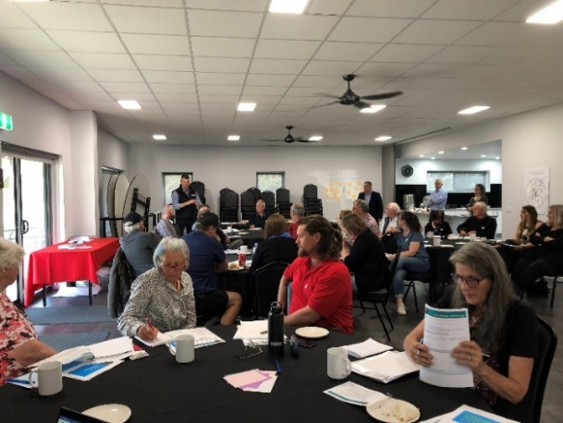
“Mr Purdey has been a member of the committee for 42 years, holding the position of Treasurer for 25 years and Secretary for nine years. Along with fellow volunteer Glen Smith, Mr Purdy was instrumental in securing a grant to build a carpark at the complex in 2012 which has made a huge difference to users of the facility.
“Mr Gemmill has been a member of the volunteer committee for 27 years and his knowledge of water issues has made him invaluable.
“He has been instrumental in consolidating the site’s water rights, ensuring future water for supply to the Golf and Trotting clubs.
“On behalf of DELWP I would like to thank Mr Pettifer, Mr Purdey and Mr Gemmill for the significant effort and time they’ve devoted to carrying out their duties and providing significant social and economic benefit to the Kyabram community and the region.”

Networking and Training
Committees of management will soon be able to participate in several networking events being ran across the state as part of a Committees of Management Reform Program initiative.

DELWP surveyed CoM volunteers to help identify how best to provide support. Targeted light training and networking sessions on key topics are currently being offered as a result of the feedback. The Grampians Region commenced their first networking event in November, and this will continue to be offered in each of the regions this year.

Committee members will have the opportunity to connect and engage with other CoMs, local government and DELWP staff, so they can support and share information, build on knowledge and gain valuable ‘take home tips’ that will help them manage, improve and maintain their Crown reserve.

Grampians Region CoM Networking Opportunity

The Clarendon Recreation Reserve hosted the first Grampians Region CoM Networking event in their new off-grid purpose-built community hub. DELWP staff were joined by Darren Sadler from the City of Ballarat, Donna Hart from the Clarendon Recreation Reserve and Cherie Graham from the Moorabool Shire Council to discuss planning for the future and financial sustainability.

The Clarendon Recreation Reserve CoM shared the story of building an important community asset with local community members and businesses. The committee provided over 1,000 in-kind volunteer hours supporting the construction and project management of the building.

Comments received following the Ballarat CoM Networking event included: “Thank you for an informative night. Well done. We have a plan moving forward.” “Very well organised night! Lots of information. Lots of ideas for grants.” “Fantastic! Learnt a lot.”
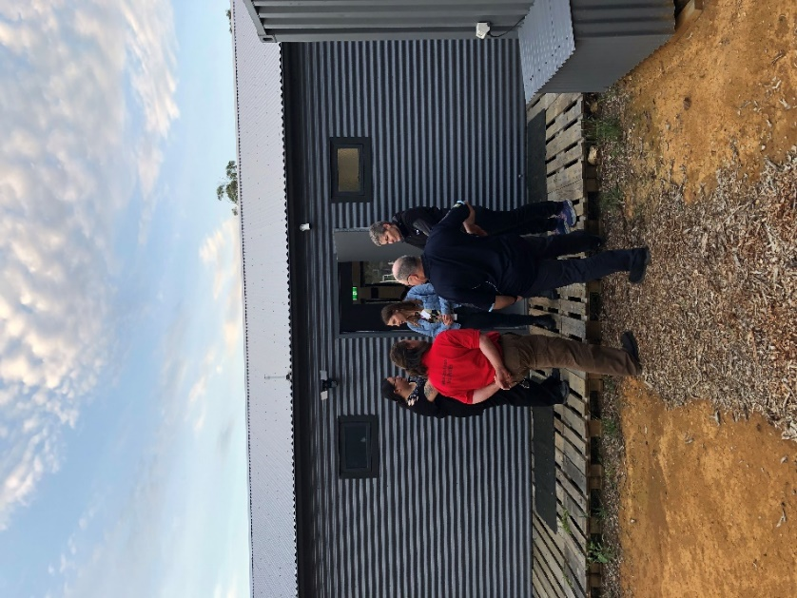
The next networking opportunities will be held in early 2020 at the Ararat Racecourse & Recreation Reserve CoM and the Kalkee Recreation Reserve CoM, near Horsham.

Grants
Federal government grants:  https://www.business.gov.au/Grants-and-Programs |  | Grants Victoria:  http://www.vic.gov.au/grants
Grant Name | Purpose | Amount | Key dates | Website
Victoria’s Great Outdoors – Camping and Caravan grants | Crown land Committee of Managements, including Councils are encouraged to apply for grants from $5,000 to $200,000 to improve the quality and capacity of natural and built assets within their reserves. | $5,000 - $200,000 | Round Two 2020:  Open: August 2020  Close: September 2020  Round Three 2021:  Open: July 2021  Close: August 2021 | https://www.forestsandreserves.vic.gov.au/grants/camping-and-caravan-grants
Melbourne Water Corridors of Green funding | To improve river health through the Corridors of Green Program | Up to $20000 | Ongoing | https://melbournewater.smartygrants.com.au/corridorsofgreen
Recreational Fishing – Small Grants Program | To support actions or programs which aim to boost participation in recreational fishing and related activities | Up to $5000 | Ongoing | https://vfa.vic.gov.au/recreational-fishing/recreational-fishing-grants-program/small-grants-program
Inspiring Environmental Solutions Community Funding Program – EPA | To enhance the environment in a public place, or undertake environmental activities for the benefit of the community | Varies | Ongoing | https://www.epa.vic.gov.au/about-epa/publications/1419
Corangamite CMA Waterways Protection Program 2016-2020 | To improve priority waterways in the Corangamite CMA region. The CMA will not be undertaking new projects in this program until July 2020. However, expressions of interest are still available for eligible landholders, mangers and community groups. |  | Contact for further information | http://www.ccma.vic.gov.au/What-we-do/Community-Funding-/Waterways-Protection-Program-2016-2020.aspx

